**NEWS APP-Flutter Application**

**HOME PAGE**

The Home Page provides access to various news categories through an intuitiveGridView layout. (StatelessWidget)

Multi-language support-**Localization**

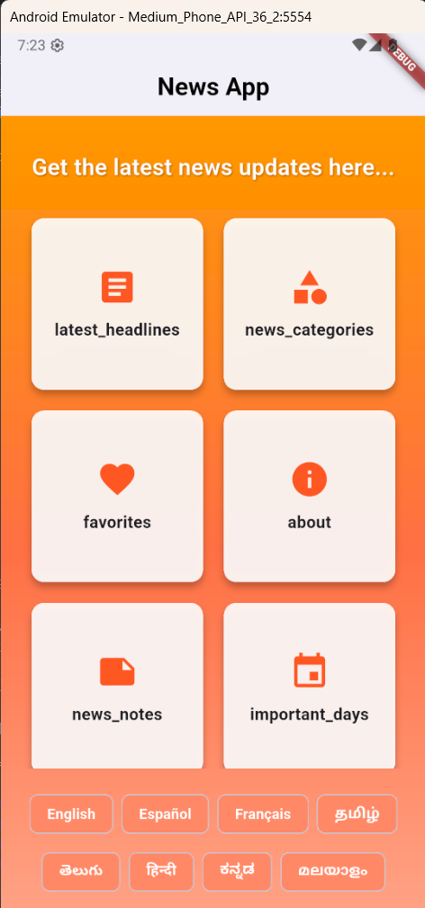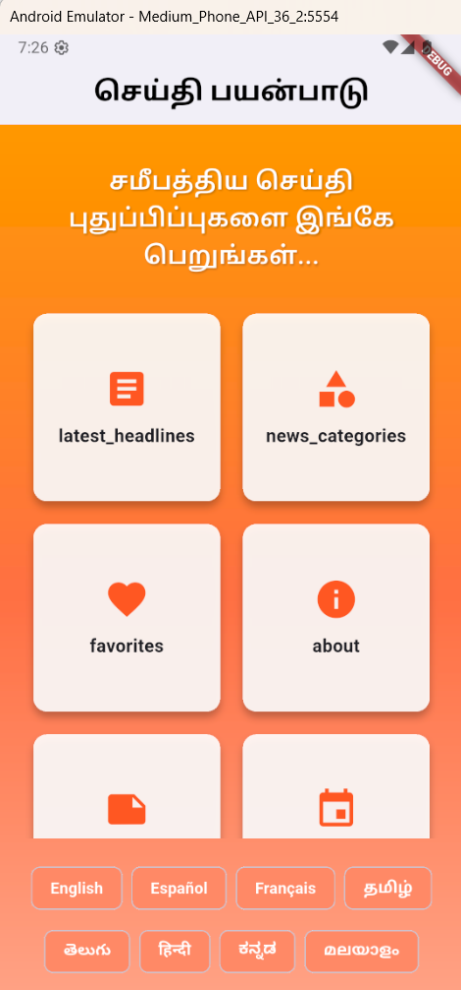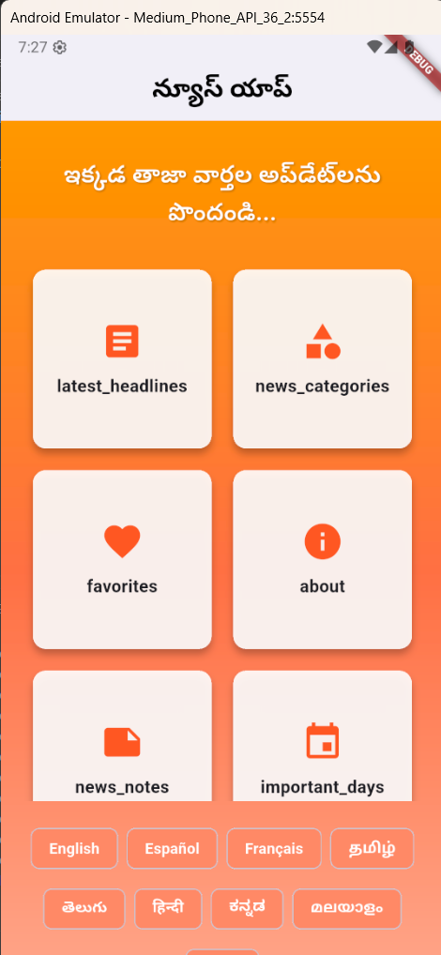

**HEADLINES PAGE**

The Headlines Page provides users with real-time news updates, ensuring they stay informed with ease.

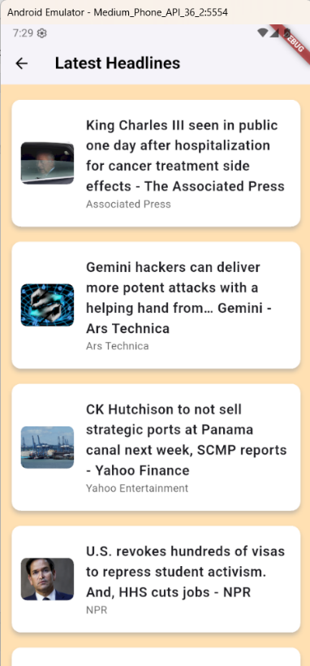

**CATEGORIES PAGE**

The Categories Page allows users to browse news based on different topics, providing an organized way to explore content.

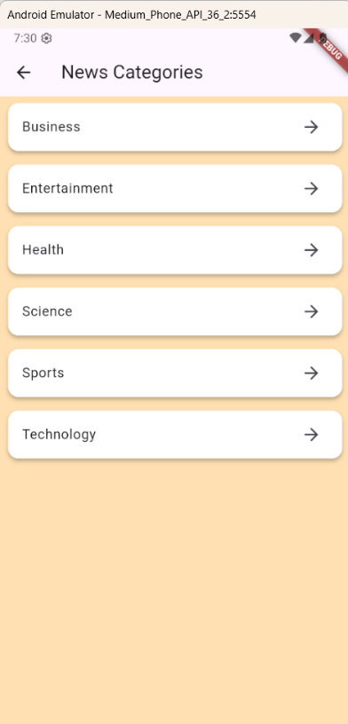 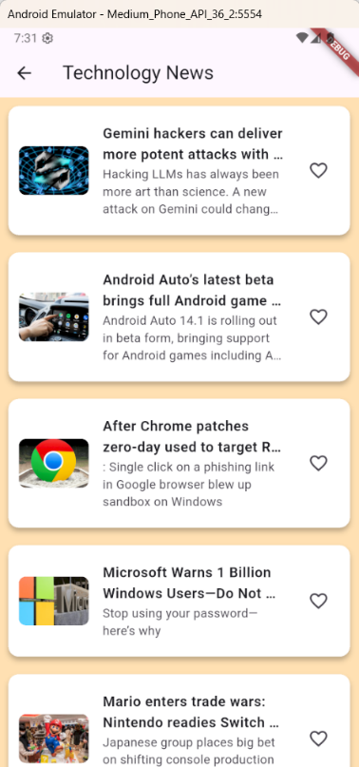 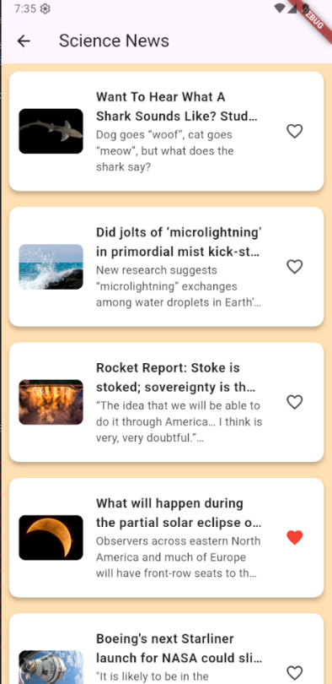

**FAVOURITES PAGE**

The Favorites Page allows users to save and revisit their favorite news articles, providing a personalized reading experience.

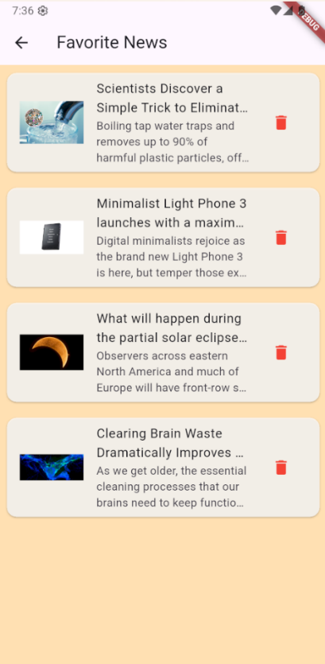

**ABOUT PAGE**

The About Page provides users with an overview of the Live News App, highlighting its purpose and key functionalities.

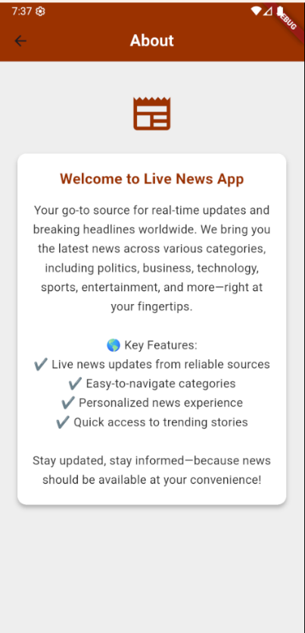

**NEWS NOTES PAGE**

The Notes Page enables users to write, save, and manage personal notes related to news articles, ensuring easy reference and organization.

It utilizes Sqflite (SQLite plugin for Flutter) for efficient local storage, providing a seamless and reliable note-taking experience.

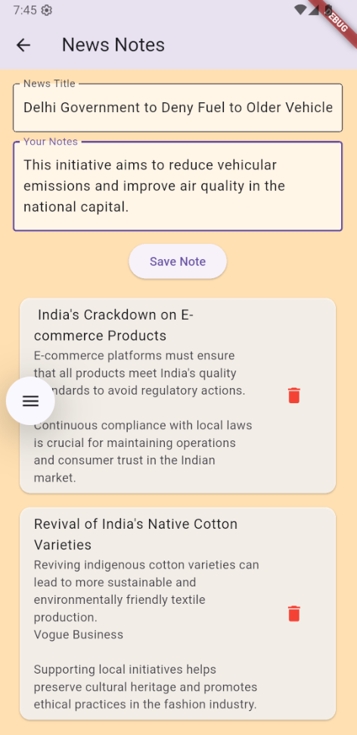 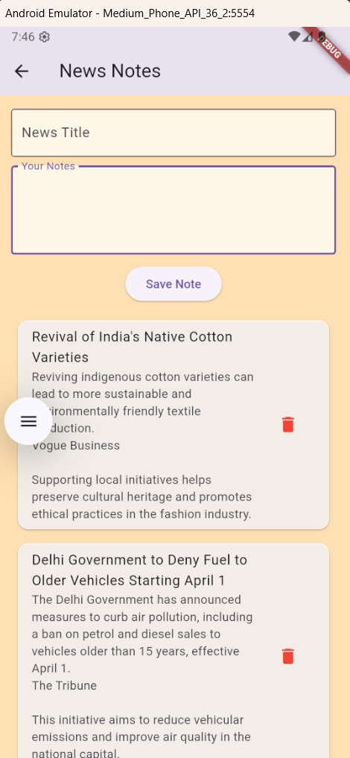

**IMPORTANT DAYS PAGE**

The Important Days Page allows users to save and track significant dates along with custom notes, ensuring important events are easily accessible.

It utilizes Firebase Firestore for real-time data storage and retrieval, providing a seamless user experience.

