***Author Component Creation***

*Assignment*

1)Create an Author component which will have 3 fields

Author Name-single line text field-Mandetry

Author Bio-multiline text field-Mandetry

Dob-date picker-Mandetry

create the component with above dialog fields

Fetch these value directly using htl properties tag

2)What is Dialog validation how to use them?

3)What is client lib?

4)Implement client lib make authorName h1

Make author bio normal body text

Bold the dob

5)What is extraclientlib and how to create custom ?

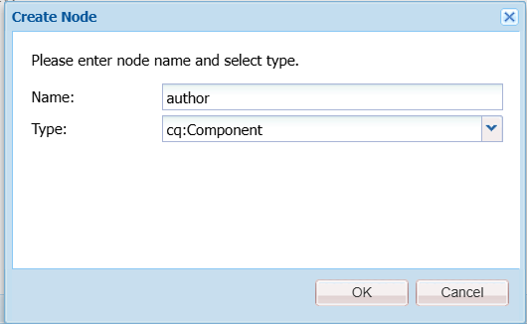

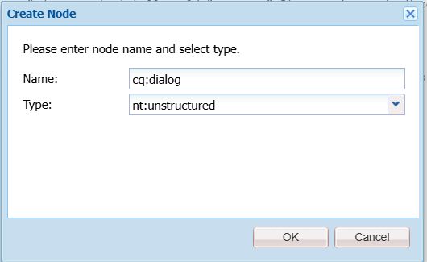

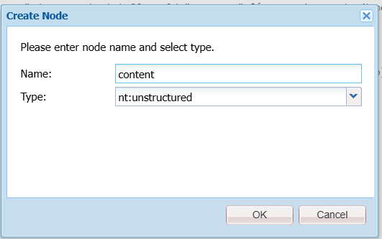

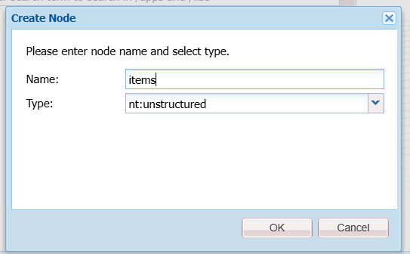

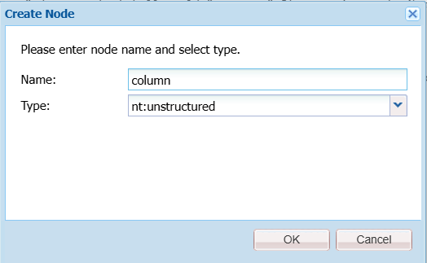

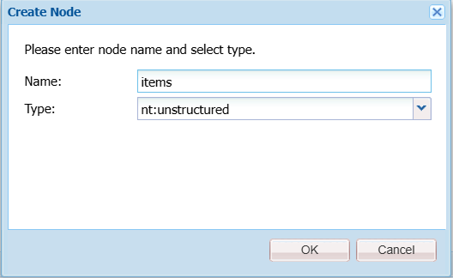

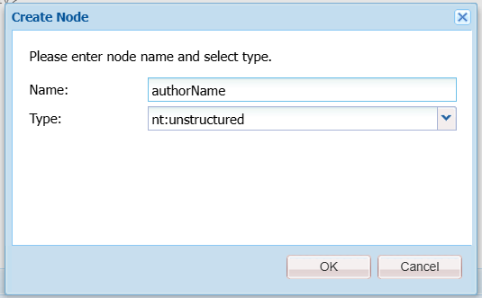

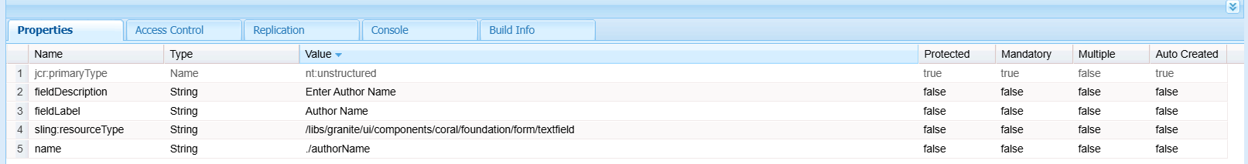

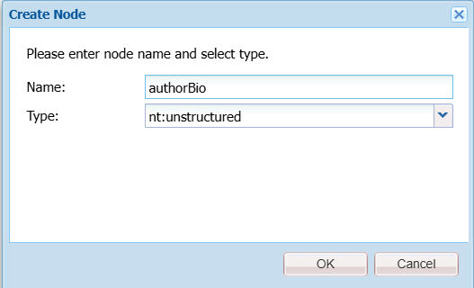

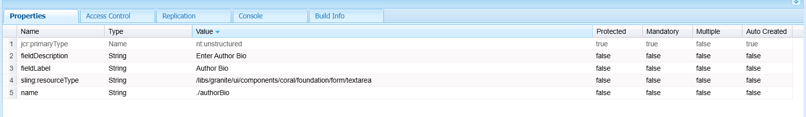

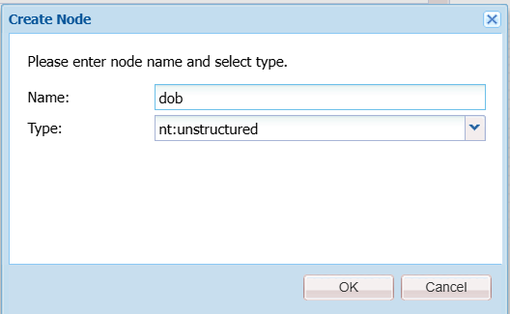

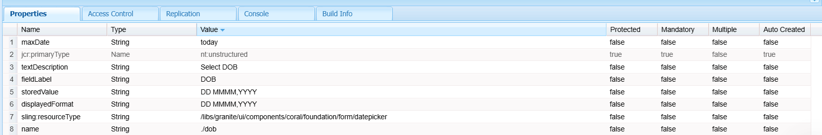

**STRUCTURE:**

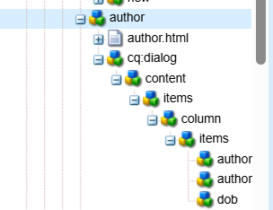

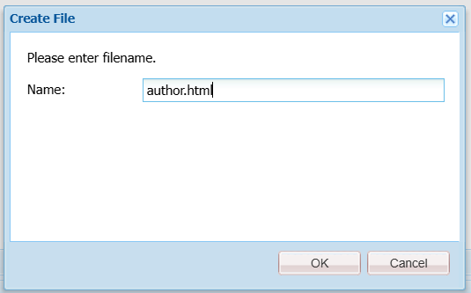

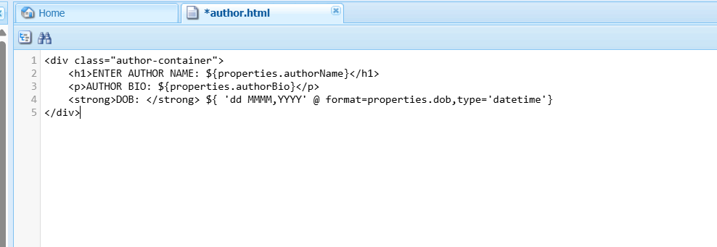

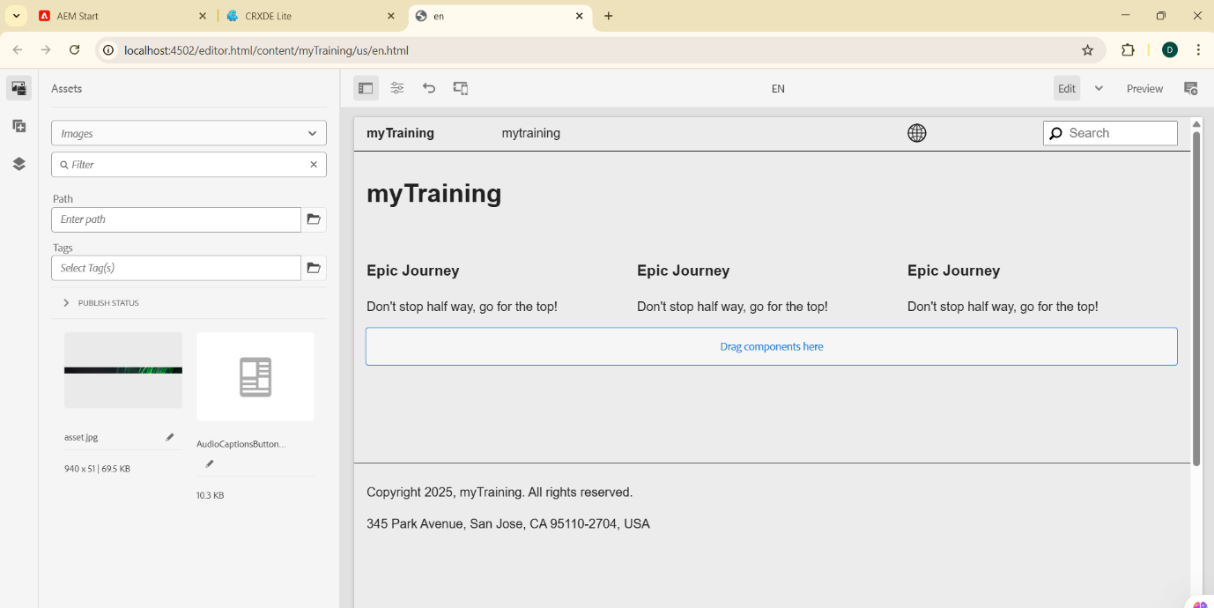

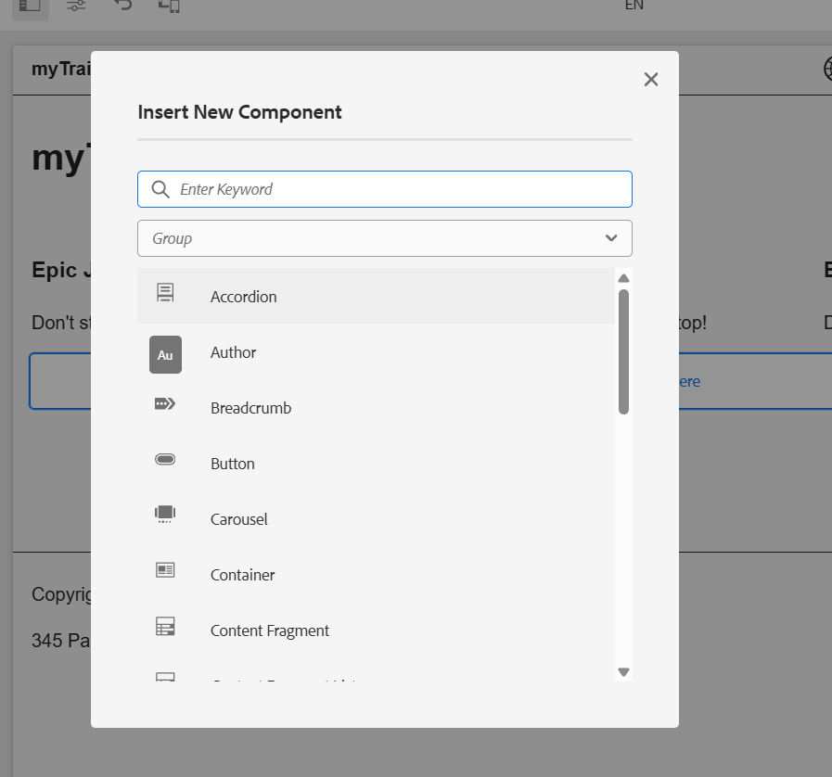

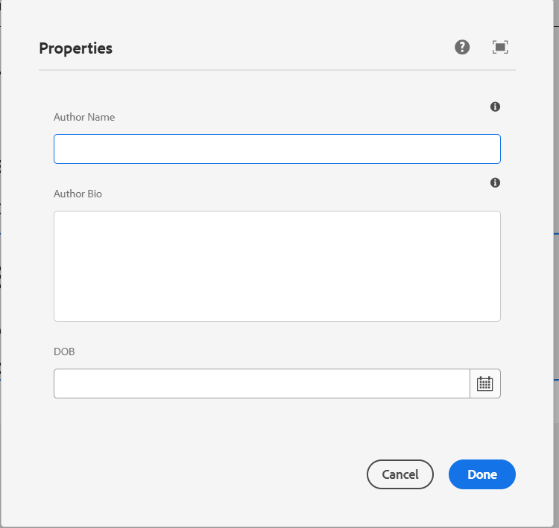

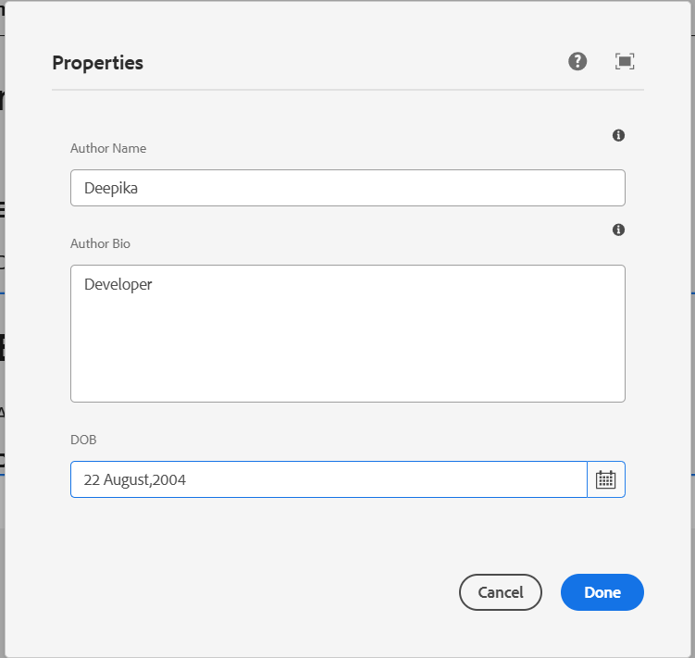

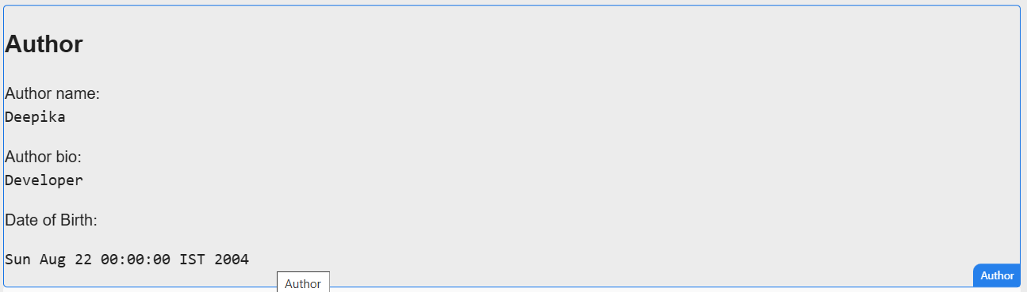  
  
  
**2)What is Dialog validation how to use them?**

Dialog validation in AEM ensures that authors input valid data when configuring components. It enhances data accuracy and improves the authoring experience by preventing incorrect or incomplete entries. Validation can be implemented using JavaScript or server-side constraints in the component’s dialog XML.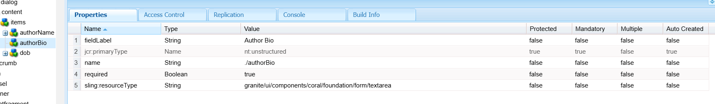

**3)What is client lib?**

A Client Library (clientlib) in AEM is a mechanism for managing and optimizing frontend assets like CSS and JavaScript. It enables bundling, minification, and efficient loading of resources, improving

performance and maintainability.

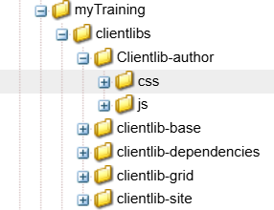

**4)Implement client lib make authorName h1**

**Make author bio normal body text**

**Bold the dob**

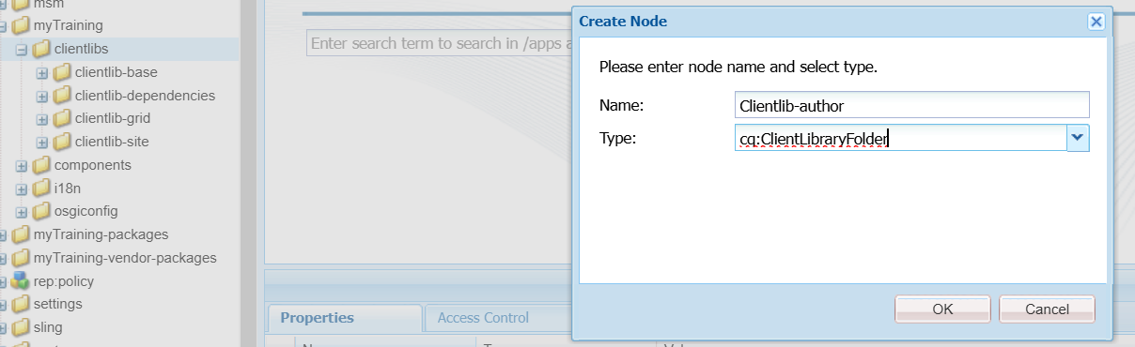

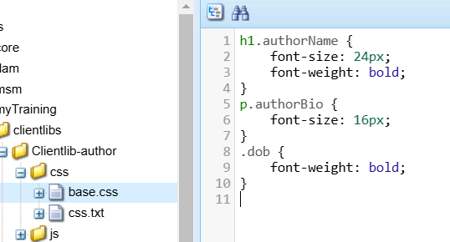

**5)What is extraclientlib and how to create custom ?**

extraClientLibs allows components to load additional client libraries dynamically. This is useful when you need custom styling or scripts for a specific component without modifying global client libraries.