Create a template with header and Footer

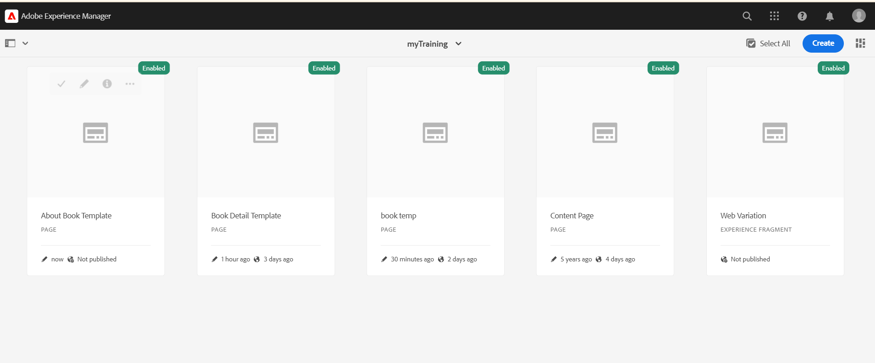

In IntelliJ,

myTraining/ui.frontend/src / main/components/

Header.scss

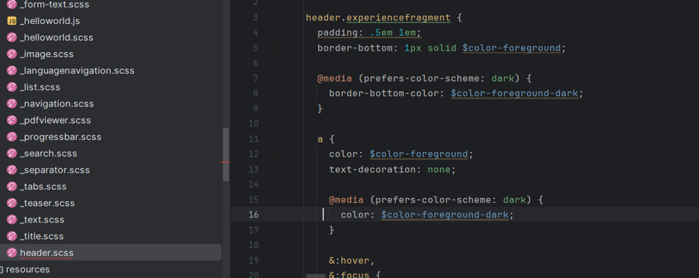

myTraining/ui.frontend/src / main/components/

Footer.scss

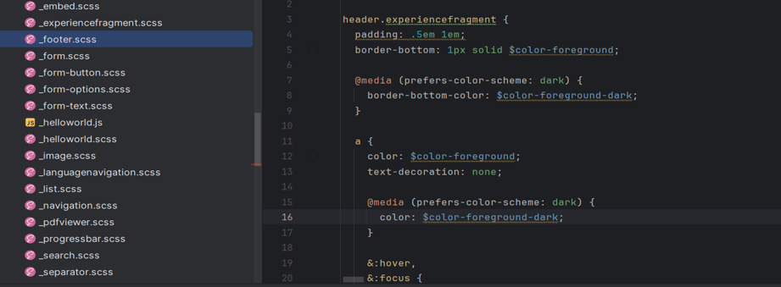

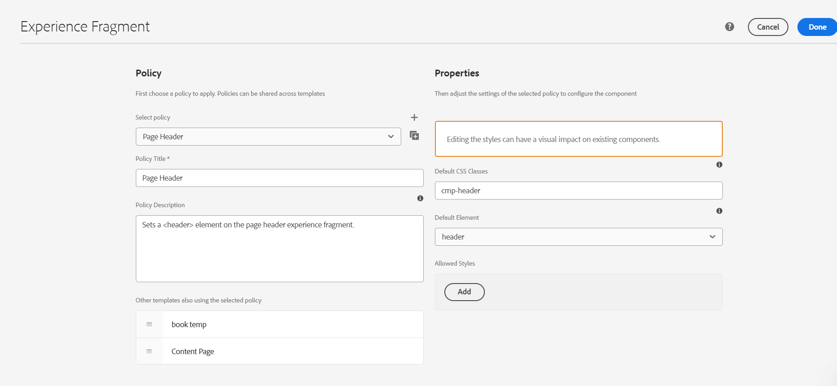

Run the project using the command **mvn clean install -PautoInstallPackage -Dmaven.test.skip=true**

