**HOMEPAGE**

View the list of products on the Home Page, and click on the Cart to navigate to the Cart Page.

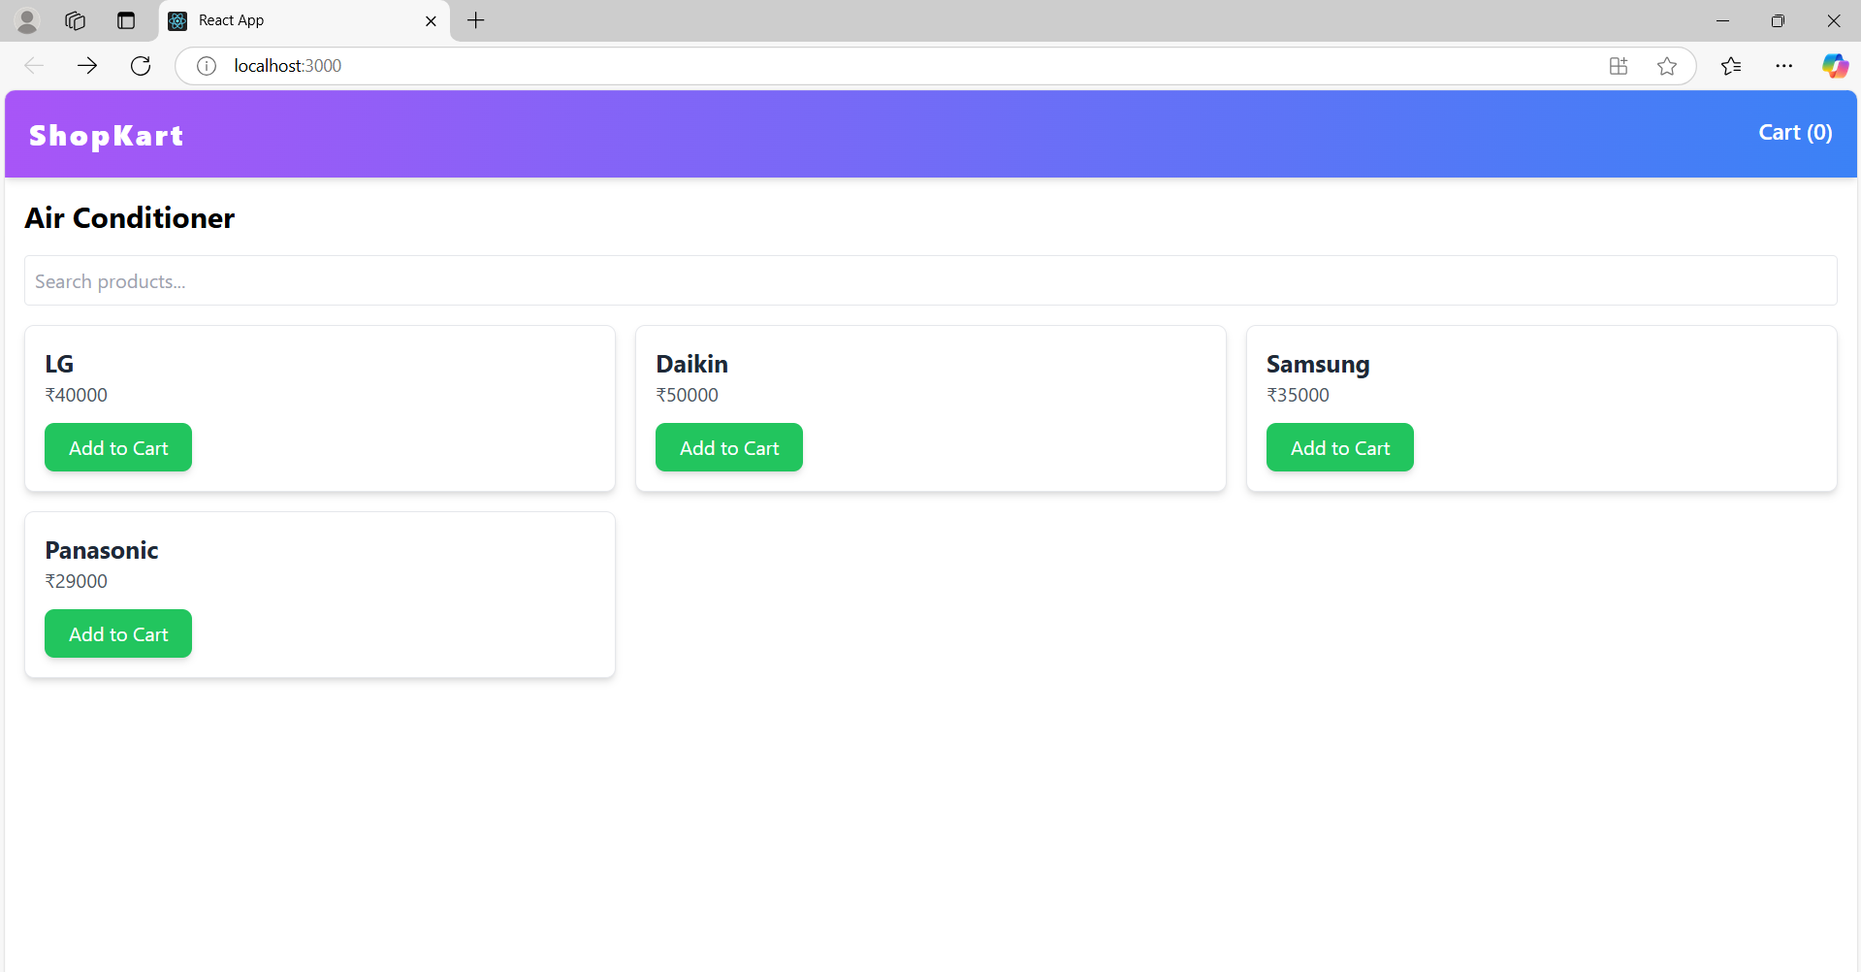

**ADDING PRODUCTS TO THE CART**

Three products added to the cart

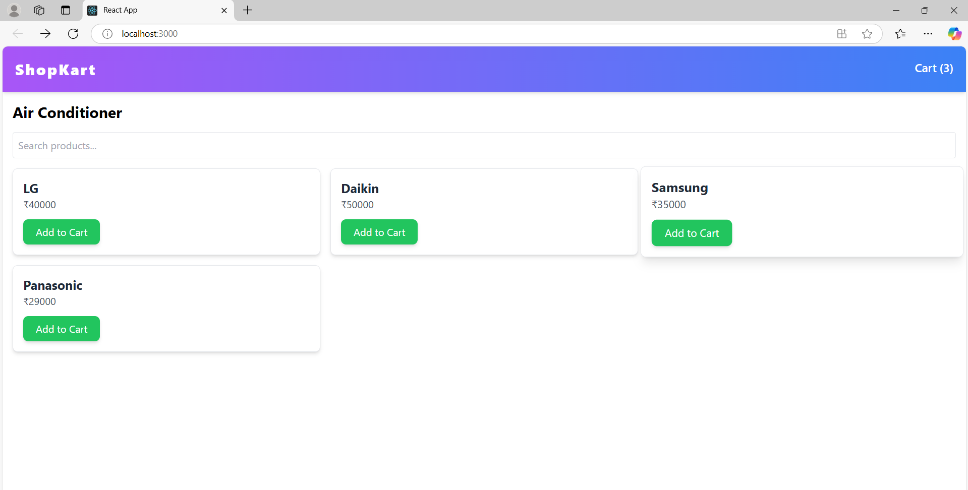

**SEARCHING PRODUCTS**

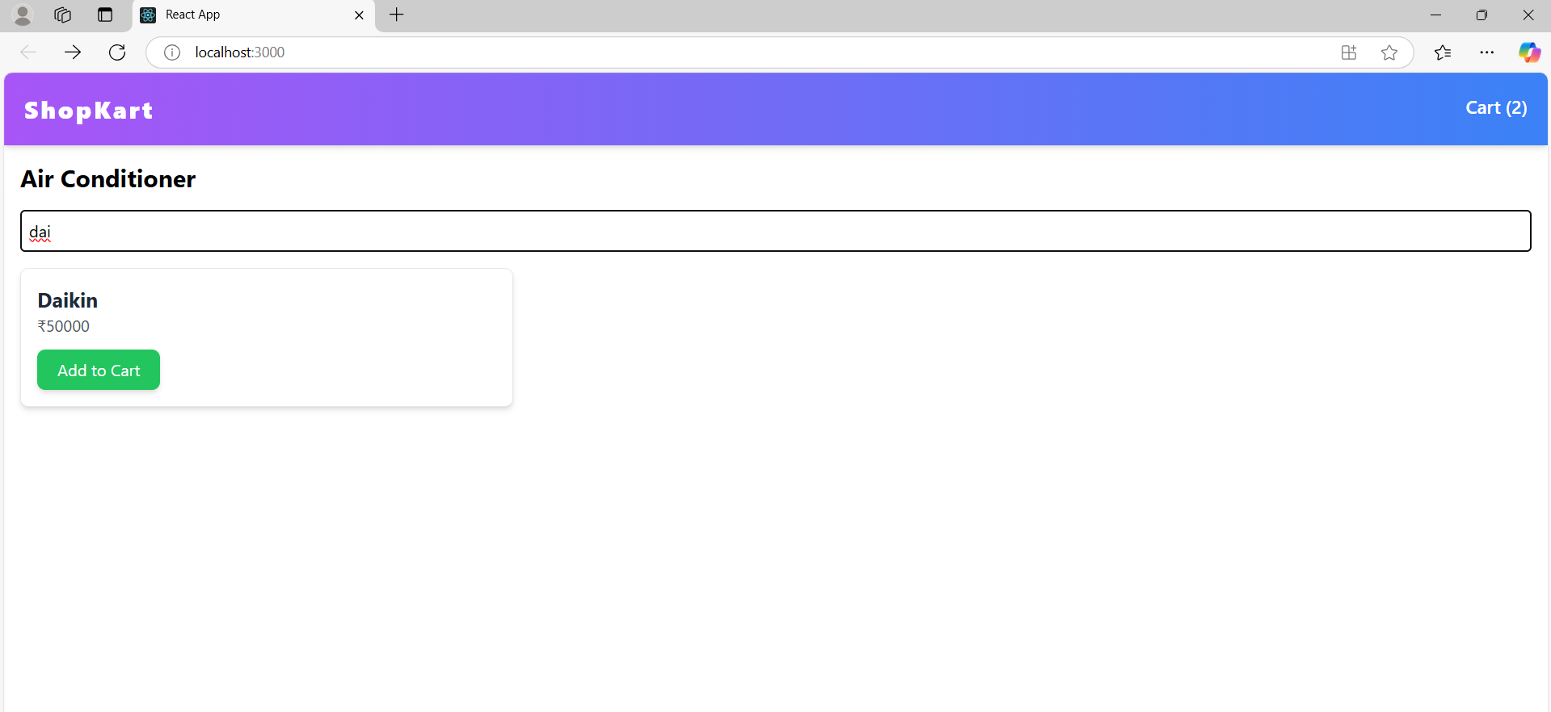

**NAVIGATE TO CART PAGE**

View the Products added to the cart

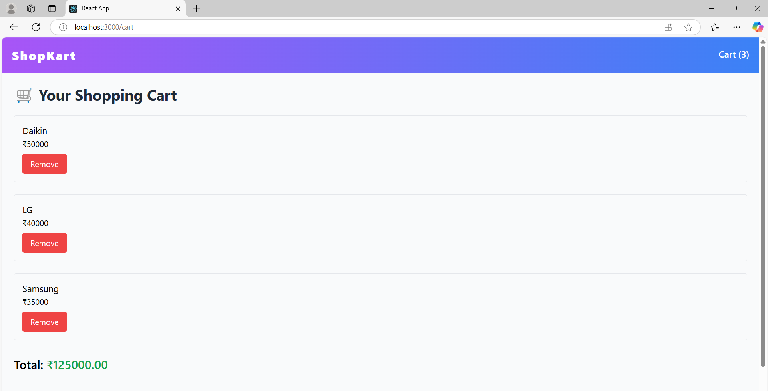

**REMOVE PRODUCT FROM THE CART AND VIEW TOTAL PRICE**

