OUTPUT PROOF:

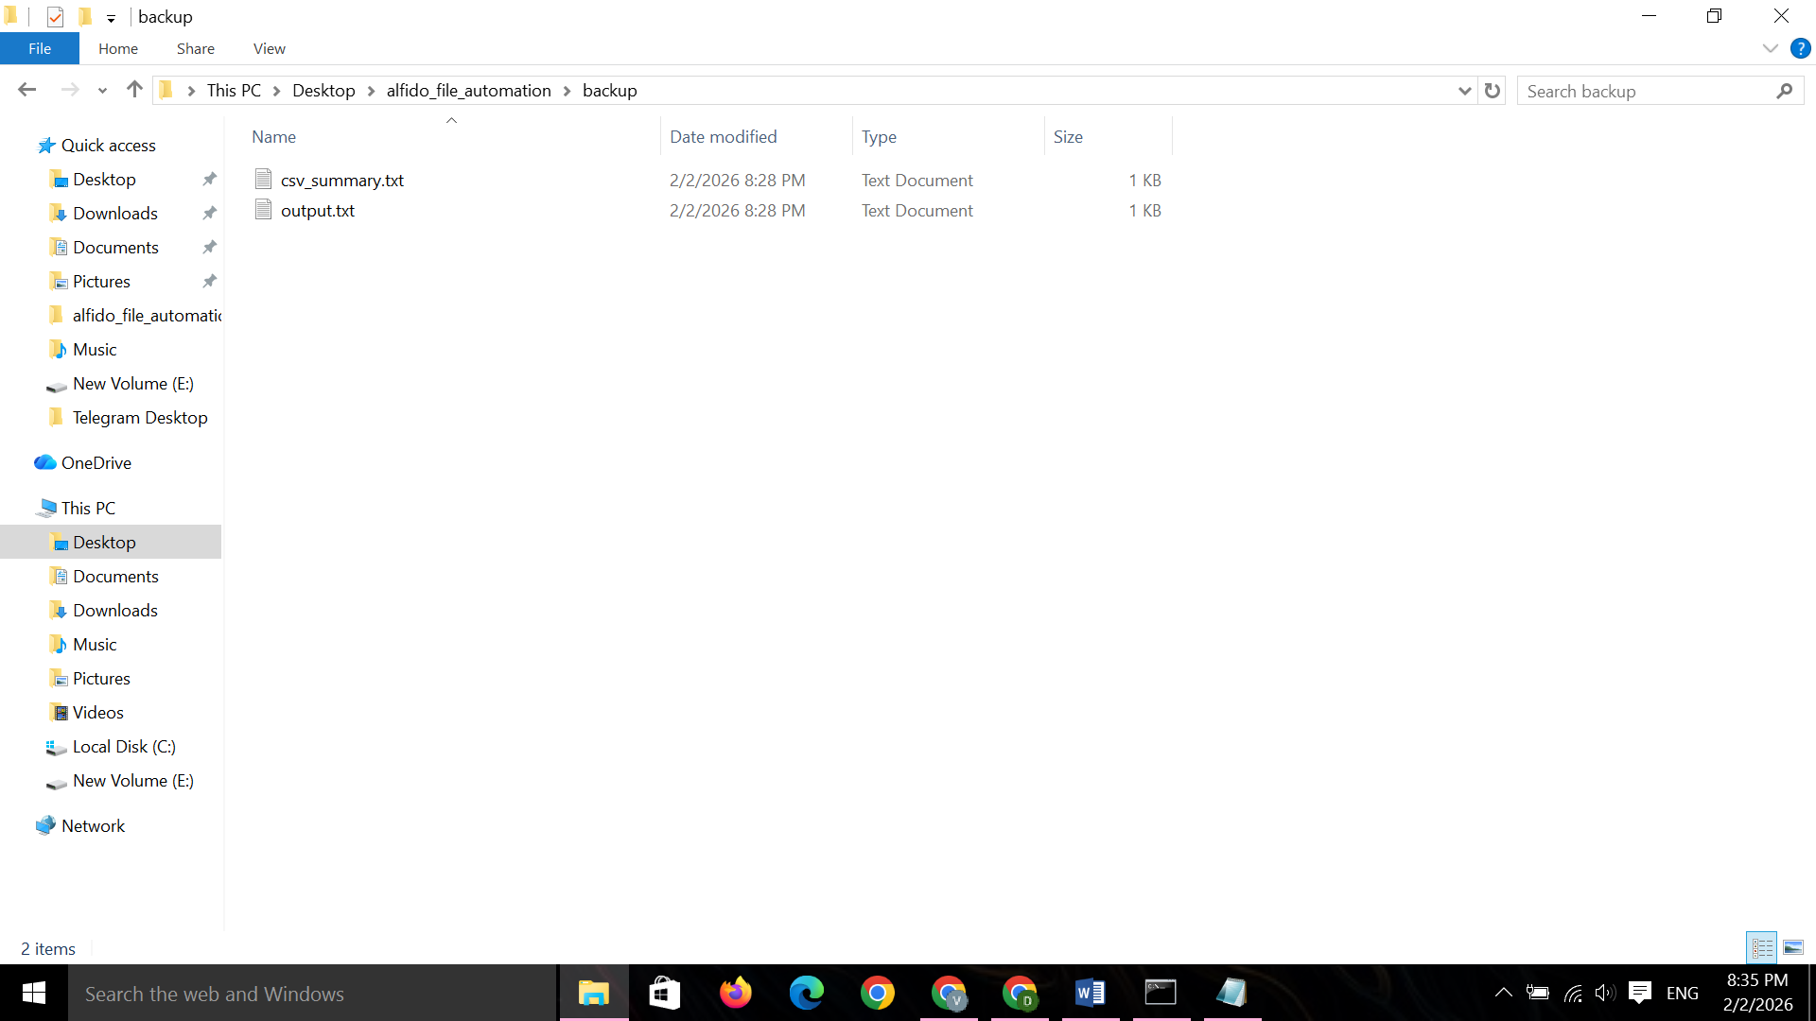
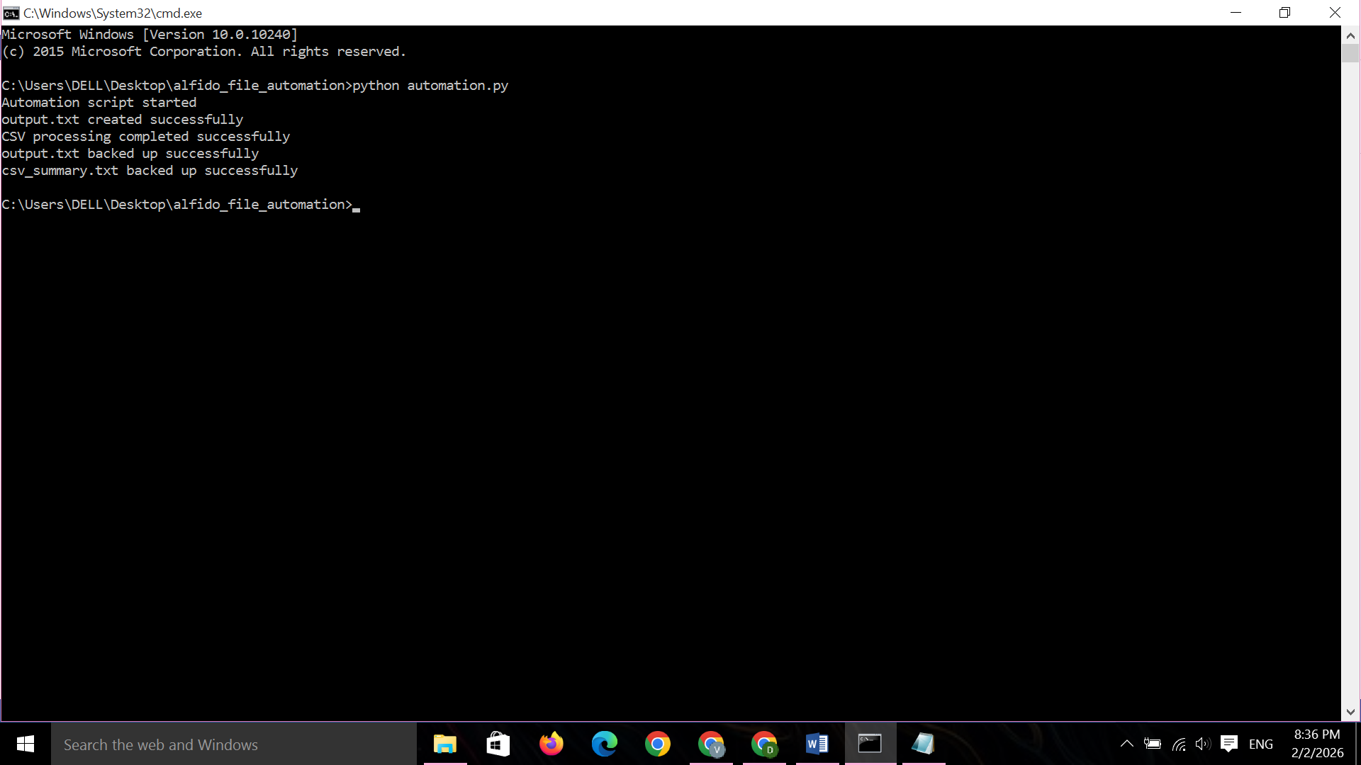
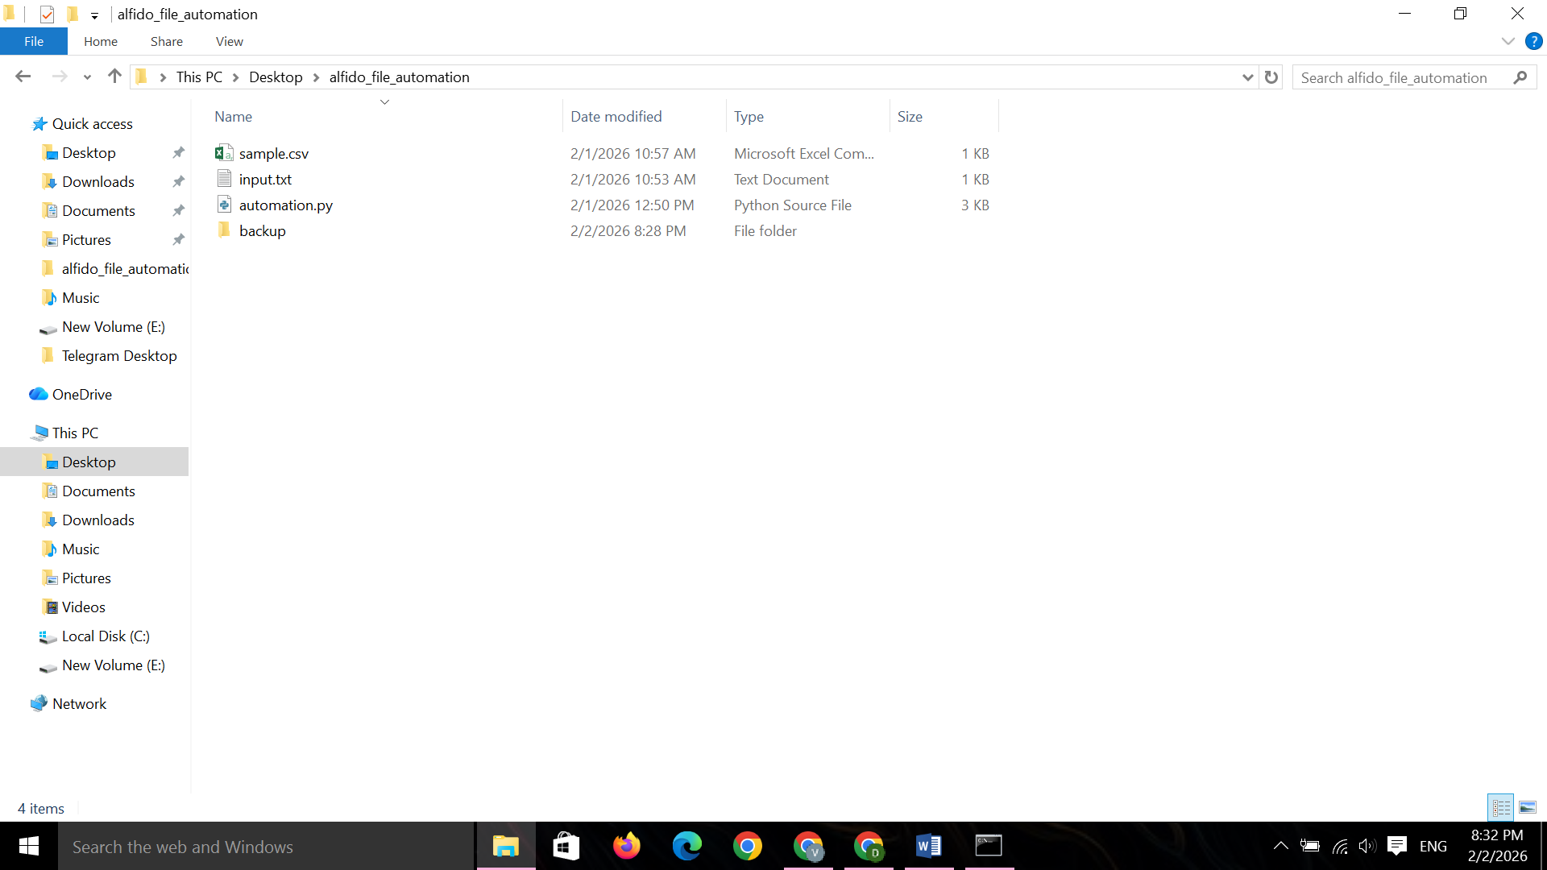

AUTOMATION.py:
import os
import shutil
import csv

def main():

print("Automation script started")

try:
with open("input.txt", "r") as f:
data = f.read()
except FileNotFoundError:
print("input.txt not found")
return try:
with open("output.txt", "w") as f:
f.write(data.upper())
print("output.txt created successfully")
except Exception as e:
print("Error while writing output.txt:", e)

try:
with open("sample.csv", "r") as csv_file:
reader = csv.reader(csv_file)
header = next(reader) # skip header row

record_count = 0
for row in reader:
record_count += 1

# Write summary to a text file
with open("csv_summary.txt", "w") as summary:
summary.write(f"Total Records: {record_count}")

print("CSV processing completed successfully")

except FileNotFoundError:
print("sample.csv not found")

except Exception as e:
print("Error while processing CSV:", e)

# Step 4: Backup automation
try:
backup_folder = "backup"

# Create backup folder if it doesn't exist
if not os.path.exists(backup_folder):
os.mkdir(backup_folder)
print("Backup folder created")

# Files to move
files_to_backup = ["output.txt", "csv_summary.txt"]

for file in files_to_backup:
source_path = file
destination_path = os.path.join(backup_folder, file)

if os.path.exists(source_path):
if os.path.exists(destination_path):
os.remove(destination_path) # delete old backup
shutil.move(source_path, backup_folder)
print(f"{file} backed up successfully")
else:
print(f"{file} already backed up or not generated")

except Exception as e:
print("Backup automation failed:", e)

if __name__ == "__main__":
main()

