WEEK 1:
SESSION 1:
LAMBDA EXPRESSIONS JAVA
import java.io.*;
import java.util.*;
interface PerformOperation {
boolean check(int a);
}
class MyMath {
public static boolean checker(PerformOperation p, int num) {
return p.check(num);
}

public PerformOperation isOdd() {
return n -> n % 2 != 0;
}

public PerformOperation isPrime() {
return n -> {
if (n <= 1) return false;
for (int i = 2; i <= Math.sqrt(n); i++) {
if (n % i == 0) return false;
}
return true;
};
}

public PerformOperation isPalindrome() {
return n -> {
String str = Integer.toString(n);
return str.equals(new StringBuilder(str).reverse().toString());
};
}
}

public class Solution {

public static void main(String[] args) throws IOException {
MyMath ob = new MyMath();
BufferedReader br = new BufferedReader(new InputStreamReader(System.in));
int T = Integer.parseInt(br.readLine());
PerformOperation op;
boolean ret = false;
String ans = null;
while (T--> 0) {
String s = br.readLine().trim();
StringTokenizer st = new StringTokenizer(s);
int ch = Integer.parseInt(st.nextToken());
int num = Integer.parseInt(st.nextToken());
if (ch == 1) {
op = ob.isOdd();
ret = ob.checker(op, num);
ans = (ret) ? "ODD" : "EVEN";
} else if (ch == 2) {
op = ob.isPrime();
ret = ob.checker(op, num);
ans = (ret) ? "PRIME" : "COMPOSITE";
} else if (ch == 3) {
op = ob.isPalindrome();
ret = ob.checker(op, num);
ans = (ret) ? "PALINDROME" : "NOT PALINDROME";

}
System.out.println(ans);
}
}
}
OUTPUT:
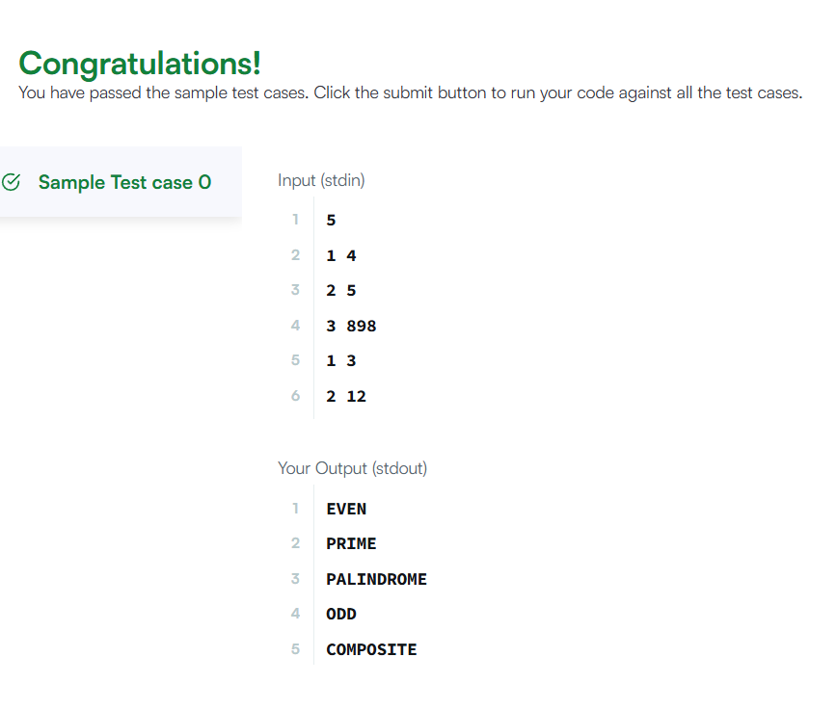

JAVA COMPARATOR:

import java.util.*;
class Checker implements Comparator<Player> {

@Override
public int compare(Player a, Player b) {
if (a.score != b.score) {
return b.score - a.score; // Higher score comes first
}
return a.name.compareTo(b.name); // Alphabetical order if scores are equal
}
}
class Player{
String name;
int score;

Player(String name, int score){
this.name = name;
this.score = score;
}
}

class Solution {

public static void main(String[] args) {
Scanner scan = new Scanner(System.in);
int n = scan.nextInt();

Player[] player = new Player[n];
Checker checker = new Checker();

for(int i = 0; i < n; i++){
player[i] = new Player(scan.next(), scan.nextInt());
}
scan.close();

Arrays.sort(player, checker);
for(int i = 0; i < player.length; i++){
System.out.printf("%s %s\n", player[i].name, player[i].score);
}
}
}
OUTPUT:

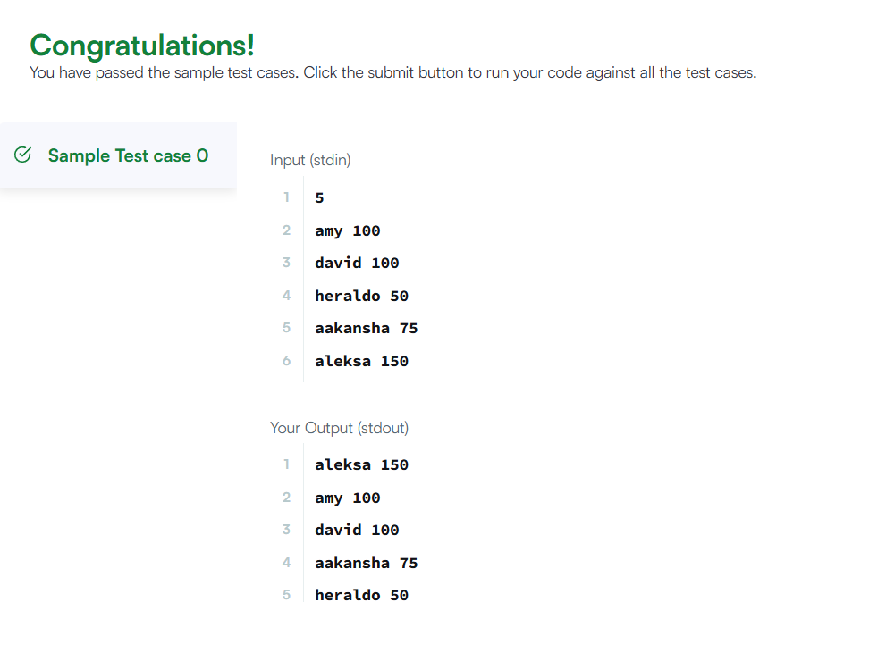

SESSION 2:
JAVA SORT
import java.util.*;

class Student {
private int id;
private String fname;
private double cgpa;

public Student(int id, String fname, double cgpa) {
this.id = id;
this.fname = fname;
this.cgpa = cgpa;
}

public int getId() {
return id;
}

public String getFname() {
return fname;
}

public double getCgpa() {
return cgpa;
}
}

public class Solution {
public static void main(String[] args) {
Scanner in = new Scanner(System.in);
int testCases = Integer.parseInt(in.nextLine());

List<Student> studentList = new ArrayList<Student>();

while (testCases > 0) {
int id = in.nextInt();
String fname = in.next();
double cgpa = in.nextDouble();

Student st = new Student(id, fname, cgpa);
studentList.add(st);

testCases--;
}

Collections.sort(studentList, new Comparator<Student>() {
@Override
public int compare(Student s1, Student s2) {

if (Double.compare(s2.getCgpa(), s1.getCgpa()) != 0) {
return Double.compare(s2.getCgpa(), s1.getCgpa());
}

if (!s1.getFname().equals(s2.getFname())) {
return s1.getFname().compareTo(s2.getFname());
}

return Integer.compare(s1.getId(), s2.getId());
}
});

for (Student st : studentList) {
System.out.println(st.getFname());
}
}
}
OUTPUT:

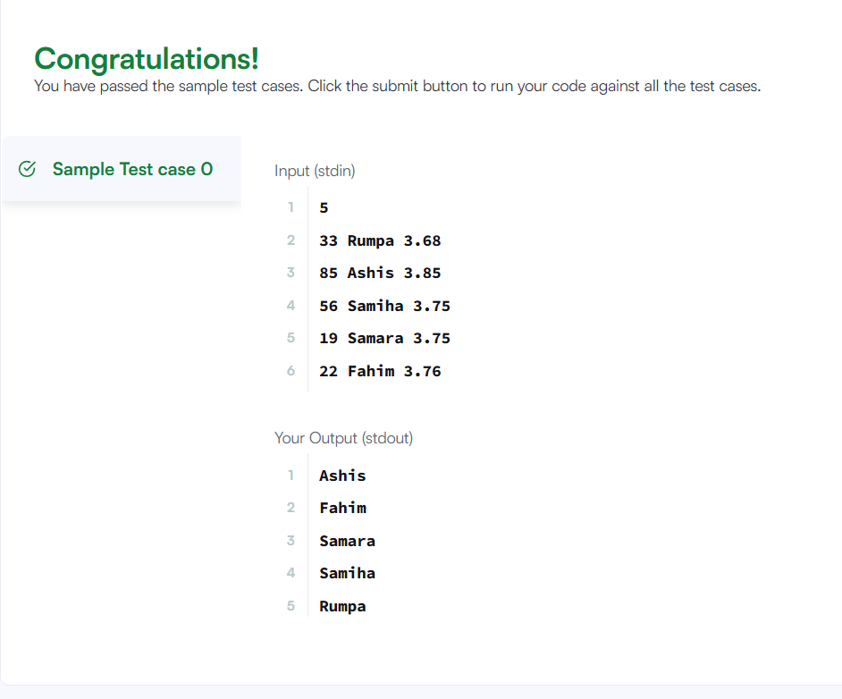

SESSION 3:
SORTING COMPARATOR:
import java.util.*;

class Player {
String name;
int score;

Player(String name, int score) {
this.name = name;
this.score = score;
}
}
class Checker implements Comparator<Player> {

@Override
public int compare(Player a, Player b) {
// Sort by score in descending order
if (a.score != b.score) {
return b.score - a.score;
}

// If scores are equal, sort by name in ascending order
return a.name.compareTo(b.name);
}
}

public class Solution {

public static void main(String[] args) {
Scanner scan = new Scanner(System.in);
int n = scan.nextInt();

Player[] player = new Player[n];
Checker checker = new Checker();

for(int i = 0; i < n; i++){
player[i] = new Player(scan.next(), scan.nextInt());
}
scan.close();

Arrays.sort(player, checker);
for(int i = 0; i < player.length; i++){
System.out.printf("%s %s\n", player[i].name, player[i].score);
}
}
}

OUTPUT:

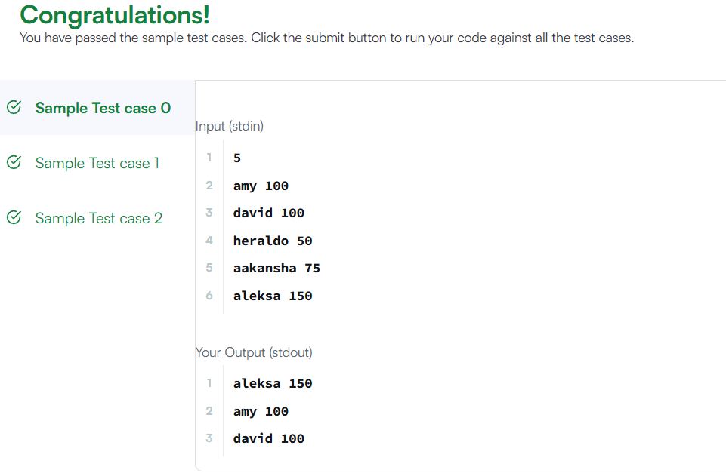

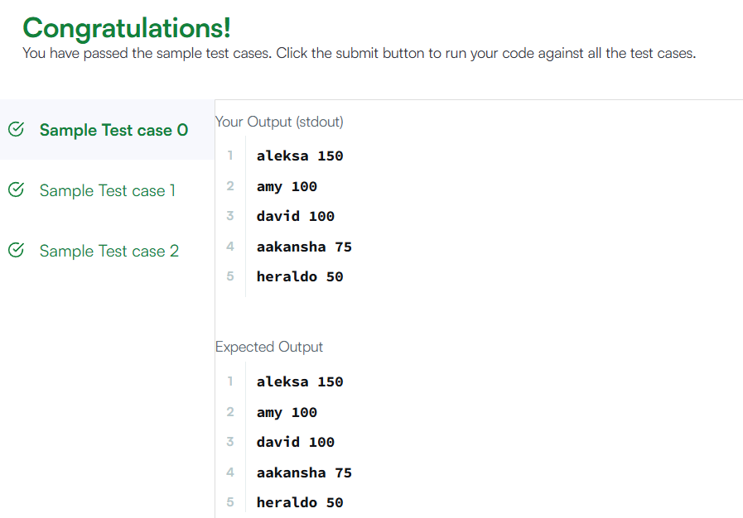

SESSION 4:
RUNNING SUM OF 1D ARRAY:
class Solution {
public int[] runningSum(int[] nums) {
for (int i = 1; i < nums.length; i++) {
nums[i] = nums[i] + nums[i - 1];
}
return nums;
}
}
OUTPUT:
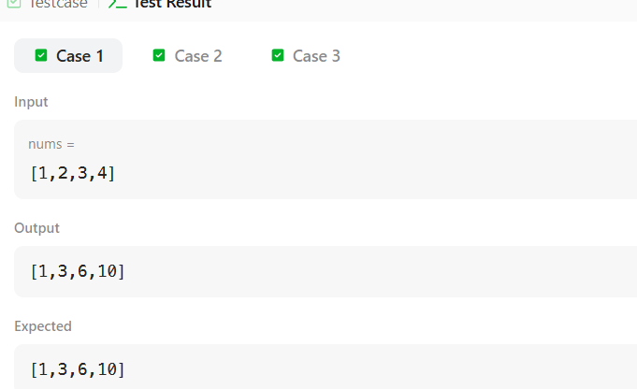

RICHEST CUSTOMER WEALTH:
class Solution {
public int maximumWealth(int[][] accounts) {
int maxWealth = 0;
for (int i = 0; i < accounts.length; i++) {
int wealth = 0;
for (int j = 0; j < accounts[i].length; j++) {
wealth += accounts[i][j];
}
if (wealth > maxWealth) {
maxWealth = wealth;
}
}
return maxWealth;
}
}
OUTPUT:
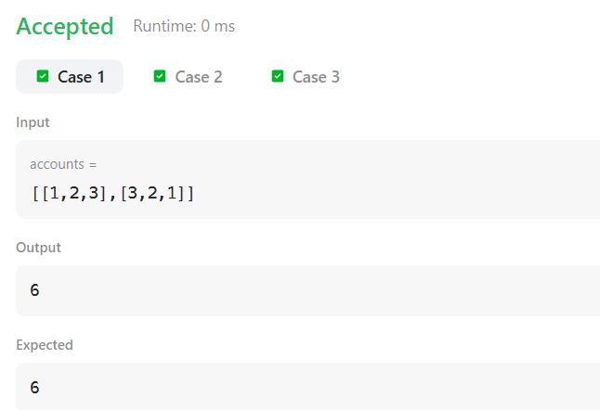

SESSION 5:
SQUARES OF A SORTED ARRAY:
class Solution {
public int[] sortedSquares(int[] nums) {
int n = nums.length;
int[] result = new int[n];

int left = 0;
int right = n - 1;
int index = n - 1;

while (left <= right) {
int leftSquare = nums[left] * nums[left];
int rightSquare = nums[right] * nums[right];

if (leftSquare > rightSquare) {
result[index] = leftSquare;
left++;
} else {
result[index] = rightSquare;
right--;
}
index--;
}

return result;
}
}

OUTPUT:
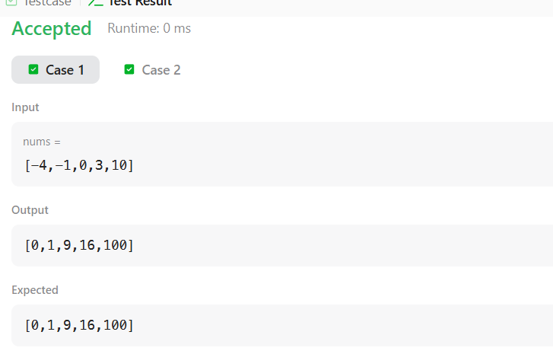

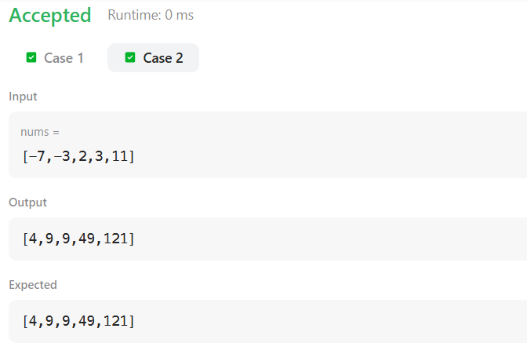

FIND PIVOT INDEX:
class Solution {
public int pivotIndex(int[] nums) {
int totalSum = 0;

// Calculate total sum
for (int num : nums) {
totalSum += num;
}

int leftSum = 0;

// Find pivot index
for (int i = 0; i < nums.length; i++) {
int rightSum = totalSum - leftSum - nums[i];

if (leftSum == rightSum) {
return i;
}

leftSum += nums[i];
}

return -1;
}
}

OUTPUT:
