

PROJECT REPORT

On

***AI For Smart City Applications***

*(cse III semester Mini project)*

*2021-2022*

***Submitted to: Submitted by:***

*Mr. Hemant Pokhariya Mullagura Deepika*

*(CC-CST_SPL 2-III Sem) Roll No:2017517*

***Guided by:*** *CST_SPL 2-III Sem*

*Mr. Sachin Sharma Session-2021-2022*

**CERTIFICATE**

Certified that Miss. Mullagura Deepika (Roll No.- 2017517) has developed mini project on “AI for Smart City Applications” for the CSE III Semester Mini Project in Graphic Era University, Dehradun. The project carried out by Students is their own work as best of my knowledge.

Date:25-02-2022

Mr. Hemant Pokhariya Mr. Sachin Sharma

**Project Co-ordinator Project Guide**

**CST SPL 2-III-Sem** Resource Person

(CSE Department) (CSE Department)

GEU Dehradun GEU Dehradun

**ACKNOWLEDGMENT**

We would like to express our gratitude to The Almighty Sachin Sharma sir, the most Beneficent and the most Merciful, for completion of project.

We wish to thank our parents for their continuing support and encouragement. We also wish to thank them for providing us with the opportunity to reach this far in our studies.

We would like to thank particularly our project Co-ordinator Mr. Hemant Pokhariya sir and our Project Guide Mr. Sachin Sharma sir for his patience, support and encouragement throughout the completion of this project and having faith in us.

At last, but not the least We greatly indebted to all other persons who directly or indirectly helped us during this work.

**Ms. Mullagura Deepika**

**Roll No.- 2017517**

**CST_SPL 2 -III-Sem**

**Session: 2021-2022**

**GEU, Dehradun**

**TABLE OF CONTENTS**

**TITLE Page NO**

**INTRODUCTION - 1**

About Project

**PROJECT - 2**

Requirement Analysis

Applications

conclusion

Project code Link

**SNAPSHOT OF PROJECT - 3**

Output samples

**REFERENCE - 4**

AI for Smart City Applications

INTRODUCTION:

* Each day, billions of passengers depend on fast, reliable, and secure connectivity during their travel. Nowadays, the deaths caused by road accidents in urban areas are increasing considerably due to various factors. These Death rates can be considerably reduced by providing medical assistance immediately. The major elements that delay the provision of medical help are traffic congestion, lack of ambulance services, no network connectivity and negligence. To resolve these factors, an automated response system is required. Smartphone and Security cameras with their in-built sensors are excellent platforms for building such automated systems. In our project we introduce the Automatic Accident Detection and Alert System (ADAS) that will minimize the time gap and ensure medical assistance immediately. This System comprises of two main components-the server and the ADAS software. Various sensors in the Smartphone and Security cameras will help in identifying the site of the accident. The ADAS system will send the message to the ambulance in case of accident. The ADAS client system will identify the location with the support of in-built sensors in the Smartphone and will alert the nearest medical assistance provider. This will enable the response team to arrive at the accident site and provide medical support to the victim on time. This project will help to decrease the action time and thus reduce the death tolls.
* **Advantages**
* The major advantages of this system are cost effective, assured safety, victim life can be saved quickly, low power consumption, better accuracy, efficient time consumption, reduce the chance of human error.
* **Disadvantages**
* The main weakness of this system is that there is a possibility of false reporting of an accident at low speeds.

PROJECT :

Requirement Analysis

In Vehicle System

* Micro Controller
* Sensors
* GPS Module
* Power Source

The Controller is placed under the rear seat of the vehicle enclosed in a hard case made of Honeycomb maze aluminum at the inner surface and glass fiber on the outer surface to prevent or minimize the damage during an accident. It uses three major sensors

1. Vibration Sensors for Impact Detection.

2. Gyroscope

3. Infrared speed sensors.

Control Room

* MATLAB based desktop applications
* Text message sending
* SQl database

**Applications**

* The main goal of the system is to alert the nearby medical services about the accident so as to provide immediate medical aid. The application can make use of a sensor (accelerometer) in mobiles and security cameras, to sense the tilt of the vehicle. ... The system shall share the exact location of the accident with emergency medical services.

CONCLUSION:

The system is an application of Internet of Things 2.0 where devices interact without major human involvement. The system provides a solution for efficient accident detection and response to nations lacking emergency response infrastructure. Real time implementation of this idea would result in saving of many lives lost due to inefficient accident response as well as eliminate the need of physically reporting the accident. This system also brings in reliability and accountability to the existing emergency service infrastructure, thus helping in improving the efficiency of emergency services. This system can be linked to drones in future for surveillance of area by the time medical help arrives and give real time inputs to medicos for efficient response. The drones can even detect fatalities occurred using heat sensors and digital image

Processing .Drones can be manipulated to detect heart rate of victim and even administer first aid medicines through in built I.V. syringes. The drones can also be helpful in predicting if air ambulance is required and nearest possible area for air ambulance to land of have access to.

Project Code link:

<https://colab.research.google.com/drive/1DrzbEHVONMGGdyKYZGBKwmOiTzxqevjw?usp=sharing>

(The code will run with the attachments attached along with the code).

e

|  |
| --- |
|  |

Output samples

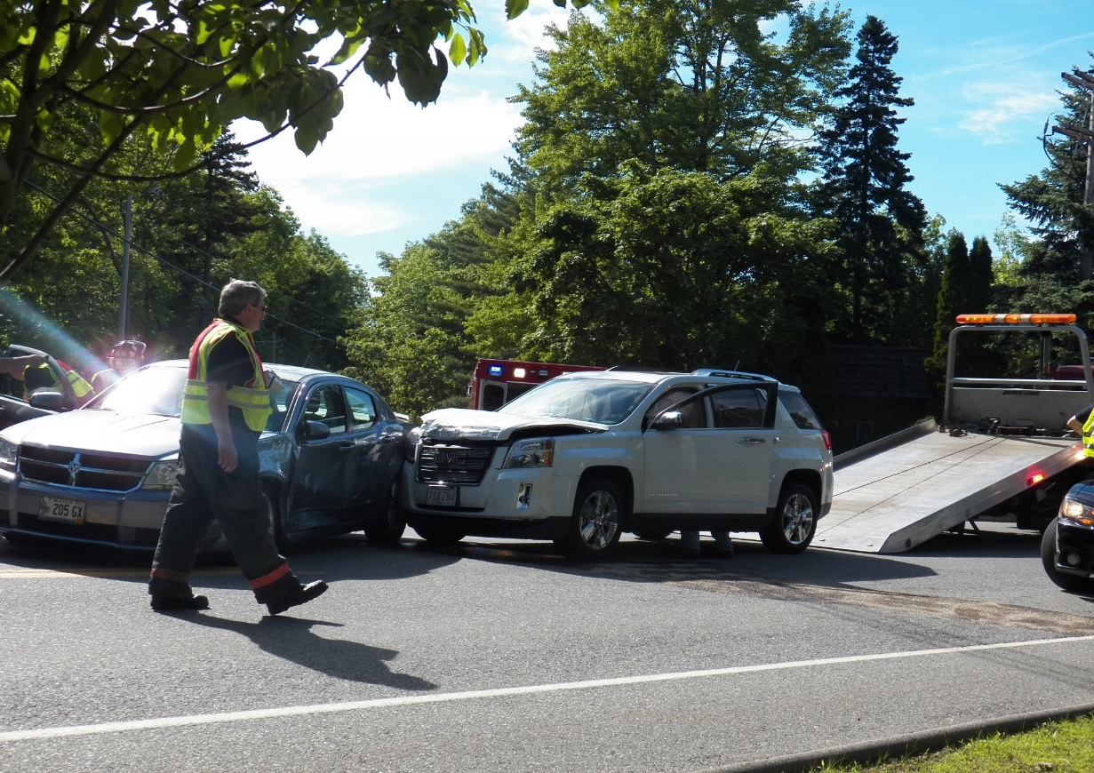

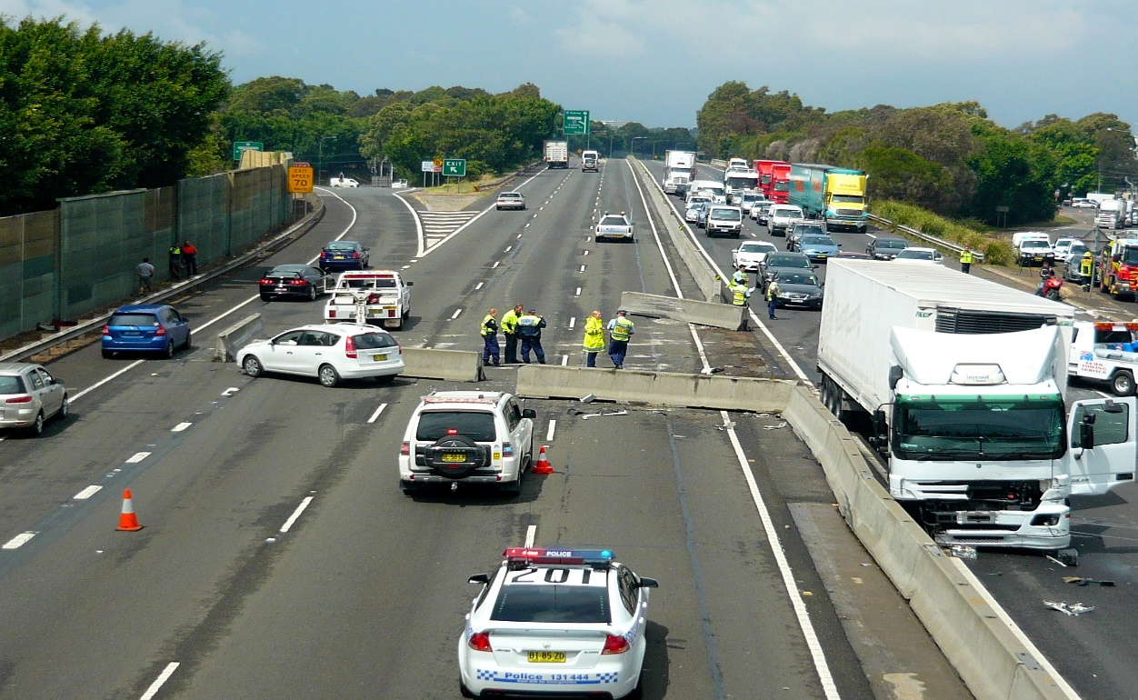



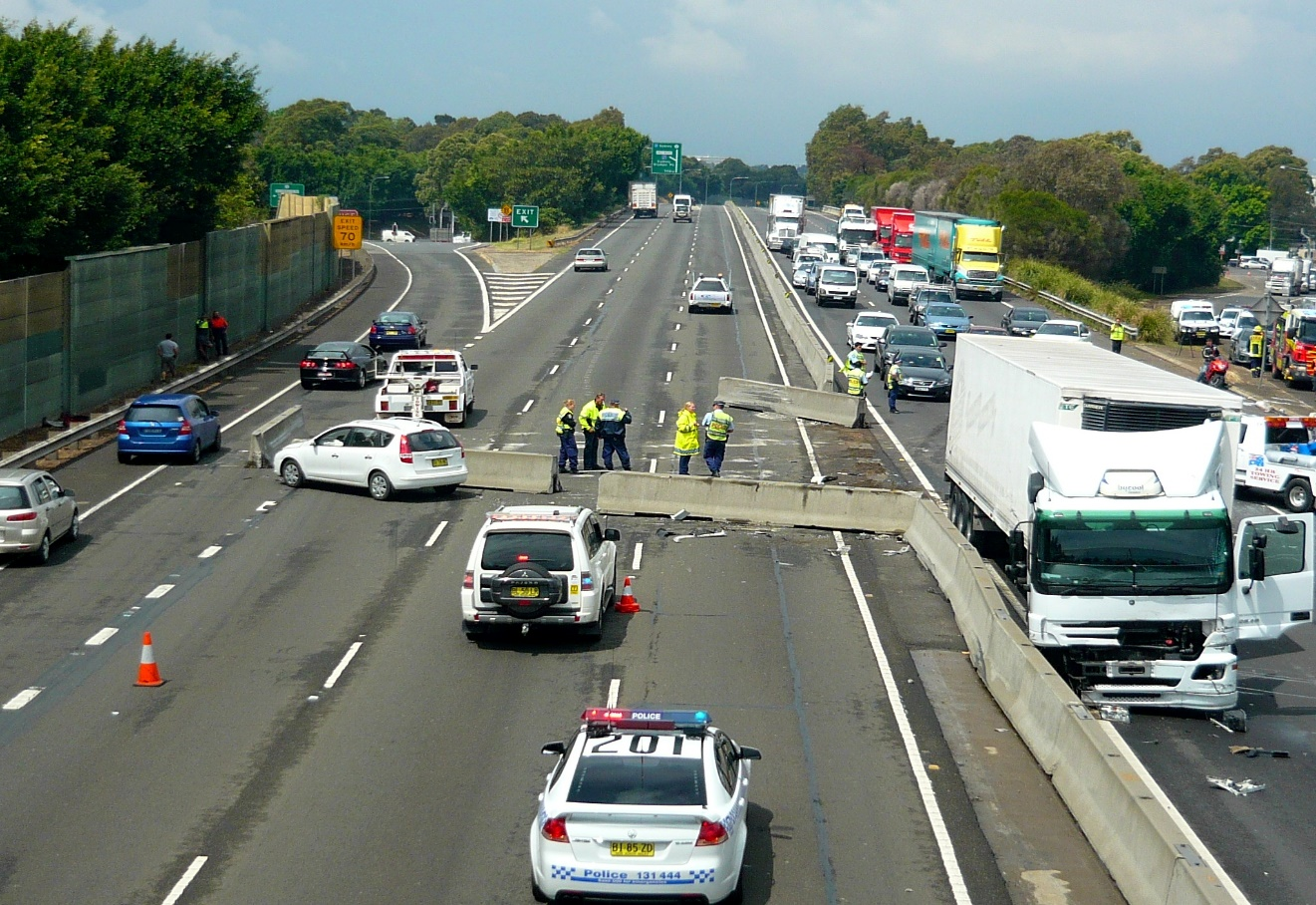

REFERENCE

From the git hub projects, refers the videos of YouTube, and google etc.…