E-COMMERCE ORDER MANAGEMENT SYSTEM
A DBMS Capstone Project Report submitted in partial fulfillment of the requirements for the award of the degree of
BACHELOR OF TECHNOLOGY
in
ARTIFICIAL INTELLIGENCE AND MACHINE LEARNING

Submitted By
U.DEEPIKA – 25B11AIC25
P.HARSHITHA – 25B11AI990
P.SUPRIYA – 25B11AI985
A.HEMANTH – 26B21AI166

Under the esteemed guidance of
Mr. T.Srinivasulu M.Tech, (Ph.D.)
Assistant Professor



DEPARTMENT OF ARTIFICIAL INTELLIGENCE AND MACHINE LEARNING
ADITYA UNIVERSITY
(Formerly Aditya Engineering College (A))
Aditya Nagar, ADB Road, Surampalem, Andhra Pradesh, India
2026 – 2027

Aditya Nagar, ADB Road, Surampalem, Andhra Pradesh, India
DEPARTMENT OF ARTIFICIAL INTELLIGENCE AND MACHINE LEARNING
CERTIFICATE
This is to certify that the DBMS Capstone Project report entitled “E-COMMERCE ORDER MANAGEMENT SYSTEM” is being submitted by U.DEEPIKA (Roll No.25B11AIC25), P.HARSHITHA (Roll No. 25B11AI990), P.SUPRIYA (Roll No. – 25B11AI985) and A.HEMANTH (Roll No.26B21AI166) in partial fulfillment of the requirements for the award of the B.Tech. degree in Artificial Intelligence and Machine Learning. The work documented in this report was carried out as part of the Capstone Project for the course Database Management Systems (2501IT05) during the academic year 2026–2027, and records the database design, implementation, and documentation undertaken by the team.

Project Guide Head of the Department

Mr. T. Srinivasulu, M. Tech, (Ph.D.) Dr. K. Naga Bhargavi,M.Tech,Ph.D.
Assistant professor Associate Professor & HOD

External Examiner

DECLARATION
We hereby declare that the DBMS Capstone Project entitled “E-COMMERCE ORDER MANAGEMENT SYSTEM” is a genuine work carried out by us. The database design, SQL implementation, queries and documentation presented in this report are our own work, completed under the guidance of T. Srinivasulu, Department of ARTIFICIAL INTELLIGENCE & MACHINE LEARNING Aditya University, Surampalem. We further declare that this work has not been submitted, in full or in part, for the award of any degree of this or any other educational institution.

Project Associates
U.DEEPIKA (25B11AIC25)
P.HARSHITHA (25B11AI990)
P.SUPRIYA (25B11AI985)
A.HEMANTH (26B21AI166)

Date: 30-9-2026
Place: Surampalem

ACKNOWLEDGEMENT
It is with immense pleasure that we express our indebted gratitude to our project guide MR.T. SRINIVASULU, Department of ARTIFICIAL INTELLIGENCE & MACHINE LEARNING, who guided us throughout the capstone project. We are thankful for the constant encouragement and valuable suggestions received at every review stage.
We are grateful to Dr. K. NAGA BHARGAVI, Head of the Department, for inspiring us and for arranging the facilities and resources needed for this project.
We extend our sincere thanks to the Management, Dr. M. Sreenivasa Reddy, Deputy Pro-Chancellor, Dr. M. B. Srinivas, Vice-Chancellor, and Dr. A. Ramesh, Pro Vice-Chancellor (Engineering & Sciences), for providing an excellent academic environment.
Not to forget, we thank the Teaching and Non-Teaching Staff, our parents and our friends, who have directly or indirectly supported us in completing this project on time.

Project Associates
U.DEEPIKA 25B11AIC25
P.HARSHITHA 25B11AI990
P.SUPRIYA 25B11AI985
A.HEMANTH 26B21AI166

ABSTRACT

The E-Commerce Order Management System is designed to efficiently manage and organize the large volume of data generated during online shopping, including customer details, products, categories, orders, order items, payments and shipping information. In traditional systems, this information may be maintained in separate files or spreadsheets, which can lead to data duplication, inconsistency, difficulty in tracking orders, and errors while retrieving customer or product information. The proposed system addresses these problems by consolidating e-commerce data into a single normalized relational database.The system identifies the core entities such as Customer, Address, Category, Product, Order, Order Item, Payment and Shipment, along with their relationships. The conceptual design is represented using an ER diagram, which is then converted into a relational schema and normalized up to the Third Normal Form (3NF) to reduce redundancy and eliminate partial and transitive dependencies. The database is implemented using MySQL with appropriate Primary Keys, Foreign Keys, UNIQUE, NOT NULL and CHECK constraints maintain data accuracy and referential integrity.The database is populated with representative sample data and several SQL queries are executed to demonstrate data retrieval, joins, aggregate functions,GROUP BY with HAVING, nested subqueries, views and relational operations. The system provides an organized and reliable way to manage customers, products, orders and related transactions. Overall, the E-Commerce Order Management System reduces data redundancy, maintains consistency, ensures referential integrity, and enables efficient retrieval of information that would otherwise require considerable manual effort

Chapter | Title | Page No.
 | Certificate | i
 | Declaration | ii
 | Acknowledgement | iii
 | Abstract | iv
 | List of Tables | v
1 | Introduction | 1
 | 1.1 Introduction to the Domain | 1
 | 1.2 Problem Statement | 1
 | 1.3 Motivation and Need for a Database | 2
 | 1.4 Objectives of the Project | 2
 | 1.5 Scope of the Project | 3
 | 1.6 Organization of the Report | 3
2 | System Study and Tools | 4
 | 2.1 Existing System and Its Limitations | 4
 | 2.2 Proposed Database System | 4
 | 2.3 Tools and Technologies Used | 5
 | 2.4 Software and Hardware Requirements | 5
3 | Database Design (Review – I) | 6
 | 3.1 Identified Entities | 6
 | 3.2 Entity Attributes and Attribute Types | 6
 | 3.3 ER Diagram | 8
 | 3.4 Relationships and Cardinality | 8
 | 3.5 Relational Database Schema | 9
 | 3.6 Primary Keys and Foreign Keys | 13
 | 3.7 Normalization up to 3NF | 13
4 | Database Implementation (Review – II) | 15
 | 4.1 Database and Table Creation – DDL | 15
 | 4.2 Sample Data Insertion – DML | 17
 | 4.3 Constraints and Data Integrity | 20
 | 4.4 Data Validation Rules | 20
5 | SQL Operations and Queries | 22
 | 5.1 DQL – Basic Retrieval Queries | 22
 | 5.2 Join Operations | 23
 | 5.3 Aggregate Functions, GROUP BY and HAVING | 25
 | 5.4 Nested and Correlated Subqueries | 26
 | 5.5 Views and Relational Set Operations | 26
 | 5.6 DCL and TCL Operations | 27
6 | Modules and Functionalities | 29
7 | Results – Sample Outputs and Screenshots | 30
8 | Testing and Data Validation | 32
9 | GitHub Repository and Team Contribution | 33
10 | Conclusion and Future Enhancements | 34
 | References | 35
 | Appendix A – Complete SQL Script | 36

LIST OF TABLES

Table No. | Title of the Table | Page No.
Table 2.3 | Tools and Technologies Used | 5
Table 2.4 | Software and Hardware Requirements | 5
Table 3.1 | Entities Identified for the Selected Domain | 6
Table 3.2 | Attributes of Each Entity | 6
Table 3.4 | Relationships and Cardinality | 8
Table 3.5 | Relational Database Schema | 9
Table 3.6 | Primary Key and Foreign Key Definitions | 13
Table 3.7 | Normalization Steps | 13
Table 4.2 | Sample Data Summary | 17
Table 4.3 | Constraints and Data Integrity Rules | 20
Table 6 | Modules and Their Functionalities | 29
Table 7 | Test Cases and Results | 32
Table 9 | Team Responsibilities | 33

CHAPTER 1: INTRODUCTION

1.1 Introduction to the Domain
An E-Commerce Order Management System is an online business system that manages customers, products, product categories, orders, payments, and shipments involved in online purchasing. Every transaction generates a large amount of data, and these data items are strongly related to one another: a product belongs to a category; a customer can have one or more addresses; a customer places orders; an order contains one or more products; and each order is associated with payment and shipping information.
The E-Commerce Order Management System is a relational database designed to efficiently store and manage e-commerce data for an online shopping platform. It covers customer details, addresses, product categories, product information, customer orders, order items, payment details, and shipment information. The system maintains the relationships between these entities and provides an organized way to store, retrieve, and manage order-related information. By using a centralized relational database, the system helps reduce data redundancy, maintain data consistency, ensure referential integrity, and support efficient management of e-commerce operations

1.2 Problem Statement
At present, the data of many e-commerce businesses is maintained in separate spreadsheet files, registers, or independent systems. The customer section maintains customer details, the product section manages product information, and the order and payment sections maintain their respective records separately. This arrangement causes four recurring problems.
· Data redundancy — a customer's name, contact details, and address may be entered repeatedly in customer records, order records, and shipping records.
· Data inconsistency — when a customer's address or contact information is updated in one file, other files may continue to contain the old information.
· No integrity checking — nothing prevents an order from being recorded for a customer who does not exist, a product from being assigned to a non-existing category, or an order item from referring to a product that is not available in the product records.
· Difficult retrieval — questions such as “which products have the highest sales,” “what is the total order amount for each customer,” or “which customers have placed more than a specified number of orders” require information to be manually collected from several files.
The proposed E-Commerce Order Management System stores each fact exactly once in a normalized table, connects the tables through foreign keys so that invalid data is rejected by the database itself, and provides efficient SQL queries for retrieving customer, product, order, payment, and shipping information. This reduces data redundancy, maintains consistency, ensures referential integrity, and makes e-commerce order management faster and more reliable.
1.3 Motivation and Need for a Database
A spreadsheet can store rows, but it cannot effectively enforce relationships between customers, products, orders, payments, and shipments. It may accept a duplicate customer ID, a negative product price, an order referring to a customer who does not exist, or an order item pointing to a product that has been deleted. A Database Management System (DBMS) prevents such invalid data through PRIMARY KEY, UNIQUE, CHECK, NOT NULL and FOREIGN KEY constraints, ensuring that incorrect data does not enter the system in the first place.
A DBMS also allows multiple users to work with the same centralized data concurrently, supports transactions so that an incomplete order or payment update can be rolled back, and provides SQL to retrieve and analyze e-commerce information efficiently. Complex questions such as finding the total sales for each product, identifying customers with multiple orders, or calculating the average order value can be expressed using SQL queries instead of being compiled manually from separate files. Therefore, a relational DBMS provides a reliable, consistent, and efficient foundation for managing the data of an E-Commerce Order Management System.

1.4 Objectives of the Project
- To design a normalized relational database for e-commerce order management with a minimum of six entities, and to represent the design as an ER diagram showing all attributes, relationships, and cardinalities.
- To convert the ER design into a relational schema and to normalize it up to the Third Normal Form (3NF), eliminating partial and transitive dependencies and reducing data redundancy.
- To implement the schema in MySQL with primary keys, foreign keys, and appropriate NOT NULL, UNIQUE, CHECK, and DEFAULT constraints, and to populate every table with representative sample data.
- To implement and execute SQL operations covering DDL, DML, DQL, joins, aggregate functions, GROUP BY with HAVING, nested and correlated subqueries, views, and relational set operations, along with DCL and TCL commands.
- To verify data integrity and consistency by demonstrating that the database rejects duplicate keys, invalid product prices, invalid order references, and orphan records through appropriate constraints.
- To provide efficient retrieval of e-commerce information such as customer orders, product sales, order totals, payment details, and shipment information using SQL queries.
- To develop a reliable and centralized database system that reduces data redundancy, maintains consistency, ensures referential integrity, and supports efficient management of e-commerce orders and related information.

1.5 Scope of the Project
The database covers the core operations of an e-commerce platform: customers, addresses, product categories, products, orders, order items, payments, and shipments. It supports multiple orders for each customer and multiple products within an order through the Order and Order Item tables. It also maintains the relationships between customers and their addresses, products and categories, orders and payments, and orders and shipments.
The system supports basic e-commerce data management, including customer information, product details, order placement, order items, payment records, shipping details, and retrieval of sales-related information through SQL queries. The database is designed to maintain data consistency, reduce redundancy, and enforce referential integrity using appropriate constraints.
The following are outside the scope of the present work: product recommendation systems, online payment gateway integration, real-time shipment tracking, inventory warehouse management, customer reviews and ratings, promotional and advertising management, and any graphical front-end or mobile application. The project is primarily a database design and implementation exercise, and all interaction with the system is performed through SQL

1.6 Organization of the Report
This report is organized into ten chapters. Chapter 2 presents the system study and the tools used. Chapter 3 covers the complete database design including the ER diagram, relational schema and normalization. Chapter 4 describes the database implementation with DDL and sample data. Chapter 5 presents the SQL operations and queries executed. Chapter 6 explains the modules and functionalities. Chapter 7 presents the results with sample outputs. Chapter 8 covers testing and data validation. Chapter 9 details the GitHub repository and the contribution of each team member. Chapter 10 concludes the report and outlines future enhancements.

CHAPTER 2: SYSTEM STUDY AND TOOLS

2.1 Existing System and Its Limitations
The existing arrangement is largely file-based. Different sections of an e-commerce business may maintain separate spreadsheets or files for customers, products, orders, payments, and shipping information. These files may be exchanged between departments or updated independently. During the study of the present system, the following limitations were observed.
· The same customer and product details appear in multiple files, so an update has to be applied in several places and may not always be updated consistently.
· There is no automatic link between an order and its related records; customer, product, payment, and shipping details may be matched manually, and a typing mistake can result in incorrect or incomplete order information.
· Data validation is limited — product prices, quantities, payment amounts, and order statuses may be entered without proper range or format checks.
· Concurrent editing is difficult when multiple users work on separate spreadsheet files, which can result in conflicting or outdated information.
· Summary reports such as total sales, customer-wise orders, product-wise sales, or average order value must be prepared manually, making the process time-consuming and prone to errors.
aggregate functions, GROUP BY, and HAVING clauses. Frequently used reports, such as customer order summaries and product sales reports, can be stored as views for easy access. The proposed system therefore provides a centralized, consistent, and reliable database for managing e-commerce customers, products, orders, payments, and shipments.

2.2 Proposed Database System
The proposed system is a single relational database in which each fact is stored once. Customer, Address, Category, Product, Order, Payment, and Shipment details are maintained in their own tables. The relationship between orders and products is resolved through the Order Item table, which allows an order to contain multiple products. Foreign keys ensure that orders, order items, payments, and shipments refer only to valid records. CHECK constraints help maintain valid product prices, quantities, and payment amounts, while UNIQUE constraints prevent duplicate customer contact details and product information where required.
Reports that were previously prepared manually can be generated efficiently using SQL SELECT statements, joins, aggregate functions, GROUP BY, and HAVING clauses. Frequently used reports, such as customer order summaries and product sales reports, can be stored as views for easy access. The proposed system therefore provides a centralized, consistent, and reliable database for managing e-commerce customers, products, orders, payments, and shipments.

2.3 Tools and Technologies Used
Category | Tool / Technology Used | Version / Remarks
Database Server |  | 8.0 — relational DBMS used for implementation
  MySQL
Query / Admin Tool | MySQL Workbench | 8.0 CE — script execution and output capture
Online SQL Practice | dbfiddle.dev | Used to verify queries independently
ER Diagram Tool | draw.io (diagrams.net) | Web version — ER and schema diagrams
Version Control | Git and GitHub | Team repository for the SQL script
Documentation | Microsoft Word | 365 — report preparation

2.4 Software and Hardware Requirements
Requirement Type | Specification
Operating System | Windows 10 / 11 (64-bit) or Ubuntu 22.04
Database Server | MySQL 8.0 or above
Client Tool | MySQL Workbench 8.0 CE / MySQL command-line client
Processor | Intel Core i3 or above
RAM | 4 GB minimum, 8 GB recommended
Disk Space | 2 GB free (server, sample data and documentation)

CHAPTER 3: DATABASE DESIGN

3.1 Identified Entities
Seven core entities were identified from the study of the e-commerce domain. These entities represent the major data involved in managing customers, products, orders, payments, and shipments. The identified entities are Customer, Address, Category, Product, Order, Order Item, Payment.

S.No | Entity Name | Description
1 | Customer | Stores customer personal and registration details
2 | Address | Stores customer delivery address and location details.
3 | Category | Stores product categories and parent-category information.
4 | Product | Stores product name, price, stock quantity and category.
5 | Orders | Stores orders placed by customers, including date and status.
6 | Order_Item Stores customer personal and registration details | Stores products included in each order, quantity and transaction price.
7 | Payment | Stores payment date, amount, method, status and transaction ID.

3.2 Entity Attributes and Attribute Types
.
Entity | Attribute | Data Type | Key (PK / FK / -) | Attribute Type
Customer | customer_id | INT | PK | Simple
Customer | first_name | VARCHAR(50) | NOT NULL | Simple
Customer | last_name | VARCHAR(50) | NOT NULL | Simple
Customer | email | VARCHAR(100) | UNIQUE, NOT NULL | Simple
Customer | phone_numbers | VARCHAR(15) | — | multivalued
Customer | registration_date | DATE | — | simple
Customer | total_orders | INT | — | Derived
Address | address_id | INT | PK | Simple
Address | customer_id | INT | FK | Simple
Address | street | VARCHAR(100) | — | Simple
Address | state | VARCHAR(50) | — | Simple
Address | pincode | VARCHAR(10) | — | Simple

Address | city | VARCHAR(50) | NOT NULL | Simple
Category | category_id | INT | PK | Simple
Category | category_name | VARCHAR(100) | UNIQUE, NOT NULL | Simple
Category | parent_category_id | INT | FK | Simple
Product | product_id | INT | PK | Simple
Product | product_name | VARCHAR(150) | NOT NULL | Simple
Product | price | DECIMAL(10,2) | CHECK >= 0 | Simple
Product | stock_quantity | INT | DEFAULT 0 | Simple
Product | price | DECIMAL(10,2) | — | Simple
Product | Category_id | INT | — | Simple
Product | tags | VARCHAR(255) | — | Multivalued
orders | Order_id | INT | PK | Simple
Orders | customer_id | INT | FK, NOT NULL | Simple
Orders | address_id | INT | FK | Simple
Orders | order_date | DATE | DEFAULT CURRENT_DATE | Simple
Orders | order_status | VARCHAR(30) | DEFAULT Pending | Simple
Orders | Total_amount | DECIMAL(10,2) | — | Simple
Order_Item | item_id | INT | PK | Simple
Order_Item | order_id | INT | FK, NOT NULL | Simple
Order_Item | product_id | INT | FK, NOT NULL | Simple
Order_Item | quantity | INT | CHECK > 0 | Simple
Order_Item | unit_price | DECIMAL(10,2) | NOT NULL | Simple
Order_Item | subtotal | DECIMAL(10,2) | — | Derived
Payment | payment_id | INT | PK | Simple
Payment | order_id | INT | PK | Simple
Payment | payment_date | DATE | — | Simple
Payment | amount | DECIMAL(10,2) | — | Simple

Payment | method | VARCHAR(30) | — | Simple
Payment | status | VARCHAR(20) | DEFAULT Pending | Simple
Payment | transaction_id | VARCHAR(100) | UNIQUE | Simple

3.3 ER Diagram

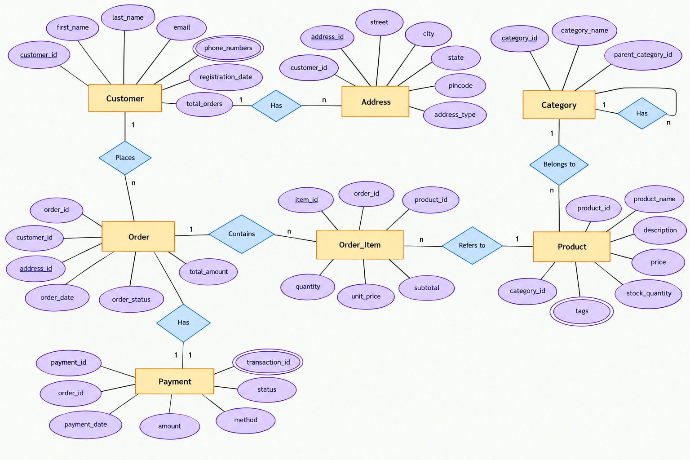

3.4 Relationships and Cardinality

Entity 1 | Relationship | Entity 2 | Cardinality (1:1 / 1:N / M:N) | Participation
Customer | has | Address | 1:M | Customer-Total,  Address-Total
Category |  |  |  | Category – Total, Product – Total
  contains
  Product
  1 : M
 | has parent | Category | 1 : M (Recursive) | Partial
  Category
Customer | places | Orders | 1 : M | Customer – Total, Orders – Total
Address |  | Orders | 1 : M | Address – Partial, Orders – Total
  used for
Orders | contains | Order_Item | 1 : M | Orders – Total, Order_Item – Total
Product | appears in | Order_Item | 1 : M | Product – Partial, Order_Item – Total
Orders |  | Payment | 1 : 1 | Orders – Total, Payment – Total
  has

3.5 Relational Database Schema

Table Name | Column Name | Data Type | Key (PK / FK / —) | Constraints
Customer | customer_id | INT |  | Simple
  PK
Customer | first_name | VARCHAR(50) | — | Simple
Customer | last_name | VARCHAR(50) | — | Simple
Customer | email | VARCHAR(100) | — | Simple
Customer | phone_numbers | VARCHAR(15) | — | Multivalued
Customer | registration_date | DATE | — | Simple
Customer | total_orders | INT | — | Derived
Address | address_id | INT | PK | Simple
Address | customer_id | INT | FK
  Simple
Address |  | VARCHAR(50) | —
  city
  Simple
Address | street | VARCHAR(50) | — | Simple
Address | state | VARCHAR(100) | — | Simple
Address | pincode | VARCHAR(10) | — | Simple
Address | Address_type | VARCHAR(20) | — | Simple
Category |  | INT | PK | Simple
  category_id
Category | category_name | VARCHAR(100)
  —
  Simple
  Category
  parent_category_id
  INT
  FK
  Simple
 |  |  |  | Simple
  Product
  product_id
  INT
  PK
Product |  |  |  | Simple
  category_id
  INT
  FK
 |  |  |  | Simple
  Product
  price
  DECIMAL(10,2)
  —
 | stock_quantity |  |  | Simple
  Product
  INT
  —
Product | product_name | VARCHAR(100) | — | Simple
Product | description | TEXT |  | Simple
Product | tags | VARCHAR(255) |  | multivalued
 | customer_id |  | PK
  Orders
  INT
  —
 | Order_id |  |  | Simple
  Orders
  INT
  FK
Orders | Total_amount | DECIMAL(10,2) | — | Simple
Orders | address_id | INT | FK | Simple
 | order_date | DATE
  Orders
  —
  Simple
Oder_Item | item_id |  |  | Simple
  INT
  PK
Order_Item
  product_id
  INT
  FK
  Simple
 | quantity | INT | —
  Order_Item
  Simple
Order_Item | unit_price | DECIMAL(10,2) | —
  Simple
Order_Item | subtotal | DECIMAL(10,2) | — | Derived
 | payment_id | INT | PK
  Payment
  Simple
 |  |  | FK | Simple
  Payment
  order_id
  INT
 |  | DATE |  | Simple
  Payment
  payment_date
  —
 |  |  | — | Simple
  Payment
  amount
  DECIMAL(10,2)
Payment | method | VARCHAR(30) | — | —
 | status |  | — | Simple
  Payment
  VARCHAR(20)
 |  |  | — | Simple
  Payment
  transaction_id
  VARCHAR(100)

3.6 Primary Keys and Foreign Keys
Table | Primary Key | Foreign Key | References (Table.Column)
Customer | customer_id | — | —
Address | address_id | customer_id | Customer(customer_id)
Category | category_id | parent_category_id | Category(category_id)
Product | product_id | category_id | Category(category_id)
Orders | order_id | customer_id / address_id | Customer(customer_id) / Address(address_id)
Order_Item | item_id | order_id / product_id | Orders(order_id) / Product(product_id)
Payment | payment_id | order_id | Orders(order_id)

3.7 Normalization up to 3NF

UNF (Unnormalized Form): A single order record could contain repeating product information, multiple delivery details or payment information. Such a structure produces redundancy and update anomalies.
1NF (First Normal Form): All attributes are atomic and repeating groups are removed. Product lines are stored separately in Order_Item, and address information is stored in Address.
2NF (Second Normal Form): Order and product details are separated so that non-key attributes depend on the complete key of their table. Order_Item stores transaction-specific quantity and unit_price.
3NF (Third Normal Form): Transitive dependencies are removed. Category information is kept in Category, product information in Product, customer information in Customer and payment information in Payment.

UNF → 1NF → 2NF → 3NF

Normal Form | Condition Satisfied | Anomaly Removed | Resulting Tables
1NF | Atomic values; no repeating groups | Repeating product/address groups | Customer, Address, Product, Order_Item
2NF | No partial dependency | Order/product details repeated in line items | Orders, Product, Order_Item
3NF | No transitive | Category/customer/payment details repeated in transaction rows | All seven normalized tables

CHAPTER 4: DATABASE IMPLEMENTATION

4.1 Database and Table Creation – DDL

CREATE DATABASE ecommerce_order_management;
USE ecommerce_order_management;

CREATE TABLE Customer (
customer_id INT PRIMARY KEY AUTO_INCREMENT,
first_name VARCHAR(50) NOT NULL,
last_name VARCHAR(50) NOT NULL,
email VARCHAR(100) UNIQUE NOT NULL,
registration_date DATE DEFAULT (CURRENT_DATE)
);
CREATE TABLE Address (
address_id INT PRIMARY KEY AUTO_INCREMENT,
customer_id INT NOT NULL,
street VARCHAR(200),
city VARCHAR(100),
state VARCHAR(100),
pincode VARCHAR(10),
address_type VARCHAR(20) DEFAULT 'Home',
FOREIGN KEY (customer_id) REFERENCES Customer(customer_id)
);
CREATE TABLE Category (
category_id INT PRIMARY KEY AUTO_INCREMENT,
category_name VARCHAR(100) NOT NULL UNIQUE,
parent_category_id INT,
FOREIGN KEY (parent_category_id) REFERENCES Category(category_id)
);
CREATE TABLE Product (
product_id INT PRIMARY KEY AUTO_INCREMENT,
product_name VARCHAR(200) NOT NULL,
description TEXT,
price DECIMAL(10,2) NOT NULL CHECK (price >= 0),
stock_quantity INT DEFAULT 0,
category_id INT,
FOREIGN KEY (category_id) REFERENCES Category(category_id)
);
CREATE TABLE Orders (
order_id INT PRIMARY KEY AUTO_INCREMENT,
customer_id INT NOT NULL,
address_id INT,
order_date DATE DEFAULT (CURRENT_DATE),
order_status VARCHAR(30) DEFAULT 'Pending',
FOREIGN KEY (customer_id) REFERENCES Customer(customer_id),
FOREIGN KEY (address_id) REFERENCES Address(address_id)
);
CREATE TABLE Order_Item (
item_id INT PRIMARY KEY AUTO_INCREMENT,
order_id INT NOT NULL,
product_id INT NOT NULL,
quantity INT NOT NULL CHECK (quantity > 0),
unit_price DECIMAL(10,2) NOT NULL,
FOREIGN KEY (order_id) REFERENCES Orders(order_id),
FOREIGN KEY (product_id) REFERENCES Product(product_id)
);

CREATE TABLE Payment (
payment_id INT PRIMARY KEY AUTO_INCREMENT,
order_id INT UNIQUE NOT NULL,
payment_date DATE,
amount DECIMAL(10,2),
method VARCHAR(30),
status VARCHAR(20) DEFAULT 'Pending',
transaction_id VARCHAR(100) UNIQUE,
FOREIGN KEY (order_id) REFERENCES Orders(order_id)
);
Output:

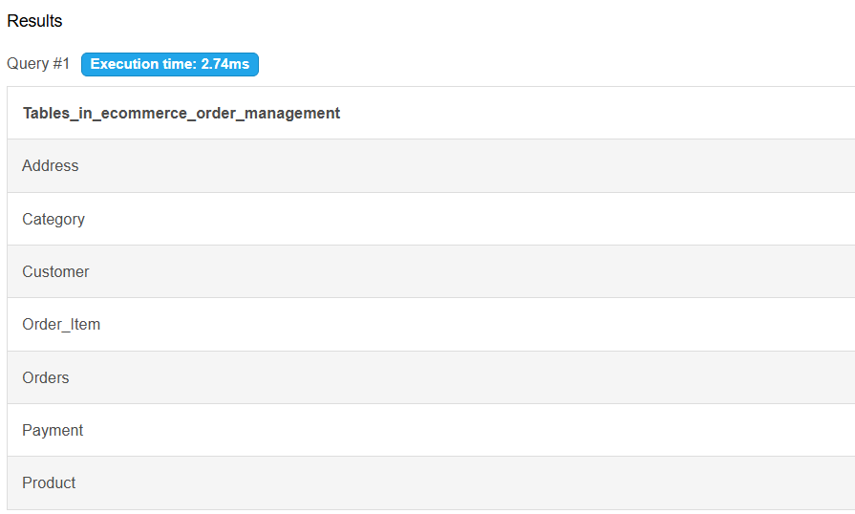

4.2 Sample Data Insertion – DML
.
S.No | Table Name | No. of Records Inserted | Screenshot Reference
1 | Customer | 10 | Customer IDs 1 to 10
2 | Address | 10 | Addresses linked to customers
3 | Category | 10 | Distinct category records
4 | Product | 10 | Product IDs 1 to 10
5 | Orders | 10 | Order IDs 1 to 10
6 | Order_Item | 10 | Order line items linked to orders and products
7 | Payment | 10 | One payment record per order

INSERT INTO Customer
(first_name, last_name, email, registration_date)
VALUES
('Anita', 'Patel', 'anita@mail.com', '2023-01-15'),
('Ramesh', 'Nair', 'ramesh@mail.com', '2023-03-22'),
('Divya', 'Singh', 'divya@mail.com', '2023-05-10'),
('Arjun', 'Rao', 'arjun@mail.com', '2023-07-18'),
('Sneha', 'Sharma', 'sneha@mail.com', '2023-09-05'),
('Rahul', 'Kumar', 'rahul@mail.com', '2024-01-12'),
('Priya', 'Reddy', 'priya@mail.com', '2024-03-20'),
('Kiran', 'Das', 'kiran@mail.com', '2024-05-14'),
('Meena', 'Iyer', 'meena@mail.com', '2024-07-08'),
('Vikram', 'Joshi', 'vikram@mail.com', '2024-09-25');
INSERT INTO Address
(customer_id, street, city, state, pincode, address_type)
VALUES
(1, '12 MG Road', 'Hyderabad', 'Telangana', '500001', 'Home'),
(2, '45 Anna Salai', 'Chennai', 'Tamil Nadu', '600002', 'Home'),
(3, '9 Park Street', 'Kolkata', 'West Bengal', '700016', 'Home'),
(4, '22 Beach Road', 'Visakhapatnam', 'Andhra Pradesh', '530001', 'Home'),
(5, '18 Gandhi Nagar', 'Vijayawada', 'Andhra Pradesh', '520010', 'Home'),
(6, '33 FC Road', 'Pune', 'Maharashtra', '411004', 'Home'),
(7, '7 Banjara Hills', 'Hyderabad', 'Telangana', '500034', 'Office'),
(8, '15 MG Road', 'Bengaluru', 'Karnataka', '560001', 'Home'),
(9, '28 Marine Drive', 'Mumbai', 'Maharashtra', '400020', 'Home'),
(10, '6 Civil Lines', 'Delhi', 'Delhi', '110054', 'Home');
INSERT INTO Category
(category_name, parent_category_id)
VALUES
('Electronics', NULL),
('Apparel', NULL),
('Mobile Phones', 1),
('Laptops', 1),
('Headphones', 1),
('Men Clothing', 2),
('Women Clothing', 2),
('Footwear', 2),
('Accessories', 2),
('Smart Watches', 1);
INSERT INTO Product
(product_name, description, price, stock_quantity, category_id)
VALUES
('Samsung Galaxy S24', 'Latest Samsung smartphone', 65000.00, 50, 3),
('iPhone 15', 'Apple smartphone', 70000.00, 40, 3),
('HP Pavilion Laptop', 'HP performance laptop', 55000.00, 30, 4),
('Dell Inspiron', 'Dell everyday laptop', 60000.00, 25, 4),
('Sony Headphones', 'Wireless noise cancelling headphones', 8999.00, 60, 5),
('Mens Cotton Shirt', 'Comfortable cotton shirt', 999.00, 100, 6),
('Womens Kurti', 'Traditional cotton kurti', 1299.00, 80, 7),
('Running Shoes', 'Lightweight sports shoes', 2499.00, 70, 8),
('Leather Wallet', 'Premium leather wallet', 799.00, 90, 9),
('Apple Watch', 'Smart watch with fitness features', 39999.00, 35, 10);
INSERT INTO Orders
(customer_id, address_id, order_date, order_status)
VALUES
(1, 1, '2024-08-01', 'Delivered'),
(2, 2, '2024-08-05', 'Shipped'),
(3, 3, '2024-08-10', 'Pending'),
(4, 4, '2024-08-15', 'Delivered'),
(5, 5, '2024-08-20', 'Shipped'),
(6, 6, '2024-08-25', 'Pending'),
(7, 7, '2024-09-01', 'Delivered'),
(8, 8, '2024-09-05', 'Shipped'),
(9, 9, '2024-09-10', 'Pending'),
(10, 10, '2024-09-15', 'Delivered');
INSERT INTO Order_Item
(order_id, product_id, quantity, unit_price)
VALUES
(1, 1, 1, 65000.00),
(2, 2, 1, 70000.00),
(3, 3, 1, 55000.00),
(4, 4, 1, 60000.00),
(5, 5, 2, 8999.00),
(6, 6, 3, 999.00),
(7, 7, 2, 1299.00),
(8, 8, 1, 2499.00),
(9, 9, 2, 799.00),
(10, 10, 1, 39999.00);
INSERT INTO Payment
(order_id, payment_date, amount, method, status, transaction_id)
VALUES
(1, '2024-08-01', 65000.00, 'Card', 'Success', 'TXN10001'),
(2, '2024-08-05', 70000.00, 'UPI', 'Success', 'TXN10002'),
(3, '2024-08-10', 55000.00, 'COD', 'Pending', 'TXN10003'),
(4, '2024-08-15', 60000.00, 'Card', 'Success', 'TXN10004'),
(5, '2024-08-20', 17998.00, 'UPI', 'Success', 'TXN10005'),
(6, '2024-08-25', 2997.00, 'COD', 'Pending', 'TXN10006'),
(7, '2024-09-01', 2598.00, 'Card', 'Success', 'TXN10007'),
(8, '2024-09-05', 2499.00, 'UPI', 'Success', 'TXN10008'),
(9, '2024-09-10', 1598.00, 'COD', 'Pending', 'TXN10009'),
(10, '2024-09-15', 39999.00, 'Card', 'Success', 'TXN10010');
Output:
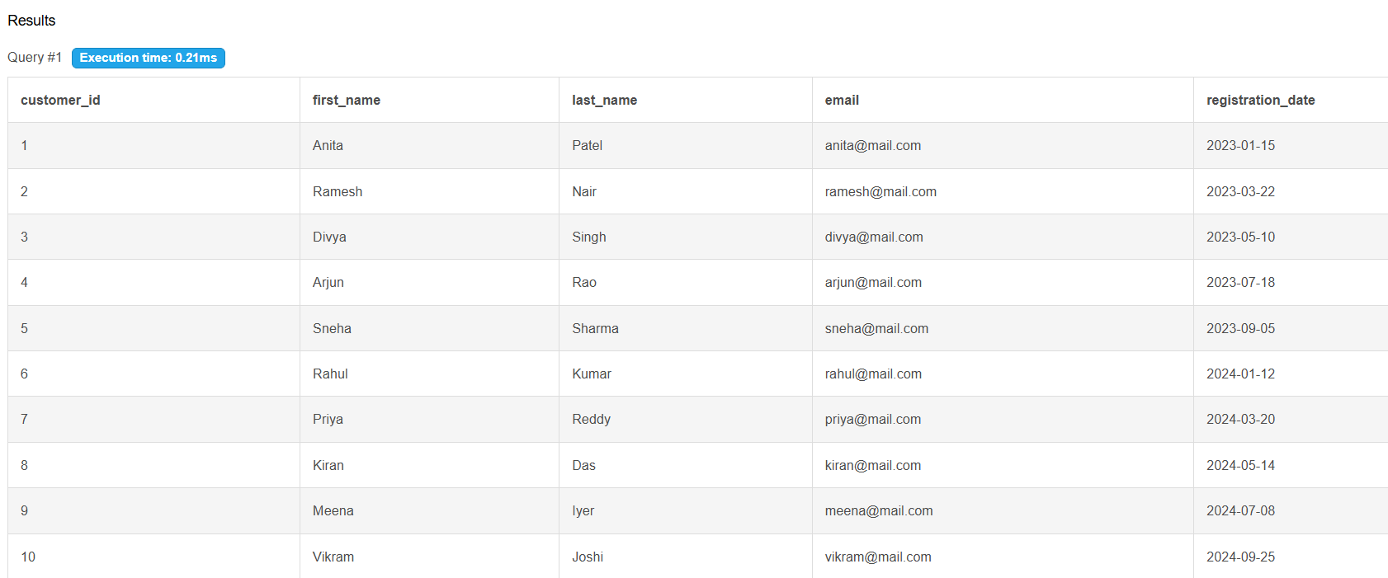

4.3 Constraints and Data Integrity

Constraint / Validation | Applied On (Table.Column) | Purpose
PRIMARY KEY | All seven tables | Uniquely identifies each row
AUTO_INCREMENT | Primary keys | Generates unique
UNIQUE | Customer.email, Category.category_name, Payment.transaction_id | Prevents duplicate identity values
NOT NULL | Required names, emails, order/customer references | Ensures mandatory information
CHECK | Product.price, Order_Item.quantity | Prevents invalid numeric values
DEFAULT | Orders.order_date, order_status; Product.stock_quantity; Payment.status | Supplies standard values
FOREIGN KEY | Relationships across tables | Maintains referential integrity
UNIQUE Payment.order_id | Payment | Enforces one payment record per order

4.4 Data Validation Rules
To confirm that the constraints of the E-Commerce Order Management System work correctly, three invalid statements can be executed deliberately. In each case, the database should reject the statement and no invalid row should be inserted.

(a) Referential integrity — product assigned to a category that does not exist:
INSERT INTO Product
VALUES (99, 'Test Product', 'Testing invalid category',1000.00, 10, 999);
Expected Error:
ERROR 1452 (23000): Cannot add or update a child row:
a foreign key constraint fails
This occurs because category_id = 999 does not exist in the Category table.

(b) CHECK constraint — negative product price:
INSERT INTO Product
VALUES (99, 'Test Product', 'Testing negative price',-500.00, 10, 1);
Expected Error:
ERROR 3819 (HY000): Check constraint is violated.
This occurs because the price column has a CHECK constraint that does not allow a price less than zero.

(c) UNIQUE constraint — duplicate customer email:
INSERT INTO Customer
VALUES (99, 'Test', 'Customer', 'anita@mail.com', '2026-10-01');
Expected Error:
ERROR 1062 (23000): Duplicate entry
'anita@mail.com' for key Customer.email
This occurs because anita@mail.com already exists in the Customer table and the email column has a UNIQUE constraint.

Constraints demonstrated
Validation | Table | Constraint
Invalid category reference | Product | FOREIGN KEY
Negative product price | Product | CHECK
Duplicate customer email | Customer | UNIQUE

CHAPTER 5: SQL OPERATIONS AND QUERIES

5.1 DQL – Basic Retrieval Queries

Q1. Display all customers with their email addresses.
SQL:
SELECT customer_id, first_name, last_name, email FROM Customer
ORDER BY customer_id;
OUTPUT:
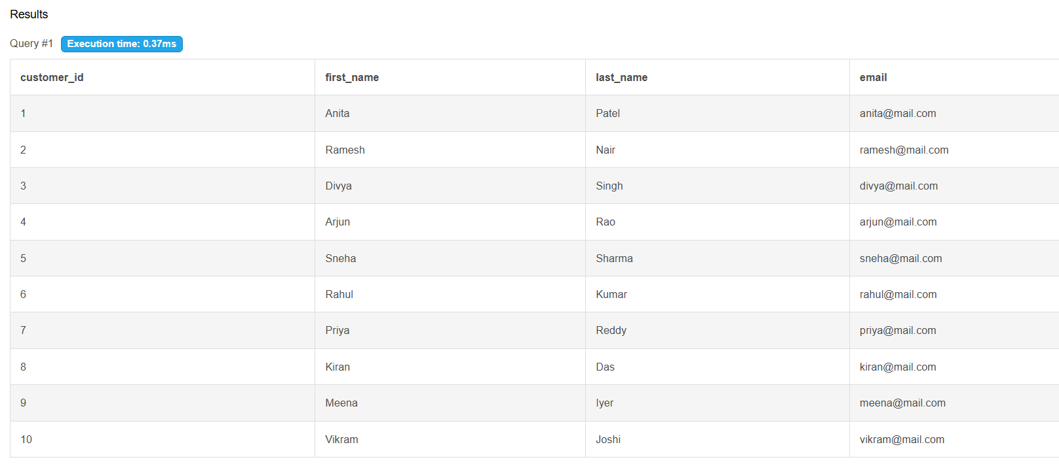

Q2. Display products whose price is greater than 1000
SQL:
SELECT product_id, product_name, price FROM Product

WHERE price > 1000

ORDER BY price DESC;
OUTPUT: 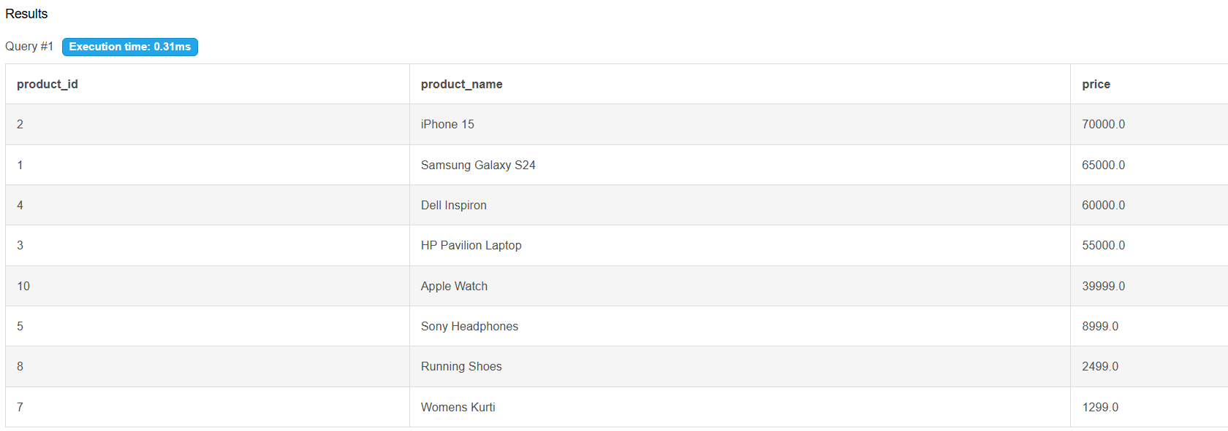

Q3. Display orders that are currently pending.
SQL:
SELECT order_id, customer_id, order_date, order_status FROM Orders
WHERE order_status = 'Pending'
ORDER BY order_id;
OUTPUT:
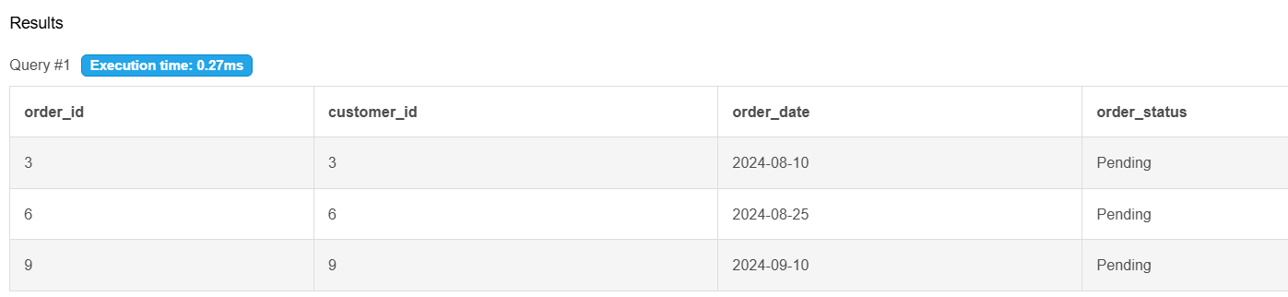

5.2 Join Operations

Q4. Display customer names with their orders using INNER JOIN.
SQL: SELECT CONCAT(c.first_name,' ',c.last_name) AS customer_name, o.order_id,
o.order_date, o.order_status FROM Customer c
INNER JOIN Orders o ON c.customer_id = o.customer_id
ORDER BY o.order_id;

OUTPUT:
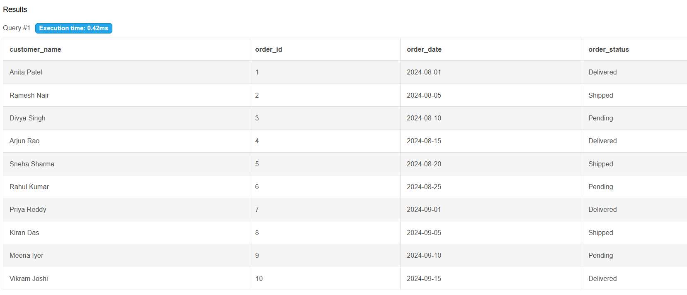

Q5. Display customer names with their orders using INNER JOIN.
SQL:
SELECT c.category_name, COUNT(p.product_id) AS total_products FROM Category c

LEFT JOIN Product p ON c.category_id = p.category_id

GROUP BY c.category_id, c.category_name

ORDER BY total_products DESC;
OUTPUT: 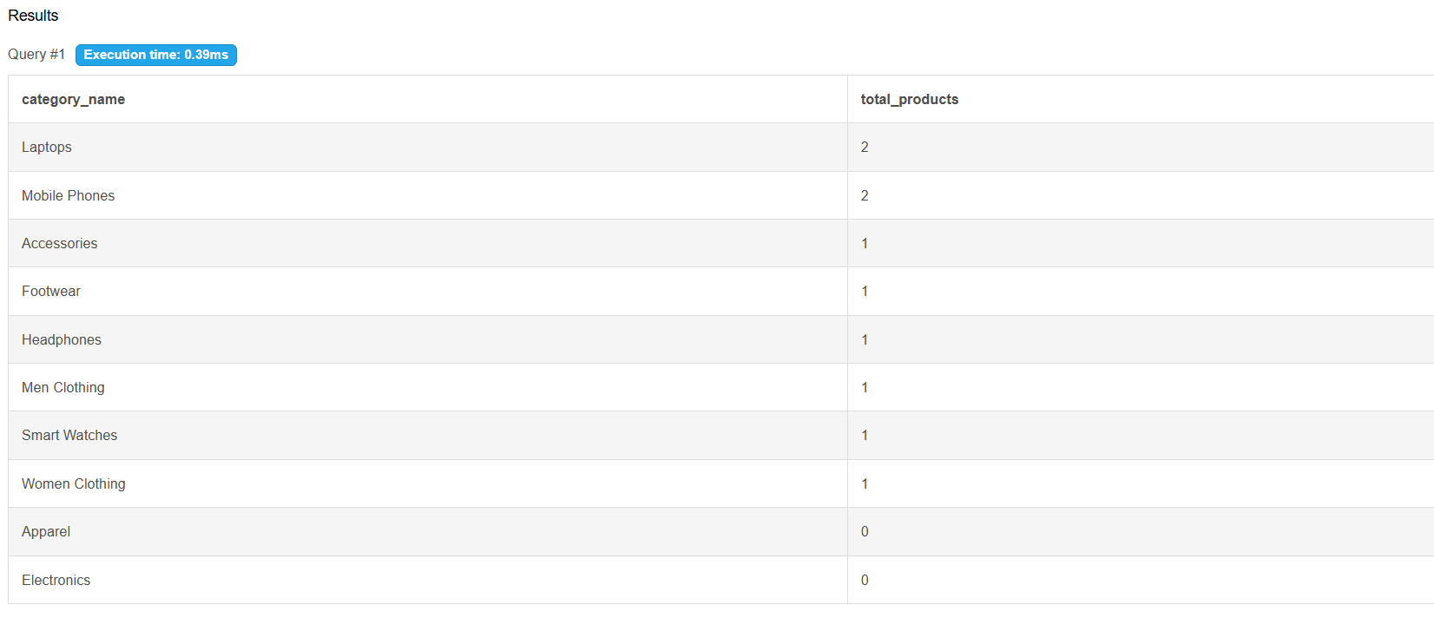

Q6. Display products with their category names using EQUI JOIN.
SQL:
SELECT p.product_id, p.product_name,c.category_name, p.price FROM Product p, Category c

WHERE p.category_id = c.category_id
ORDER BY p.product_id;
OUTPUT:
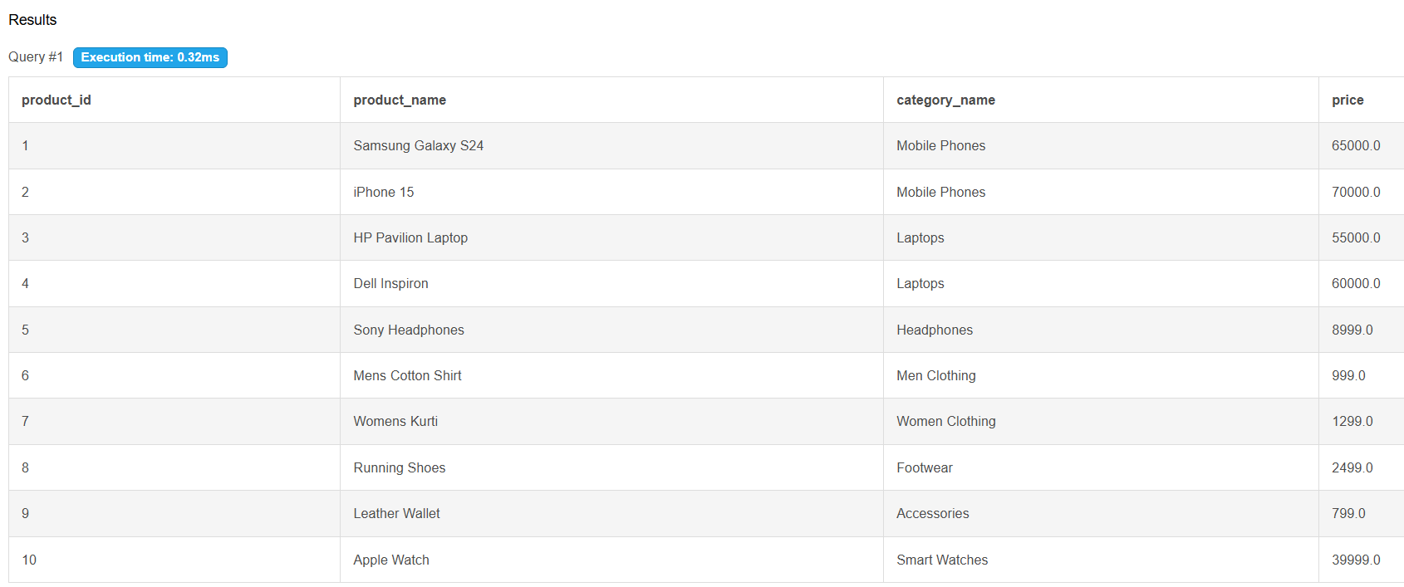

5.3 Aggregate Functions, GROUP BY and HAVING
Q7. Find the number of orders placed by each customer.
SQL:
SELECT customer_id, COUNT(*) AS total_orders FROM Orders

GROUP BY customer_id

ORDER BY total_orders DESC;

OUTPUT:
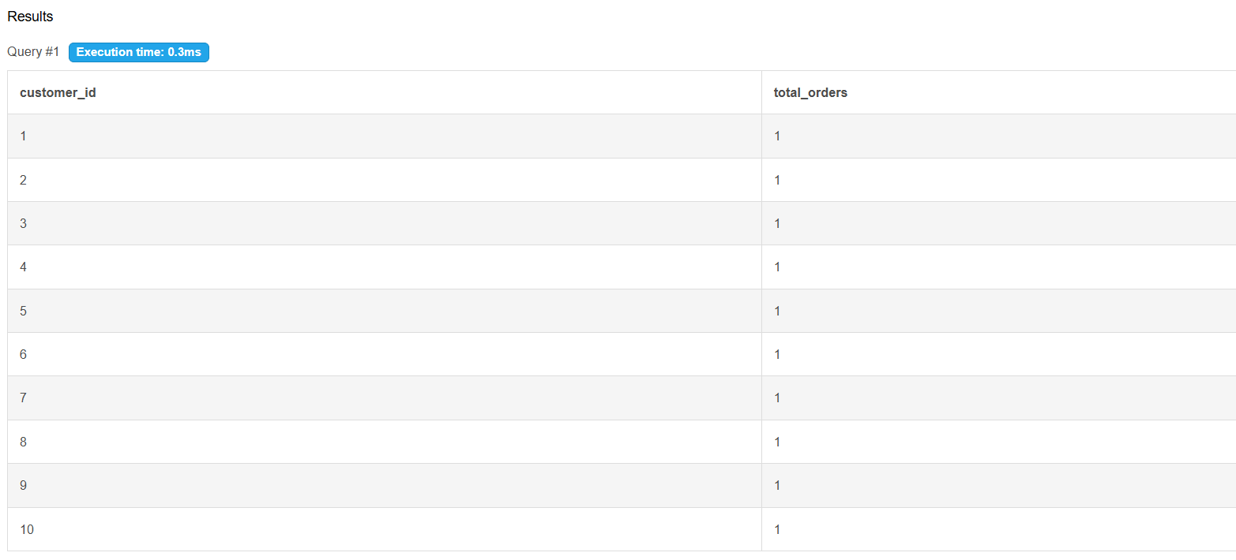
5.4 Nested and Correlated Subqueries
Q8. Display the highest-priced product in each category, along with its product ID, product name, category ID, and price.
SELECT p.product_id,
p.product_name,
p.category_id,
p.price
FROM Product p
WHERE p.price = (
SELECT MAX(p2.price)
FROM Product p2
WHERE p2.category_id = p.category_id)
ORDER BY p.category_id;
Output:
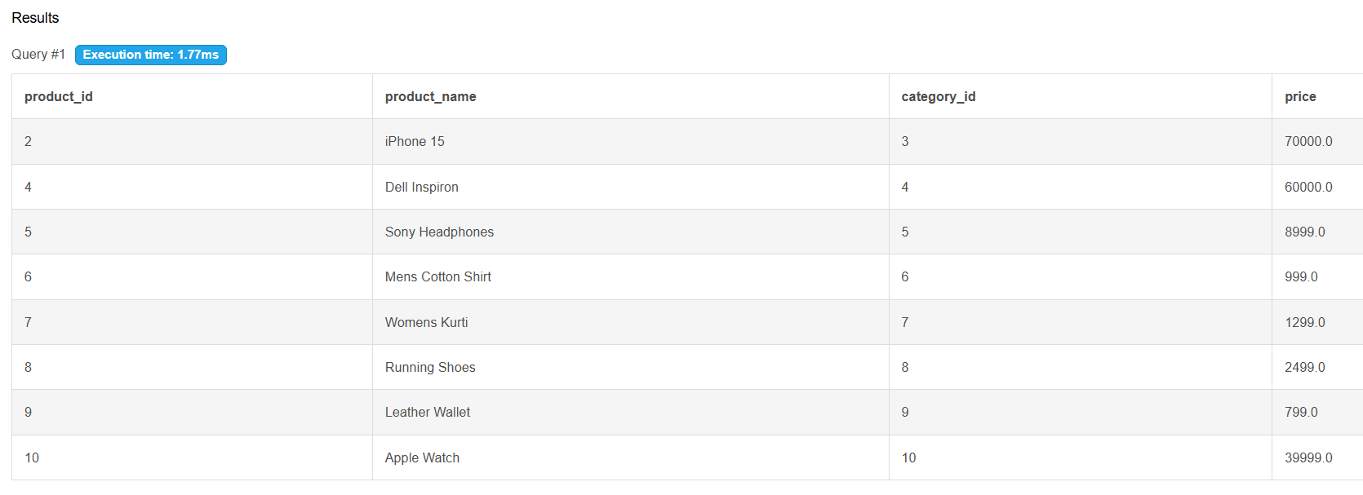

5.5 Views and Relational Set Operations
Q9. Display the names and prices of products from the Mobile Phones and Laptops categories using the UNION set operation
SQL:
SELECT p.product_name, p.price
FROM Product p
JOIN Category c
ON p.category_id = c.category_id
WHERE c.category_name = 'Mobile Phones'
UNION
SELECT p.product_name, p.price
FROM Product p
JOIN Category c
ON p.category_id = c.category_id
WHERE c.category_name = 'Laptops';
Output:
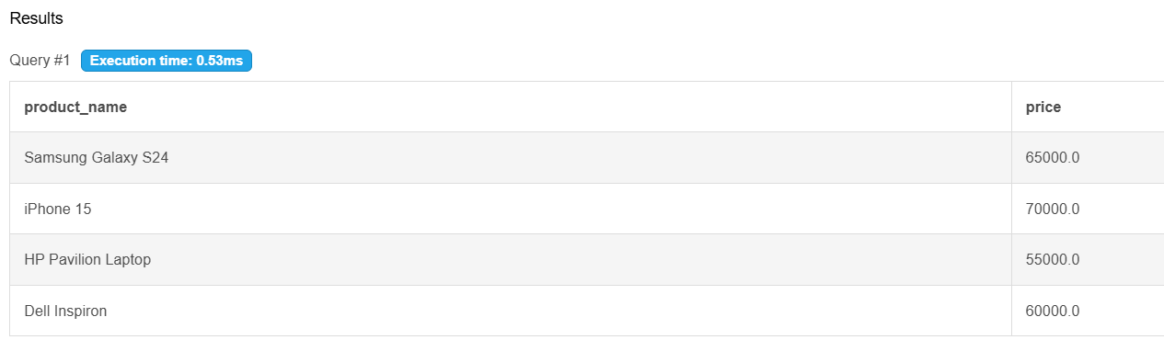

5.6 DCL and TCL Operations

-- Create a user
CREATE USER 'project_user'@'localhost'
IDENTIFIED BY 'project@123';
-- Grant SELECT permission on Customer table
GRANT SELECT
ON ecommerce_order_management.Customer
TO 'project_user'@'localhost';
-- Grant SELECT permission on Product table
GRANT SELECT
ON ecommerce_order_management.Product
TO 'project_user'@'localhost';
-- Grant INSERT and UPDATE permissions on Orders table
GRANT INSERT, UPDATE
ON ecommerce_order_management.Orders
TO 'project_user'@'localhost';
-- Display the granted permissions
SHOW GRANTS FOR 'project_user'@'localhost';
-- Revoke INSERT and UPDATE permissions from Orders table
REVOKE INSERT, UPDATE
ON ecommerce_order_management.Orders
FROM 'project_user'@'localhost';
-- Apply privilege changes
FLUSH PRIVILEGES;
CHAPTER 6: MODULES AND FUNCTIONALITIES.

S.No | Module Name | Functionality | Tables Involved
1 | Customer & Address Management | Create customer records, maintain contact details and manage delivery addresses. | Customer, Address
2 | Category & Product Management | Create categories, maintain product information, price and stock. | Category, Product
3 | Order Management | Place orders, track order dates and statuses, and associate delivery addresses. | Customer, Orders, Address
4 | Order Item Management | Record products purchased, quantity and transaction unit price. | Orders, Order_Item, Product
5 | Payment & Transaction Management | Record payment amount, method, status and transaction ID. | Orders, Payment

6.1 Customer & Address Management
The Customer table stores customer ID, first name, last name, email and registration date. The Address table stores delivery address details such as street, city, state, pincode and address type. Each address is associated with a customer.
6.2 Category & Product Management
The Category table stores product categories and supports parent categories for sub-categories. The Product table stores product name, description, price, stock quantity and category information.
6.3 Order Management
The Orders table stores customer orders along with order date, order status and delivery address. Each order is associated with a customer and an address.
6.4 Order Item Management
The Order_Item table connects orders with products. It records the quantity ordered and the unit price of the product at the time of purchase.
6.5 Payment & Transaction Management
The Payment table stores payment information for orders, including payment date, amount, payment method, payment status and unique transaction ID. Each order can have one associated payment record.

CHAPTER 7: RESULTS – SAMPLE OUTPUTS AND SCREENSHOTS

The two principal reports produced by the E-Commerce Order Management System are shown below. Both reports are generated using SQL SELECT statements with the e-commerce database tables.
Report 1 — Customer-wise Order Report.
SELECT c.customer_id, CONCAT(c.first_name, ' ', c.last_name) AS customer_name,
o.order_id,o.order_date, o.order_status FROM Customer c
JOIN Orders o ON c.customer_id = o.customer_id
ORDER BY c.customer_id;
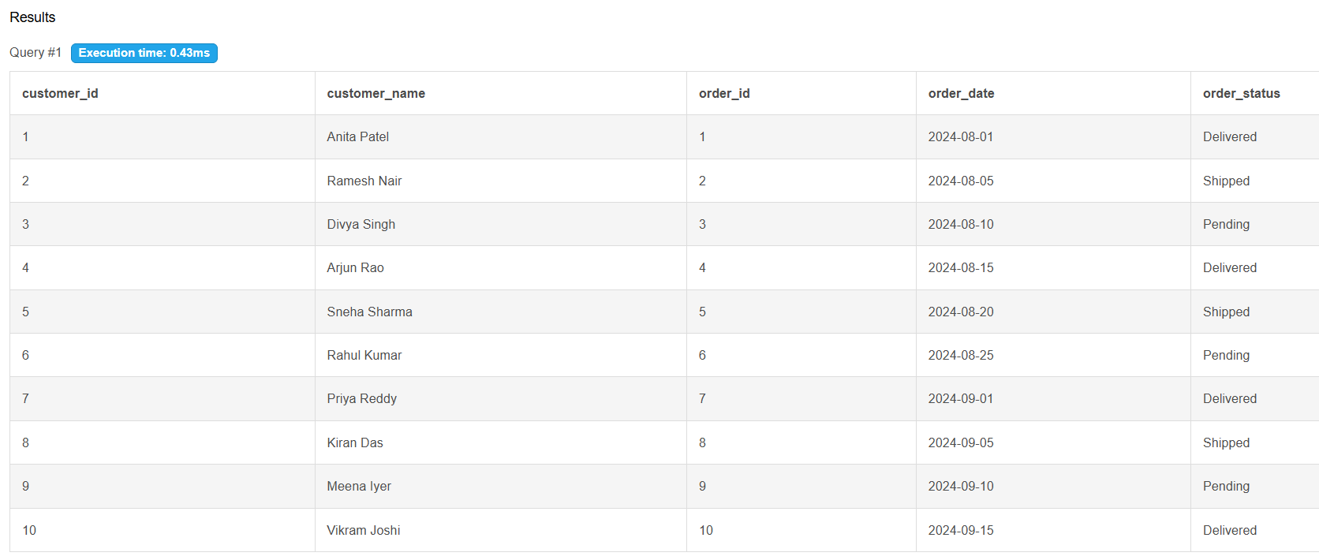
Report 2 — Order-wise Product and Payment Report.
SELECT o.order_id,p.product_name,oi.quantity,oi.unit_price,oi.quantity * oi.unit_price AS subtotal,
pay.method,pay.status AS payment_status
FROM Orders o JOIN Order_Item oi ON o.order_id = oi.order_id
JOIN Product p ON oi.product_id = p.product_id LEFT JOIN Payment pay
ON o.order_id = pay.order_id
ORDER BY o.order_id;
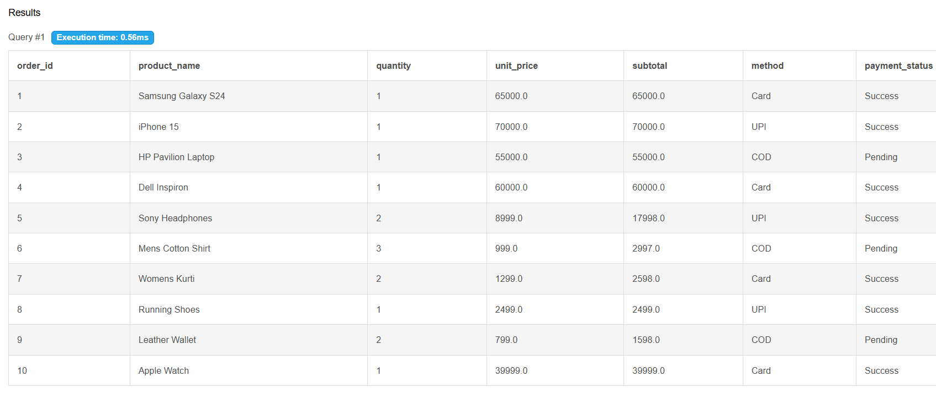

CHAPTER 8: TESTING AND DATA VALIDATION

Test Case | Input / Operation | Expected Result | Result
TC01 | Insert duplicate customer email | UNIQUE constraint rejects duplicate email | Pass when constraint is enforced
TC02 | Insert product with negative price | CHECK constraint rejects negative price | Pass when constraint is enforced
TC03 | Insert product with invalid category_id | FOREIGN KEY rejects invalid category reference | Pass when constraint is enforced
TC04 | Insert order with invalid customer_id | FOREIGN KEY rejects invalid customer reference | Pass when constraint is enforced
TC05 | Insert order item with invalid order_id | FOREIGN KEY rejects orphan order item | Pass when constraint is enforced
TC06 | Insert order item with quantity less than or equal to zero | CHECK constraint rejects invalid quantity | Pass when constraint is enforced
TC07 | Insert payment with duplicate order_id | UNIQUE constraint rejects duplicate order payment | Pass when constraint is enforced
TC08 | Insert customer without first_name | NOT NULL constraint rejects record | Pass when constraint is enforced
TC09 | Query delivered orders | Only orders with Delivered status are returned | Pass
TC10 | Calculate order subtotal | Quantity × unit price gives correct subtotal | Pass

8.1 Data Validation Rules
- Primary keys give each record a unique ID.
- Foreign keys connect related tables correctly.
- UNIQUE prevents duplicate emails and transaction IDs.
- NOT NULL makes sure important fields are not empty.
- CHECK prevents invalid values like negative prices or zero quantities.
- DEFAULT automatically gives values such as order status and dates.
- AUTO_INCREMENT automatically generates IDs.
- Derived values like subtotal are calculated when needed.

CHAPTER 9: GITHUB REPOSITORY AND TEAM CONTRIBUTION

9.1 Github Repository

The project SQL script and documentation can be maintained in a GitHub repository so that the team can manage changes and keep the project files organized. The repository can contain the SQL script, project report, ER diagram, database schema and relevant screenshots.

9.2 Team Responsibilities and Contribution

S.No | Student Name | Roll Number | Role / Responsibility | Contribution Status
1. | U.Deepika | 25B11AIC25 | Database Design & Integration | Completed(100%)
2. | P.Harshitha | 25B11AI990 | SQL Development & Operations | Completed(100%)
3. | P.Supriya | 25B11AI985 | Documentation | Completed(100%)
4. | A.Hemanth | 26B21AI166 | Testing | Completed(100%)

CHAPTER 10: CONCLUSION AND FUTURE ENHANCEMENTS

10.1 Conclusion

The E-Commerce Order Management System was designed as a structured relational database for managing customers, addresses, categories, products, orders, order items and payments. The design uses primary keys and foreign keys to maintain relationships and constraints to protect data integrity.
The system supports DDL, DML, DQL, CRUD, joins, aggregate functions, GROUP BY and HAVING, nested and correlated subqueries, views, set operations, DCL and TCL. The normalized design reduces redundancy and makes transaction information easier to retrieve and analyze.

10.2 Future Enhancements
- Add secure online payment options such as UPI, cards and net banking.
- Allow customers to create accounts and manage their orders.
- Add order tracking to show delivery status.
- Add product search and filtering options.
- Automatically update stock after each purchase.
- Generate sales and customer order reports.
- Convert the database into a complete e-commerce web application.
- Add notifications for order confirmation, payment and delivery updates.

REFERENCES

Abraham Silberschatz, Henry F. Korth and S. Sudarshan, “Database System Concepts”, 8th Edition, McGraw-Hill.
Raghurama Krishnan and Johannes Gehrke, “Database Management Systems”, 4th Edition, McGraw-Hill.
Ramez Elmasri and Shamkant B. Navathe, “Fundamentals of Database Systems”, 7th Edition, Pearson.
C. J. Date, “An Introduction to Database Systems”, 9th Edition, Pearson.
MySQL 8.0 Reference Manual, Oracle Corporation.
W3Schools SQL Tutorial.
The supplied E-Commerce Order Management System reference document and the supplied capstone template.

APPENDIX A – COMPLETE SQL SCRIPT
The following consolidated script contains the table definitions used in this report. Execute the statements in dependency order in MySQL.
CREATE DATABASE ecommerce_order_management;
USE ecommerce_order_management;

CREATE TABLE Customer (
customer_id INT PRIMARY KEY AUTO_INCREMENT,
first_name VARCHAR(50) NOT NULL,
last_name VARCHAR(50) NOT NULL,
email VARCHAR(100) UNIQUE NOT NULL,
registration_date DATE DEFAULT (CURRENT_DATE)
);

CREATE TABLE Address (
address_id INT PRIMARY KEY AUTO_INCREMENT,
customer_id INT NOT NULL,
street VARCHAR(200),
city VARCHAR(100),
state VARCHAR(100),
pincode VARCHAR(10),
address_type VARCHAR(20) DEFAULT 'Home',
FOREIGN KEY (customer_id) REFERENCES Customer(customer_id)
);

CREATE TABLE Category (
category_id INT PRIMARY KEY AUTO_INCREMENT,
category_name VARCHAR(100) NOT NULL UNIQUE,
parent_category_id INT,
FOREIGN KEY (parent_category_id) REFERENCES Category(category_id)
);

CREATE TABLE Product (
product_id INT PRIMARY KEY AUTO_INCREMENT,
product_name VARCHAR(200) NOT NULL,
description TEXT,
price DECIMAL(10,2) NOT NULL CHECK (price >= 0),
stock_quantity INT DEFAULT 0,
category_id INT,
FOREIGN KEY (category_id) REFERENCES Category(category_id)
);

CREATE TABLE Orders (
order_id INT PRIMARY KEY AUTO_INCREMENT,
customer_id INT NOT NULL,
address_id INT,
order_date DATE DEFAULT (CURRENT_DATE),
order_status VARCHAR(30) DEFAULT 'Pending',
FOREIGN KEY (customer_id) REFERENCES Customer(customer_id),
FOREIGN KEY (address_id) REFERENCES Address(address_id)
);

CREATE TABLE Order_Item (
item_id INT PRIMARY KEY AUTO_INCREMENT,
order_id INT NOT NULL,
product_id INT NOT NULL,
quantity INT NOT NULL CHECK (quantity > 0),
unit_price DECIMAL(10,2) NOT NULL,
FOREIGN KEY (order_id) REFERENCES Orders(order_id),
FOREIGN KEY (product_id) REFERENCES Product(product_id)
);

CREATE TABLE Payment (
payment_id INT PRIMARY KEY AUTO_INCREMENT,
order_id INT UNIQUE NOT NULL,
payment_date DATE,
amount DECIMAL(10,2),
method VARCHAR(30),
status VARCHAR(20) DEFAULT 'Pending',
transaction_id VARCHAR(100) UNIQUE,
FOREIGN KEY (order_id) REFERENCES Orders(order_id)
);

