**­­­­ Fig1: Vps1 and Rvs167 deletion**

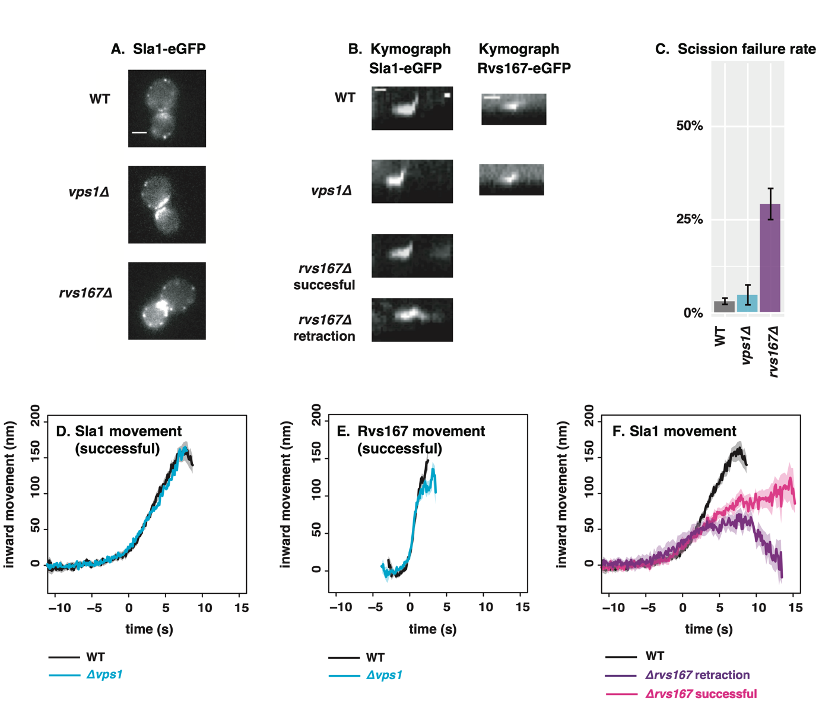

**Needs:**

**P values**

**Fig.2: Inp deletions**

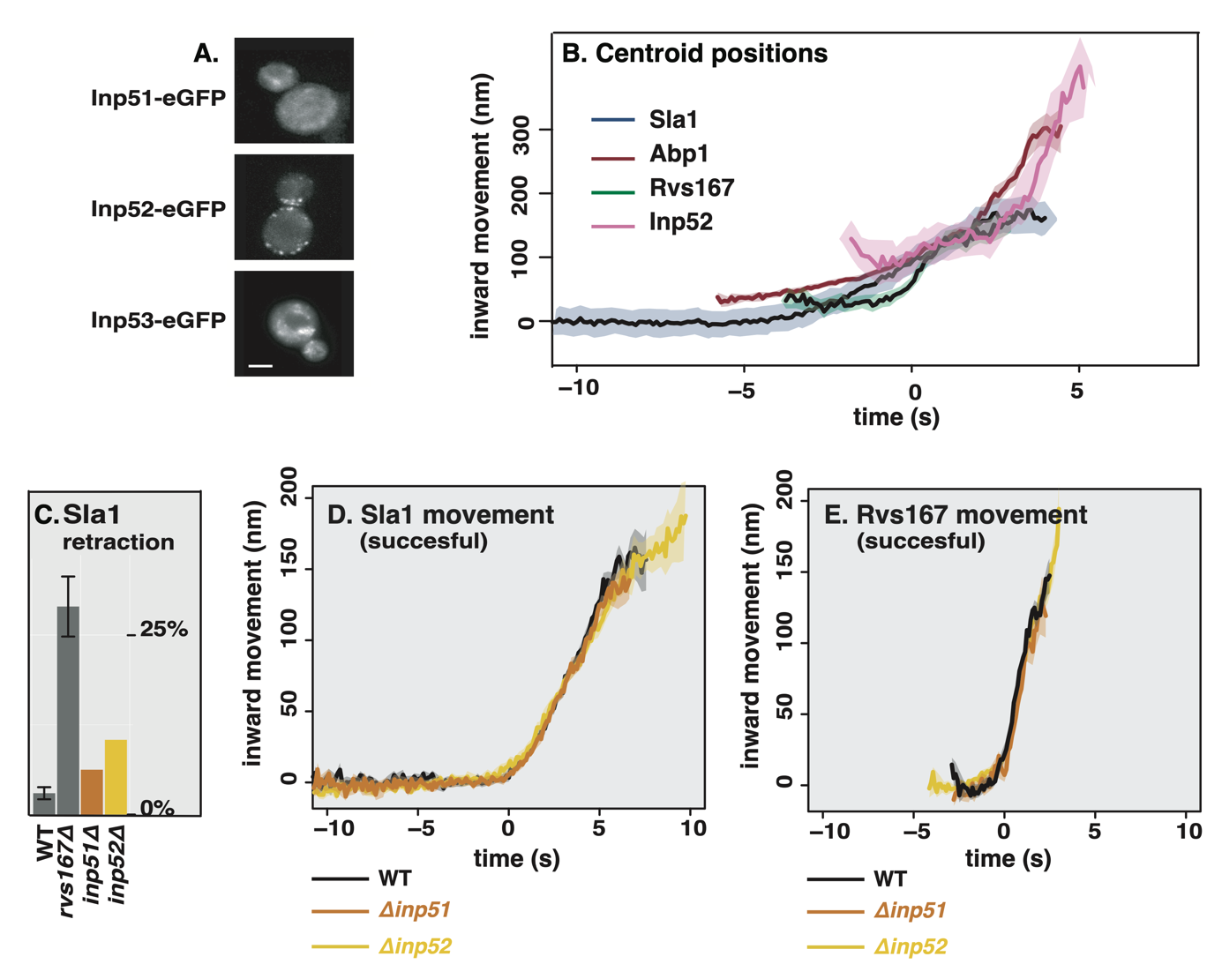

**Needs:**

**C: P values, error bars for retraction**

**Fig.3: Rvs recruitment**

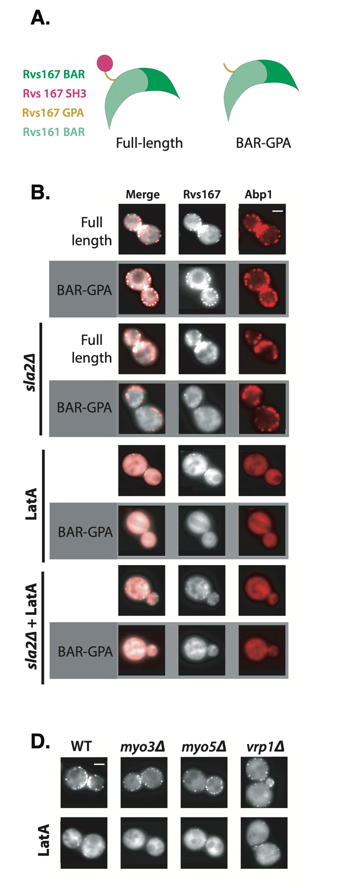**Needs: “merge” panels on the right?**

**Fig.4: BAR-GPA dynamics**

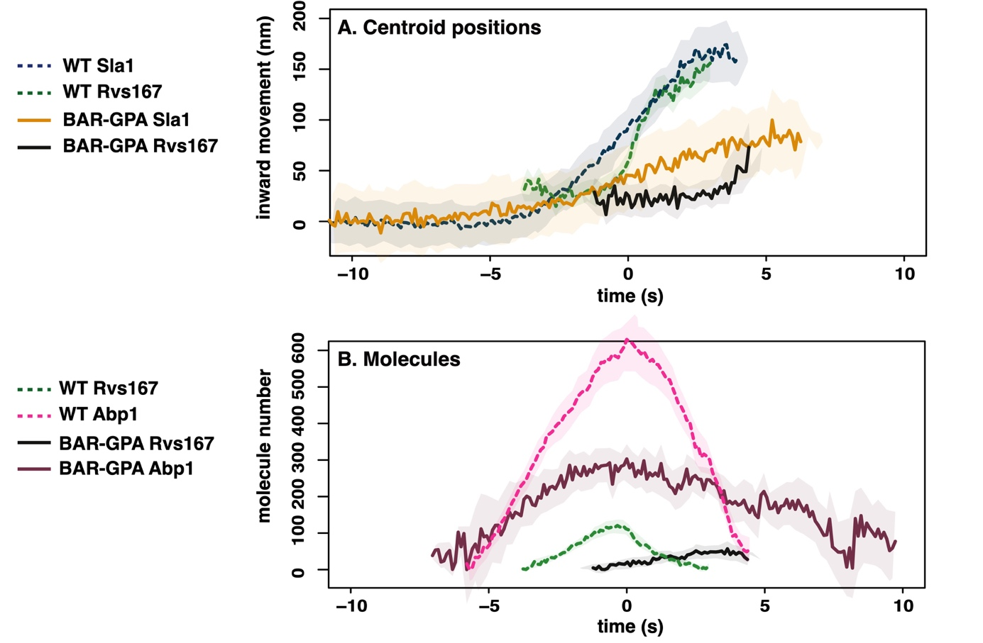

**Needs:**

**B: move the frame higher**

**Fig.5: Rvs duplication**

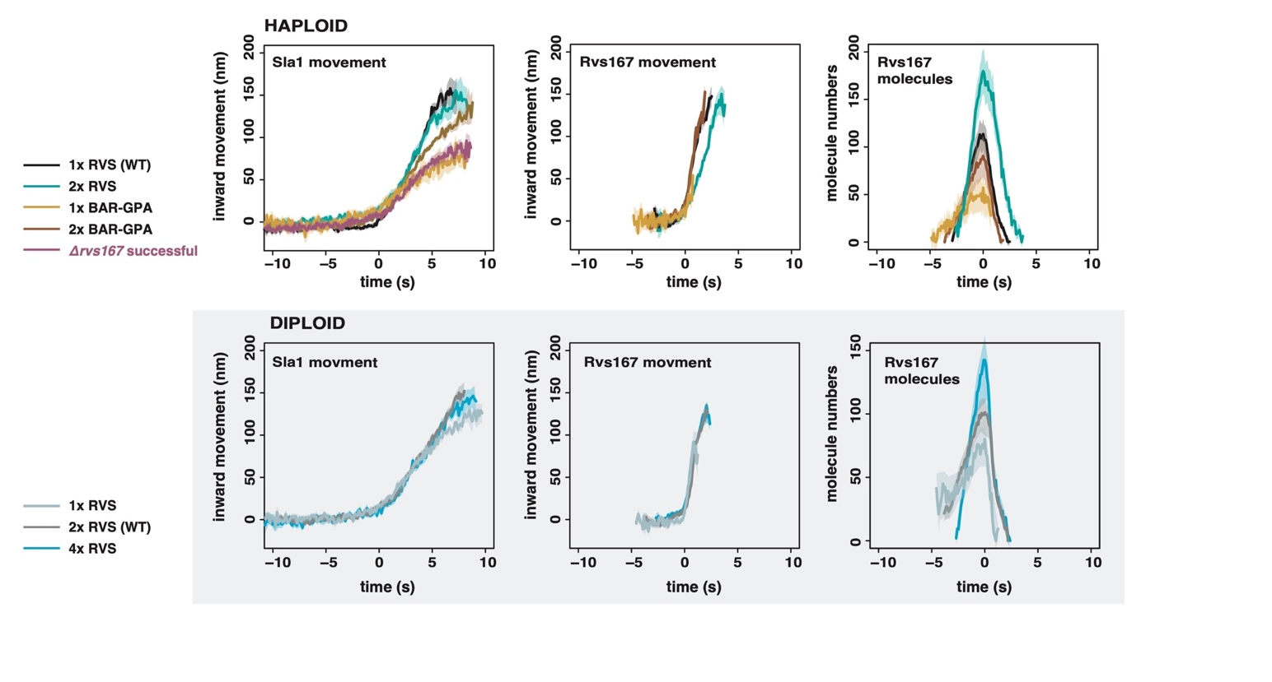**Needs: maybe abp1 panel**