**Regulation of membrane scission in yeast endocytosis**

**Fig.1: Rvs deletion reduces coat movement**

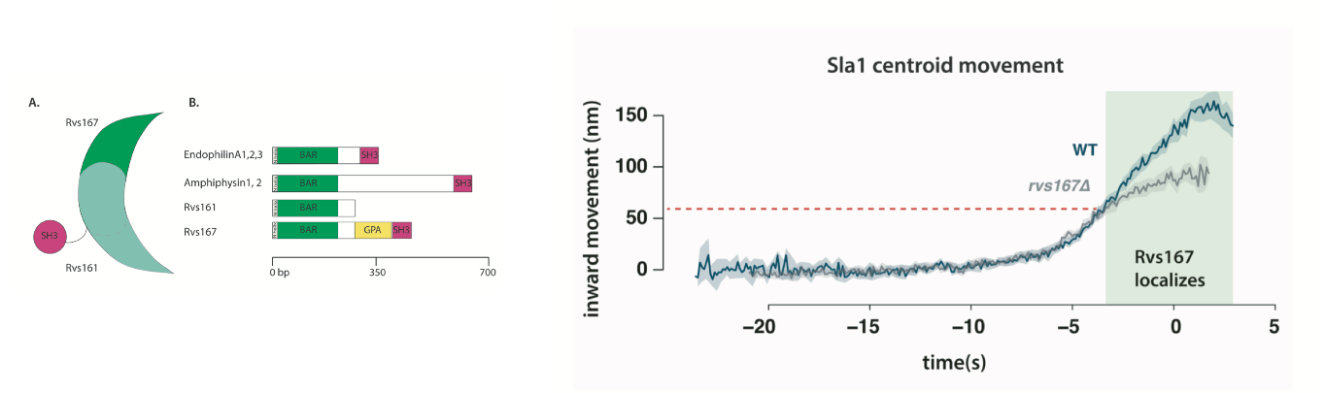

**Fig.2: Rvs BAR domains recognize membrane curvature *in-vivo*.**

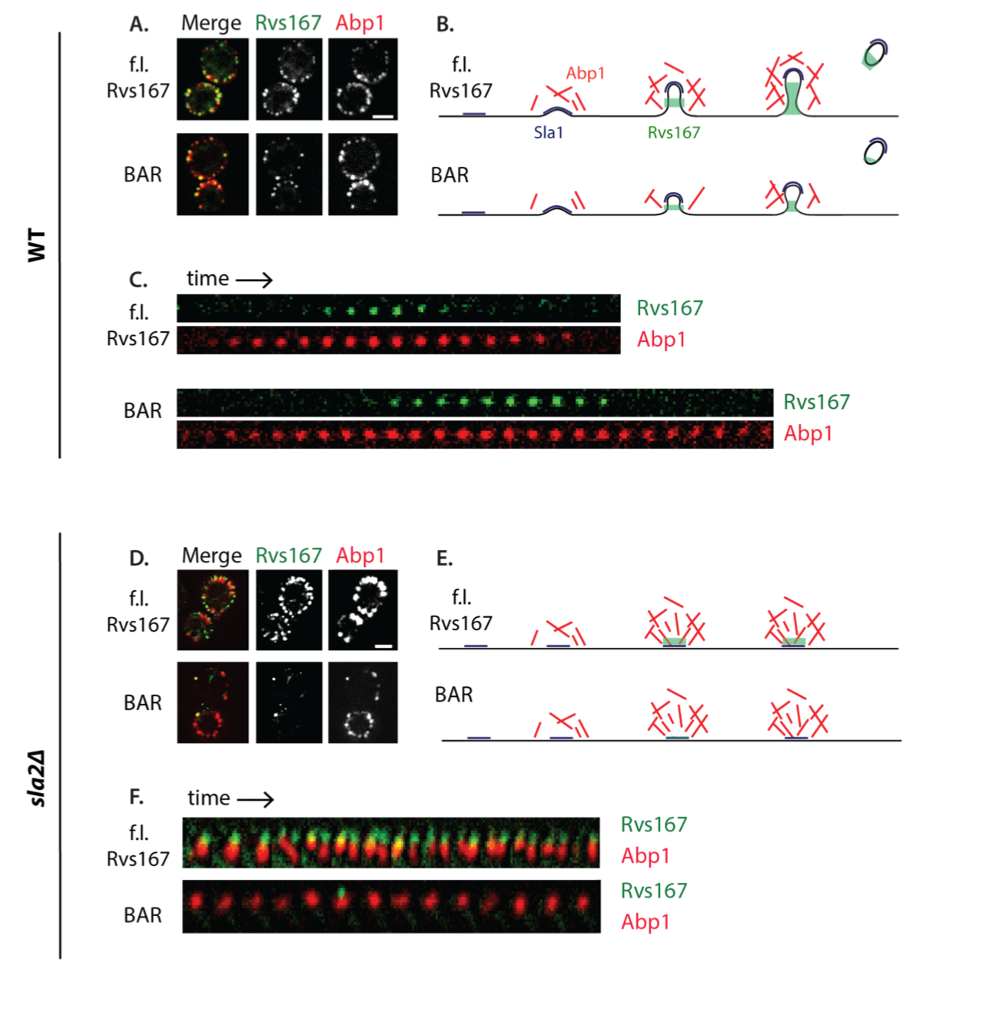

**Fig.3: Increased recruitment of BAR domains corresponds to increased membrane movement.**

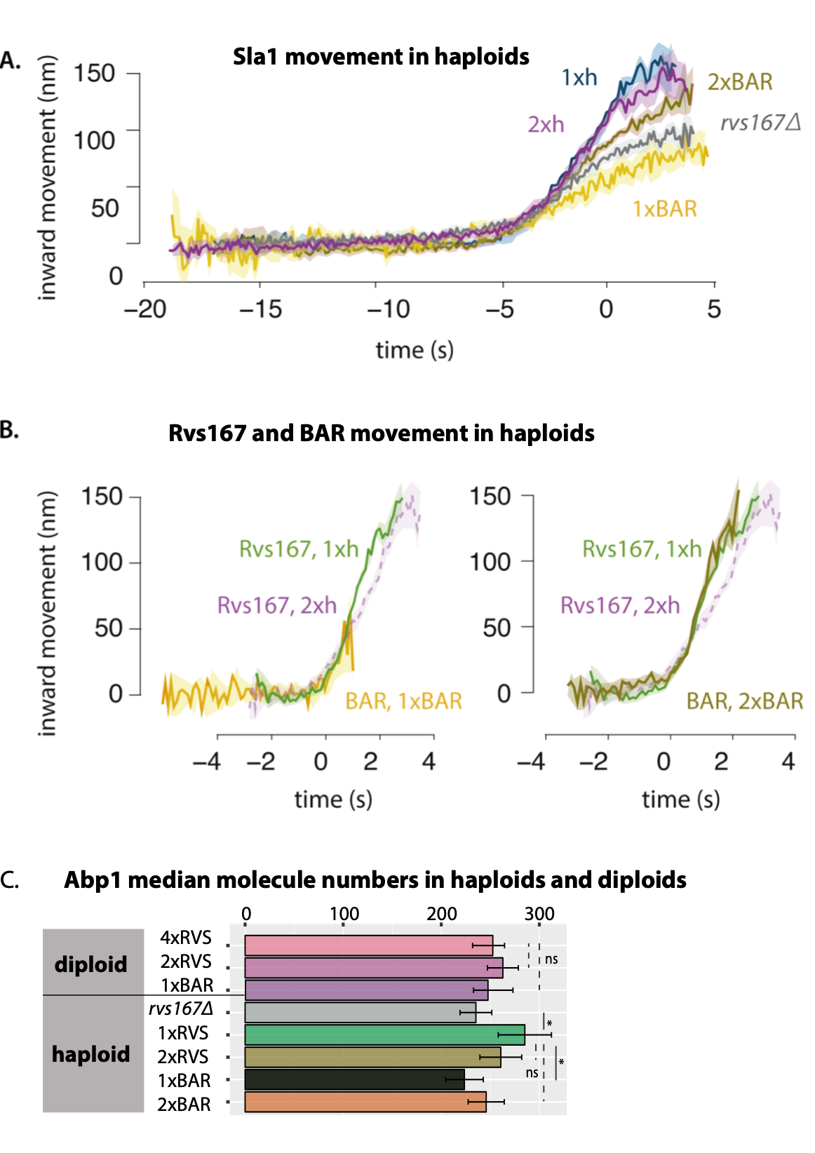

**Fig.4: SH3 domain can be recruited to the plasma membrane in a curvature and actin-independent manner**

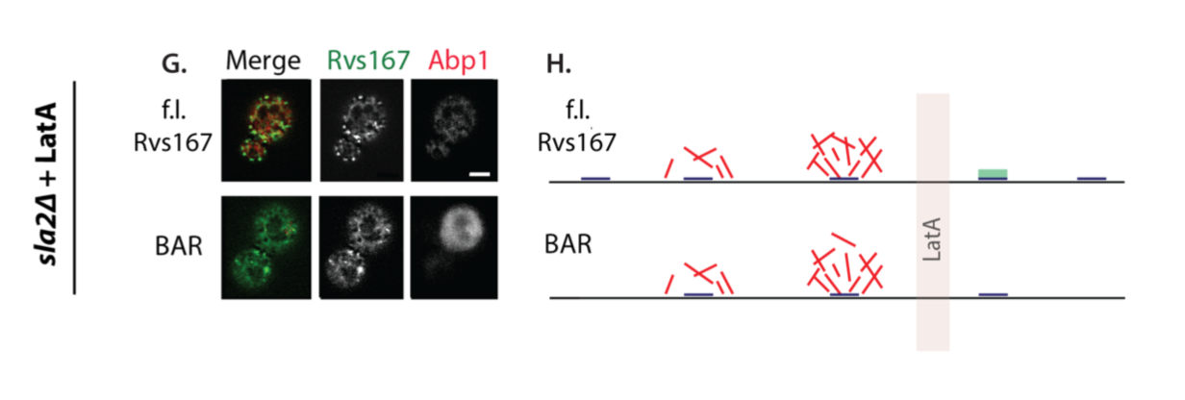

**Fig.5: SH3 domain interacts with Myo5**

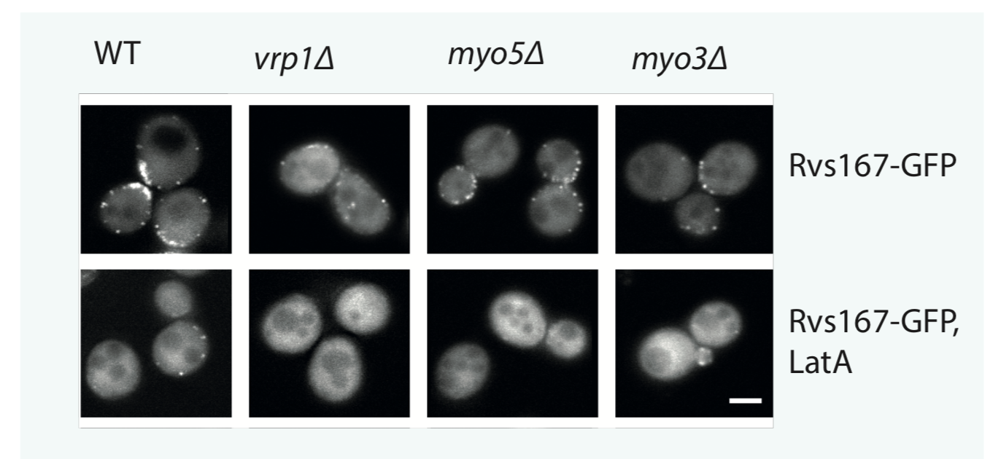

**Fig.6: Nhelix, GPA domains do not contribute to Rvs recruitment to endocytic sites**

[…coming up]

**Fig.7: Vps1 does not influence coat or scission dynamics. Synaptojanins likely influence vesicle uncoating, but not scission dynamics.**

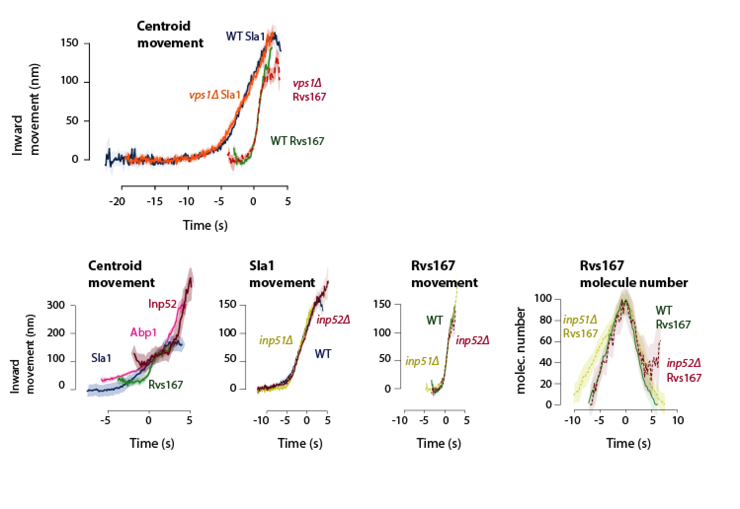

Discussion:

Rvs recruitment times membrane scission

Rvs recruitment is driven by BAR as well as SH3 domain interaction

BAR domains scaffold the membrane tube and prevent scission

Membrane scission requires a threshold recruitment of actin

Scission models: neither yeast dynamin, lipid hydrolysis, nor protein friction play a major role in membrane scission

Additions:

Another actin network marker? Sac6?