Membrane scission in the absence of dynamin: Vps1, Synaptojanins, Rvs, actin forces

Actin forces basically cause scission, and scission module protein function is to regulate timing?

Turgor pressure experiments: what does the rvs scaffold compensate for?

NOT turgor pressure, just actin force?

Sorbitol/ reduced pressure 🡪 should then acquire less actin?

Scission module interactions: Rvs and sh3 interaction partner, Inp and interaction partner

Rvs recruitment and removal

function of domains: sh3, bar, gpa, Nhelix

bzz1 stuff goes in here?

Leftover shit:

Bzz1, cmd1

Assumed shit: bar domains form helices that act as scaffolds for dynamin, which typically causes scission.

Scission in vitro occurs by a nice variety, but no in-vivo mechanism.

Bar domains sense or induce curvature, shown mostly in overexpression of bar in mammalian systems.

Version 1:

What causes membrane scission?

Vps1 doest play a role in scission, neither does lipid hydrolysis, protein frition, gpa clustering, n-helix insertion, or any other fancy mechanism. Forces come from actin, polymerization, scission occurs over a threshold that is likely determind by membrane properties.

Can we change the properties, and see forces change?

Hyper and hypo-osmotic shock 🡪 number counting here is going to be complicated

Spheroblast 🡪 abp1 numbers

Robbie’s strains that don’t adapt to osmotic shock?

How is scission regulated?

Bar domains are recruited to curvature, sh3 domains are recruited to some actin binding protein, play some regulatory function. N helix does nothing (except salt case), gpa does nothing (except keep the sh3 domain from interfering with the bar function, or make it accessible for the binding partner)

Bar domain acts as the timer for recruitment.

Bar domain acts as scaffold against actin forces

Sh3 domain communicates disassembly to actin network?

Version 2:

A: What causes membrane scission?

Vps1 doest play a role in scission, neither does lipid hydrolysis, protein frition, gpa clustering, n-helix insertion, or any other fancy mechanism. Forces come from actin, polymerization, scission occurs over a threshold that is likely determind by membrane properties. BAR domains scaffold against premature scission.

Can we change the properties, and see forces change?

Hyper and hypo-osmotic shock 🡪 number counting here is going to be complicated

Spheroplast 🡪 abp1 numbers under low pressure/tension

Robbie’s strains that don’t adapt to osmotic shock?

Loss of turgor pressure does not affect rate of endocytosis

Probably needs another actin marker, or actin itself to be labelled, and quantified

B: BAR domain proteins regulate timing of membrane scission

Bar domains are recruited to curvature, sh3 domains are recruited to some actin binding protein, play some regulatory function. N helix does nothing (except salt case), gpa does nothing (except keep the sh3 domain from interfering with the bar function, or make it accessible for the binding partner)

Bar domain acts as the timer for recruitment.

Sh3 domain communicates disassembly to actin network?

Fig.A Diploid number titration: 4, 2, 1x:

Sla1 movement, Rvs movement, Abp1 numbers shows that

coat movement is similar over a threshold amount of Rvs,

abp1 numbers are the same (at scission time)

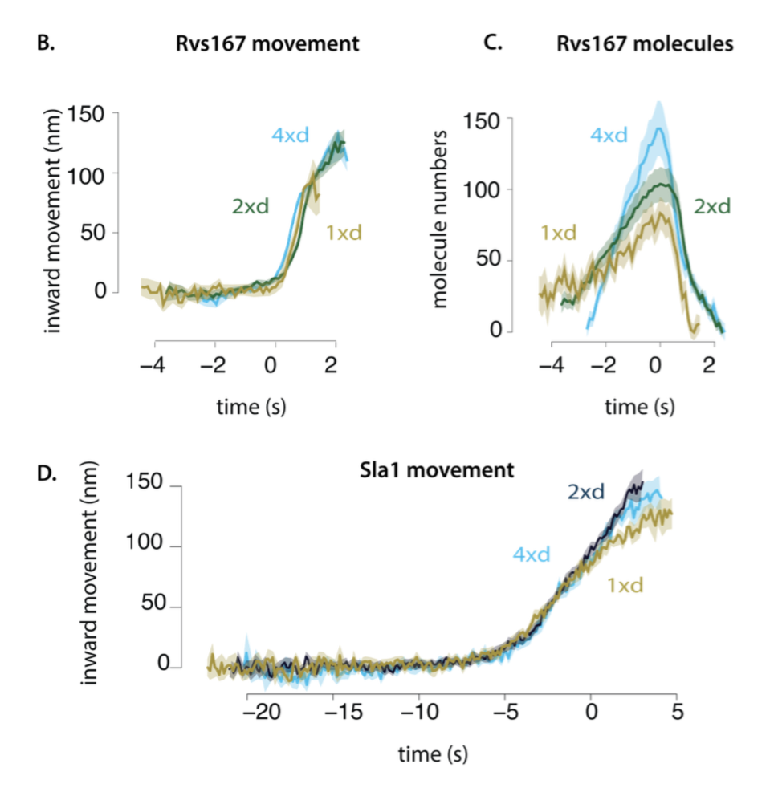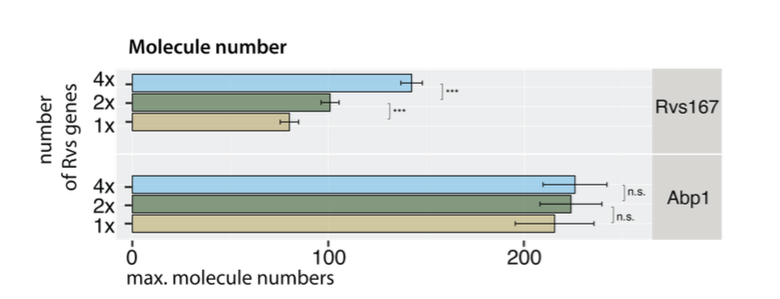

Fig.B Haploid titration 4, 2x, bar duplication, abp1 numbers shows that

abp1 numbers are the same also in haploids, even when “dumping Rvs”.

BAR domain scaffolds the tube

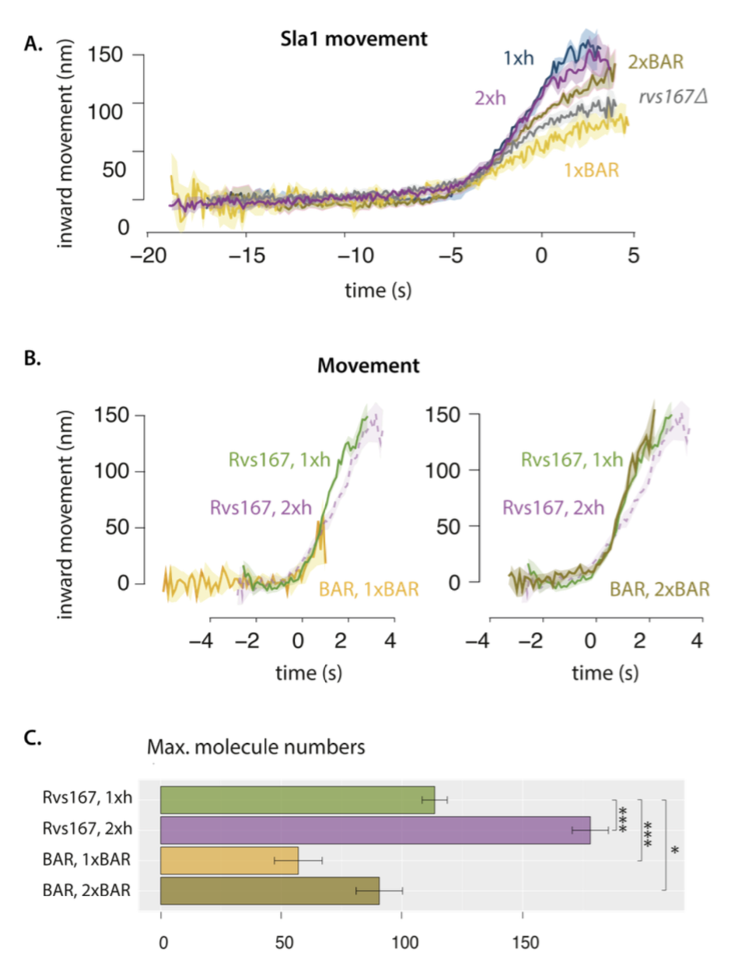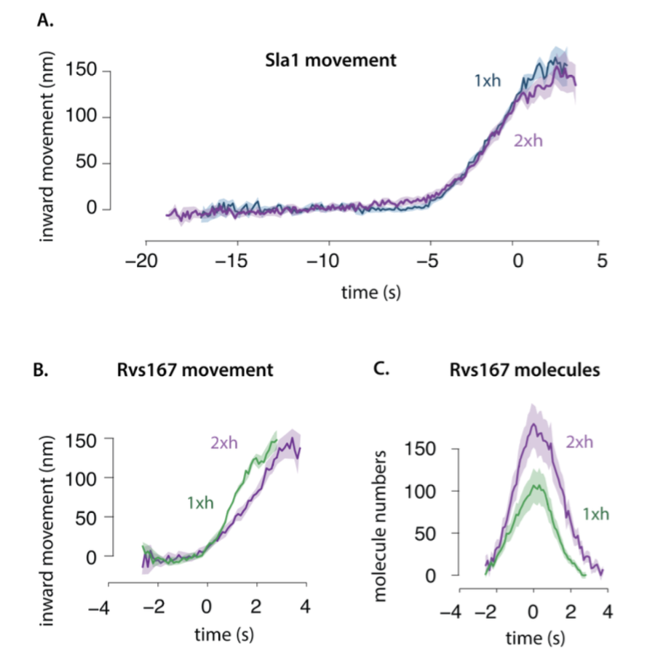

Fig.C Vps1 stuff shows no change in coat or scission,

doensnt affect endocytosis progression

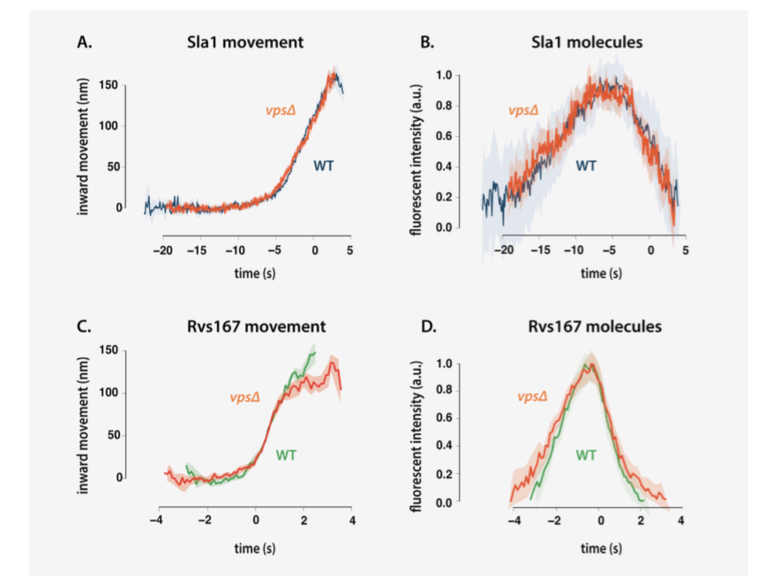

Fig.F: GPA deletion, N-helix deletion, SH3 deletion: coat movement, molecule numbers shows that sh3 region is required to recruit, etc…

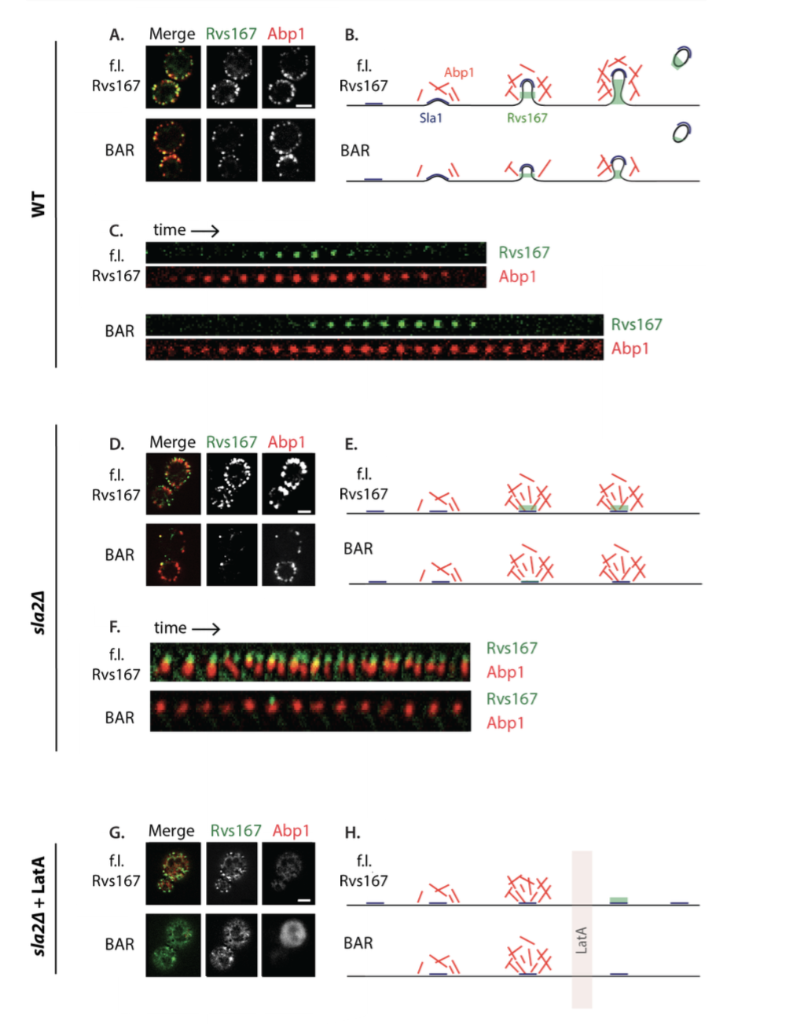

Fig.D Inp stuff: timeline, deletions show arrival at the late stage affects uncoating rather than scission (timing) Needs abp1 co-color for the deletions

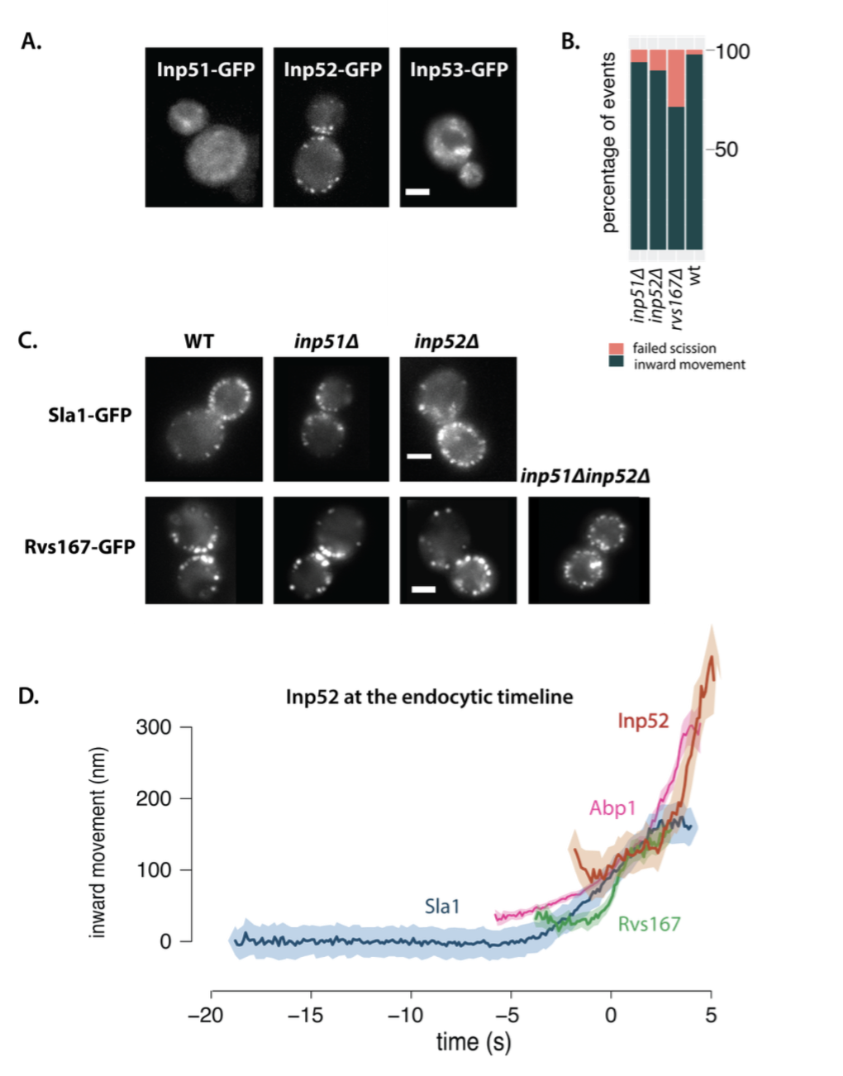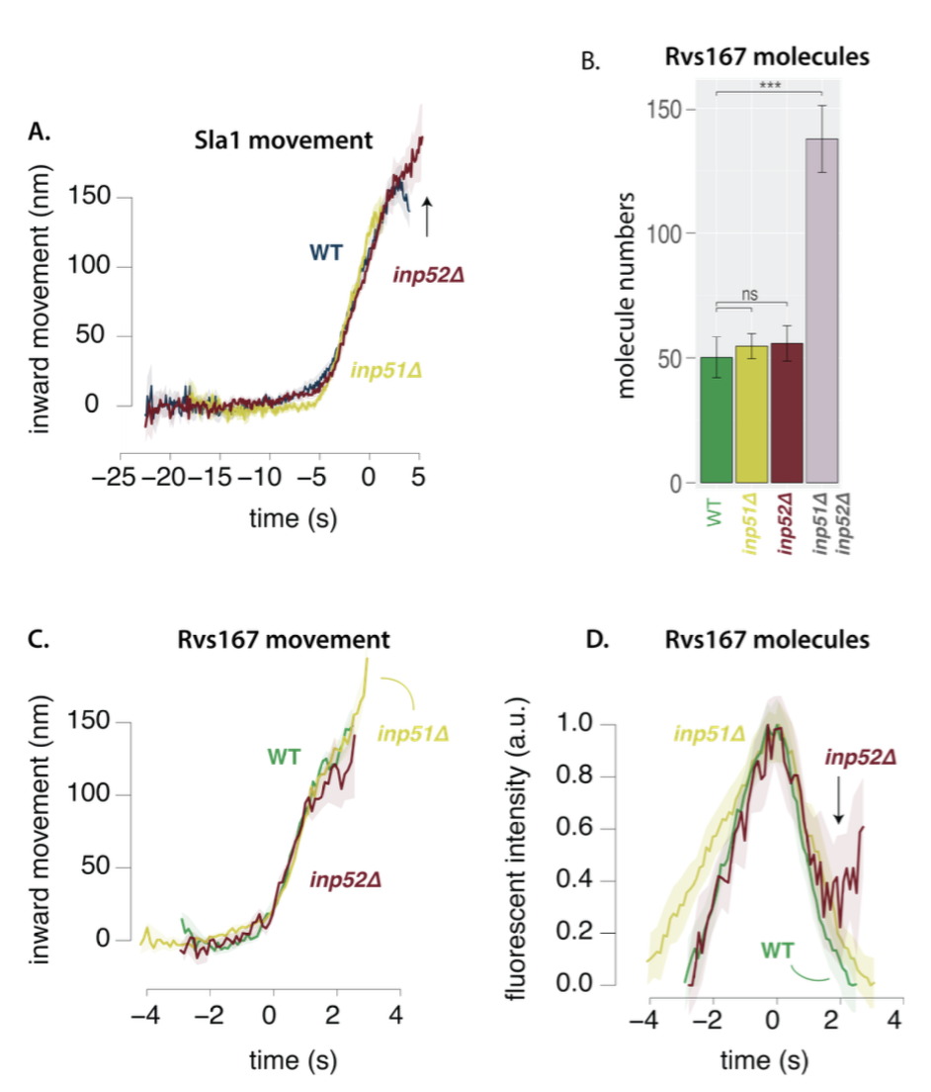

Fig.E Turgor pressure shows that arrival doesn’t compensate internal pressure

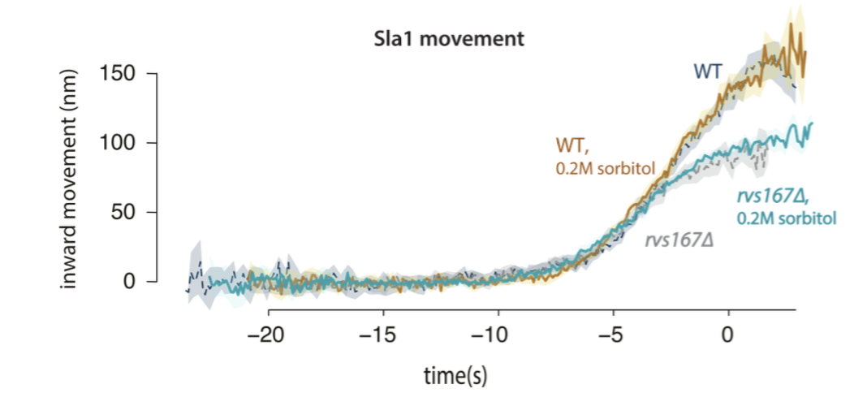

Fig.G: Interaction partner of Rvs sh3 domain

Fig.H: Interaction partner of the Inps? Abp1 sh3?

Fig.I: BAR swap shows that curvature determines timing