**Regulation of membrane scission in yeast endocytosis**

Overleaf:

m3%%3nQKu+QT7dw

**Results:**

**Vps1 does not influence coat or scission dynamics. Synaptojanins likely influence vesicle uncoating, but not scission dynamics.**

Endocytic membrane scission in mammalian cells is understood to be driven by constriction of the tubule neck by the Gtpase Dynamin {a bunch of dynamin papers}. In yeast, it has been reported that the Dynamin-like protein Vps1 is recruited to endocytic sites {ref_Ayscough}. To test whether Vps1 influences scission, coat and scission dynamics are observed in cells lacking Vps1.

Fig1a shows kymographs of coat protein Sla1 endogenously tagged at the N-terminus with eGFP in WT and vps1_del cells. Lifetimes and inward movement of Sla1 in WT and vps1_del cells are the same. In Fig.1b, the averaged centroid trajectory {ref2_andrea}- henceforth centroid- of Sla1 endogenously tagged at the C-terminus with eGFP is tracked in ~50 endocytic sites in vps1_deletion and wild-type cells. Beginning of inward movement of the centroid is set as the initial position of averaged centroid. Inward movement of Sla1 centroid serves as a proxy for plasma membrane movement through the endocytic process {ref2_andrea}. Centroid movement of Sla1-eGFP in wild-type cells shows a linear movement to about 150nm, and Sla1 movement in vps1_del cells is the same. Position of the vesicle formed at the end of scission process is determined from the final position of the Rvs167 centroid {ref2_andrea}. Rvs167 centroid position in WT and vps1-del cells indicates that vesicle formation is the same as in WT cells.

Lipid hydrolysis by synaptojanins is

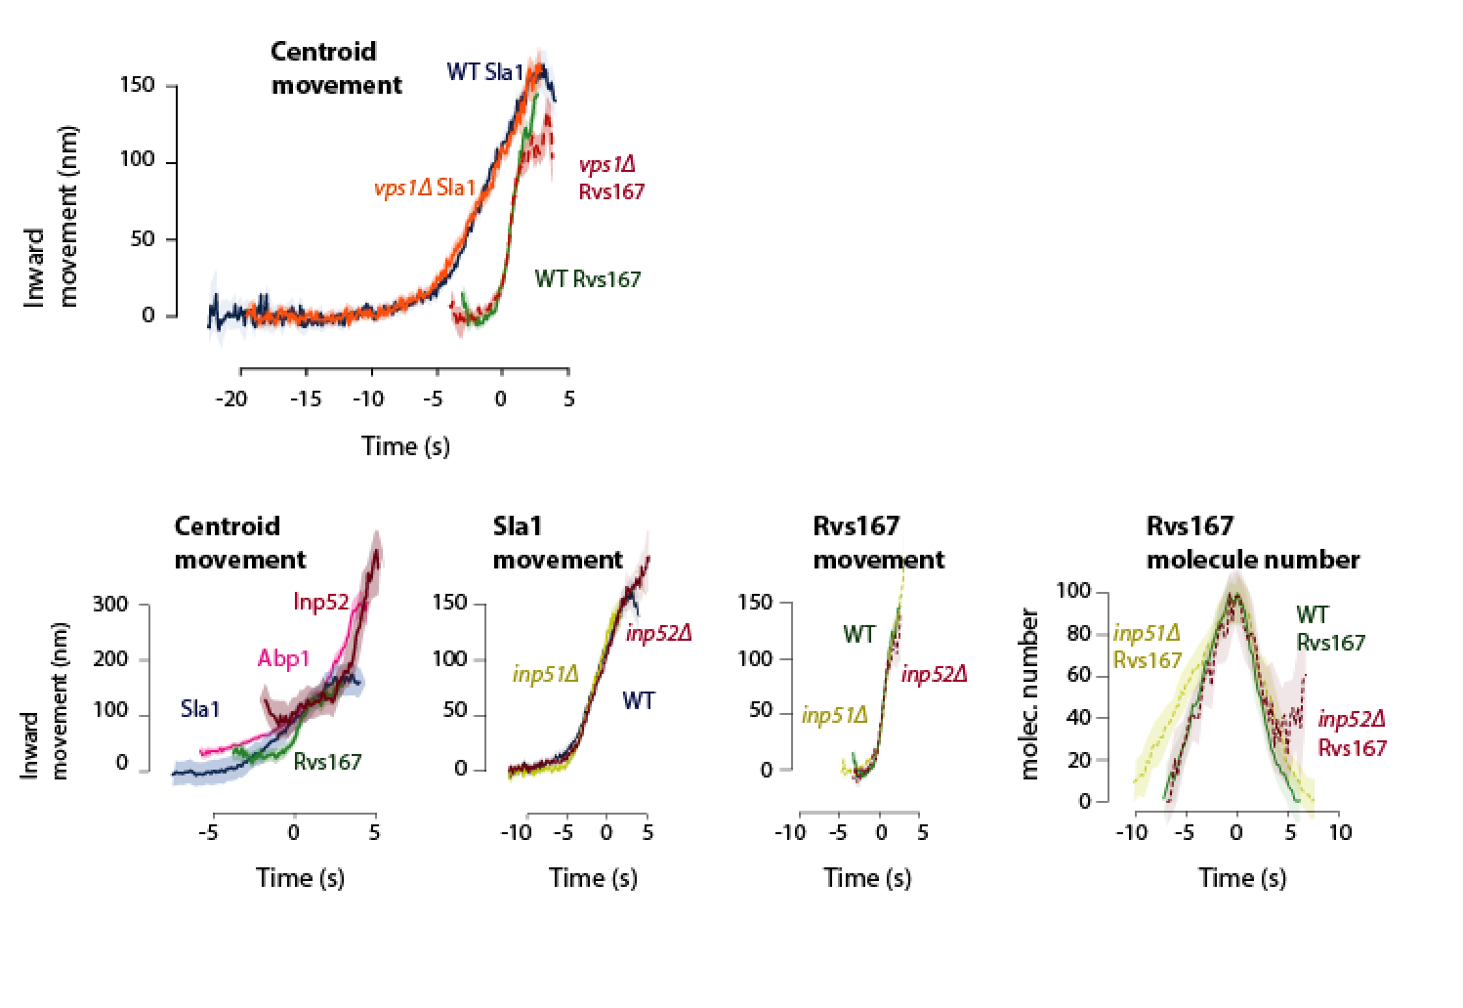

**Rvs deletion reduces coat movement**

The Rvs complex is known to influence scission: deletion reduces scission efficiency by 30% {ref1_marko}. Failed scission events are characterized by inward movement, followed by retraction of the coat protein Sla1 {ref1_marko}. Contribution of Rvs to the scission process, and therefore, an understanding of why its absence might cause a scission defect, is currently unclear. In the remaining 70% of successful invaginations, inward movement of the coat protein Sla1 also deviates from the wild-type. Sla1 centroid in rvs167_deletion cells follows the wild-type centroid movement till about 60nm, after which movement slows down and scission occurs. That scission occurs at shorter invaginations lengths is confirmed by formation of smaller vesicles and shorter invagination lengths in rvs167_deletion cells, quantified by Correlative light and electron microscopy (CLEM) {ref3_wanda}. Invagination lengths of 60nm is the time window for arrival of Rvs167 {ref3_wanda}, indicating that coat movement of endocytic sites in rvs167_deletion cells progresses normally till the expected arrival of Rvs. Time alignment is established by tracking the centroid of a second protein, here m-Cherry tagged Actin binding protein Abp1. Simultaneous tracking of GFP-tagged protein of interest and m-Cherry tagged Abp1 allows us to align all other proteins to the Abp1 reference centroid {ref2_andrea}. Scission time, t=0, is established as the peak of the Abp1 fluorescence intensity, which in wild-type is concomitant with the peak of Rvs167 fluorescent intensity {ref2_andrea, ref3_wanda}.s

[fig1: DC alignment of sla1 in wt and rvs167_del ]

**Rvs BAR domains recognize *in-vivo* membrane curvature.**

In intrinsic curvature of N-BAR domain proteins are thought to make them either curvature sensitive, causative, or a combination of the two. The Rvs N-BAR domain is unlikely to cause macroscopic membrane curvature changes, since CLEM data has indicated that membrane curvature does not change after the arrival of Rvs. To test whether the BAR domains are sensors of membrane curvature, we test the recruitment of full-length and SH3-deleted Rvs proteins in sla2deletion cells. Sla2 is the yeast homologue of mammalian protein Hip, a coat protein that forms the link between forces produced by the actin machinery and the plasma membrane under it. In cells lacking Sla2, endocytic sites recruit components of the actin machinery, but the membrane is flat {ref.

**Increased recruitment of BAR domains increases membrane movement.**

SH3 domain can be recruited to the plasma membrane in a curvature and actin-independent manner

SH3 domain interacts with Myo5

SH3 domain influences coat movement and recruitment of actin module proteins : is not actually true

Nhelix, GPA domains do not contribute to Rvs recruitment to endocytic sites

Discussion:

Rvs recruitment times membrane scission

Rvs recruitment is driven by BAR as well as SH3 domain interaction

BAR domains scaffold the membrane tube and prevent scission

Membrane scission requires a threshold recruitment of actin

Scission models: neither yeast dynamin, lipid hydrolysis, nor protein friction play a major role in membrane scission