**﻿\subsection{Removal of Vps1, not Rvs167 results in reduced coat movement}**

Endocytic membrane scission in mammalian cells is understood to be driven by constriction of the tubule neck by the Gtpase Dynamin (Grigliatti et al., 1973; Poodry and Edgar, 1979; van der Bliek and Meyerowrtz, 1991). Mammalian Dynamin is recruited to endocytic sites via their proline-rich domains (PRD) to SH3 domains of N-BAR proteins amphiphysin and endophilin (Grabs et al., 1997; Cestra et al., 1999; Farsad et al., 2001; Meinecke et al., 2013, Ferguson, 2009). In yeast, the Dynamin-like protein Vps1 is essential for vacuolar protein sorting, and does not contain a PRD. It is however, reportedly recruited to endocytic sites and interacts with endocytic proteins (refAyscough, Yu, 2004; Nannapaneni et al., 2010; Goud Gadila et al., 2017). Vps1 tagged both N- and C-terminally with GFP constructs failed to co-localize with endocytic proteins in our hands (Fig.1 supplement), indicating that Vps1 may not play a role in yeast endocytosis.

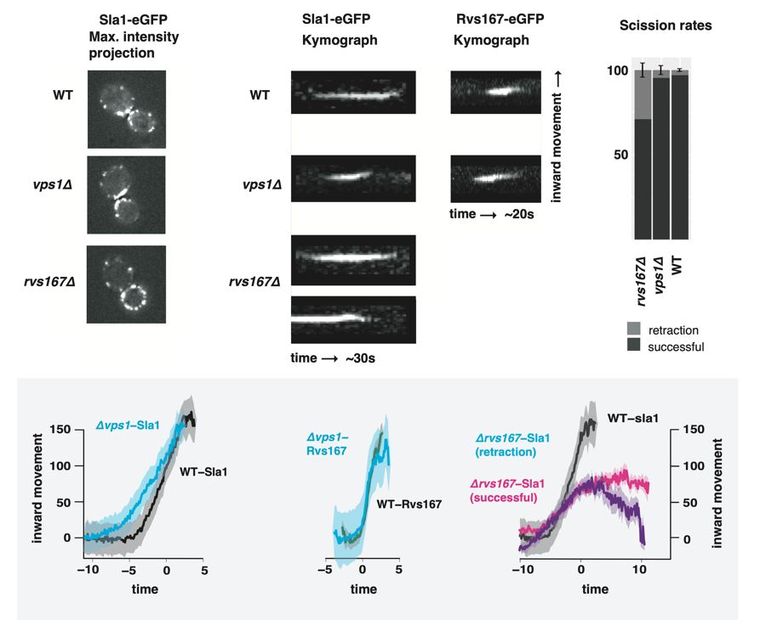

﻿To test whether absence of Vps1 influences scission, endocytic dynamics are observed in cells lacking Vps1 and compared against WT cells. Vps1 deletion is confirmed by sequencing the open reading frame, and Vps1 deleted cells show the growth phenotype at 37\si{\degree}C (Fig.1, supplement) recorded in other work (ref. ayscough). In Fig.1c, retraction of the membrane \textit{vps1$\Delta$} and wild-type (WT) cells (Fig.1a) is quantified. Membrane retraction, that is, inward movement and consequent retraction of the invaginated membrane back towards the cell wall is a scission-specific phenotype (ref.Marko). Sla1 is an endocytic coat protein that acts as a marker for membrane movement. Upon actin polymerization, the endocytic coat is pulled along with the membrane as it invaginates (ref.Skruzny?), and thus Sla1 acts as a proxy for the behaviour of the plasma membrane. We endogenously tagged Sla1 at the N-terminus with eGFP in WT and \textit{rvs167$\Delta$} cells (Fig.1a), and tracked the dynamics. Retraction rates do not increase in \textit{vps1$\Delta$} cells compared to the WT.

In order to study the total inward movement of the coat, and therefore the depth of the invagination, the averaged centroid trajectory of Sla1-eGFP (ref. Andrea) is tracked in ~50 endocytic sites in \textit{vps1$\Delta$} and WT cells (Fig.1d). In brief, yeast cells expressing fluorescently-tagged endocytic proteins are imaged at the equatorial plane. Since membrane invagination progresses perpendicularly to the plane of the plasma membrane, proteins that move into the cytoplasm during invagination do so in the imaging plane. Centroids of Sla1 patches- each patch being an endocytic site- are tracked in time. Between 40-50 Sla1 centroids are averaged. This provides an averaged centroid that can be followed with high spatial and temporal resolution. When different endocytic proteins are simultaneously imaged with Actin Binding Protein Abp1, Abp1 provides a frame of reference to which all the other proteins can be aligned. Abp1 is used because it is abundant at endocytic sites and therefore easily imaged. Time=0 is established as the peak of the Abp1 fluorescence intensity in respective co-tagged strains strains. Abp1 fluorescent intensity maxima in wild-type cells is concomitant with the peak of Rvs167 fluorescent intensity and is time window in which scission occurs (ref2andrea, refwanda). Centroid movement of Sla1-eGFP in WT cells shows a linear movement to about 140nm. Sla1 movement in \textit{vps1$\Delta$} cells has the same magnitude of inward movement to about 140nm. In spite of slight differences in the rates of inward movment, the total inward movment, and so the depth of endocytic invagination does not change.

Centroid tracking has shown that the number of molecules of Rvs167 peaks at the time of scission, and is followed by a rapid loss of fluorescent intensity, simultaneous with a sharp jump of the centroid into the cytoplasm (ref.Andrea). This jump, also seen in Rvs167-GFP kymographs (Fig.1b), is interpreted as loss of protein on the membrane tube, causing an apparent spatial jump to the protein localized at the base of the newly formed vesicle. Kymographs of Rvs167-GFP (Fig.1b), as well as Rvs167 centroid tracking (Fig.1e) in Vps1 deleted cells show the same jump.

Since removal of the Rvs complex is known to increase the retraction rate at endocytic sites, involvement of these proteins in the scission process was investigated further. Rvs161 and Rvs167 form dimers (ref.Dominik), so deletion of Rvs167 effectively removes both proteins from endocytic sites. We quantified the effect of deletion of Rvs167 on membrane invagination (Fig.1a-c). 27\% of Sla1 patches that begin to form invaginations move inward and then retract in \textit{rvs167$\Delta$} cells (Fig.1c), consistent with retraction rates measured in other experiments (Kaksonen, Toret and Drubin, 2005), and suggesting failed scission in 27\% of endocytic events. Movement of the retractions and of successful endocytic events were quantified (Fig.1f) as described in Picco et. al, 2015. Sla1 centroid movement in both successful and retracting endocytic events in \textit{rvs167$\Delta$} cells and WT look similar up to about 60nm (Fig.1f). Consequent movement in successful scission events slows dramatically, and invaginations appear to undergo scission at lengths between 60 -80 nm. Correlative light and electron microscopy (CLEM) has shown that Rvs167 localizes to endocytic sites after the invaginations are about 60nm long (Kukulski et al., 2012). Sla1 movement in \textit{rvs167$\Delta$} indicates therefore that membrane invagination is unaffected till Rvs is supposed to arrive. Sla1 in \textit{rvs167$\Delta$} then continues to move at a much slower rate to about 80nm, following which scission likely occurs. That membrane scission occurs at shorter invagination lengths than in WT is corroborated by the smaller vesicles formed in \textit{rvs167$\Delta$} cells (Kukulski et al., 2012).

﻿**\subsection{Synaptojanins likely influence vesicle uncoating, but not scission dynamics.}**

**﻿**There are three Synaptojanin-like proteins in budding yeast: Inp51, Inp52, and Inp53. Inp51-eGFP exhibits a diffuse cytoplasmic signal, and Inp53 localizes to patches within the cytoplasm- cellular localization that is consistent with involvement in trans-Golgi signalling (refGolgi)- Inp53 was not investigated further. Inp52-eGFP localizes to cortical actin patches that are endocytic sites (Fig.2, supplement). Spatial and temporal alignment with Sla1 and Rvs167 shows that Inp52 protein molecules arrive in the late scission stage, and localizes to the bud tip, consistent with a role in membrane scission (Fig.2b).

Inp51 and Inp52 were tested as potential candidates for scission regulators. Sla1-eGFP and Rvs167-eGFP in cells with either Inp51, Inp52 deleted were studied. Retraction events do not significantly increase compared to the WT in either \textit{inp51$\Delta$} or \textit{inp52$\Delta$} cells. Magnitude and speed of coat movement in \textit{inp51$\Delta$} is the same as the WT. In \textit{inp52$\Delta$} cells, coat movement also has the same magnitude and speed, but Sla1-eGFP signal is persistent after membrane scission. Similarly, Rvs167 disassembly has a delay, while the assembly is similar to WT. Assembly of Rvs167 has a delay in \textit{inp51$\Delta$} cells. The magnitude of the inward movement of both Sla1 and Rvs167 in cells containing either deletion are the same as in WT.

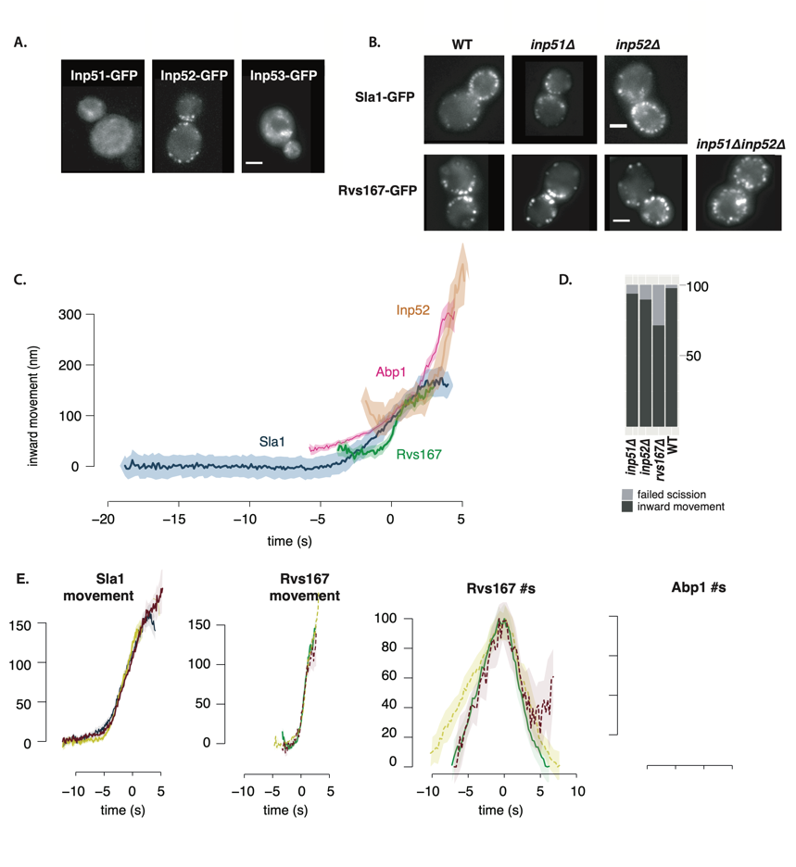

﻿**\subsection{Rvs BAR domains recognize membrane curvature in-vivo}**

﻿The curvature interaction of Rvs167 in vivo has not so far been tested. In order to do so, we deleted the SH3 domain of Rvs167 (henceforth BAR-GPA) and observed the localization of Rvs167-eGFP with and witout the SH3 domain. The GPA region is a disordered region that has no previously reported function and was retained to ensure proper folding and function of the BAR domain. Endogenously tagged Rvs167-eGFP and BAR-GPA-eGFP and Abp1-mCherry in WT and sla2deletion cells are compared. Sla2 acts as the molecular linker between forces exerted by the actin network and the plasma membrane (ref. Skruzny). Sla2deletion cells therefore contain polymerizing actin network at endocytic patches, but the membrane remains flat and endocytosis fails. In these cells, the full-length Rvs167 protein co-localizes with Abp1-mCherry, indicating that it is recruited to endocytic sites. BAR-GPA-eGFP localization is removed, except for rare transient patches that do not co-localize with Abp1-mCherry, indicating that in the absence of membrane curvature, the BAR domains cannot localize to endocytic sites. 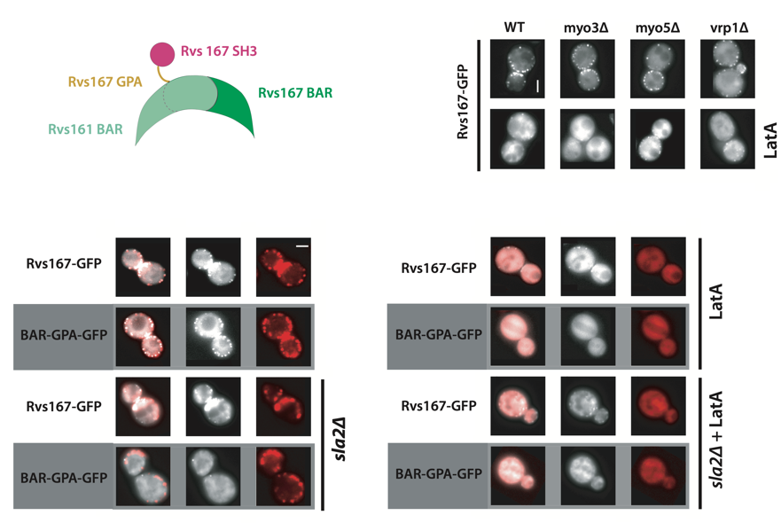

**\subsection{Rvs SH3 domains contribute to curvature independent localization}**

We have shown for the first time in vivo that yeast N-BAR domains need membrane curvature to localize. Full-length Rvs167, however, is recruited to endocytic patches in sla2deletion cells. This indicates that a second interaction- that is not the BAR-curvature dependent- recruits the protein to endocytic sites. This interaction must come from the SH3 region, showing that Rvs localization is dependent on both BAR as well as SH3 domain interactions. Absence of the SH3 domain also reduces total recruitment of Rvs and Abp1 protein, giving the SH3 domain an important and surprising role in regulating the late stage of endocytosis.

**\subsection{SH3 domains are recruited by Myosin 5}**

SH3 domains have been shown to interact with several proteins in the actin module of endocytosis: Las17, type I myosins, and Vrp1 all have genetic or physical interactions with Rvs167 SH3 domains (Lila and Drubin, 1997; Colwill et al., 1999, Madania et al., 1999; Liu et al., 2009).

We tested the interaction by studying the localization of full-length Rvs167 in cells with one of these proteins deleted, and treated with LatA to reproduce the situation in which BAR-curvature interaction is removed.

Deletion of neither Las17 nor Myo3 in combination with LatA treatment does not remove the localization of Rvs167. Deletion of Vrp1 and Myo5, with LatA treatment removes localization of Rvs167. Since Vrp1 is required for the recruitment of Myo5 (refMyo5), SH3 domains likely interact with Myo5 rather than Vrp1.

\subsubsection{\color{red}

what about the differences in myo5 and myo3 number... if the Rvs recruitment only slightly depended on myo3 we probably wouldnt see a difference

}

**﻿\subsection{Increased BAR domain recruitment corresponds to increased membrane movement}**

The decreased Sla1 movement in BAR cells can be explained by a loss of interaction of the SH3 domain, or by reduced recruitment of the BAR domains. To check whether increasing the recruitment of the Rvs complex alone can rescue reduced Sla1 movement, the Rvs167 and Rvs161 ORF was duplicated endogenously (ref Huber dude) in diploid and haploid yeast cells. In diploid cells, Rvs duplication results in either 4x copies of both Rvs genes, 2x copies (WT diploid) or 1x copies, in which one gene of Rvs167 and Rvs161 are deleted. We show that amount of Rvs167 recruited to sites increases linearly, without changing either the rate of movement or total movement before scission of Sla1.

Similarly, in haploid cells, increasing the gene copy of Rvs167 and Rvs161 results in increased recruitment of Rvs167, without influencing the dynamics of Sla1. Expressing two instead of one copy of the Rvs167 BAR domain alone rescues the loss of Sla1 movement in the 1x copy of BAR domain alone, as well the inward jump of BAR-GFP itself. The loss of inward movement in 1xBAR suggests that smaller vesicles are produced in these cells, confirmed by CLEM. This would in corollary indicate that the increased inward movement in 2xBAR produces WT-sized vesicles.

