﻿\subsection{**Removal of Rvs167, not Vps1, results in reduced coat movement}**

Yeast Dynamin-like protein Vps1 does not contain the canonical Proline Rich Domain, which in mammalian cells is required for recruitment to endocytic sites (ref Grabs et al., 1997; Cestra et al., 1999; Farsad et al., 2001; Meinecke et al., 2013). Some work has reported its recruitment at endocytic proteins (refAyscough, Yu, 2004; Nannapaneni et al., 2010). Vps1 tagged both N- and C-terminally with GFP constructs failed to co-localize with endocytic protein Abp1 in our hands (Fig.1 supplement), consistent with other work that observed localization only with other parts of the trafficking pathway (ref Gadila 2017).

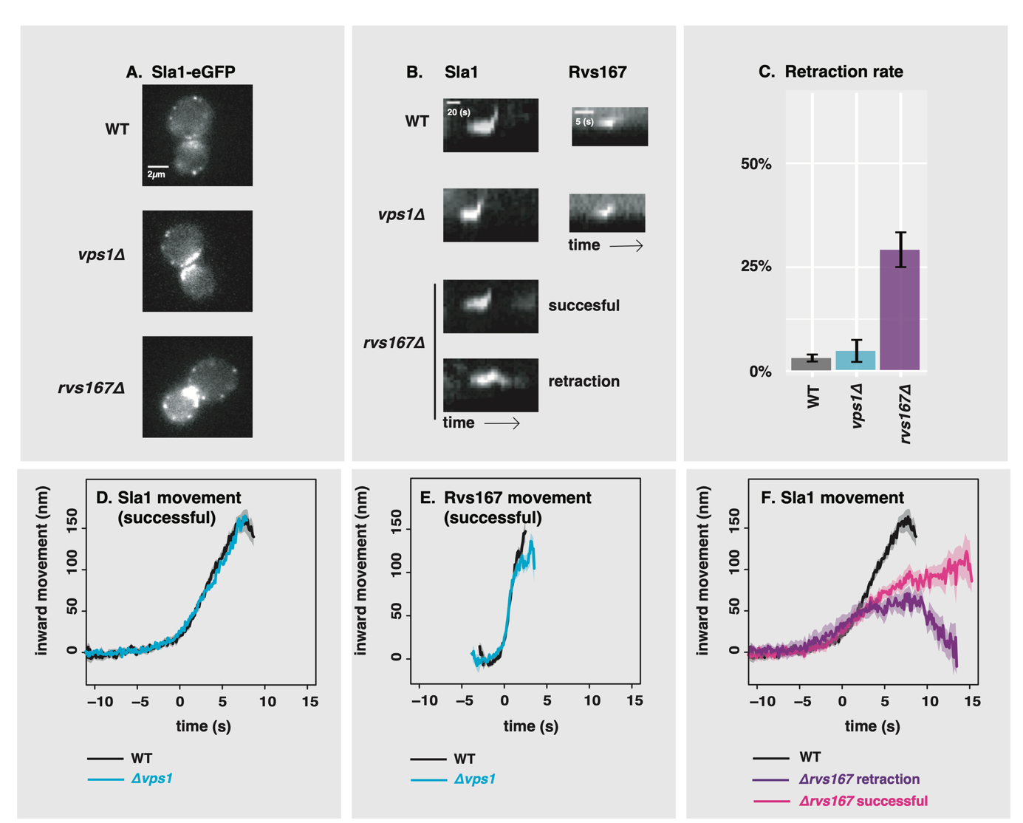

﻿ ﻿\caption{A: Slice from image of WT, \textit{vps1$\Delta$}, and \textit{rvs167$\Delta$} cells expressing Sla1-eGFP. Scale bar= 2{\textmu}m. B: Representative kymographs of Sla1-eGFP and Rvs167-eGFP patches in WT, \textit{vps1$\Delta$}, and \textit{rvs167$\Delta$} cells. Scale bar for Sla1-egfp = 20(s), scale bar for Rvs167-eGFP = 5(s). C: Histogram of Sla1-eGFP retraction percentages in WT, \textit{vps1$\Delta$}, and \textit{rvs167$\Delta$} cells. Error bars are standard deviation from two data sets, p<0.001 = *. D: Averaged centroid positions of Sla1-eGFP in WT and \textit{vps1$\Delta$} cells. E: Averaged position of Rvs167-eGFP in WT and \textit{vps1$\Delta$} cells. F: Averaged position of Sla1-eGFP in WT, and successful and retracted Sla1-eGFP positions in \textit{rvs167$\Delta$} cells. All averaged positions are aligned in time to begin inward movement at the same time=0(s), and aligned in space to a starting position = 0(nm). Note that in E, averaged Rvs167-eGFP inward movement is concomitant with the maxima of its fluorescent intensity (Fig1.supplement3)}

﻿To test whether absence of Vps1 influences scission, dynamics of endocytosis are observed in cells lacking Vps1 and compared against wild-type (WT) cells (Fig.\ref{vps}A-F). Vps1 deletion is confirmed by sequencing the open reading frame, and these cells show a growth phenotype at 37\si{\degree}C (Fig.1, supplement2) that has been previously reported (ref. ayscough). Rates of retraction of the membrane in \textit{vps1$\Delta$} and WT cells is quantified by tracking the endocytic coat protein Sla1 tagged at the C-terminus with eGFP (Fig.\ref{vps}C). Upon actin polymerization, the endocytic coat is pulled into the cytoplasm along with the membrane as it invaginates (ref.Skruzny?). Coat protein Sla1 thus acts as a proxy for the behaviour of the plasma membrane. Membrane retraction, that is, inward movement and subsequent retraction of the invaginated membrane back towards the cell wall is a scission-specific phenotype (ref.Marko). Retraction rates do not increase in \textit{vps1$\Delta$} cells compared to the WT (Fig.\ref{vps}C).

﻿

In order to study the total inward movement of the endocytic coat, and therefore the depth of the endocytic invagination, the averaged centroid trajectory of ~50 Sla1-eGFP patches (ref. Picco, eLife 2015) in \textit{vps1$\Delta$} and WT cells is tracked and compared (Fig.\ref{vps}D). In brief: yeast cells expressing fluorescently-tagged endocytic proteins are imaged at the equatorial plane. Since membrane invagination progresses perpendicularly to the plane of the plasma membrane, proteins that move into the cytoplasm during invagination do so in the imaging plane. Centroids of Sla1 patches- each patch being an endocytic site- are tracked in time and averaged. This provides an average centroid that can be followed with high spatial and temporal precision. For more details, refer to Picco et. al, eLIFE 2015. Averaged centroid movement of Sla1-eGFP in WT cells is linear to about 140nm (Fig.\ref{vps}D). Sla1 movement in \textit{vps1$\Delta$} cells has the same magnitude of movement (Fig.\ref{vps}D). In spite of slight differences in the rates of movement, the total inward movement- and so the depth of endocytic invagination- does not change.

**﻿**

\subsection{**Synaptojanins likely influence vesicle uncoating, but not scission dynamics.}**

﻿Three Synaptojanin-like proteins have been identified in budding yeast: Inp51, Inp52, and Inp53. Inp51-eGFP exhibits a diffuse cytoplasmic signal, Inp52-eGFP localizes to cortical actin patches that are endocytic sites (Fig2 supplement) and Inp53 localizes to patches within the cytoplasm (ref). Spatial and temporal alignment of Inp52 with Sla1, Abp1, and Rvs167 (ref.Pico) shows that Inp52 protein molecules arrive in the late stage of endocytosis after Rvs167, and localizes to the invagination tip, suggesting a potential role in membrane scission (Fig.2b).

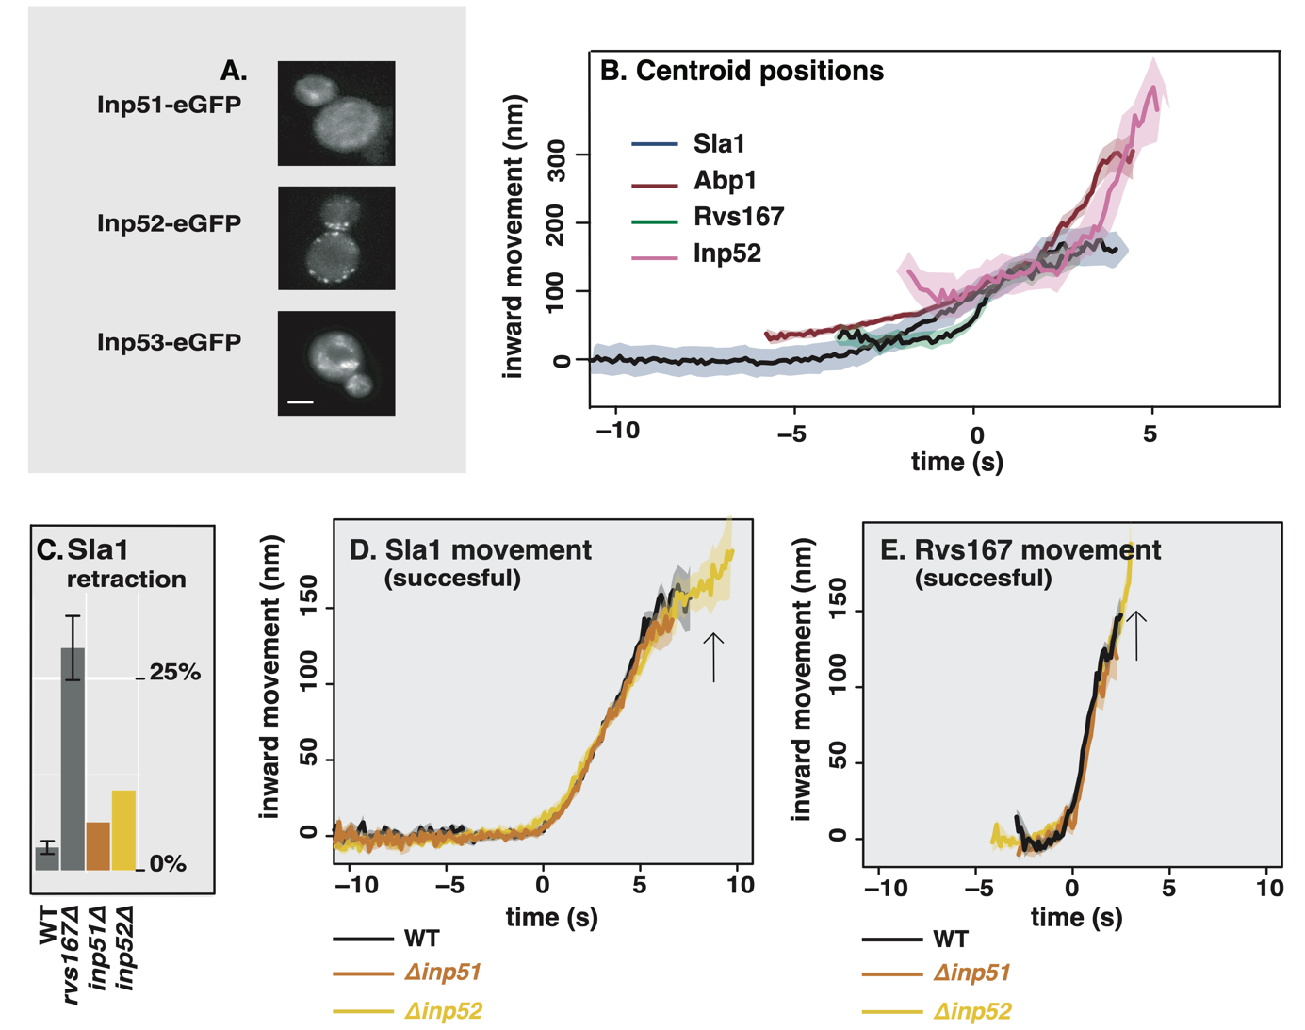

**﻿** \caption{A. Cells with endogenously tagged Inp51, Inp52, and Inp53. B: Inp52 centroid trajectory is aligned in space and time to other endocytic proteins. C: Sla1 retraction rates in \textit{inp51$\Delta$} and \textit{inp52$\Delta$} cells compared to WT and \textit{rvs167$\Delta$}. Error bars are standard deviation from two data sets. D: Averaged centroid positions of Sla1-eGFP in WT, \textit{inp51$\Delta$}, and \textit{inp52$\Delta$} cells. E: Averaged centroid positions of Rvs167-eGFP in WT, \textit{inp51$\Delta$}, and \textit{inp52$\Delta$} cells.}

**﻿**Inp53 was not investigated further, as its localisation conforms with other literature that find it is involved in the golgi trafficking pathway rather than endocytosis (ref Golgi). Although we were unable to see Inp51 localisation at endocytic sites, it may be recruited in small numbers below our detection limit. Deletion of Inp51 has been shown to exacerbate the effect of \textit{inp52$\Delta$} on membrane retraction (ref Liu), so both Inp51 and Inp52 were tested as potential candidates as scission regulators.

~\\

Dynamics of Sla1-eGFP and Rvs167-eGFP in either \textit{inp51$\Delta$} or \textit{inp52$\Delta$} cells were compared against the WT. Membrane retraction events do not significantly increase in either compared to the WT (Fig2c).

Magnitude and speed of Sla1 and Rvs167 centroid movement in \textit{inp51$\Delta$} is the same as the WT (Fig2.d, e). In \textit{inp52$\Delta$} cells, Sla1 movement also has the magnitude and speed as WT, but Sla1-eGFP signal is persistent after membrane scission (Fig.2d, arrow). Similarly, although Rvs167 inward movement looks similar to WT in \textit{inp52$\Delta$} (Fig2e), Rvs167-eGFP signal is persistent after inward movement (Fig2e arrow), and Rvs167 and Sla1 disassembly has a delay (Fig2 supplement)

﻿\subsection{**Rvs BAR domains recognize membrane curvature in-vivo**}

﻿So far Rvs167 remains the protein that has a major influence on scission rates and inward moment of Sla1. Recruitment of the Rvs complex to endocytic sites was thus investigated further. Interaction between Rvs and membrane curvature in vivo has been indicated by work on other BAR domain proteins (ref BAR), but has not so far been tested. In order to do so, we deleted the SH3 domain of Rvs167 leaving the N-terminal BAR and GPA regions (henceforth BAR-GPA, Fig3a) and observed the localization of the BAR region without SH3 influence. The GPA region is a disordered domain that has no previously reported function (ref) and was retained to ensure proper folding and function of the BAR domain. Endogenously tagged Rvs167-eGFP and BAR-GPA-eGFP colocalization with Abp1-mCherry in WT and \textit{sla2$\Delta$} cells were compared (Fig3b). Sla2 acts as the molecular linker between forces exerted by the actin network and the plasma membrane (ref. Skruzny). \textit{sla2$\Delta$} cells therefore contain a polymerizing actin network at endocytic patches, but the membrane has no curvature, and endocytosis fails. In these cells, the full-length Rvs167 protein co-localizes with Abp1-mCherry, indicating that it is recruited to endocytic sites (Fig3b, “\textit{sla2$\Delta$}”). BAR-GPA localization is removed, except for rare transient patches that do not co-localize with Abp1-mCherry.

\subsection{**Rvs SH3 domains have an actin and curvature independent localisation**}

The SH3 domain has known genetic interactions with actin-related endocytic proteins. In order to test if these interactions are prevalent in vivo, we tested the localisation of full-length Rvs167 and BAR-GPA in LatA treated cells (Fig3b, “LatA”). Plasma membrane localisation of full-length Rvs167 remains upon LatA treatment, and transient patches continue to exist in \textit{sla2$\Delta$} cells treated with LatA (Fig3b, “\textit{sla2$\Delta$}+ LatA”). BAR-GPA localisation on the other hand, is removed in both.

﻿\subsection{**SH3 domains are likely recruited by Myosin 3**}

Type I myosins Myo3 and Myo5, and Vrp1 have genetic or physical interactions with Rvs167 SH3 domains (Lila and Drubin, 1997; Colwill et al., 1999, Madania et al., 1999; Liu et al., 2009). We tested  the interaction between these proteins and the Rvs167 SH3 region by studying the localization of full-length Rvs167 in cells with one of these proteins deleted, and treated with LatA. By LatA treatment we expected to produce the situation in which BAR-curvature interaction is removed (Fig3b). Then if we lost SH3 interaction because we deleted the protein with which it interacts, we would lose localisation of Rvs167 completely. Deletion  of neither Vrp1 nor Myo5 in combination with LatA treatment removes the localization of Rvs167. Deletion of Myo3 with LatA treatment removes localization of Rvs167.

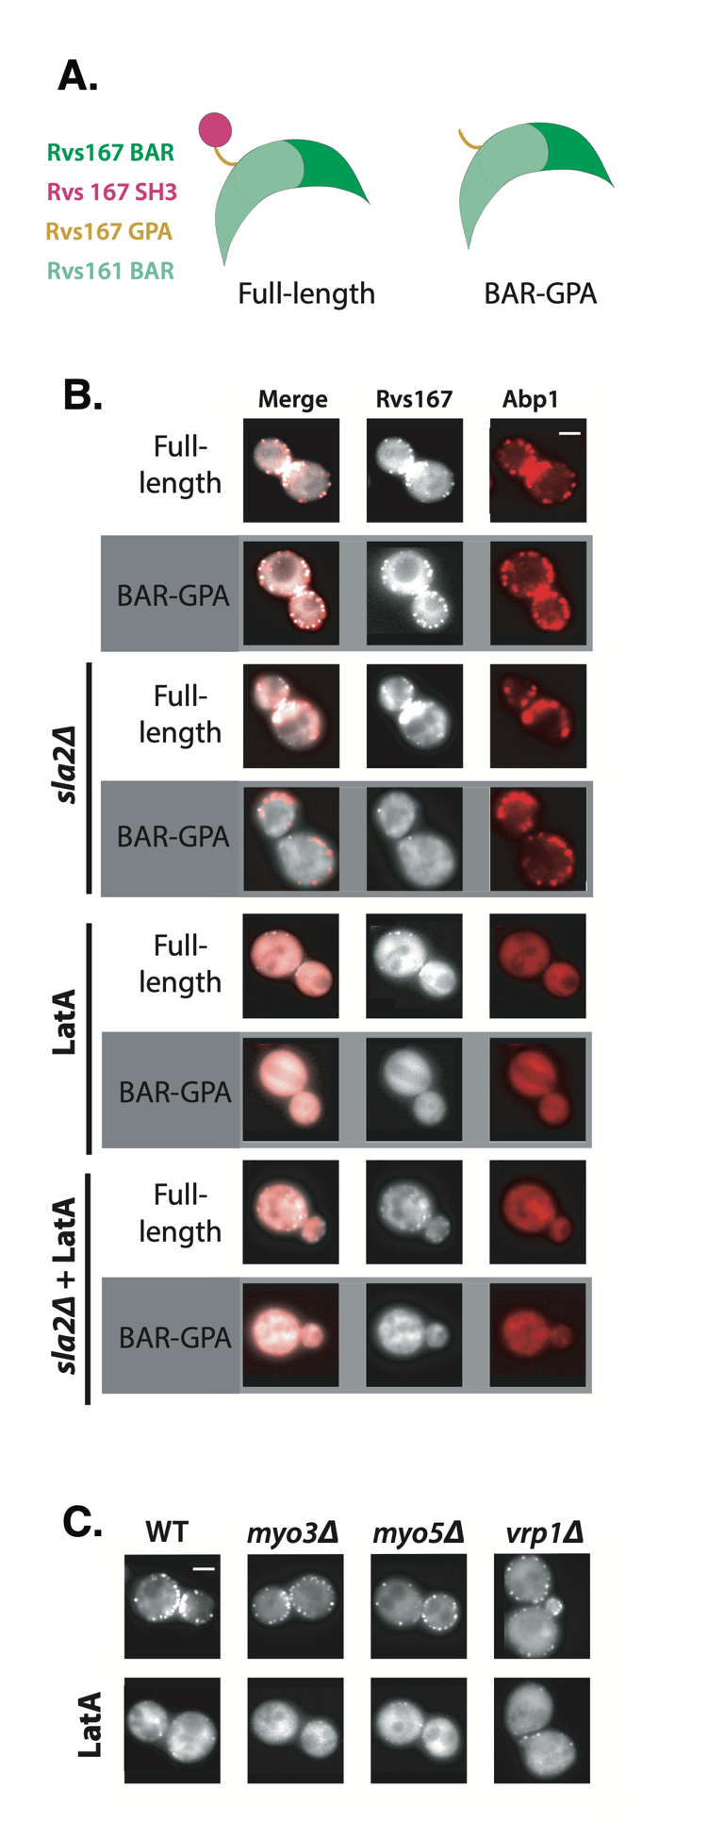­­­

﻿ \caption{A: Schematic of Rvs protein complex with and without the SH3 domain. B: Localization of full-length and BAR-GPA in WT, \textit{sla2$\Delta$}, LatA treated, and LatA treated \textit{sla2$\Delta$} cells. C: Localization of full-length Rvs167-eGFP in WT, \textit{myo3$\Delta$}, \textit{myo5$\Delta$}, and \textit{vrp1$\Delta$} cells. Scale bars=2{\textmu}m.