﻿\subsection{**Removal of Rvs167, not Vps1, results in reduced coat movement}**

Yeast Dynamin-like protein Vps1 does not contain a Proline Rich Domain, which in mammalian cells is required for recruitment to endocytic sites (Grabs et al., 1997; Cestra et al., 1999; Farsad et al., 2001; Meinecke et al., 2013). In spite of the lack of a canonical interaction domain, some works have reported its recruitment to endocytic proteins, including to N-BAR protein Rvs167 (Nannapaneni et al. 2010; Yu 2004; Rooij et al. 2010). The question of whether or not Vps1 has a function at endocytic sites has been obfuscated by potential tagging-induced dysfunction of Vps1 molecules. Vps1 tagged both N- and C-terminally with GFP constructs failed to co-localize with endocytic protein Abp1 in our hands, consistent with other work that observed localization only with other parts of the trafficking pathway (Gadila 2017). We argued that even if tagging Vps1 induced defects in its localization and/or function, its contribution to endocytosis could be examined by observing the dynamics of other endocytic proteins in cells lacking Vps1. The canonical interaction partner of Vps1, Rvs167, localizes to endocytic sites, and has a role in scission, although it is unclear what that is (Kukulski et al. 2012; Picco et al. 2015). In order to determine the roles of these proteins in endocytic scission, we studied endocytic proteins in cells lacking Vps1 and Rvs167, and compared against wild-type (WT) cells (Fig.\ref{vps}A-F).

­­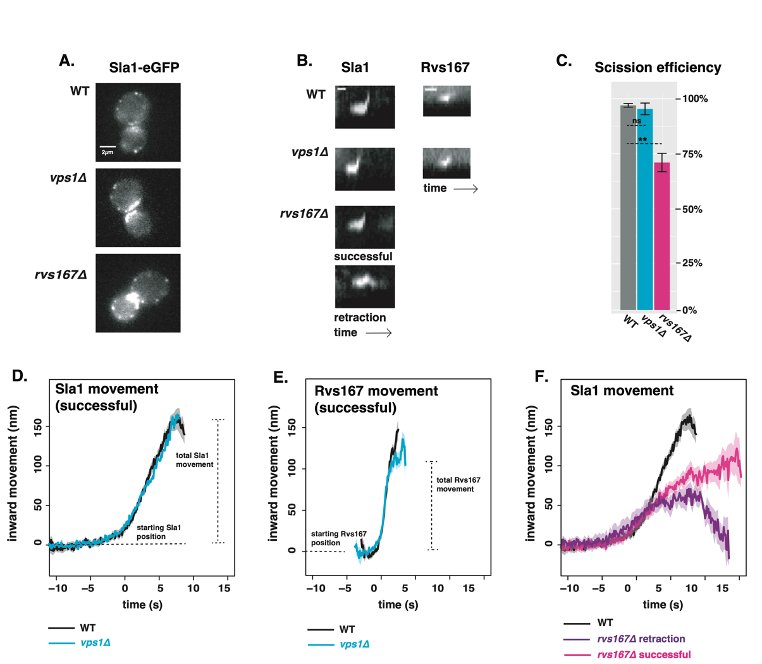

﻿ ﻿\caption{A: One slice from time series image of WT, \textit{vps1$\Delta$}, and \textit{rvs167$\Delta$} cells expressing Sla1-eGFP. Scale bar= 2{\textmu}m. B: Representative kymographs of Sla1-eGFP and Rvs167-eGFP patches in WT, \textit{vps1$\Delta$}, and \textit{rvs167$\Delta$} cells. Scale bar for Sla1 kymographs= 20(s), scale bar for Rvs167 = 5(s). C: Scission efficiency in WT, \textit{vps1$\Delta$}, and \textit{rvs167$\Delta$} cells. Error bars are standard deviation from two data sets. P values from t-test p<0.05 = *, p<0.01=**, p<0.001=***. D: Averaged centroid positions of Sla1-eGFP in WT and \textit{vps1$\Delta$} cells. E: Averaged position of Rvs167-eGFP in WT and \textit{vps1$\Delta$} cells. F: Averaged position of Sla1-eGFP in WT, and successful and retracted Sla1-eGFP positions in \textit{rvs167$\Delta$} cells. All averaged positions are aligned in time to begin inward movement at the same time=0(s), and aligned in space to a starting position = 0(nm).

﻿Vps1 deletion was confirmed by sequencing the gene locus, and these cells showed a previously reported (Rothman and Stevens 1986) growth phenotype at 37\si{\degree}C (Fig.1, supplement1). Scission efficiency was quantified by tracking the endocytic coat protein Sla1 tagged at the C-terminus with eGFP (Fig.\ref{vps}C). Upon actin polymerization, the endocytic coat moves into the cytoplasm along with the membrane as it invaginates (Skruzny et al. 2012) . Movement of coat protein Sla1 thus acts as a proxy for the growth of the plasma membrane invagination. Membrane retraction, that is, inward movement and subsequent retraction of the invaginated membrane back towards the cell wall is a scission-specific phenotype (ref.Marko). Retraction rates do not increase in \textit{vps1$\Delta$} cells compared to the WT (Fig.\ref{vps}C).

﻿

In order to study the total movement of the endocytic coat, and therefore the length of the endocytic invagination, the averaged centroid trajectory of ~50 Sla1-eGFP patches (Picco, eLife 2015) in \textit{vps1$\Delta$} and WT cells were tracked and compared (Fig.\ref{vps}D). In brief: yeast cells expressing fluorescently-tagged endocytic proteins were imaged at the equatorial plane. Since membrane invagination progresses perpendicularly to the plane of the plasma membrane, proteins that move into the cytoplasm during invagination do so in the imaging plane. Centroids of Sla1 patches- each patch being an endocytic site- were tracked in time and averaged. This provided an average centroid that could be followed with high spatial and temporal precision (Picco et. al, eLIFE 2015). Averaged centroid movement of Sla1-eGFP in WT cells was linear to about 140nm (Fig.\ref{vps}D). Sla1 movement in \textit{vps1$\Delta$} cells had the same magnitude of movement (Fig.\ref{vps}D). In spite of slight differences in the rates of movement, the total inward movement- and so the depth of endocytic invagination- did not change.­

Centroid tracking has shown that the number of molecules of Rvs167 peaks at the time of scission, and is followed by a rapid loss of fluorescent intensity, simultaneous with a sharp jump of the centroid into the cytoplasm (Picco, eLife 2015) . This jump, also seen in Rvs167-GFP kymographs (Fig.1B), is interpreted as loss of protein on the membrane tube, causing an apparent spatial jump to the protein localized at the base of the newly formed vesicle. Kymographs of Rvs167-GFP (Fig.1B), as well as Rvs167 centroid tracking (Fig.1E) in Vps1 deleted cells showed the same jump as in WT.

The Rvs complex is composed of Rvs161 and Rvs167 dimers (Boeke et al. 2014), so deletion of Rvs167 effectively removes both proteins from endocytic sites. We quantified the effect of *rvs167*Δ on membrane invagination (Fig.1A-C). Only 73% of Sla1 patches undergo successful scission in *rvs167*Δ cells (Fig.1C). Similar scission defects were measured in other experiments (Kaksonen, Toret and Drubin, 2005), and suggest failed scission in the remaining 27% of endocytic events. Coat movement both of retractions and of successful endocytic events were quantified (Fig.1F) as described in Picco et. al, 2015. Sla1 centroid movement in both successful and retracting endocytic events in *rvs167*Δ cells look similar to WT up to about 50nm (Fig.1F). In WT cells, Abp1 intensity begins to drop at scission time; similarly, in successful endocytic events, Abp1 intensity drops after Sla1 centroid has moved about 100nm (Fig.1supplement), suggesting that scission occurs at invagination lengths between 60 -100 nm. That membrane scission occurs at shorter invagination lengths than in WT is corroborated  by the smaller vesicles formed in *rvs167*Δ cells by Correlative light and electron microscopy (CLEM) (Kukulski et al., 2012). CLEM has moreover shown that Rvs167 localizes to endocytic sites after the invaginations are about 60nm long (Kukulski et al., 2012). Sla1 movement in *rvs167*Δ indicates therefore that membrane invagination is unaffected till Rvs is supposed to arrive.

Supplement Fig.1

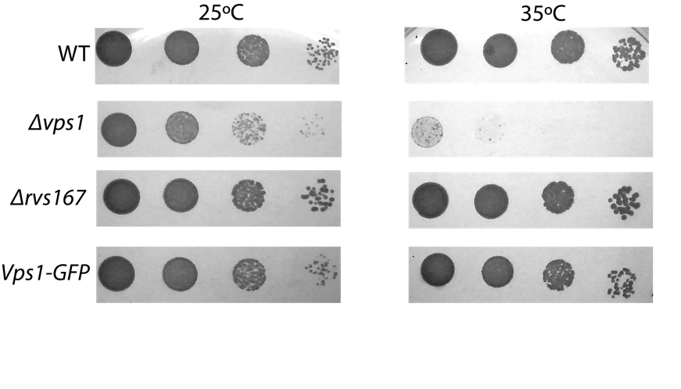

﻿ ﻿\caption{Growth assay of WT, \textit{vps1$\Delta$}, \textit{rvs167$\Delta$}, and cells expressing Vps1-eGFP at 25C and 35C }

Supplement Fig.2

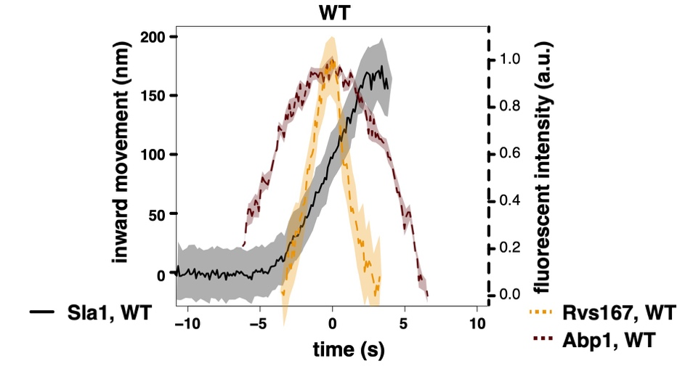

­

Supplement Fig.3

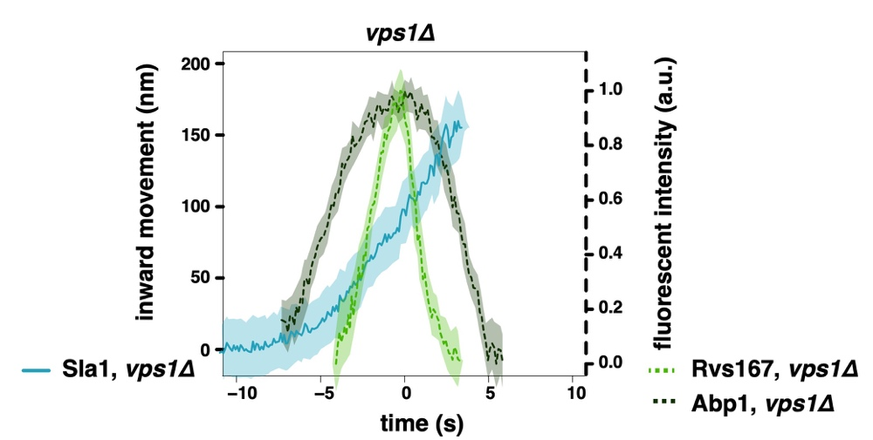

\subsection{**Synaptojanins likely influence vesicle uncoating, but not scission dynamics.}**

﻿As Vps1 appears to not influence the formation of vesicles, we proceeded to test another scission model. The lipid hydrolysis model proposes that deletion of yeast synaptojanins would inhibit membrane scission and therefore result in longer invaginations (Liu et al. 2009). Three Synaptojanin-like proteins have been identified in *S. cerevisiae*: Inp51, Inp52, and Inp53. Inp51-eGFP exhibits a diffuse cytoplasmic signal, Inp52-eGFP localizes to cortical patches that are endocytic sites (Fig2A, Fig2 supplement) and Inp53 localizes to patches within the cytoplasm (Fig2A, Bensen, Costaguta, and Payne 2000). Since Inp52 localizes to endocytic patches marked by Abp1, we began with determining the spatial and temporal recruitment of Inp52 within the endocytic machinery. We aligned the averaged centroid of Inp52 in space and time to other endocytic proteins (Picco et al. 2015). In order to do this, we imaged Inp52-eGFP simultaneously with Abp1-mCherry, and did the same with Sla1-eGFP and Rvs167-eGFP. Using Abp1 as the common reference frame, we were able to compare the arrival of the different proteins with respect to that of Abp1. We assigned as time =0 (s) the fluorescent intensity maximum of Rvs167, which in WT cells is concomitant with membrane scission, and also coincides with the maximum of the Abp1 fluorescent intensity (Fig1 supplement). On the y axis, 0 (nm) indicates the position of the Sla1 centroid; positions of the other centroids are in relation to the Sla1 centroid. Inp52 molecules arrive in the late stage of endocytosis after Rvs167, and localize to the invagination tip, suggesting a potential role in membrane scission (Fig.2b).

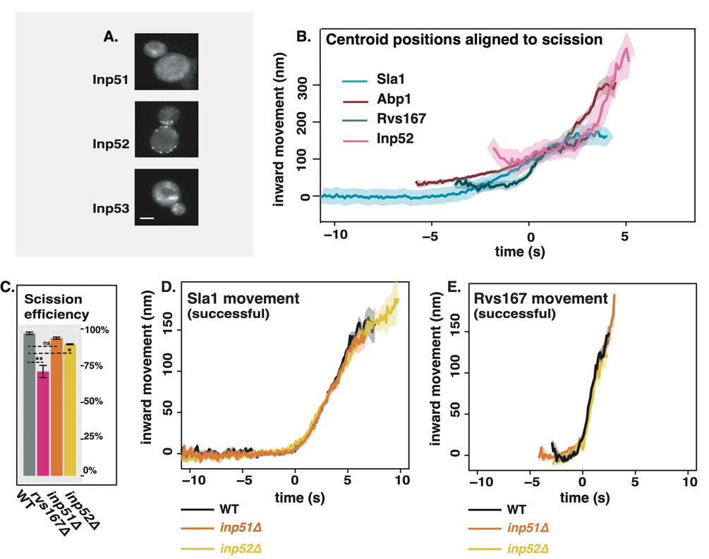

**﻿** \caption{A. Cells with endogenously tagged Inp51, Inp52, and Inp53. B: Inp52 centroid trajectory is aligned in space and time to other endocytic proteins. C: Sla1 retraction rates in \textit{inp51$\Delta$} and \textit{inp52$\Delta$} cells compared to WT and \textit{rvs167$\Delta$}. Error bars are standard deviation from two data sets. D: Averaged centroid positions of Sla1-eGFP in WT, \textit{inp51$\Delta$}, and \textit{inp52$\Delta$} cells. E: Averaged centroid positions of Rvs167-eGFP in WT, \textit{inp51$\Delta$}, and \textit{inp52$\Delta$} cells.}

**﻿**Inp53 was not investigated further, as its localization conforms with other literature that find it is involved in the golgi trafficking pathway and not endocytosis (ref Golgi). Although we were unable to observe localization of Inp51 at endocytic sites, deletion of Inp51 has been shown to exacerbate the effect of \textit{inp52$\Delta$} on membrane retraction (Liu et al. 2009), so both Inp51 and Inp52 were tested as potential candidates as scission regulators.

~~( it may be recruited in small numbers below our detection limit. )~~

Dynamics of Sla1-eGFP and Rvs167-eGFP in \textit{inp51$\Delta$} and \textit{inp52$\Delta$} cells were then compared against the WT (Fig2 d, e). Scission efficiency does not significantly decrease in either compared to the WT (Fig2c). Magnitude and speed of Sla1 and Rvs167 centroid movement in \textit{inp51$\Delta$} is the same as the WT (Fig2.d, e), while Rvs167 assembly has a slight delay (Fig2 supplement). In \textit{inp52$\Delta$} cells, Sla1 movement also has the magnitude and speed as WT, but Sla1-eGFP signal is persistent after membrane scission (Fig.2d, arrow). Similarly, although Rvs167 inward movement looks similar to WT in \textit{inp52$\Delta$} (Fig2e), Rvs167-eGFP signal is persistent after inward movement (Fig2e arrow), and Rvs167 and Sla1 disassembly has a delay (Fig2 supplement). This data are consistent with synaptojanin involvement in assembly and disassembly of coat and scission proteins rather than in membrane scission.

Fig2 supplement1,2

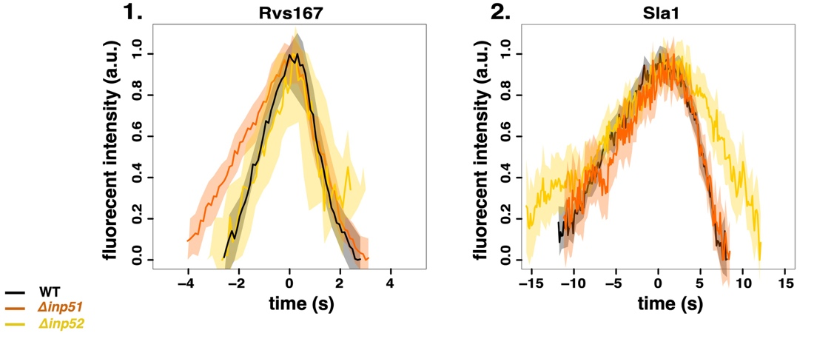

­

\subsection{**Rvs BAR domains recognize membrane curvature in-vivo**}

﻿So far Rvs167 remains the protein that has a major influence on scission efficiency and movement of Sla1. Rvs can tubulate liposomes in vitro (Youn et al. 2010), but its interaction with membrane curvature in vivo has not so far been tested. Recruitment of the Rvs complex to endocytic sites, and BAR-membrane interaction was thus investigated further. The SH3 domain has known interactions with proteins within actin network. We removed the contribution of the SH3 by deleting the SH3 domain (this construct is henceforth BAR-GPA, Fig3a) and observed the localization of the BAR-GPA compared to full-length Rvs167. Endogenously tagged Rvs167-eGFP and BAR-GPA-eGFP colocalization with Abp1-mCherry in WT and \textit{sla2$\Delta$} cells were compared (Fig3b). Sla2 acts as the molecular linker between forces exerted by the actin network and the plasma membrane (Skruzny et al. 2012). \textit{sla2$\Delta$} cells therefore contain a polymerizing actin network at endocytic patches, but the membrane has no curvature, and endocytosis fails. In these cells, the full-length Rvs167 protein co-localizes with Abp1-mCherry, indicating that it is recruited to endocytic sites independently of membrane curvature (Fig3b, “\textit{sla2$\Delta$}”). BAR-GPA does not localize to the plasma membrane, except for rare transient patches that do not co-localize with Abp1-mCherry: BAR-GPA is not recruited to endocytic sites in sla2del.

\subsection{**Rvs SH3 domains have an actin and curvature independent localisation**}

In order to test if genetic interactions of SH3 domains are prevalent in in vivo endocyotosis, we tested the localization of full-length Rvs167 and BAR-GPA in LatA treated cells (Fig3b, “LatA”). Plasma membrane localization of full-length Rvs167 remains upon LatA treatment, and transient patches continue to exist in \textit{sla2$\Delta$} cells treated with LatA (Fig3b, “\textit{sla2$\Delta$}+ LatA”). BAR-GPA does not localize to the plasma membrane in either case: localization of full-length Rvs167 in the presence of LatA is due to the SH3 domain. This indicates that the SH3 domain is able to drive Rvs molecules to the plasma membrane in an actin- and curvature-independent manner.

﻿\subsection{**SH3 domains are likely recruited by Myosin 3**}

Type I myosins Myo3 and Myo5, and Vrp1 have known genetic and/or physical interactions with Rvs167 SH3 domains (Lila and Drubin, 1997; Colwill et al., 1999, Madania et al., 1999; Liu et al., 2009). We tested the interaction between these proteins and the Rvs167 SH3 region by studying the localization of full-length Rvs167 in cells with one of the genes for these proteins deleted, and treated with LatA. By LatA treatment we expected to reproduce the situation in which BAR-curvature interaction is removed (Fig3b). Then if we lost SH3 interaction because we removed the protein with which it interacts, we would lose localization of Rvs167 completely. Deletion of neither Vrp1 nor Myo5 in combination with LatA treatment removes the localization of Rvs167. Deletion of Myo3 with LatA treatment removes localization of Rvs167, indicating that SH3 domains interact at endocytic sites with Myo3.

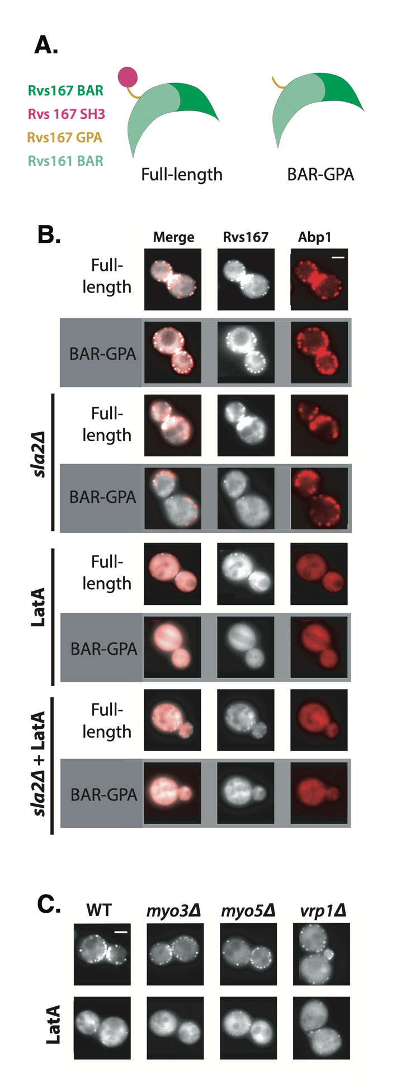­­­

﻿ \caption{A: Schematic of Rvs protein complex with and without the SH3 domain. B: Localization of full-length and BAR-GPA in WT, \textit{sla2$\Delta$}, LatA treated, and LatA treated \textit{sla2$\Delta$} cells. C: Localization of full-length Rvs167-eGFP in WT, \textit{myo3$\Delta$}, \textit{myo5$\Delta$}, and \textit{vrp1$\Delta$} cells. Scale bars=2{\textmu}m.

﻿\subsection{**Loss of Rvs167 SH3 domain affects coat and actin dynamics**}

﻿Since the Rvs167 SH3 domain appears to have an important influence on the recruitment of the Rvs complex to endocytic sites, we wondered if the domain also affected growth of the endocytic invagination ~~endocytic dynamics.~~ We compared dynamics of Sla1 and Rvs167 in WT and BAR-GPA strains (Fig4). Movement of Sla1 centroid is slower in BAR-GPA cells than in WT (Fig4a,b). Tubular invaginations are formed in BAR-GPA cells, and qualitatively resemble those in WT, as seen by CLEM (Fig.4 supplement). movementa,

There is delay in BAR-GPA recruitment compared to the onset of Abp1 assembly (Fig4 c, d). In WT cells, Rvs167 and Abp1 molecule number peaks are coincident: the actin network begins disassembling as soon as scission occurs. Asynchronous peaks in BAR-GPA cells indicates a disruption in the feedback between actin network dynamics and membrane scission. BAR-GPA accumulation begins when Abp1 molecule numbers in the mutant are about the same as in WT (about 300 copies, Fig4c,d). ~~Recruitment of both Rvs167 and Abp1 molecules is delayed in BAR-GPA cells.~~ Rvs167 centroids in both WT and BAR-GPA arrive at endocytic sites when the Sla1 centroid is 20-30 nm away from its starting position. Taken together, this data suggests that the Rvs complex is recruited to a specific geometry of membrane invagination, and that Rvs167 recruitment in BAR-GPA is delayed because invaginations in this mutant take longer to acquire this specific geometry.

Recruitment of Rvs167 in *Rvs167Δsh3* cells is reduced to half of that in WT (Fig4c,d), although cytoplasmic concentration of Rvs167 in both cell types are not different (Fig4 supplement). Recruitment therefore is unlikely to be limited by cytoplasmic expression of the mutant protein. Abp1 disassembly is slowed down in BAR-GPA cells compared to WT, and recruitment is reduced to 50\% of WT recruitment (Fig.4b), indication disruption of actin network dynamics.

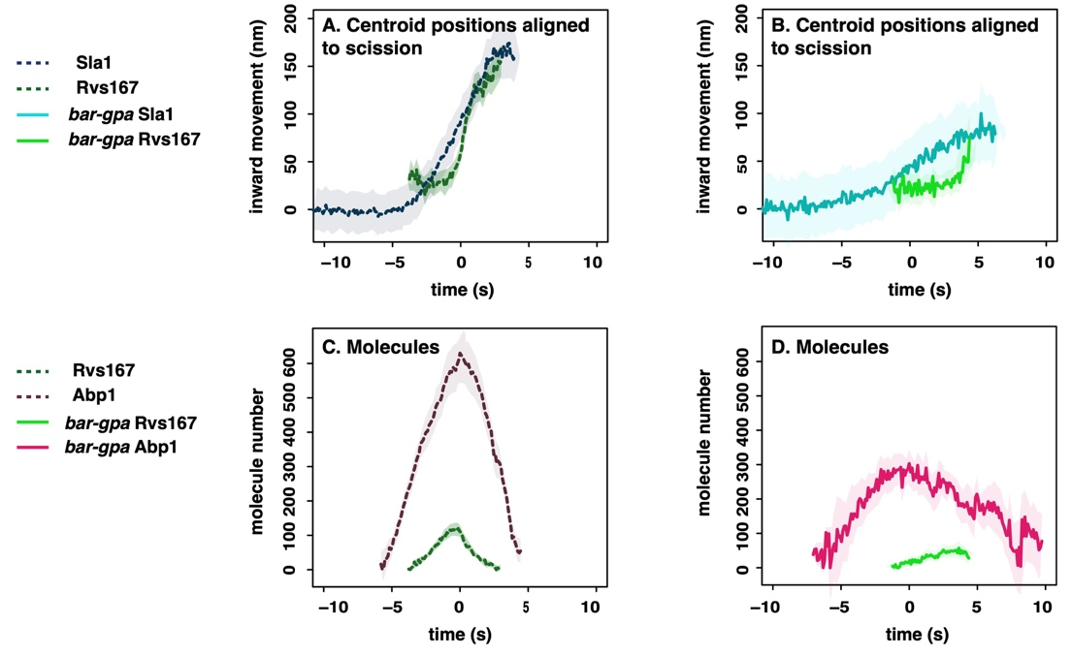

﻿ \caption{A: Averaged centroid positions of Sla1 and Rvs167 aligned in space and time so that time=0(s) is the peak of fluorescent intensity of Abp1 in WT and BAR-GFP strains respectively. B: Numbers of molecules of in WT and BAR-GPA strains, aligned so that time=0(s) is the maximum of fluorescent intensity of Abp1 in the corresponding strai

Fig4 supplement1



Fig4 supplement2



\subsection{**Reduced BAR domain recruitment corresponds to reduced membrane movement**}

Since *Δ* *rvs* and *Rvs167Δsh3* results in decreased Sla1 movement, we wondered if Sla1 movement would scale with amount of Rvs recruited to endocytic sites. We titrated the amount of Rvs expressed in cells by duplicating the Rvs167 and Rvs161 genes endogenously (Huber et al. 2014) in diploid and haploid yeast cells (Fig.5) . We thus made diploid strains with 4x copies of both the Rvs genes, 2x copies (WT diploid cells), and 1x copy. Number of molecules of Rvs167 recruited to endocytic sites increases with gene copy number (Fig5f). “Excess” Rvs recruited to endocytic sites in the 4x case does not change the rate or total movement of Sla1, or of Rvs167 (Fig5d,e). In the case of 1x Rvs, Sla1 movement is slightly reduced after 100nm (Fig5c). Magnitude of Rvs167 inward movement is unchanged, but the Rvs167-eGFP signal is lost immediately after the inward movement in the 1x case, unlike in the 4x and 2x cases, likely because fewer molecules are recruited (Fig.5c). Unlike in the *Rvs167Δsh3* case, Abp1 and Rvs167 peaks are concomitant for all three strains, with similar amounts of Abp1 recruited irrespective of Rvs167 numbers. There is there no apparent disruption of the actin network, or of the coupling between scission and actin network disassembly. It did not appear that adding more Rvs than in the WT case in diploids led to differences in Sla1 movement, although reducing the amount of Rvs- as in the 1x case- marginally decreased movement.

In haploids, we duplicated the full-length Rvs167 gene, as well as *Rvs167Δsh3* gene, producing strains with 2x copies of the Rvs genes (2xRvs), 1x copy of each (WT haploid, 1xRvs), 2x copies of the BAR-GPA domains (2x BAR), or 1 copy of BAR-GPA domains (1xBAR). Maximum Rvs167 numbers at endocytic sites varied in these strains between 50 and 180 copies. Sla1 dynamics remains the same in Rvs duplicated strain (2x) as in the WT (Fig5a). Duplicating the BAR-GPA domains alone increases the amount of BAR-GPA molecules recruited to endocytic sites compared to 1x BAR (Fig5e), and increases the Sla1 movement, as well the inward jump of Rvs167 (Fig5d,e). Total Abp1 numbers recruited are reduced for 1xBAR and \textit{rvs167$\Delta$} strains (Fig5g,h), compared to the 2xBAR, 1xRvs and 2xRvs. Higher Abp1 numbers corresponds to larger Sla1 centroid movement in both diploid and haploid cells, suggesting a correlation between the maximum number of Abp1 recruited and total invagination length.

﻿~~We wondered if the decreased Sla1 movement in BAR-GPA cells (Fig4a) was induced by loss of an SH3 domain mediated interaction, or because Rvs167 in the BAR-GPA mutant is recruited in smaller numbers to endocytic sites.~~ ~~In haploid cells, increasing the number of Rvs167 and Rvs161 genes results in increased recruitment of Rvs167 to about 1.6 times the WT amount (Fig5c). Sla1 dynamics remains the same as in the WT (Fig5a). Duplicating the BAR-GPA domains alone increases the amount of BAR-GPA molecules recruited to endocytic sites (Fig5c), and rescues the loss of Sla1 movement in the 1x BAR-GPA, as well the inward jump of BAR-GPA itself (Fig5a,b).~~

~~By gene duplication, diploid cells are generated containing either 4 copies of both Rvs genes, 2 copies of each gene (WT diploid), or 1 copy (by deleting one copy of Rvs167 and Rvs161). In diploid cells (Fig5d-f),~~

~~(!!image panels not inserted yet)~~

~~%%We measured the total number of Abp1 molecules at endocytic sites for different strains (Fig5g,h), and found that higher Abp1 numbers corresponds to larger Sla1 centroid movement. Total Abp1 numbers recruited are reduced for 1xBAR and \textit{rvs167$\Delta$} strains (Fig5g,h), suggesting a correlation between the maximum number of Abp1 recruited and total invagination length. %~~

~~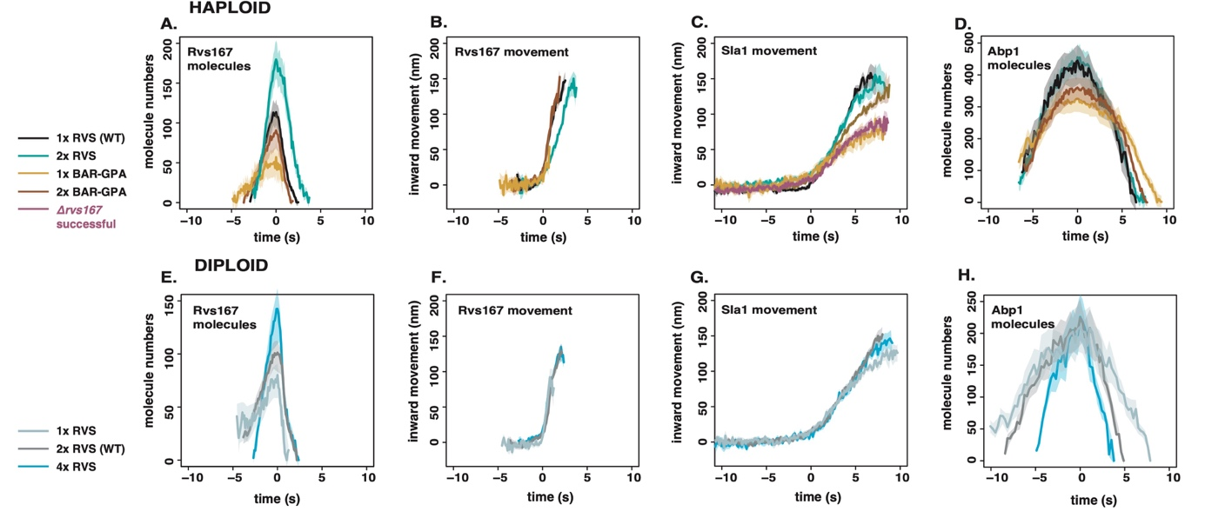~~

﻿ \caption{A: Sla1 centroid positions in haploid strains with different copy number of Rvs167 and Rvs161 genes. B: Rvs167 centroid positions in these haploid strains. C: Recruitment of Rvs167 in time in these strains. D: Sla1 centroid positions in diploid strains expressing different copy numbers of Rvs167 and Rvs161. E, F: Rvs167 centroid positions, and recruitment in the diploid strains.

All centroid positions are aligned in the time axis so that time=0(s) corresponds to beginning of inward movement of each average centroid. They are aligned in the y axis so that y=0(nm) corresponds to the beginning of the average centroid position}