﻿**\subsection{Removal of Rvs167, not Vps1, results in reduced coat movement}**

The yeast Dynamin-like protein Vps1 does not contain the canonical Proline Rich Domain, which in mammalian cells is required for recruitment to endocytic sites (ref). It is however, reportedly recruited to and interacts with endocytic proteins (refAyscough, Yu, 2004; Nannapaneni et al., 2010; Goud Gadila et al., 2017). Vps1 tagged both N- and C-terminally with GFP constructs failed to co-localize with endocytic proteins in our hands (Fig.1 supplement).

﻿To test whether absence of Vps1 influences scission, endocytic dynamics are observed in cells lacking Vps1 and compared against wild-type (WT) cells (Fig1a-f). Vps1 deletion is confirmed by sequencing the open reading frame, and these cells show the growth phenotype at 37\si{\degree}C (Fig.1, supplement) recorded in other work (ref. ayscough). In Fig.1c, rates of retraction of the membrane in \textit{vps1$\Delta$} and WT cells is quantified. Membrane retraction, that is, inward movement and consequent retraction of the invaginated membrane back towards the cell wall is a scission-specific phenotype (ref.Marko). Sla1 is an endocytic coat protein that acts as a marker for membrane movement. Upon actin polymerization, the endocytic coat is pulled along with the membrane as it invaginates (ref.Skruzny?), and thus Sla1 acts as a proxy for the behaviour of the plasma membrane. We endogenously tagged Sla1 at the N-terminus with eGFP in WT and \textit{rvs167$\Delta$} cells (Fig.1a), and tracked the dynamics. Retraction rates do not increase in \textit{vps1$\Delta$} cells compared to the WT (Fig.1c).

﻿In order to study the total inward movement of the coat, and therefore the depth of the endocytic invagination, the averaged centroid trajectory of Sla1-eGFP (ref. Picco, eLife 2015) is tracked in ~50 endocytic sites in \textit{vps1$\Delta$} and WT cells (Fig.1d). In brief, yeast cells expressing fluorescently-tagged endocytic proteins are imaged at the equatorial plane. Since membrane invagination progresses perpendicularly to the plane of the plasma membrane, proteins that move into the cytoplasm during invagination do so in the imaging plane. Centroids of 40-50 Sla1 patches- each patch being an endocytic site- are tracked in time and averaged. This provides an average centroid that can be followed with high spatial and temporal resolution.

When different endocytic proteins are simultaneously imaged with Actin Binding Protein Abp1, Abp1 provides a frame of reference to which all the other proteins can be aligned. Abp1 is used because it is abundant at endocytic sites and therefore easily imaged. Time=0 is established as the peak of the Abp1 fluorescence intensity in respective co-tagged strains strains. Abp1 fluorescent intensity maxima in wild-type cells is concomitant with the peak of Rvs167 fluorescent intensity and is time window in which scission occurs (ref2andrea, refwanda).

Centroid movement of Sla1-eGFP in WT cells is linear to about 140nm. Sla1 movement in \textit{vps1$\Delta$} cells has the same magnitude of movement (Fig1d). In spite of slight differences in the rates of movement, the total inward movement- and so the depth of endocytic invagination- does not change.

﻿Centroid tracking has shown that the number of molecules of Rvs167 peaks at the time of scission, and is followed by a rapid loss of fluorescent intensity, simultaneous with a sharp jump of the centroid into the cytoplasm (ref.Andrea). This jump, also seen in Rvs167-GFP kymographs (Fig.1b), is interpreted as loss of protein on the membrane tube, causing an apparent spatial jump to the protein localized at the base of the newly formed vesicle. Kymographs of Rvs167-GFP (Fig.1b), as well as Rvs167 centroid tracking (Fig.1e) in Vps1 deleted cells show the same jump. Sla1 and Rvs167 behaviour in \textit{vps1$\Delta$} cells indicate that loss of Vps1 does not influence the depth of membrane invagination or scission dynamics.

﻿Since removal of the Rvs complex is known to increase the retraction rate at endocytic sites, involvement of these proteins in the scission process was investigated further. Rvs161 and Rvs167 form dimers (ref.Dominik), so deletion of Rvs167 effectively removes both proteins from endocytic sites. We quantified the effect of deletion of Rvs167 on membrane invagination (Fig.1a-c). 27\% of Sla1 patches that begin to form invaginations move inward and then retract in \textit{rvs167$\Delta$} cells (Fig.1c), consistent with retraction rates measured in other experiments (Kaksonen, Toret and Drubin, 2005), and suggesting failed scission in these 27\% of endocytic events. Coat movement of the retractions and of successful endocytic events were quantified (Fig.1f) as described in Picco et. al, 2015. Sla1 centroid movement in both successful and retracting endocytic events in \textit{rvs167$\Delta$} cells and WT look similar up to about 60nm (Fig.1f). In successful endocytic events, Sla1-egfp signal is then lost, similar to WT cells, and Abp1 intensity drops (Fig.1supplement), indicating that scission occurs at invagination lengths between 60 -80 nm. That membrane scission occurs at shorter invagination lengths than in WT is corroborated by the smaller vesicles formed in \textit{rvs167$\Delta$} cells by Correlative light and electron microscopy (CLEM) (Kukulski et al., 2012). In retraction events, the Sla1 centroid moves back towards its original position. CLEM has also shown that Rvs167 localizes to endocytic sites after the invaginations are about 60nm long (Kukulski et al., 2012). Sla1 movement in \textit{rvs167$\Delta$} indicates therefore that membrane invagination is unaffected till Rvs is supposed to arrive.

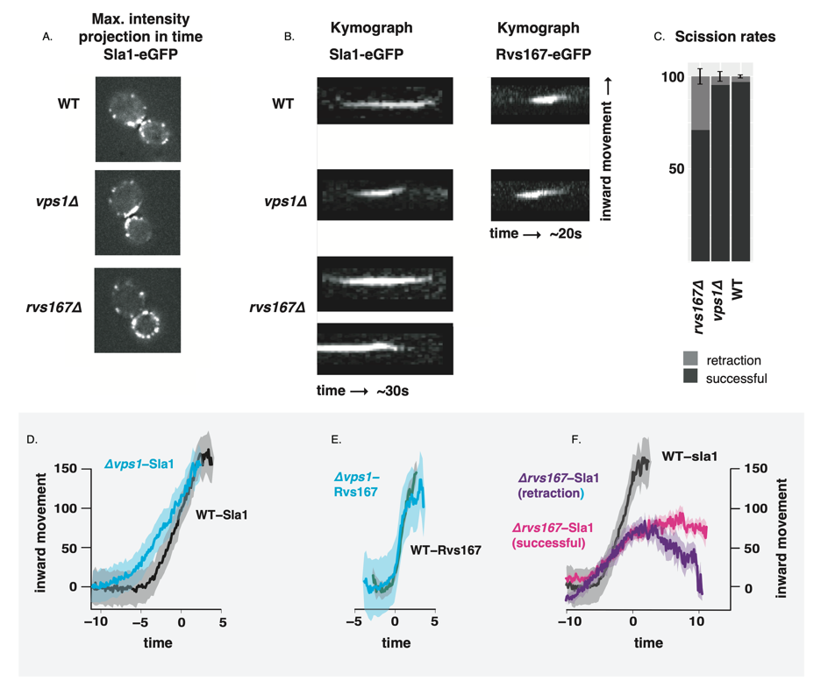

Fig1

**﻿\subsection{Synaptojanins likely influence vesicle uncoating, but not scission dynamics.}**

There are three Synaptojanin-like proteins in budding yeast: Inp51, Inp52, and Inp53 (Fig2a). Inp51-eGFP exhibits a diffuse cytoplasmic signal, and Inp53 localizes to patches within the cytoplasm- cellular localization that is consistent with involvement in trans-Golgi signalling (refGolgi)- Inp53 was not investigated further. Inp52-eGFP localizes to cortical actin patches that are endocytic sites (Fig2 supplement). Spatial and temporal alignment with Sla1 and Rvs167 shows that Inp52 protein molecules arrive in the late scission stage, and localizes to the bud tip, consistent with a role in membrane scission (Fig.2b).

﻿

Inp51 and Inp52 were tested as potential candidates for scission regulators. Sla1-eGFP and Rvs167-eGFP in cells with either Inp51 or Inp52 deleted were studied. Retraction events do not significantly increase compared to the WT in either \textit{inp51$\Delta$} or \textit{inp52$\Delta$} cells (Fig2c). Magnitude and speed of coat movement in \textit{inp51$\Delta$} is the same as the WT (Fig2.d). In \textit{inp52$\Delta$} cells, coat movement also has the magnitude and speed as WT, but Sla1-eGFP signal is persistent after membrane scission (Fig.2d). Similarly, although Rvs167 inward movement looks the similar (Fig2e), disassembly has a delay, while the assembly is similar to WT (Fig2f). Assembly of Rvs167 has a delay in \textit{inp51$\Delta$} cells. The magnitude of the inward movement of both Sla1 and Rvs167 in cells containing either deletion are the same as in WT, while assembly and disassembly dynamics of Rvs167 is changed.

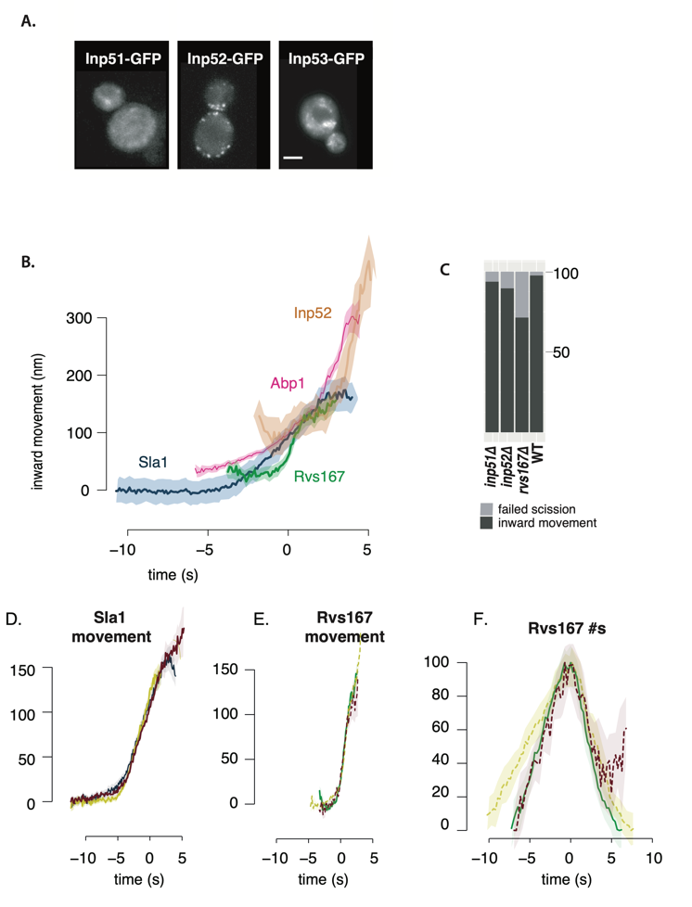

Fig.2

**﻿\subsection{Rvs BAR domains recognize membrane curvature in-vivo}**

**﻿**

The interaction between Rvs167 and membrane curvature \textit{in vivo} has not so far been tested. In order to do so, we deleted the SH3 domain of Rvs167 leaving the N-terminal BAR region (henceforth BAR-GPA) and observed the localization of full-length Rvs167 and BAR-GPA (Fig3a). The GPA region is a disordered region that has no previously reported function and was retained to ensure proper folding and function of the BAR domain. Endogenously tagged Rvs167-eGFP and BAR-GPA-eGFP colocalization with Abp1-mCherry in WT and \textit{sla2$\Delta$} cells are compared (Fig3b). Sla2 acts as the molecular linker between forces exerted by the actin network and the plasma membrane (ref. Skruzny). \textit{sla2$\Delta$} cells therefore contain a polymerizing actin network at endocytic patches, but the membrane remains flat and endocytosis fails. In these cells, the full-length Rvs167 protein co-localizes with Abp1-mCherry, indicating that it is recruited to endocytic sites (Fig3b). BAR-GPA-eGFP localization is removed, except for rare transient patches that do not co-localize with Abp1-mCherry, indicating that in the absence of membrane curvature, the BAR domains cannot localize to endocytic sites (Fig3b, \textit{sla2$\Delta$}).

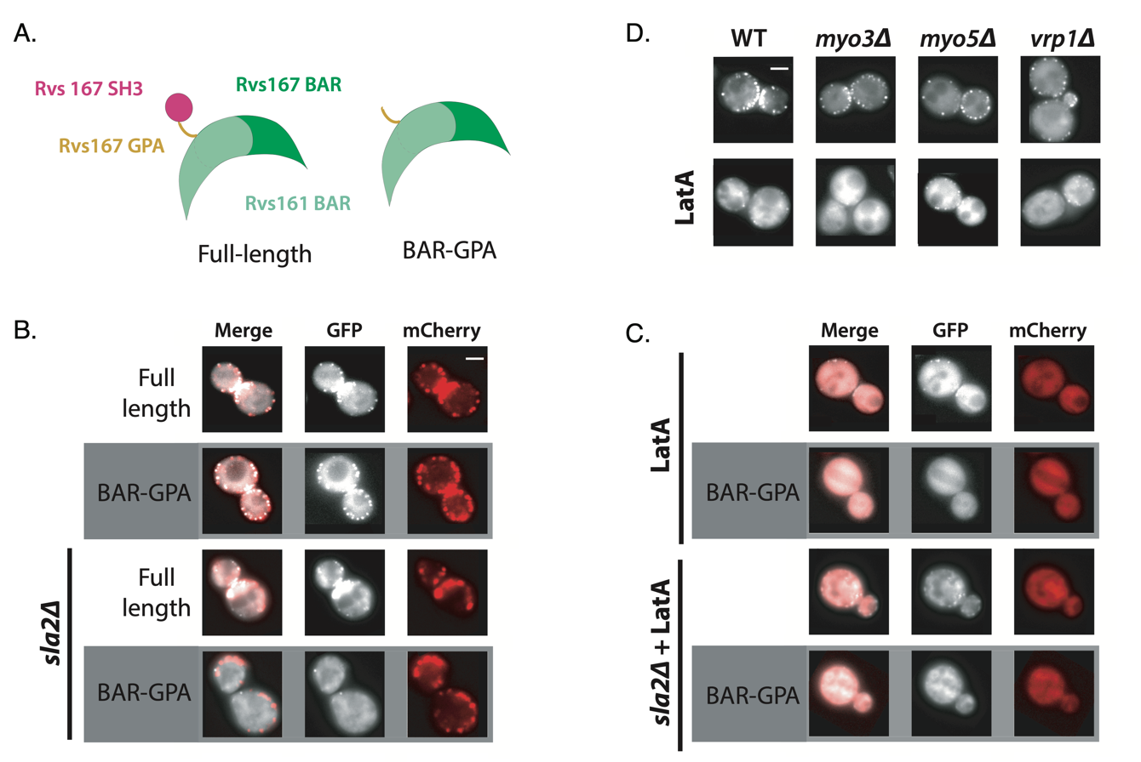

Fig.3

**﻿\subsection{SH3 domains are likely recruited by Myosin 3}**

SH3 domains have been shown to interact with several proteins in the actin module of endocytosis. Type I myosins Myo3 and Myo5, and Vrp1 have genetic or physical interactions with Rvs167 SH3 domains (Lila and Drubin, 1997; Colwill et al., 1999, Madania et al., 1999; Liu et al., 2009).

We tested the interaction between these proteins and the Rvs167-SH3 region by studying the localization of full-length Rvs167 in cells with one of these proteins deleted, and treated with LatA to reproduce the situation in which BAR-curvature interaction is removed, and SH3 interaction remains.

Deletion of neither Vrp1 nor Myo5 in combination with LatA treatment removes the localization of Rvs167. Deletion of Myo3 with LatA treatment removes localization of Rvs167.

**﻿\subsection{Loss of Rvs167 SH3 domain affects coat and actin dynamics}**

In order to further probe the contribution of the Rvs167 SH3 domain to endocytosis, we compared dynamics of Sla1, as well as Rvs167 and BAR-GPA centroids (Fig4a). Movement of Sla1 centroid is reduced in BAR-GPA cells (Fig4a). Both full length Rvs167 and BAR-GPA however, arrive at endocytic coats when Sla1 centroid is about 30nm away from the initial position (Fig1a, red line to the y axis). Tubular invaginations are formed in BAR cells, and qualitatively resemble that in WT cells, as seen by CLEM (Fig.4 supplement). The inward jump of BAR-GPA is less than that of full-length Rvs167 (Fig.4b). Recruitment of BAR is reduced to half that of Rvs167 (Fig4c), although cytoplasmic concentration of Rvs167 and BAR are not different (Fig4 supplement). We also quantified the number of Abp1 and Rvs molecules recruited to endocytic sites (Fig4b). Abp1 disassembly is slowed down in BAR-GPA cells compared to WT (Fig4b), and recruitment is reduced to 50\% of WT recruitment (Fig.4c), likely indication disruption of actin network assembly.

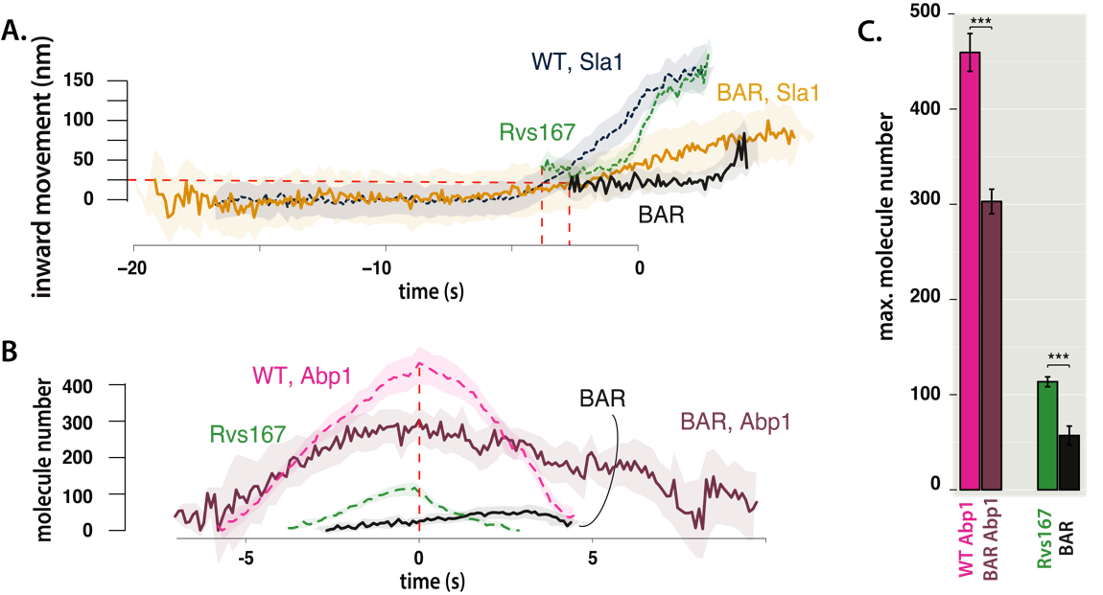

Fig.4

﻿

**\subsection{Reduced BAR domain recruitment corresponds to reduced membrane movement}**

﻿Decreased Sla1 movement in BAR-GPA cells (Fig4a) can be explained by loss of some interaction mediated by the SH3 domain, or because the BAR-GPA mutant is recruited in smaller numbers to endocytic sites. To check whether increasing the recruitment of the Rvs complex alone can rescue reduced Sla1 movement, Rvs167 and Rvs161 genes were duplicated endogenously (ref Huber) in diploid and haploid yeast cells. Diploid cells are thus generated containing either 4 copies of both Rvs genes (by gene duplication), 2 copies of each gene (WT diploid), or 1 copy (by deleting one copy of Rvs167 and Rvs161).

In diploid cells (Fig5a-c), amount of Rvs167 recruited to sites increases with gene copy number (Fig5c). Adding excess Rvs to endocytic sites in the 4x case does not change the rate or total inward movement of Sla1, or of Rvs167.

In the case of 1x Rvs, Sla1 movement is slightly reduced after 100nm (Fig5a). Magnitude of Rvs167 inward movement is unchanged, but the Rvs167-eGFP signal is lost immediately after the inward movement, unlike in the 4x and 2x cases.

In haploid cells, increasing the number of Rvs167 and Rvs161 genes results in increased recruitment of Rvs167 to about 1.6 times the WT amount (Fig5f,h). Sla1 dynamics however, remains the same as in the WT(Fig5d). Duplicating the BAR-GPA domain alone rescues the loss of Sla1 movement in the 1x BAR-GPA, as well the inward jump of BAR-GPA itself (Fig5d,e). We measured the total number of Abp1 molecules at endocytic sites for different strains (Fig5g,h), and found that higher Abp1 numbers corresponds to larger Sla1 centroid movement. Total Abp1 numbers recruited are reduced for 1xBAR and \textit{rvs167$\Delta$} strains (Fig5g,h), suggesting a correlation between the maximum number of Abp1 recruited and total invagination length.

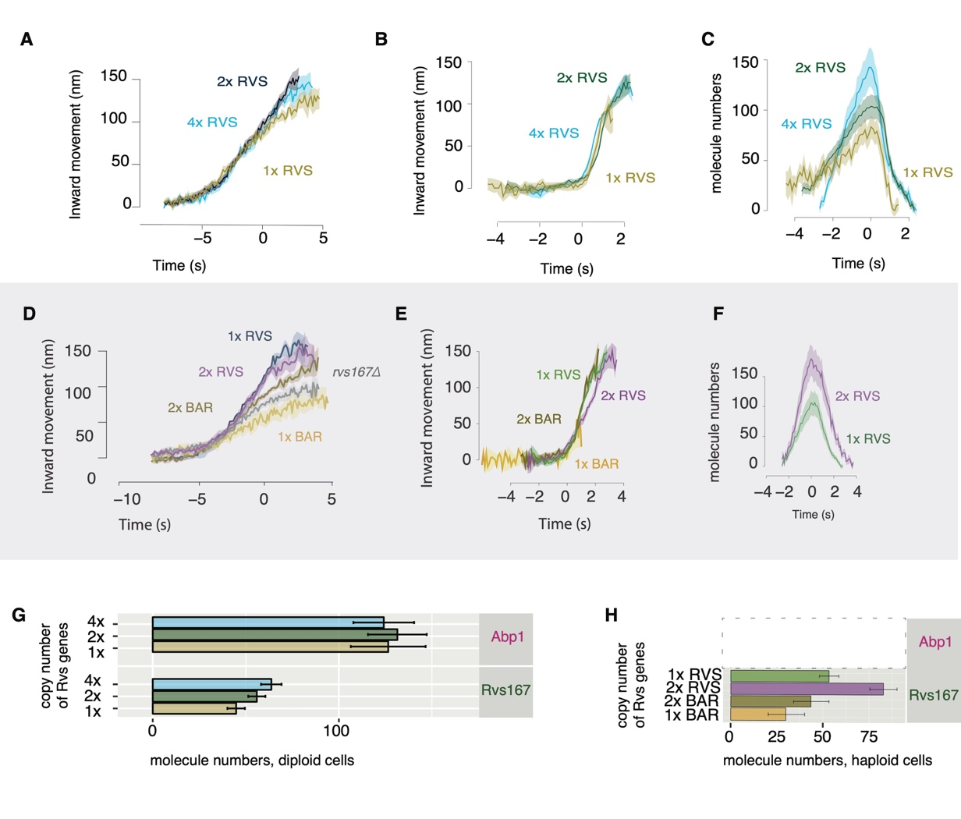

Fig.5