GLOBAL ECONOMIC & DEMOGRAPHIC ANALYSIS – PROJECT DOCUMENTATION

Submitted by : Deepika B
Course : DA/DS, Offline
Batch : JUNE 2025

1. Executive Summary
The Global Economic and Demographic Analysis project focuses on exploring key global indicators such as population, GDP, literacy, infant mortality, and industry distribution across countries and regions. Multiple datasets from SQL and Excel were integrated, cleaned, transformed, modeled, and visualized using Power BI. This report presents the entire workflow—from data preparation to final insights and dashboard design—offering a complete analytical and business intelligence narrative.

2. Project Overview
The objective of this project is to analyze worldwide economic and demographic trends using structured datasets from multiple sources. Using Power BI as the primary analytical tool, the goal was to perform descriptive statistics, develop DAX-based insights, and build an interactive dashboard highlighting regional and global trends.
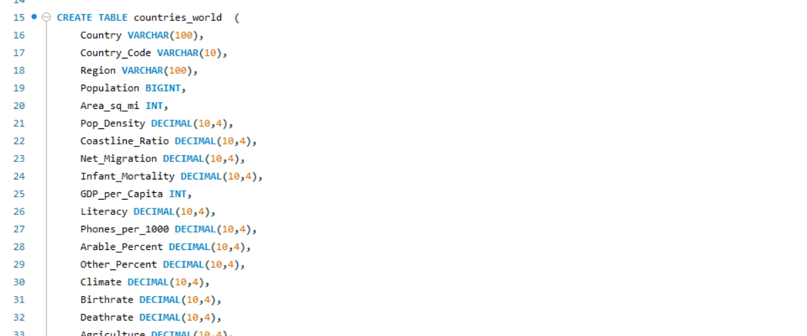
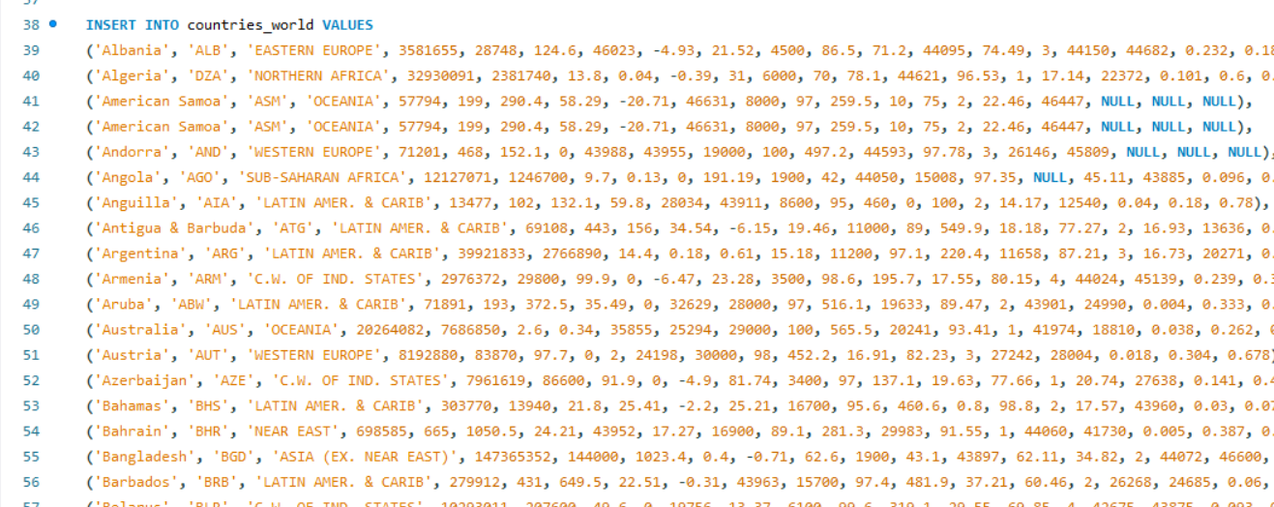

4. Data Cleaning & Preparation (Power Query)
Data cleaning included:
- Handling missing values
- Standardizing country names and country codes
- Converting data types (text → numeric)
- Removing duplicates
- Merging tables using Country Name and Country Code
- Unpivoting population year columns for time-series analysis
- Removing null/empty records for GDP and population
- Filtering out countries with incomplete data
- Creating clean dimension and fact tables

5. Data Model Design
The data model follows a star-schema structure:
Contains numeric measures such as population, GDP, birthrate, deathrate, literacy, industry %, agriculture %, services %, infant mortality.
Country dimension, region dimension, metadata dimension.

Relationships:
- Country Code → Primary linking field
- One-to-many relationships between metadata and fact tables

6. Descriptive Statistical Analysis
Key statistical measures were computed:

Population Statistics:
- Mean, median, mode
- Standard deviation across countries
- Year-wise global population growth

GDP Analysis:
- Average GDP per capita by country and region
- Highest & lowest GDP countries

Infant Mortality:
- Minimum, maximum and deviation
- Regional comparison

Literacy:
- Average literacy rate across countries
- Relation with GDP

7. DAX Calculations
Some of the important DAX measures used:

Total Population = SUM('Data'[Population])

Average GDP per Capita = AVERAGE('Data'[GDP_per_Capita])

Life Expectancy Avg = AVERAGE('Data'[Life_Expectancy])

Birthrate Total = SUM('Data'[Birthrate])

Deathrate Total = SUM('Data'[Deathrate])

Population Growth % =
VAR prev = CALCULATE(SUM('Data'[Population]), DATEADD('Date'[Date], -1, YEAR))
VAR curr = SUM('Data'[Population])
RETURN (curr - prev) / prev
```

8. Dashboard Visualizations & Documentation
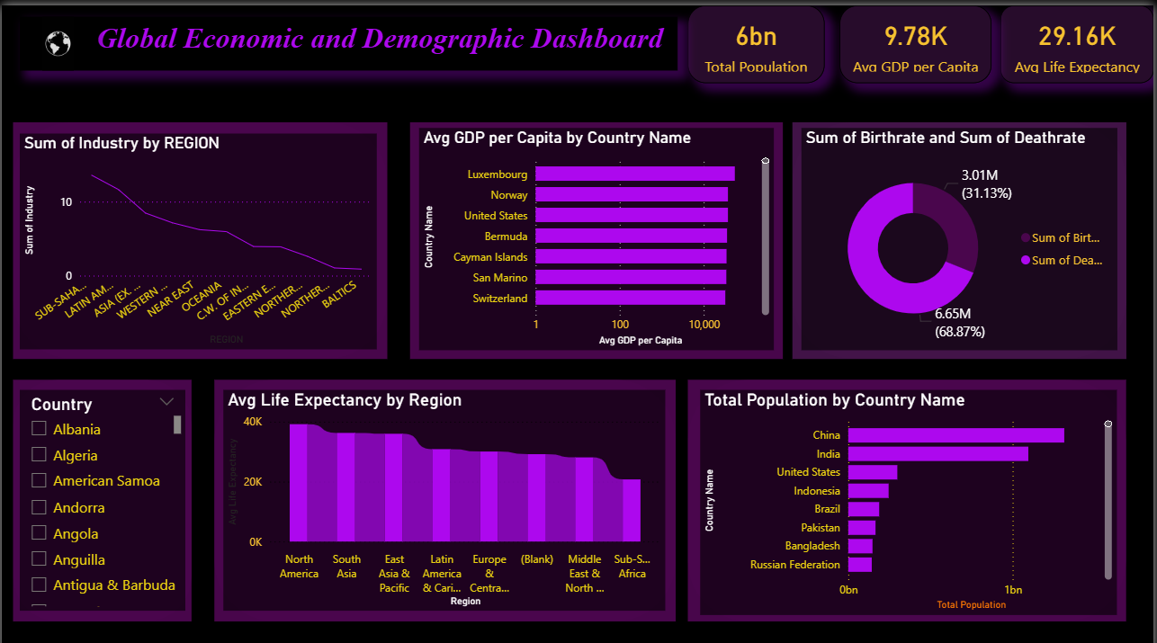

1. Sum of Industry by Region
Shows regional industrial contribution.

2. Average GDP per Capita by Country
Highlights top-performing countries.

3. Birthrate vs Deathrate
Displays population dynamics.

4. Life Expectancy by Region
Compares regional health standards.

5. Total Population by Country
Shows most populated countries.

6. Country Slicer
Enables interactive filtering.

9. Insights & Observations
Major insights include:
- China and India hold the largest populations.
- Luxembourg, Switzerland, and Norway lead in GDP per capita.
- Sub-Saharan Africa shows lower life expectancy.
- Birthrate is significantly higher than deathrate → population growth.
- Industry % varies sharply among regions.

10. Conclusion
This project successfully integrates SQL and Excel datasets to deliver a powerful analytical solution using Power BI. Through cleaning, modeling, descriptive statistics, and interactive dashboard creation, global economic and demographic patterns are clearly visualized. The dashboard provides meaningful insights for decision-making, research, and policy development.

