AWS CLOUD WEB APPLICATION
PROJECT DOCUMENTATION
AWS Web Application – Infrastructure & Deployment Guide
Project | AWS Web Application
Cloud Platform | Amazon Web Services (AWS)
Core Services | VPC, Internet Gateway, Security Group, EC2, S3
Purpose | Deploy and document a basic cloud-hosted web application environment

1. Project Overview
This project demonstrates the setup of a basic AWS web application environment. The infrastructure includes a VPC for network isolation, an Internet Gateway for internet access, Security Groups for traffic control, EC2 for compute/server hosting, and S3 for object storage. The supplied project screenshots are included below as evidence of the configuration.

2. Architecture
Logical flow:
Internet → Internet Gateway → VPC → Security Group → EC2
↘ S3

3. VPC Configuration
A Virtual Private Cloud (VPC) provides an isolated networking environment for AWS resources. The VPC forms the base network layer for the project.

Screenshot – VPC Created

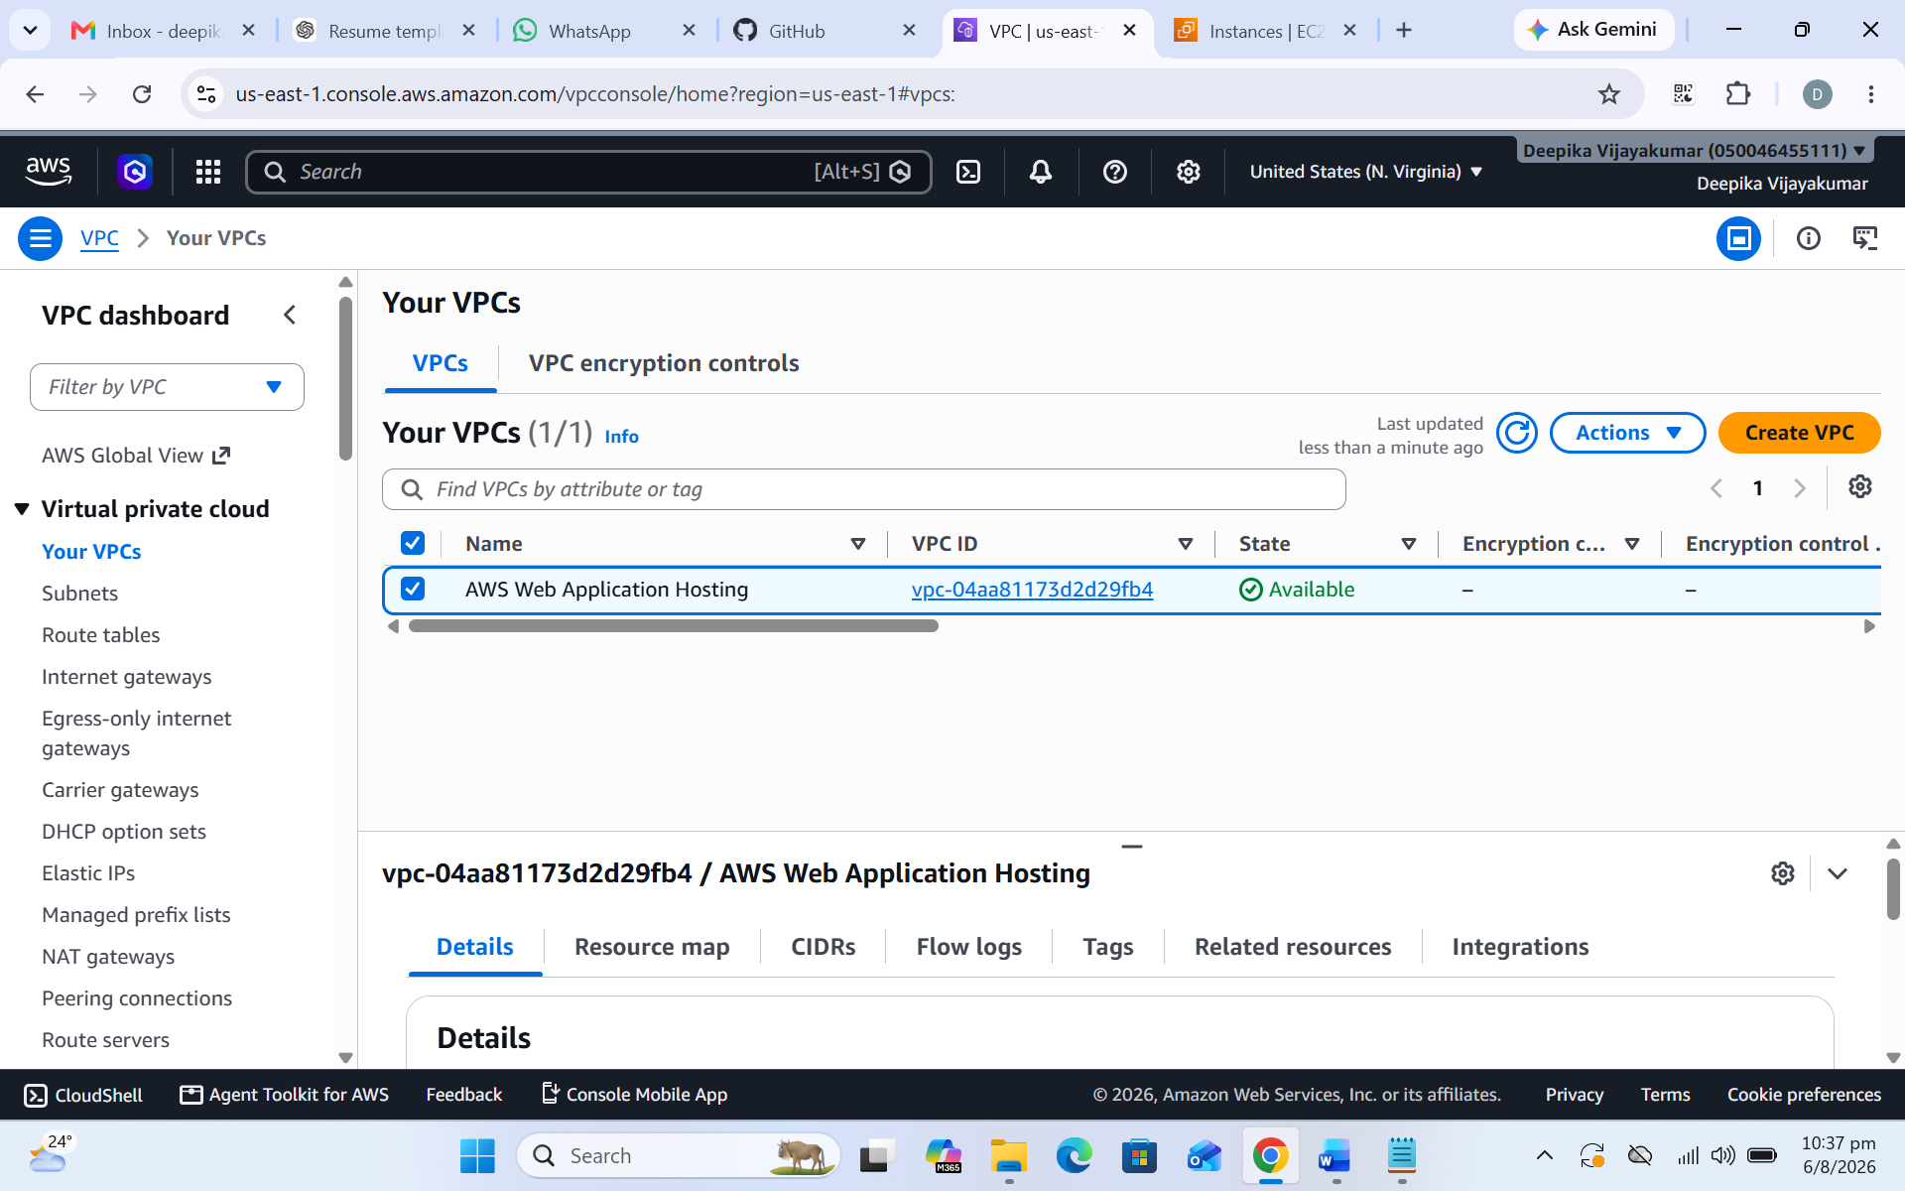
Figure 1: VPC creation/configuration evidence.

4. Internet Gateway
The Internet Gateway provides a path between the VPC and the public internet when the route table and subnet configuration allow it.

Screenshot – Internet Gateway
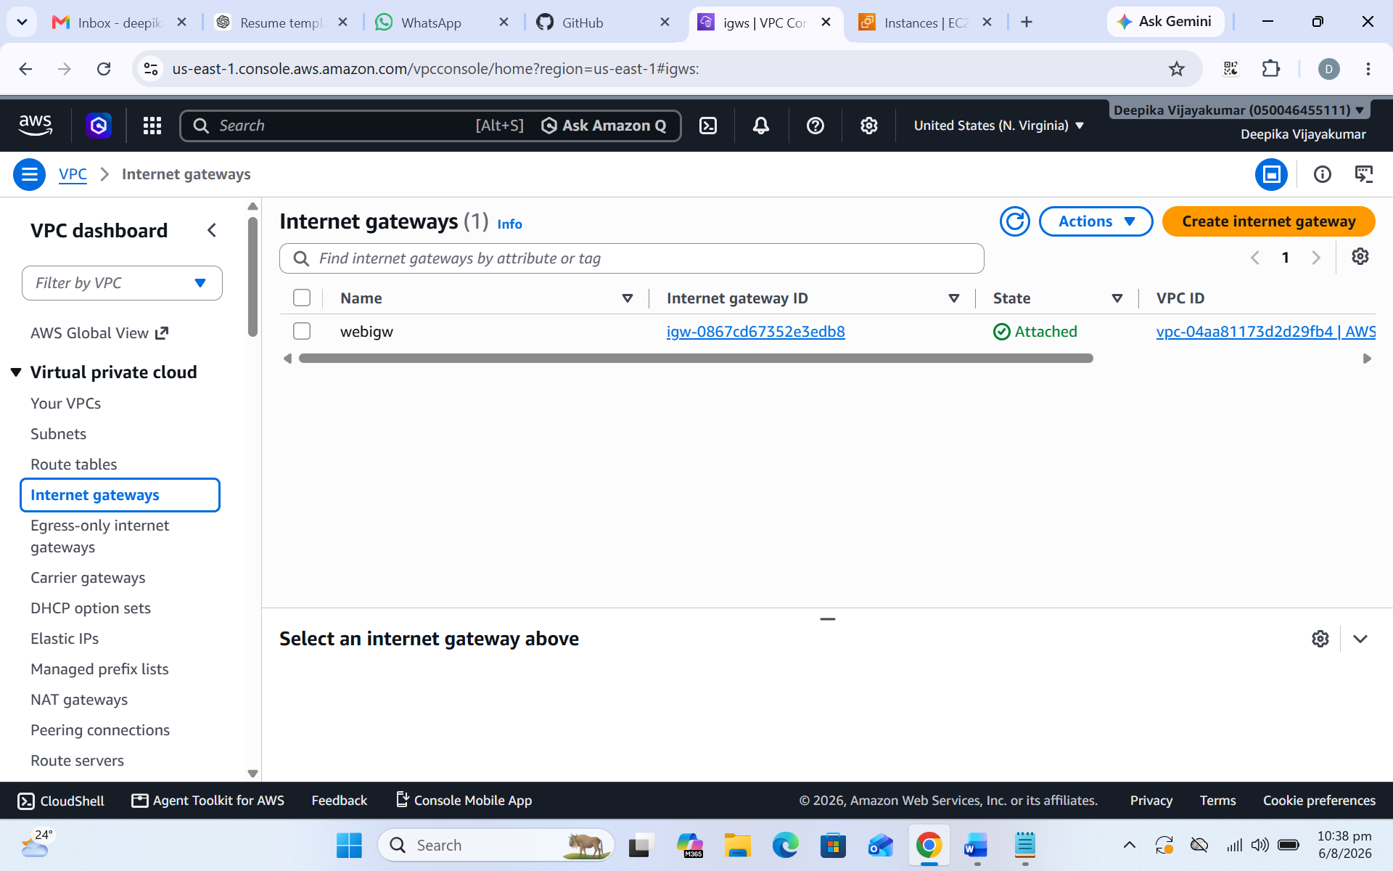
Figure 2: Internet Gateway configuration evidence.

5. Security Group
A Security Group acts as a virtual firewall for resources such as EC2. Inbound rules should allow only the ports required by the application; unnecessary public access should be avoided.

Screenshot – Security Group
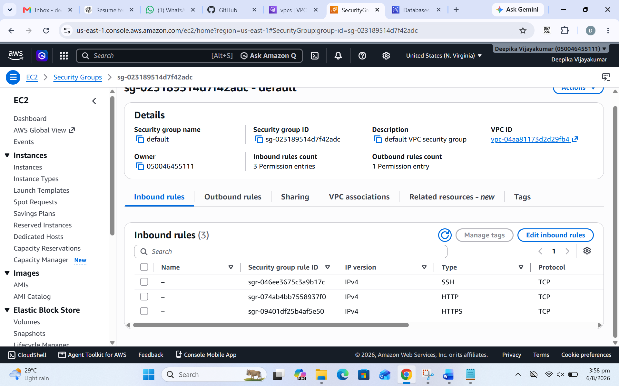
Figure 3: Security Group configuration evidence.

6. EC2 Instance
Amazon EC2 provides the virtual server used to host or test the web application. After launching the instance, the server can be accessed using the appropriate connection method and configured with the required software.

Screenshot – EC2 Creation
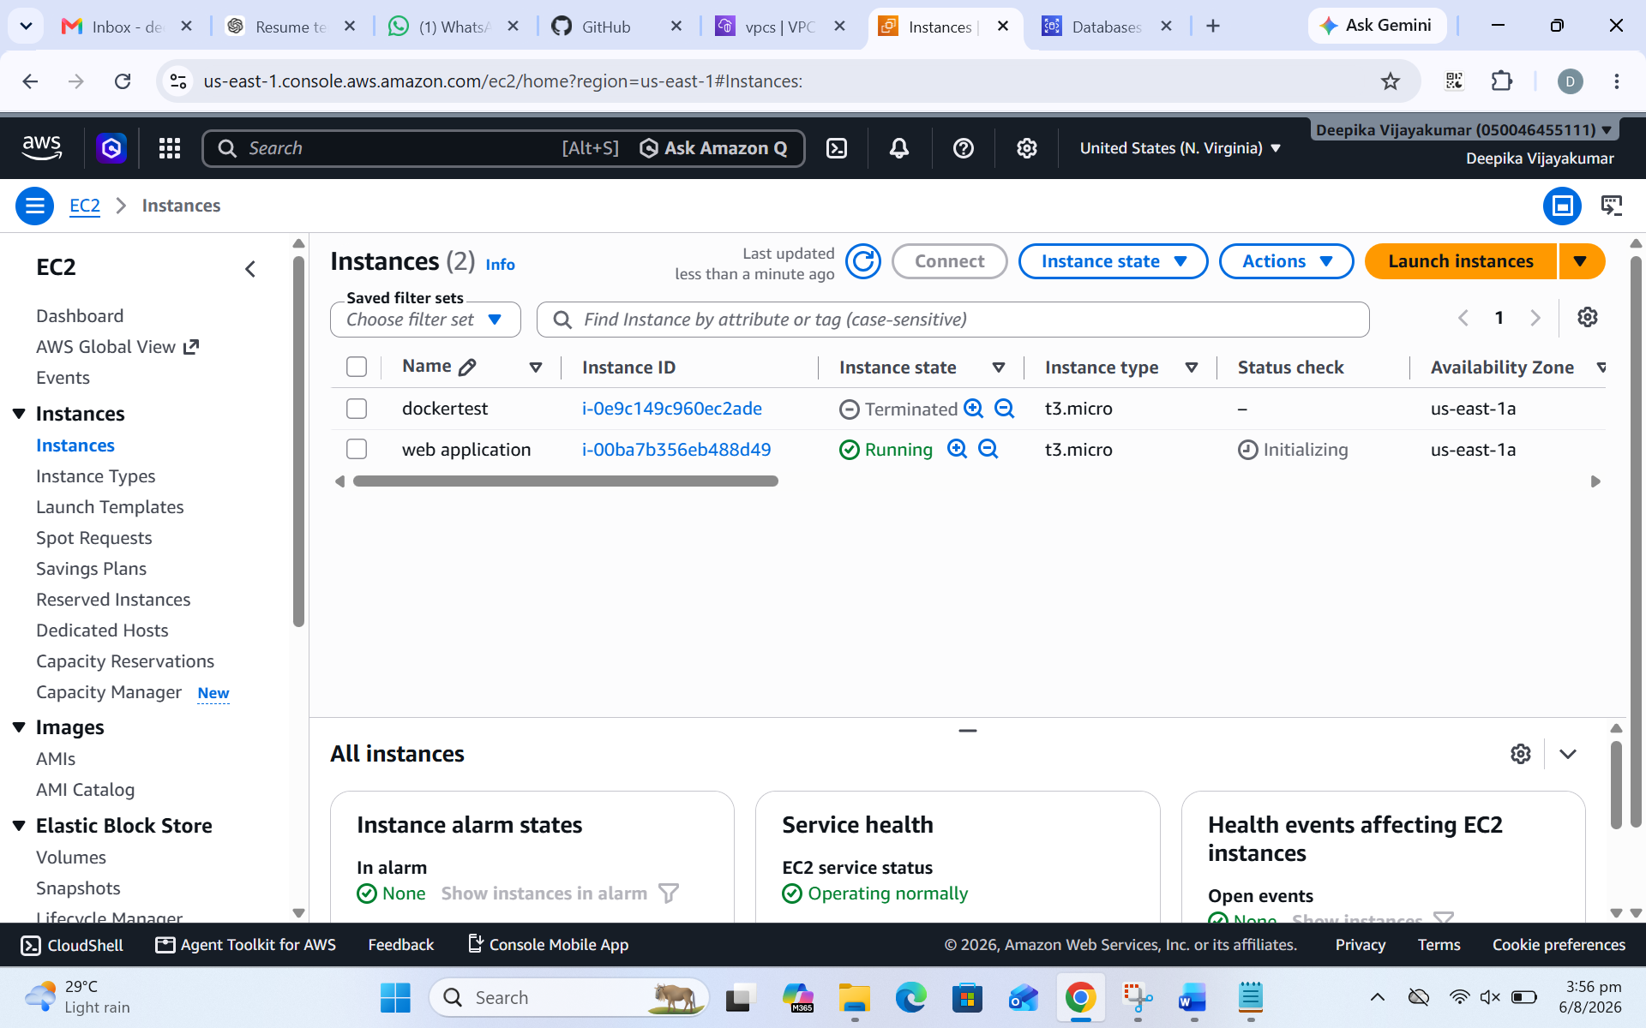
Figure 4: EC2 instance creation evidence.

7. Linux Server Configuration
Linux commands are used to manage services and verify the server environment. Service status checks are important during real-world troubleshooting.

Screenshot – Linux Service Management
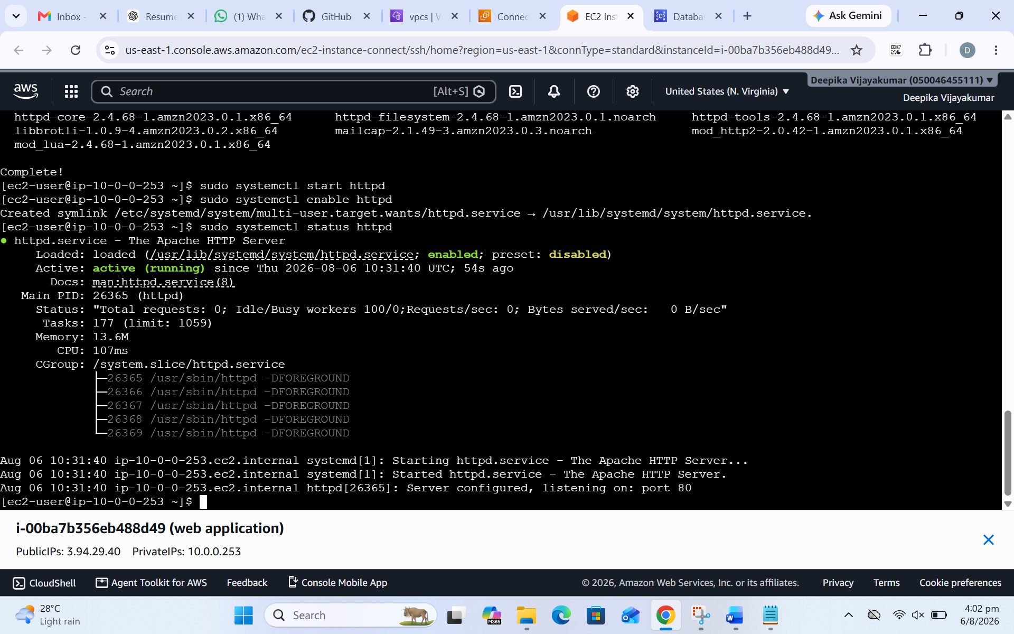
Figure 5: Linux service management command evidence.

8. S3 Configuration
Amazon S3 is used for object storage. It can store application assets, documents, backups, logs, and other files.

Screenshot – S3 Bucket Created
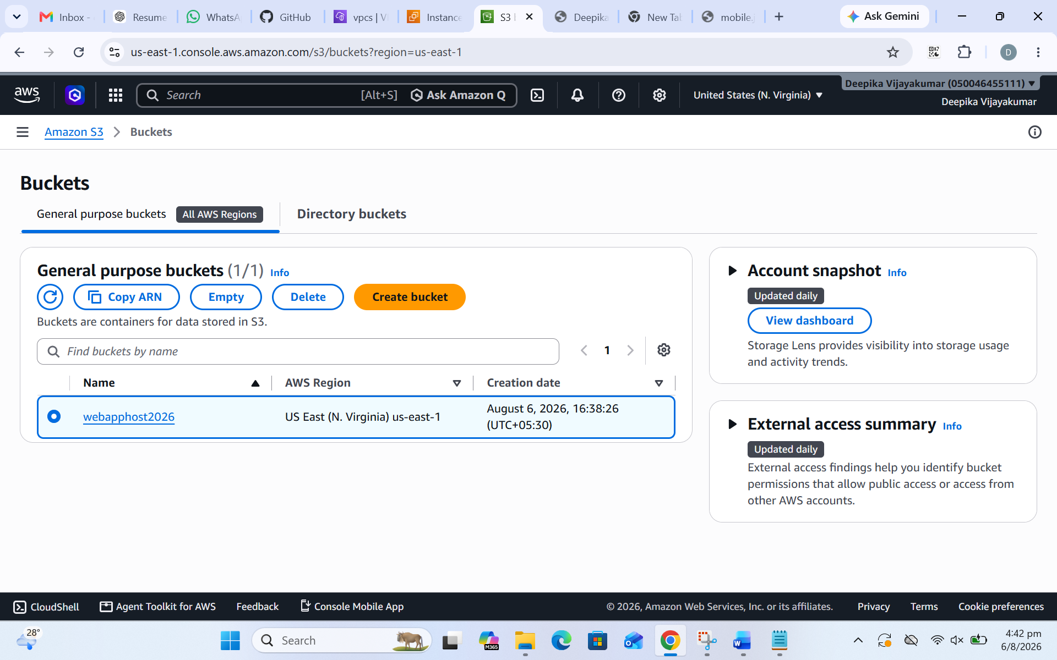
Figure 6: S3 bucket creation evidence.

9. S3 Objects
The following screenshot shows objects available in the S3 bucket.
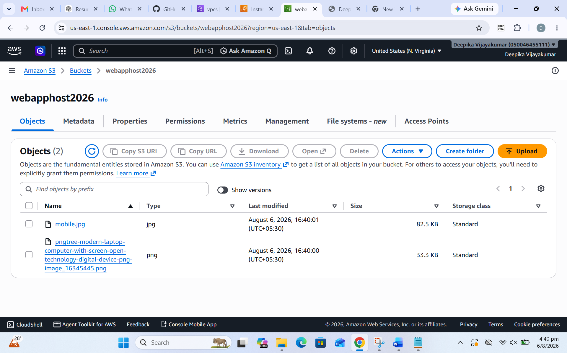
Figure 7: S3 objects evidence.

10. Application / Project Output
The supplied output screenshot is included as the final project evidence.
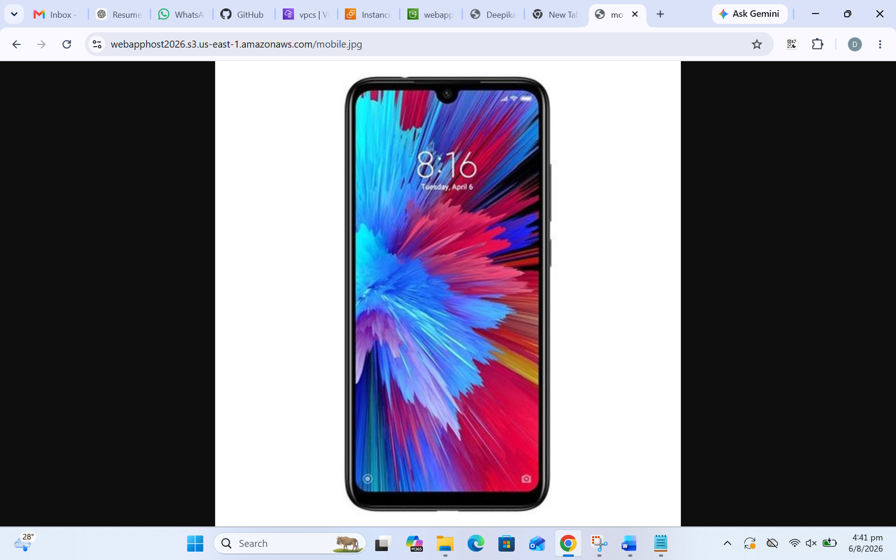
Figure 8: Project output evidence.

11. Project History / Activity
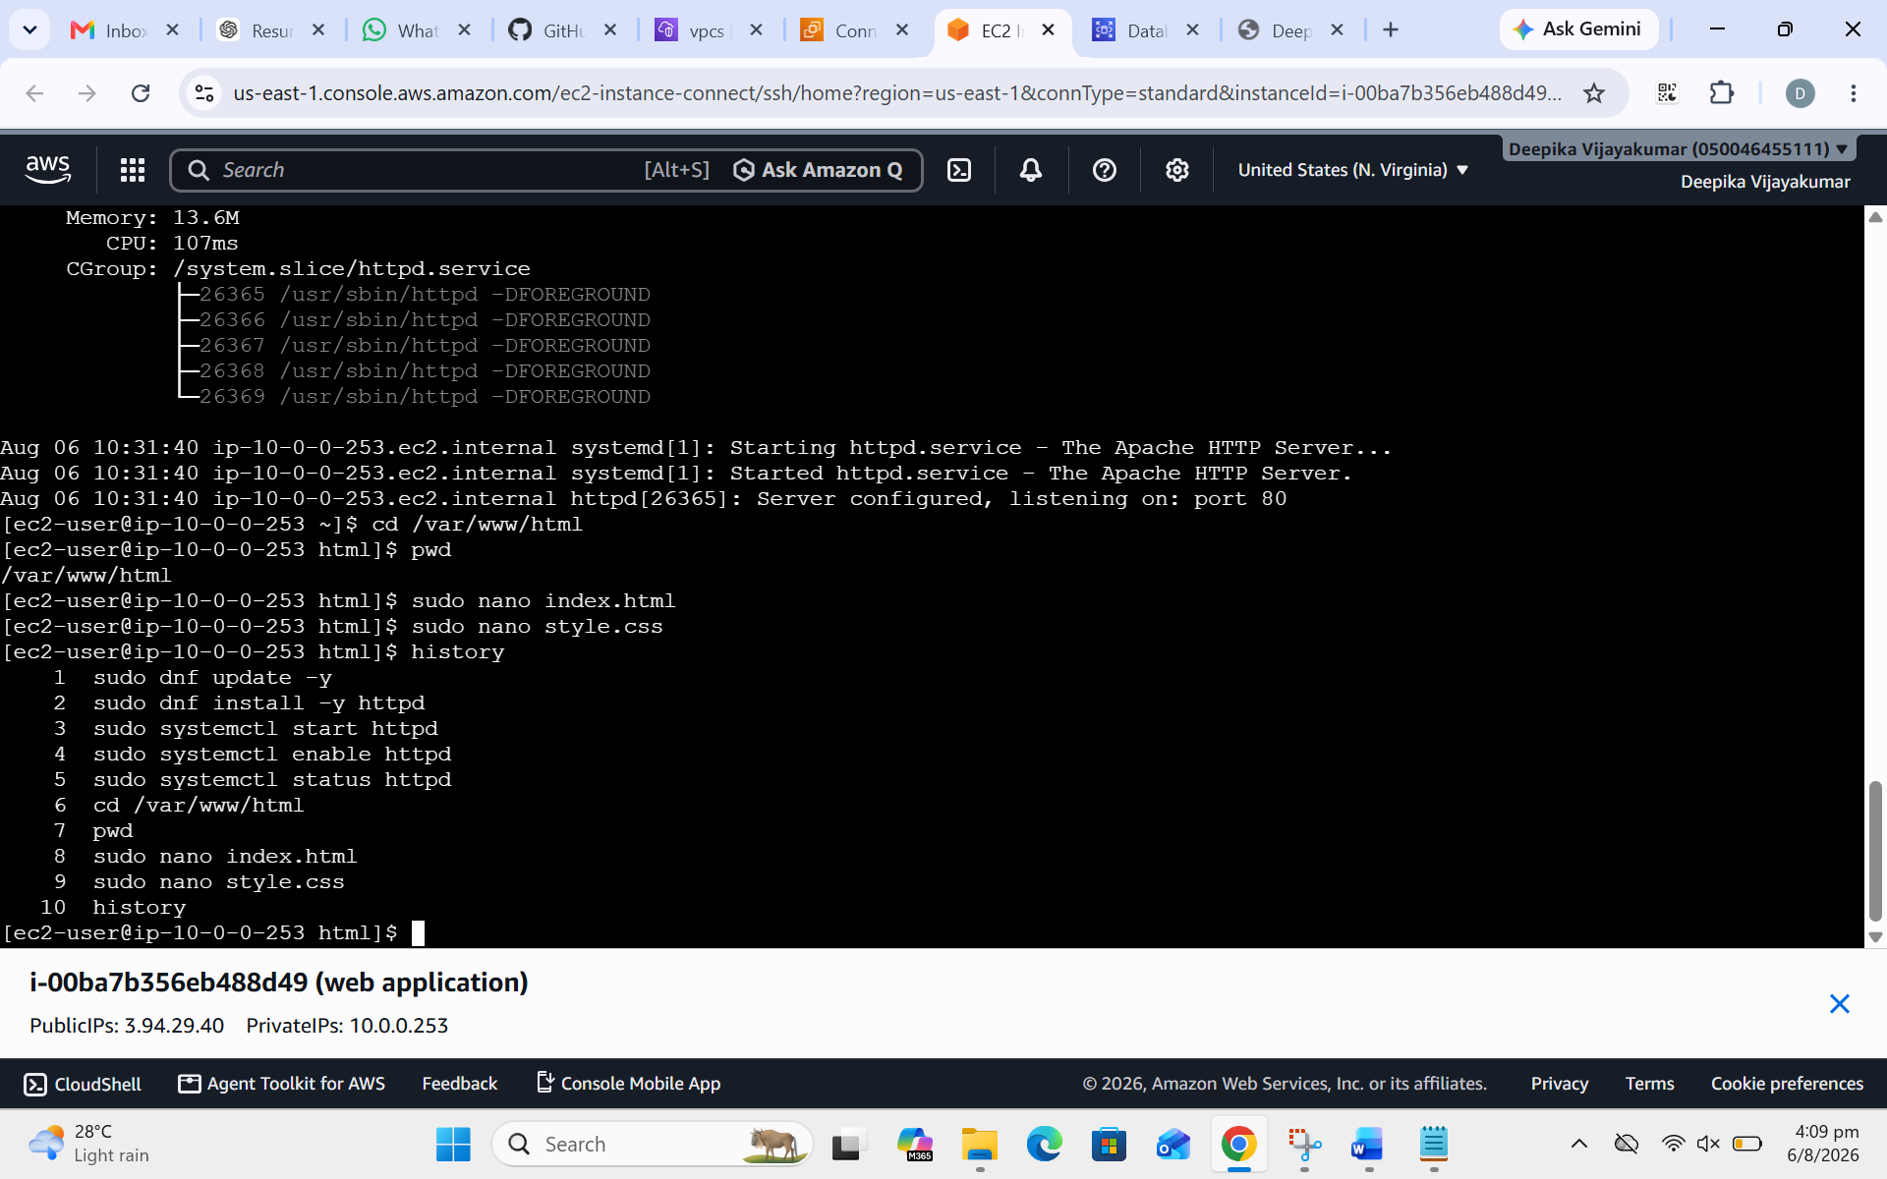
Figure 9: Project/activity history evidence.

12. Troubleshooting Checklist
- EC2 is not reachable → check instance state, status checks, Security Group, subnet route and Internet Gateway.
- Web application is not opening → verify the application/service is running and the required port is listening.
- S3 Access Denied → check IAM permissions, bucket policy and Block Public Access settings according to the intended access model.
- Linux service issue → use service status/log commands to identify the failure.
- For production environments, avoid opening ports to 0.0.0.0/0 unless there is a clear requirement.

13. Interview Explanation
I created a basic AWS web application environment using VPC, Internet Gateway, Security Group, EC2 and S3. I configured the network, controlled access using Security Groups, used EC2 as the compute environment, and used S3 for object storage. I also performed Linux service management and verified the application output.

14. Services Used – Quick Reference
Service | Purpose | Project Role
VPC | Private AWS networking | Base network
Internet Gateway | Internet connectivity | Public access path
Security Group | Virtual firewall | Traffic control
EC2 | Virtual server | Application/server hosting
S3 | Object storage | File/object storage
Linux | Server OS management | Service administration

