SRI ESHWAR COLLEGE OF ENGINEERING
Department of CSE (Artificial Intelligence and Machine Learning)
CLOUD COMPUTING IMPLEMENTATION REPORT
Docker • GitHub Actions • Amazon ECR • Amazon ECS Fargate

Name | Deepika
Department / Section | CSE (AIML) – A
Subject | Cloud Computing Technologies
Course Code | U23IT4AS4 / U23IT402 – Cloud Computing
Project Title | Buddy-to-Study – Containerized Cloud Deployment
Deployment Approach | Docker → GitHub Actions → Amazon ECR → Amazon ECS Fargate

1. Objective
To containerize the Buddy-to-Study full-stack application using Docker, automate the build and image publishing process with GitHub Actions, store Docker images in Amazon Elastic Container Registry (ECR), and deploy the frontend and backend as services on Amazon ECS using the Fargate launch type.

2. Technologies and AWS Services Used
Component | Technology / Service
Frontend | React + Vite
Backend | Node.js + Express
Database | MongoDB Atlas
Containerization | Docker and Docker Compose
CI/CD | GitHub Actions
Container Registry | Amazon ECR
Cloud Deployment | Amazon ECS Fargate
Region | Asia Pacific (Mumbai) – ap-south-1

3. Step-by-Step Implementation
Step 1 – Prepare the Dockerized Application
Dockerfiles were created separately for the React frontend and Node.js backend. The frontend uses a multi-stage build and Nginx to serve the Vite build output. The backend image installs production dependencies and starts the Express server on port 5000.
Step 2 – Configure Docker Compose
Docker Compose was used to build and run the frontend and backend services together. The frontend is mapped to port 3000 and the backend to port 5000. The frontend uses Nginx to proxy API and Socket.IO requests to the backend container.
Step 3 – Build and Test Docker Images Locally
The Docker images were built successfully and the containers were tested locally. The application homepage was accessible through localhost:3000.
Step 4 – Push Source Code to GitHub
The application source code and CI/CD workflow were maintained in a GitHub repository. The workflow file was placed under .github/workflows/ci.yml.
Step 5 – Configure GitHub Actions
GitHub Actions was configured to checkout the source code, install dependencies, build the frontend, install backend dependencies, authenticate with AWS using OIDC, log in to ECR, build Docker images and push the images to ECR.
Step 6 – Store Images in Amazon ECR
Two private ECR repositories were used: buddy-to-study-frontend and buddy-to-study-backend. The workflow successfully pushed the Docker images with the latest tag.
Step 7 – Deploy on Amazon ECS Fargate
An ECS cluster named buddy-to-study-cluster was used. Separate frontend and backend task definitions and services were configured with the Fargate launch type.
Step 8 – Verify Cloud Deployment
The ECS services were started and the deployed application was accessed through its public endpoint. The final Buddy-to-Study interface was displayed successfully.

4. Implementation Screenshots

4.1 Frontend Dockerfile
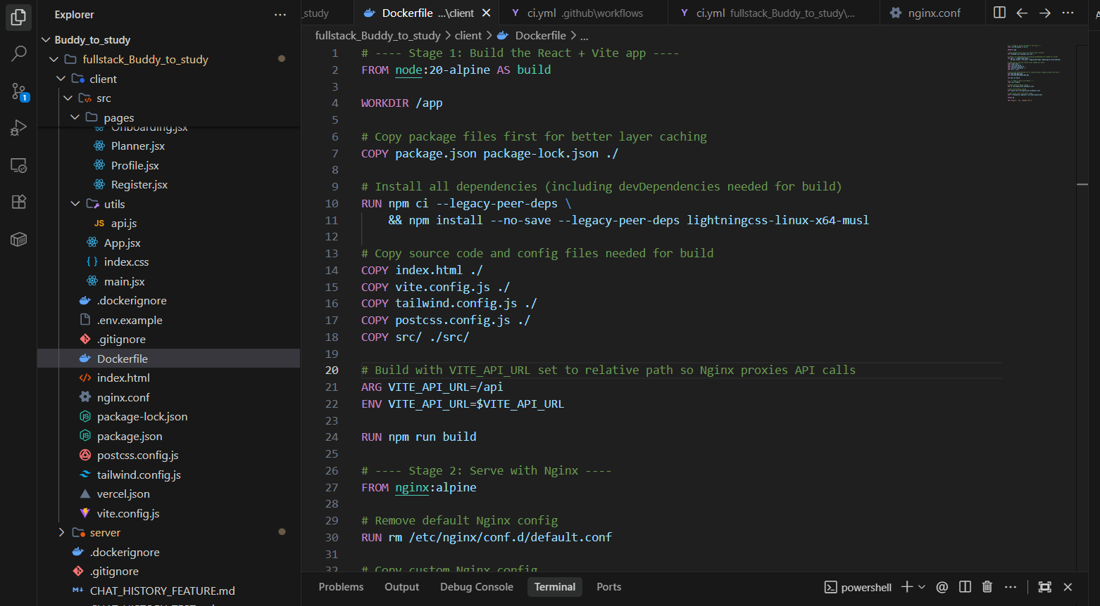
Figure 1. Frontend Dockerfile using Node.js and Nginx

4.2 Docker Compose Configuration
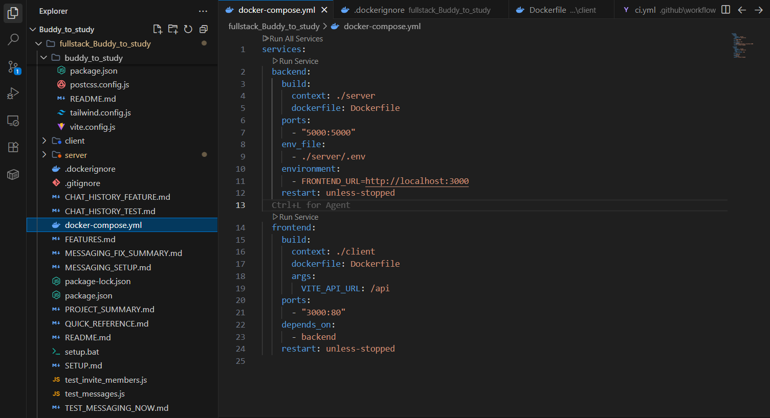
Figure 2. Docker Compose configuration for frontend and backend

4.3 Backend Dockerfile
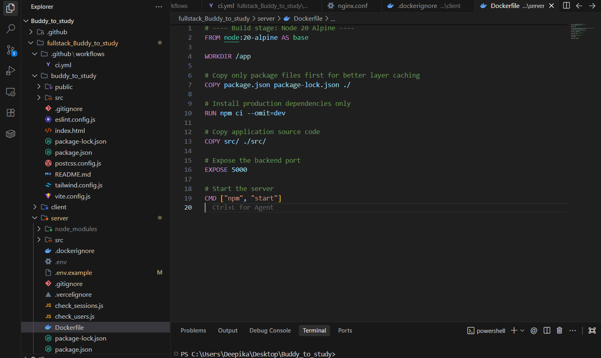
Figure 3. Backend Dockerfile exposing port 5000

4.4 Docker Images Created Locally
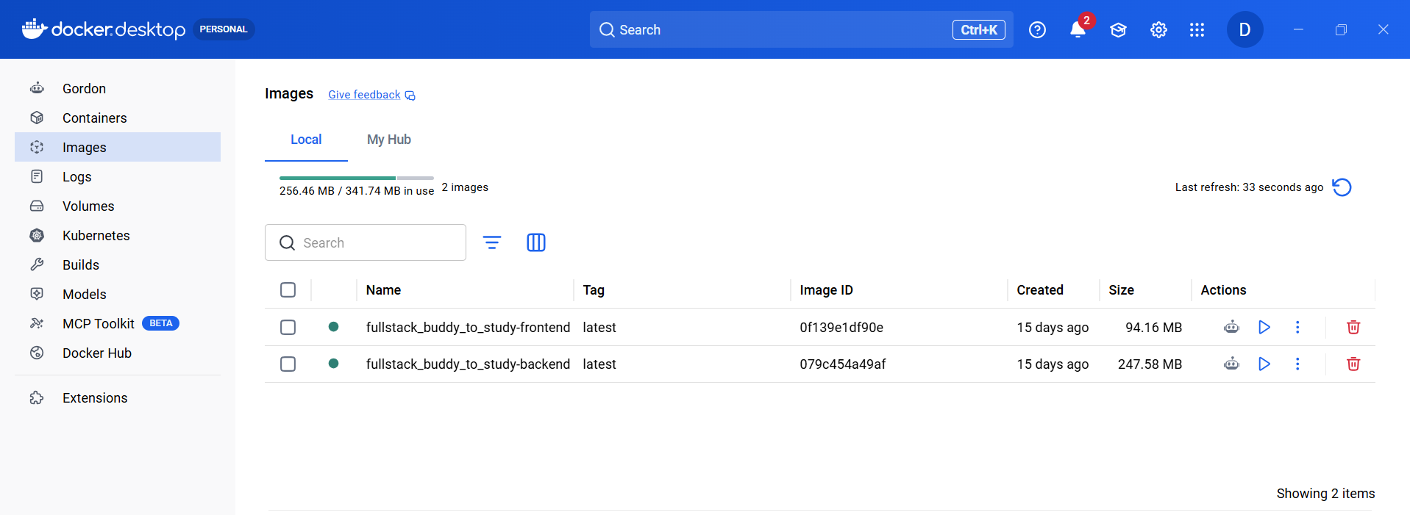
Figure 4. Docker Desktop showing frontend and backend images

4.5 Local Application Output
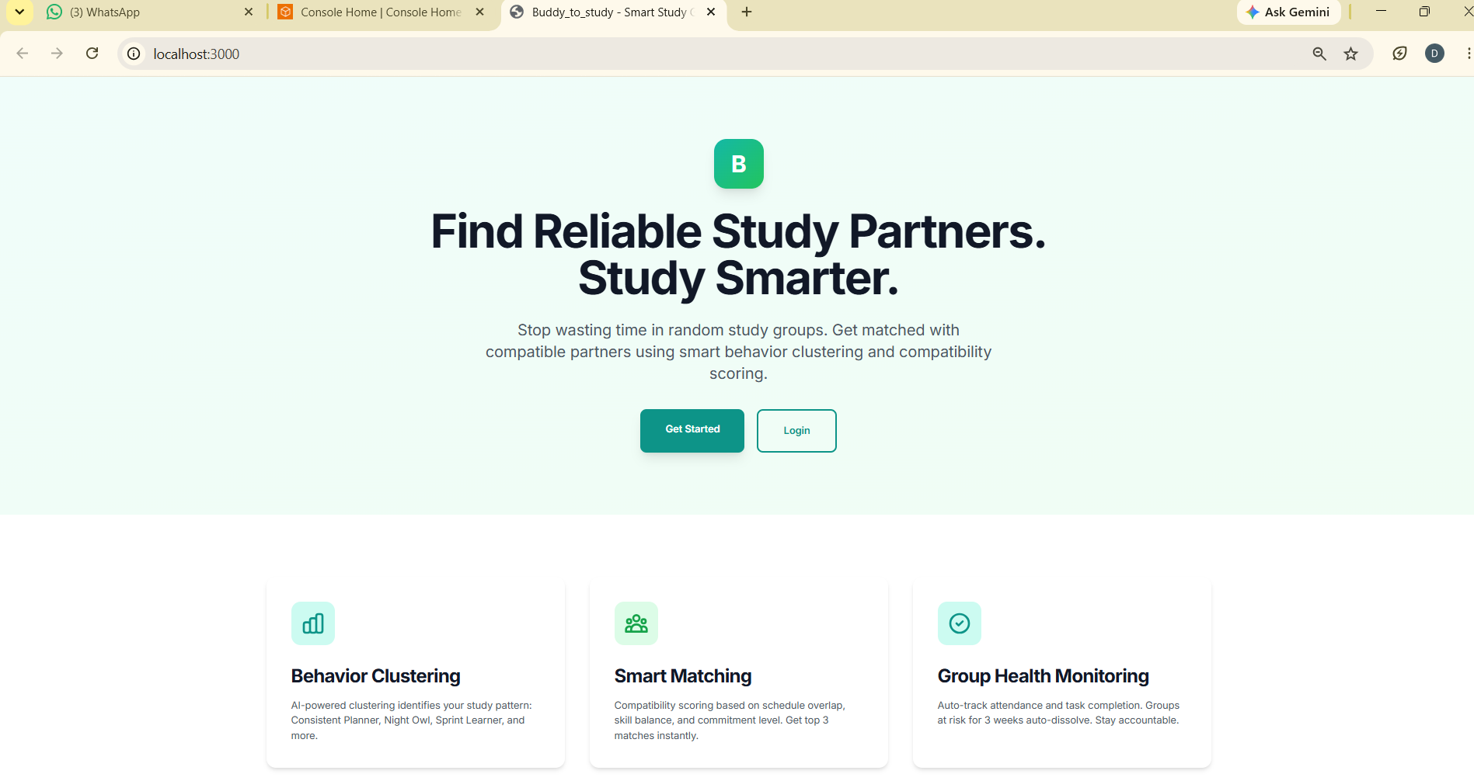
Figure 5. Buddy-to-Study application running locally through Docker

4.6 GitHub Repository
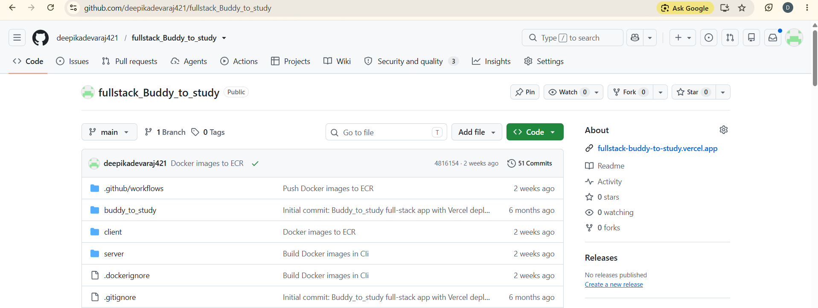
Figure 6. Buddy-to-Study source code repository on GitHub

4.7 GitHub Actions CI/CD Success
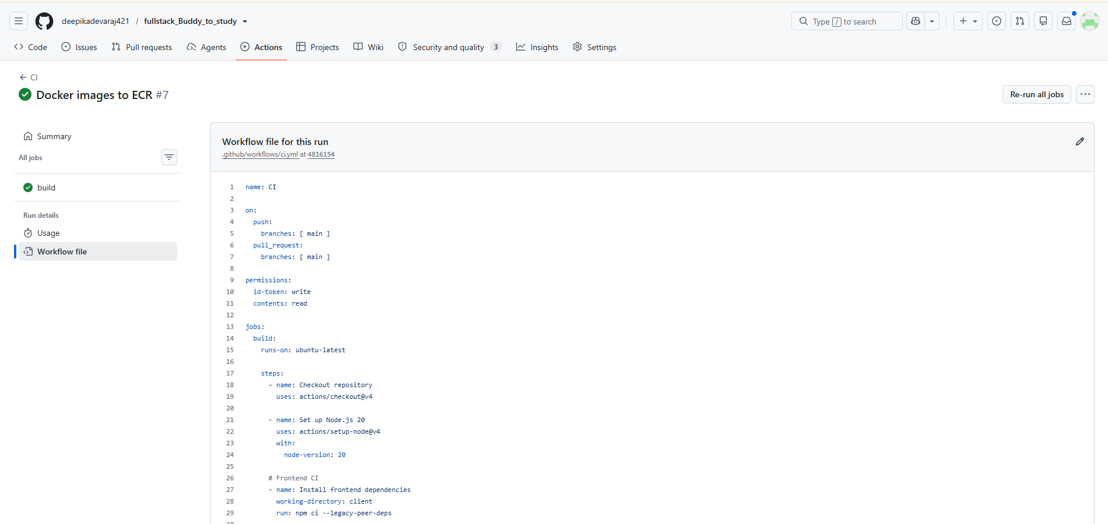
Figure 7. Successful GitHub Actions CI/CD workflow

4.8 Amazon ECR Repositories
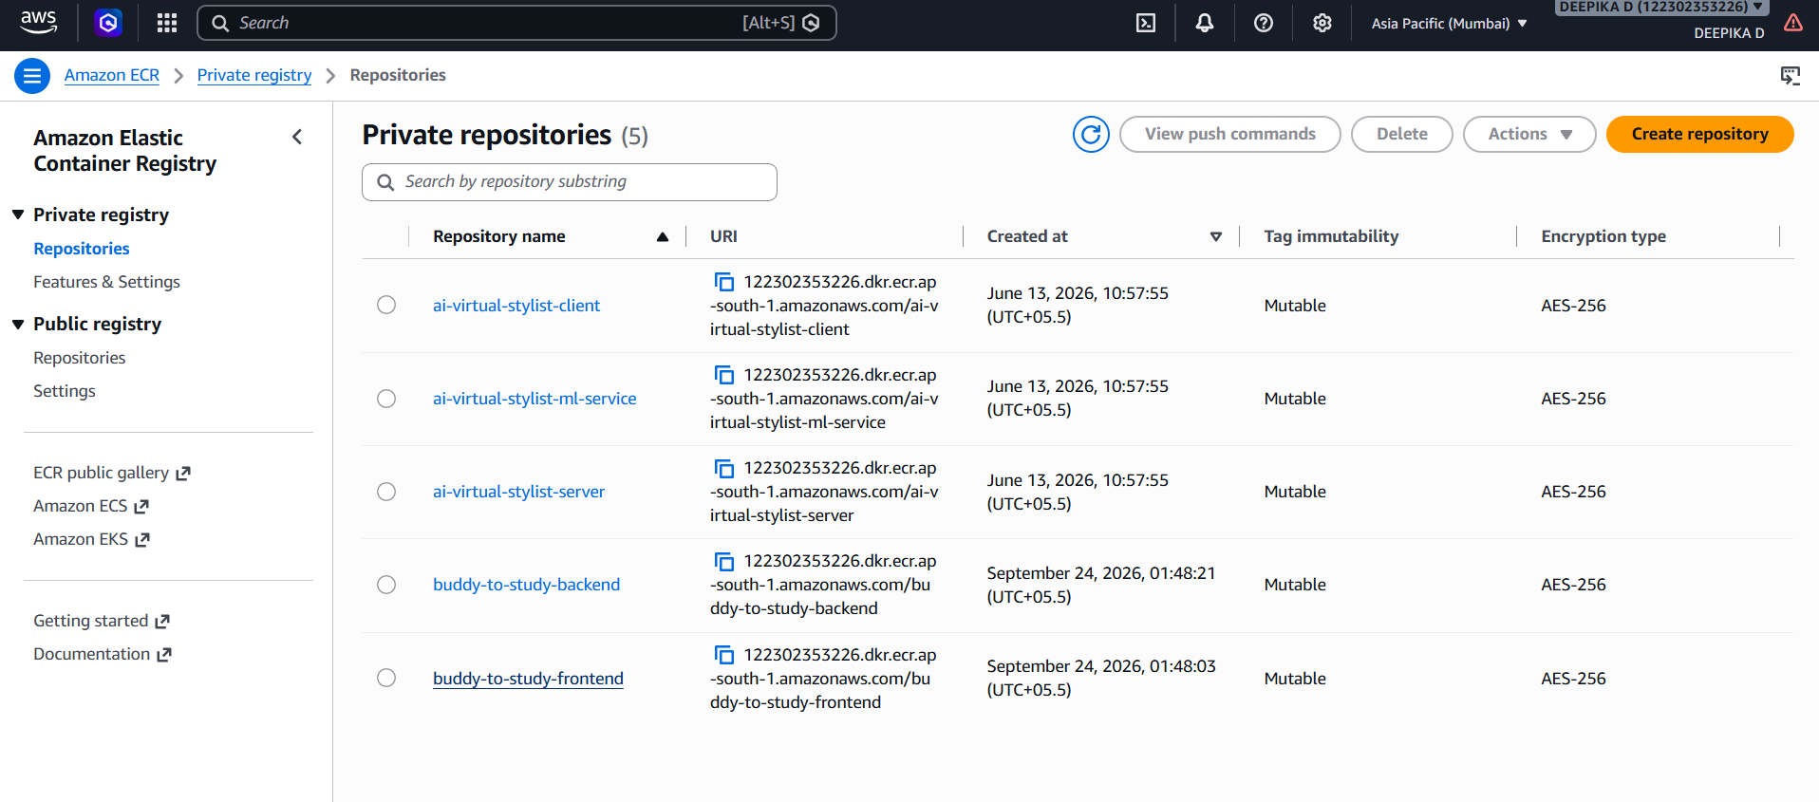
Figure 8. Amazon ECR repositories for frontend and backend images

4.9 Amazon ECS Fargate Cluster and Services
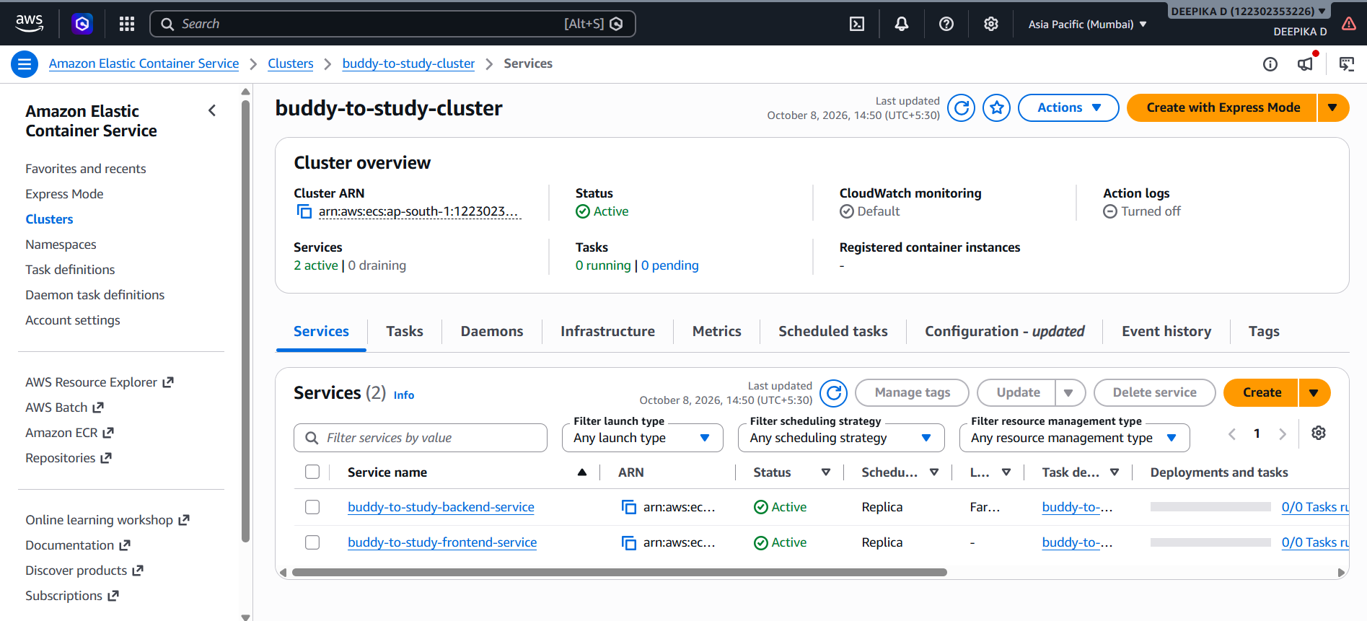
Figure 9. ECS Fargate cluster with frontend and backend services

4.10 ECS Task Definitions
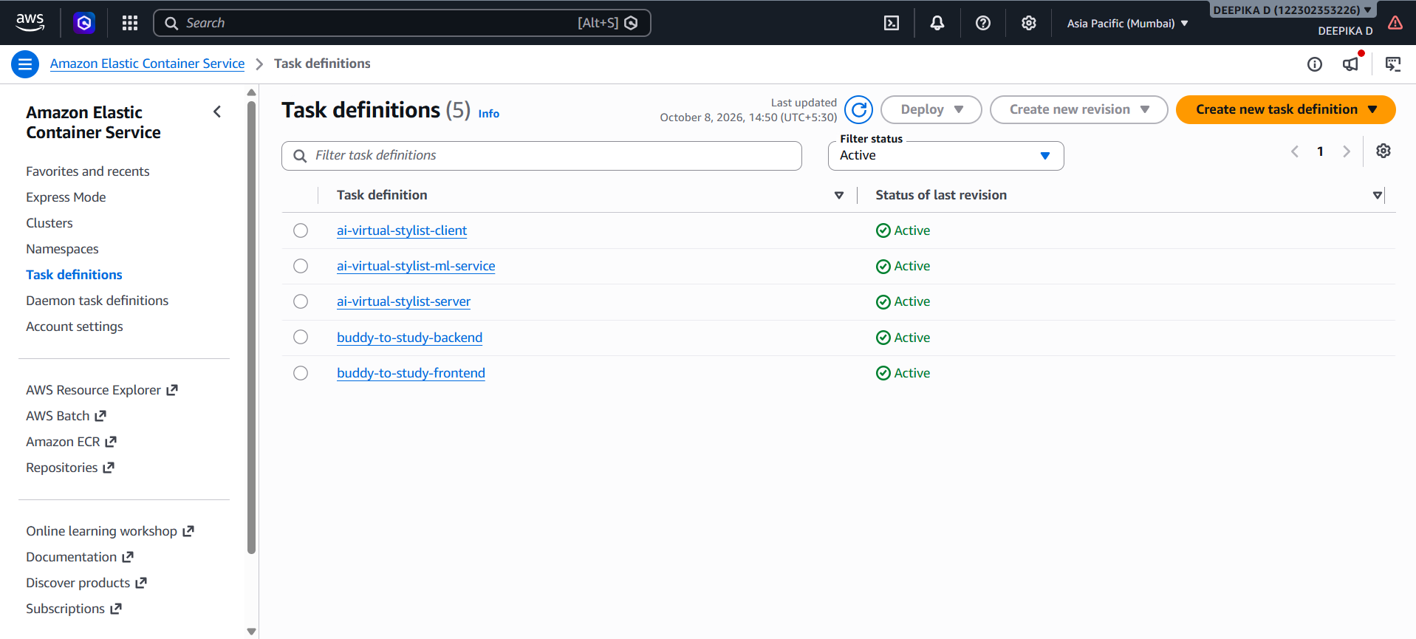
Figure 10. ECS task definitions for the application

4.11 Final Deployed Application Output
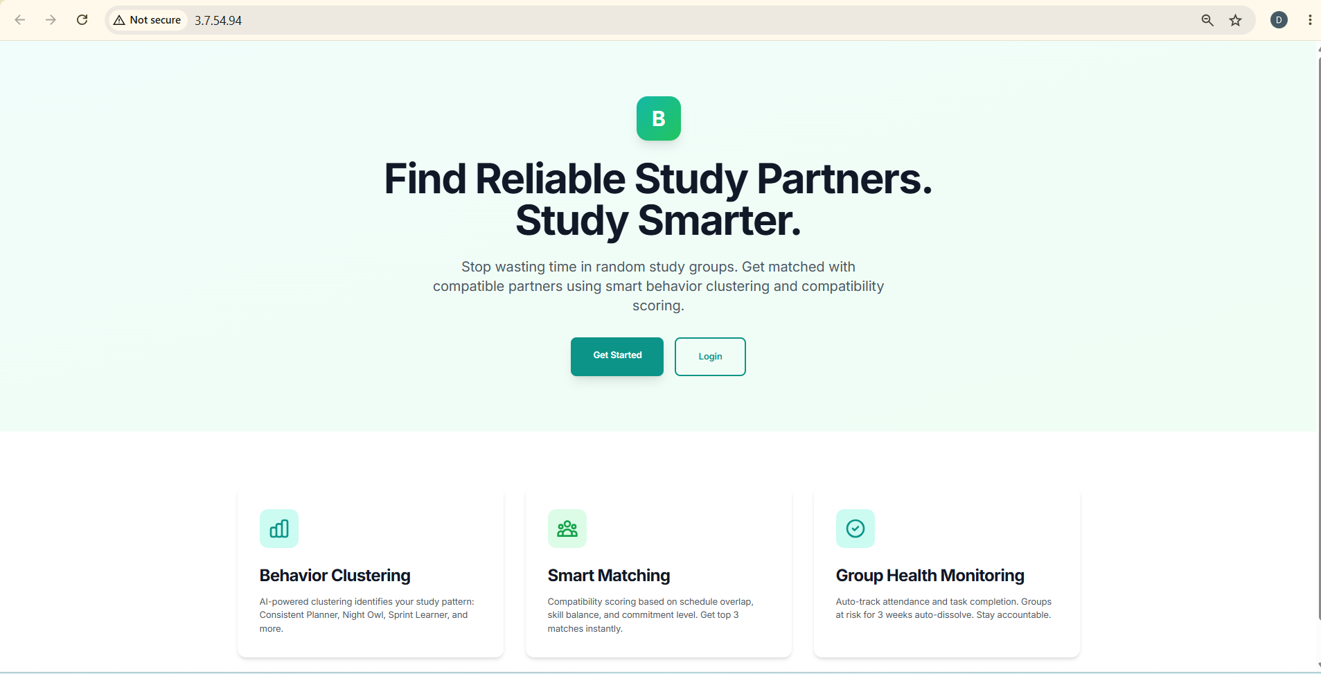
Figure 11. Final Buddy-to-Study application deployed on AWS ECS

5. Deployment Flow
GitHub Repository
↓
GitHub Actions – Build & CI/CD
↓
Docker Image Build
↓
Amazon ECR
├── buddy-to-study-frontend
└── buddy-to-study-backend
↓
Amazon ECS Fargate
├── Frontend Service : Port 80
└── Backend Service : Port 5000
↓
MongoDB Atlas

6. Result
The Buddy-to-Study application was successfully containerized using Docker. The Docker images were built through GitHub Actions and pushed to Amazon ECR. The frontend and backend were then deployed as ECS Fargate services, and the final application interface was verified through the deployed public endpoint.

7. Conclusion
This implementation demonstrates a practical cloud deployment workflow in which source code changes can be validated through GitHub Actions, packaged as Docker images, stored in Amazon ECR, and deployed using Amazon ECS Fargate. The approach provides a clear foundation for scalable and automated cloud deployment of a full-stack application.

8. Note
The screenshots in this report document the actual implementation and verification steps performed for the Buddy-to-Study application. AWS resources used for testing can be stopped or removed after demonstration to avoid unnecessary ongoing usage charges.

