1. Using our own terms and diagrams, explain INCEPTIONNET ARCHITECTURE.

**Ans : The paper proposes a new type of architecture – GoogLeNet or Inception v1. It is basically a convolutional neural network (CNN) which is 27 layers deep. 1×1 Convolutional layer before applying another layer, which is mainly used for dimensionality reduction.**

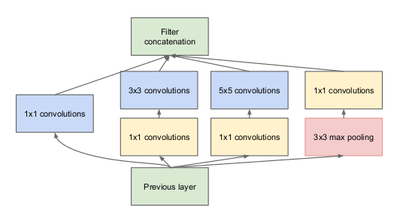

2. Describe the Inception block.

**Ans : An Inception Module is an image model block that aims to approximate an optimal local sparse structure in a CNN. Put simply, it allows for us to use multiple types of filter size, instead of being restricted to a single filter size, in a single image block, which we then concatenate and pass onto the next layer.**

3. What is the DIMENSIONALITY REDUCTION LAYER (1 LAYER CONVOLUTIONAL)?

**Ans : imensionality reduction refers to techniques that reduce the number of input variables in a dataset. More input features often make a predictive modeling task more challenging to model, more generally referred to as the curse of dimensionality.**

4. THE IMPACT OF REDUCING DIMENSIONALITY ON NETWORK PERFORMANCE

**Ans : Dimensionality reduction refers to techniques that reduce the number of input variables in a dataset. More input features often make a predictive modeling task more challenging to model, more generally referred to as the curse of dimensionality.**

5. Mention three components. Style GoogLeNet

**Ans : Deep learning revolution.**

**Artificial neural networks.**

**Deep neural networks.**

6. Using our own terms and diagrams, explain RESNET ARCHITECTURE.

**Ans : ResNet, which was proposed in 2015 by researchers at Microsoft Research introduced a new architecture called Residual Network. Residual Block: In order to solve the problem of the vanishing/exploding gradient, this architecture introduced the concept called Residual Network.**

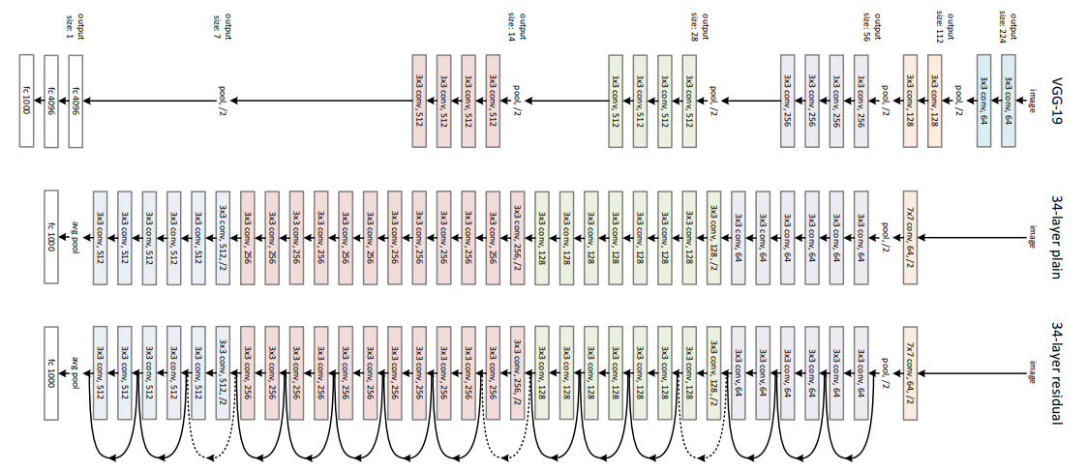

7. What do Skip Connections entail?

**Ans : Skip Connections (or Shortcut Connections) as the name suggests skips some of the layers in the neural network and feeds the output of one layer as the input to the next layers. Skip Connections were introduced to solve different problems in different architectures.**

8. What is the definition of a residual Block?

**Ans : A residual block is a stack of layers set in such a way that the output of a layer is taken and added to another layer deeper in the block. The non-linearity is then applied after adding it together with the output of the corresponding layer in the main path.**

9. How can transfer learning help with problems?

**Ans : Transfer learning helps developers take a blended approach from different models to fine-tune a solution to a specific problem. The sharing of knowledge between two different models can result in a much more accurate and powerful model. The approach allows for the building models in an iterative way.**

10. What is transfer learning, and how does it work?

**Ans : Transfer learning is an optimization that allows rapid progress or improved performance when modeling the second task. Transfer learning is the improvement of learning in a new task through the transfer of knowledge from a related task that has already been learned.**

11. HOW DO NEURAL NETWORKS LEARN FEATURES?

**Ans : Neural networks generally perform supervised learning tasks, building knowledge from data sets where the right answer is provided in advance. The networks then learn by tuning themselves to find the right answer on their own, increasing the accuracy of their predictions.**

12. WHY IS FINE-TUNING BETTER THAN START-UP TRAINING?

**Ans : In that case the answer is yes for deep networks because it is very hard to train the whole network with backprop because of the vanishing gradient problem. Your last layers will learn quickly but your first layer, the one connecting the input data to the first layer of hidden units, will learn so slowly that it will be almost identical to the random initialization. This doesn't depend on the size of the dataset but the number of levels in the network. Shallow nets can be trained with backprop, deep nets are better with greedy training layer by layer and then backprop to finetune the results. Note that when you tune the final result you are not really learning but optimizing an already existing network so your results can only get better.**