Day 2 Task motherboard and CPU
Q.1 Draw a labeled diagram of an ATX motherboard and mark at least 8 different slots and ports (such as RAM slots, PCIe slots, SATA ports, USB headers, CPU socket, power connector, etc.).
Ans=>

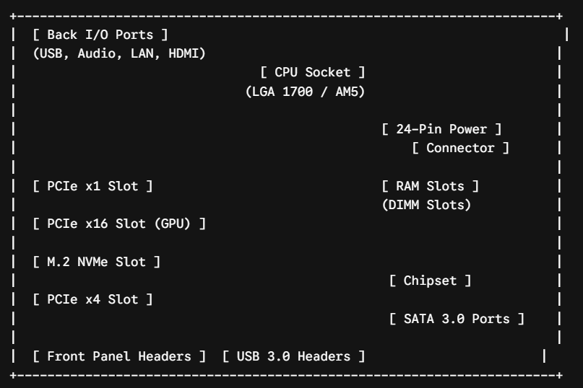

Key Component Labels & Explanations
1. CPU Socket (Central Processing Unit Socket):
- Function: The main slot where the processor (Intel or AMD) is installed and locked in using a retention lever.
2. DIMM RAM Slots (Random Access Memory Slots):
- Function: Long dual-inline memory slots (typically 4 on ATX boards) used to install DDR4 or DDR5 RAM modules.
3. PCIe x16 Slot (Peripheral Component Interconnect Express):
- Function: The primary high-bandwidth expansion slot used to install dedicated graphics cards (GPUs).
4. 24-Pin ATX Main Power Connector:
- Function: Receives main DC power supply cables directly from the Power Supply Unit (PSU) to power the motherboard circuit.
5. SATA III Ports (Serial AT Attachment):
- Function: Data transfer connectors used to connect 2.5-inch SATA SSDs and 3.5-inch hard disk drives (HDDs) via SATA cables.
6. M.2 PCIe Slot:
- Function: High-speed compact slot designed for mounting ultra-fast M.2 NVMe SSD storage drives directly onto the board.
7. USB Front Panel Headers (USB 2.0 / USB 3.0 / USB-C):
- Function: Internal pins connected to the chassis front panel ports to enable external USB functionality.
8. 8-Pin EPS / CPU Power Connector:
- Function: Dedicated power port usually located near the top-left edge that supplies clean power directly to the CPU VRM (Voltage Regulator Module).

Q.2 Research and list 3 popular CPU socket types (for example: LGA1151, AM064, LGA1200) and name one compatible CPU model for each.

Ans=>

Socket Type | Manufacturer | Compatible CPU Model
AM4 | AMD | AMD Ryzen 5 5600
LGA1700 | Intel | Intel Core i7-12700
AM5 | AMD | AMD Ryzen 7 7700X

- AM4: Supports 1st through 5th generation AMD Ryzen desktop processors (such as the Ryzen 5 5600).
- LGA1700: Supports Intel 12th, 13th, and 14th generation Core desktop processors (such as the Core i7-12700).
- AM5: Supports AMD Ryzen 7000, 8000, and 9000 series desktop processors.

Q.3 Explain in your own words the primary functions of the CPU and the chipset on a motherboard, and describe how they work together when you open a music app like Spotify.
Ans=>
Primary Functions of the CPU and Chipset
- CPU (Central Processing Unit): The CPU acts as the primary processing brain of the computer. Its role is to execute program instructions, calculate complex mathematical operations, and manage system tasks requested by software.
- Chipset: The chipset serves as the communications director on the motherboard. It manages and routes data traffic between the CPU and all peripheral devices, including storage drives, RAM, audio cards, and USB interfaces.
How They Work Together to Open Spotify
- User Request: When you click the Spotify icon, an input signal travels from your mouse or touchscreen through the chipset to alert the CPU that an action has been requested.
- Fetching Data: The CPU processes this instruction and commands the chipset to locate and retrieve Spotify's application files from your SSD or Hard Drive.
- Loading into Memory: The chipset routes the application data from the storage drive directly into system RAM so the CPU can access the files at ultra-high speeds.
- Execution & Playback: The CPU processes Spotify's core code to open the user interface. Once you play a song, the CPU decodes the digital audio file and sends the stream through the chipset to the audio controller, delivering sound through your headphones or speakers.

Q.4 Find a clear photo of a real motherboard (from the internet or your own device), and identify at least 5 different ports or slots by circling them and labeling each one.

Ans=> 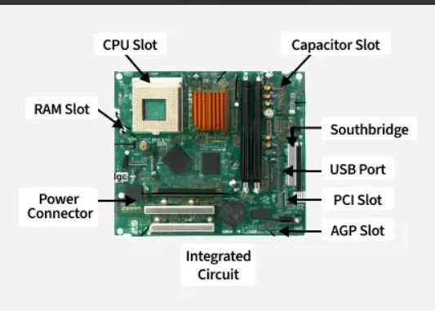

• CPU Socket:
- Location: Upper-center area of the motherboard.
- Function: Houses the CPU (processor) and connects it directly to the motherboard via electrical contact pins.
• DIMM RAM Slots:
- Location: Right side of the CPU socket.
- Function: Long dual inline memory slots used to install system RAM modules (DDR4 / DDR5) for short-term memory access.
• PCIe x16 Expansion Slot:
- Location: Lower-left section beneath the CPU socket.
- Function: High-bandwidth PCI Express slot primarily used to install dedicated Graphics Cards (GPUs).
• 24-Pin ATX Power Connector:
- Location: Far-right edge of the motherboard.
- Function: Main power delivery header connected directly to the Power Supply Unit (PSU) to power the motherboard electronics.
• SATA Ports (Serial ATA):
- Location: Bottom-right edge of the motherboard.
- Function: Data connector interface used for connecting 2.5-inch SATA SSDs, 3.5-inch Hard Drives (HDDs), and optical drives via SATA cables.

