Day 1 :overview of hardware and component
Task
Q.1 Draw a labeled diagram of a desktop PC, clearly marking the motherboard, CPU, RAM, GPU, and both HDD and SSD storage components.
Ans=>
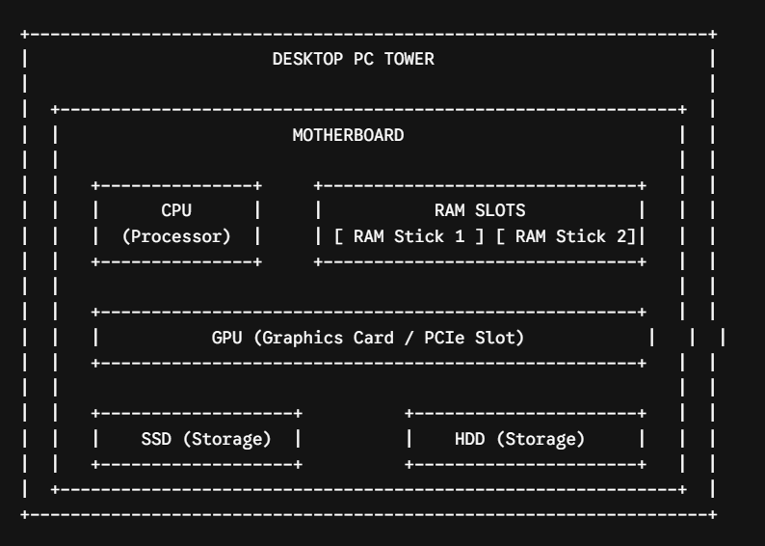

Key Component Descriptions:
- Motherboard: The main circuit board that connects all internal components together.
- CPU (Central Processing Unit): The "brain" of the computer that executes instructions and calculations.
- RAM (Random Access Memory): High-speed temporary memory used to store data currently in active use.
- GPU (Graphics Processing Unit): Dedicated processor for rendering images, video, and 3D graphics.
- SSD (Solid State Drive): Fast, flash-based storage drive for the operating system and applications.
- HDD (Hard Disk Drive): High-capacity magnetic mechanical drive used for bulk file storage.
Q.2 Create a comparison table showing the main differences between HDD and SSD storage in terms of speed, durability, and typical use cases.<br><br><em><strong>Hint:</strong> Think about which one is faster, which is more shock-resistant, and where you would usually find each type (laptop, gaming PC, etc.).</em>
Ans=>

Feature | Hard Disk Drive (HDD) | Solid State Drive (SSD)
Speed | Slower: Uses mechanical spinning platters (typical read/write speeds are around 80–160 MB/s). | Much Faster: Uses flash memory (read/write speeds range from 500 MB/s to over 7,000 MB/s).
Durability | Less Durable: Moving parts make it sensitive to drops, vibrations, and physical shocks. | Highly Durable: No moving parts, making it shock-resistant and safer for portable devices.
Typical Use Cases | Mass storage, long-term backups, desktop PCs needing high capacity on a budget, and data servers. | Laptops, high-performance gaming PCs, boot drives for operating systems, and fast photo/video editing.

Q.3 Write a short explanation (2-3 sentences each) describing the role of the CPU, RAM, and GPU in running a game like PUBG or Free Fire on a PC.
Ans=>
CPU (Central Processing Unit): The CPU acts as the primary brain of the computer, handling core game logic, physics calculations, and user input processing. In fast-paced battle royale games like PUBG or Free Fire, it tracks player movements, hit detection, and AI behavior across the entire map.
RAM (Random Access Memory): RAM serves as high-speed short-term memory, holding active game files, map layouts, and character assets so the processor can access them instantly. Having enough fast RAM prevents game stuttering and severe lag spikes when rendering large, open-world environments.
GPU (Graphics Processing Unit): The GPU is responsible for rendering all visual elements, including 3D environments, character textures, lighting, and particle effects. It processes these complex graphics in real time to deliver high frame rates, ensuring smooth visuals during intense combat sequences.

Q.4 Imagine you want to upgrade your PC to run the latest version of FIFA smoothly. List which hardware components you would consider upgrading and explain why for each.
Ans=>
To run the latest version of FIFA (EA Sports FC) smoothly at high settings and frame rates, here are the main hardware components to upgrade and the reasons for each:
- GPU (Graphics Processing Unit / Graphics Card)
  - Why: FIFA relies heavily on 3D graphics rendering, realistic lighting, detailed stadium environments, and advanced player animations. Upgrading your GPU ensures you get smooth 60+ FPS (frames per second) at 1080p or 4K resolution without stuttering or visual lag during fast-paced matches.
- RAM (Random Access Memory)
  - Why: Modern FIFA games require a minimum of 8 GB to 12 GB, but upgrading to 16 GB of high-speed RAM ensures the system can load detailed player models, realistic crowds, and stadium textures without background bottlenecking or sudden frame drops.
- Storage Drive (Upgrading from HDD to NVMe SSD)
  - Why: Moving the game to a fast Solid State Drive (SSD) drastically improves game load times, menu responsiveness, and transition speeds into matches compared to a traditional Hard Disk Drive (HDD).
- CPU (Central Processing Unit / Processor)
  - Why: FIFA calculates real-time physics, AI player positioning, and user inputs simultaneously. A faster multi-core CPU prevents bottlenecking high-end GPUs, ensuring smooth game simulation and consistent frame delivery.

