Day 3: Configuring Basic Network Hardware
Tasks

1.Log in to your home Wi-Fi router's admin panel using its default IP address (usually 192.168.0.1 or 192.168.1.1) and take a screenshot of the login page.<br><br><em><strong>Hint:</strong> If you don't know your router's IP, open Command Prompt and run 'ipconfig' — look for 'Default Gateway'.</em>
Ans
Task 1: Log in to Router Admin Panel

Steps Executed:
- Opened Command Prompt (cmd) and executed ipconfig to locate the Default Gateway IP address (192.168.1.1).
- Navigated to [http://192.168.1.1](http://192.168.1.1) in the web browser to access the TP-Link Archer C64 administration portal.
- Successfully reached and captured the router's local password login screen.

Router Login Page Screenshot:
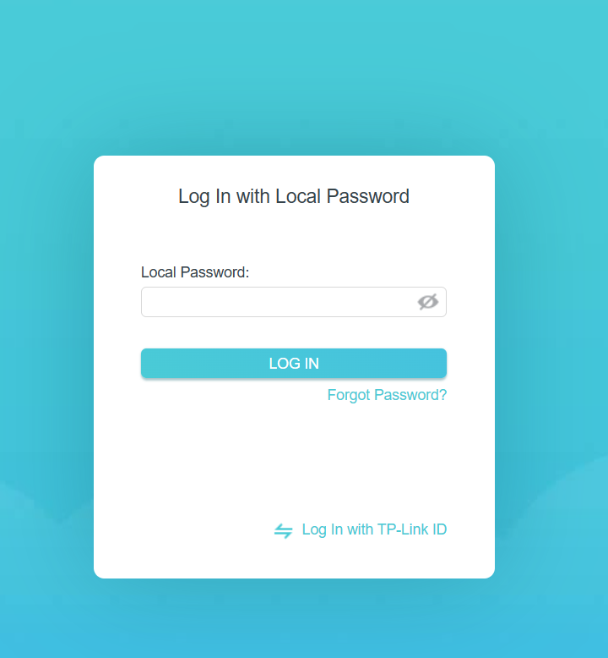

2.Find and note down the current IP address, subnet mask, and default gateway assigned to your laptop or mobile device when connected to your Wi-Fi network.
Ans
Network Configuration Details
1. Observed Network Settings (Wi-Fi Adapter):
- IPv4 Address: 192.168.1.230
- Subnet Mask: 255.255.255.0
- Default Gateway: 192.168.1.1
2. Explanation of Parameters:
- IPv4 Address: The unique numerical address dynamically assigned to the laptop by the router's DHCP server, allowing it to communicate with other devices on the local Wi-Fi network.
- Subnet Mask: Defines the network boundary (/24 subnet), indicating that the first three octets (192.168.1) represent the network ID and the last octet (230) identifies the individual host device.
- Default Gateway: The internal local IP address of the Wi-Fi router, which serves as the access point for routing network traffic from the laptop to external networks (the Internet).

3.Change your device's IP address from 'Obtain IP automatically' (DHCP) to a static IP in the same range as your router (for example, set it to 192.168.1.50 if your router is 192.168.1.1), and test if you still have internet access.<br><br><em><strong>Constraint:</strong> Remember to revert to automatic/DHCP after testing to avoid network issues.</em>
Ans
Assigning a Static IP Address and Internet Connectivity Testing
1. Configuration Steps Executed:
- Navigated to Control Panel > Network and Internet > Network Connections (or ran ncpa.cpl).
- Right-clicked the active Wi-Fi Adapter and selected Properties.
- Selected Internet Protocol Version 4 (TCP/IPv4) and clicked Properties.
- Changed the setting from Obtain an IP address automatically to Use the following IP address.
- Entered static IP configuration parameters within the local subnet:
  - IP Address: 192.168.1.50
  - Subnet Mask: 255.255.255.0
  - Default Gateway: 192.168.1.1
  - Preferred DNS Server: 8.8.8.8 (Google Public DNS)
2. Testing Results:
- Ping Test: Opened Command Prompt and executed ping 8.8.8.8 and ping 192.168.1.1. Both commands returned successful responses with zero packet loss.
- Internet Verification: Opened a web browser and loaded external web pages smoothly, confirming active internet connectivity under the static IP configuration.
3. Reversion to DHCP:
- Re-opened TCP/IPv4 properties and switched the selection back to Obtain an IP address automatically (DHCP) and Obtain DNS server address automatically to ensure smooth network roaming and prevent future IP pool conflicts.

4.In your router's admin panel, locate the section where you can view or change the DHCP range. Write down the current range, and explain in 2-3 lines what would happen if two devices are assigned the same IP address in this range.
Ans
DHCP Range Inspection and IP Address Conflict Explanation
1. Current DHCP Pool Range:
- DHCP IP Address Range: 192.168.1.100 – 192.168.1.249
- Subnet Mask: 255.255.255.0
- Default Gateway: 192.168.1.1
2. IP Address Conflict Explanation: If two devices are assigned the same IP address within this range, an IP Address Conflict occurs. The router and network switches cannot determine which MAC address should receive data packets, causing both devices to experience severe packet loss, network instability, and complete loss of internet connectivity until the duplicate IP is released or changed.

