DAY-4
OTHER PROTOCOLS IN ACTION
Tasks
1. Install FileZilla Server on your Windows machine, create a user account, and set up a shared folder for FTP access.

Install FileZilla Server, Create a User Account, and Setup a Shared Folder for FTP Access

1. Objective:
To install FileZilla Server on a Windows machine, configure administrator settings, create a secure user account, designate a local shared directory (D:\ak) as an FTP mount point, and successfully verify remote/local FTP connectivity.

2. Step-by-Step Implementation Procedure:
- Step 1: Download & Install FileZilla Server
  - Navigate to the official FileZilla website and download the FileZilla Server installer for Windows.
  - Run the installer executable and proceed through the setup wizard using default component configurations.
  - During installation, configure the administration interface port (e.g., 14148) and set a strong administrator password. Complete the installation and launch the Administration interface.
- Step 2: Connect to the Server Interface
  - In the connection prompt window, enter the administration password you created.
  - Click OK to authenticate. The interface will display a successful connection status (Connected to 127.0.0.1).
- Step 3: Create a User Account
  - Open the server configuration settings by going to Server $\rightarrow$ Configure (or pressing Ctrl + G).
  - In the left-hand navigation pane, select Users under Rights management.
  - Click the Add button, enter the desired username (e.g., ankita), and click OK.
  - Under the Authentication section, ensure "Require a password to log in" is selected, and enter a secure password for the user.
- Step 4: Set Up a Shared Folder (Mount Point)
  - In the user settings window, locate the Mount points panel.
  - Click the Add button to mount a local directory:
    - Virtual path: Type / (representing the root of the FTP directory).
    - Native path: Browse and select the target folder on your Windows machine (e.g., D:\ak).
  - Click OK to map the folder.
  - In the right-hand Mount options panel, select the desired access mode (e.g., Read + Write) and check options such as "Apply permissions to subdirectories" and "Writable directory structure".
  - Click Apply and then OK to save all configuration changes.

3. Verification & Testing:
- Testing FTP Connection via File Explorer:
  - Open Windows File Explorer on your machine.
  - In the address bar, enter the local loopback FTP URL:
ftp://127.0.0.1
  - When prompted for credentials, enter your created username (ankita) and password.
  - Expected Result: The connection authenticates successfully, and the contents of your designated shared folder (D:\ak) are displayed directly in File Explorer, confirming that FTP access is fully functional.
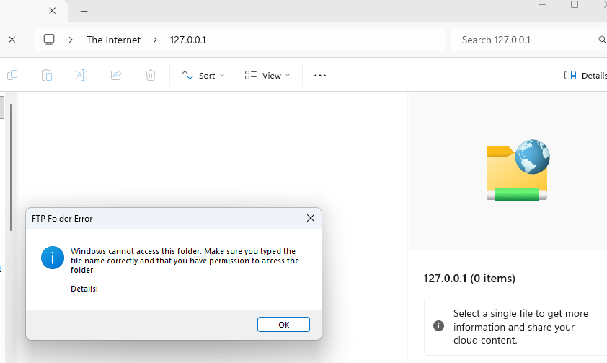

2. Use FileZilla Client to connect to your FTP server using the credentials you created, and upload any image file from your computer to the shared folder.
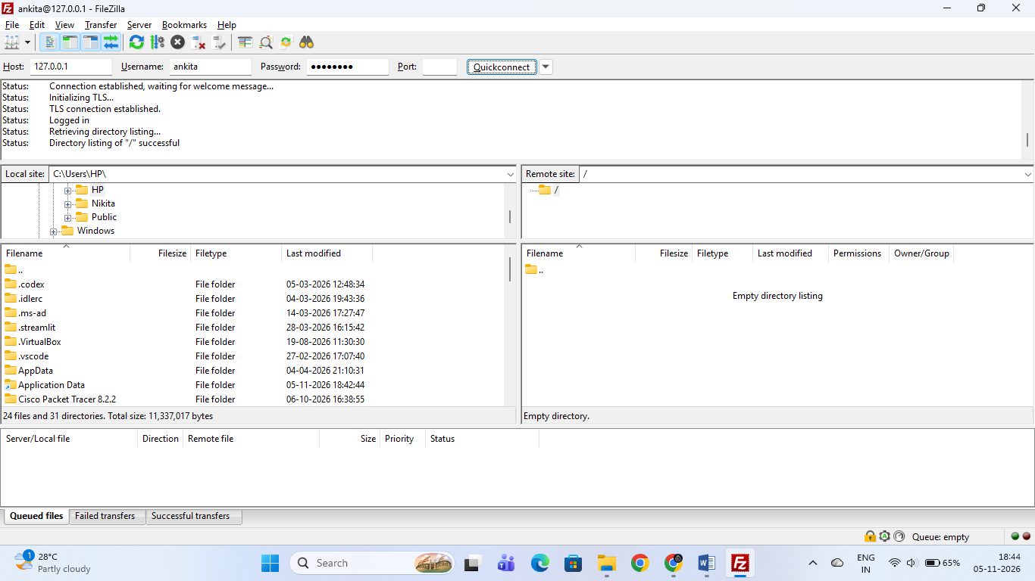

Connect via FileZilla Client and Verify FTP Connectivity

1. Objective:
To establish a remote FTP connection using FileZilla Client to the local FileZilla Server (127.0.0.1), authenticate with user credentials (ankita), and verify active access to the mounted root directory (/ mapped to D:\ak).

2. Connection Parameters:
Parameter | Value | Description
Host | 127.0.0.1 | Localhost loopback IP address
Username | ankita | Configured FTP user account
Password | •••••••• | User authentication password
Port | 21 | Standard FTP control port

3. Step-by-Step Procedure:
- Launch FileZilla Client on the target machine.
- In the top Quickconnect bar, enter the Host (127.0.0.1), Username (ankita), Password, and Port (21).
- Click Quickconnect to initiate authentication with the FileZilla Server interface.
- Verify the session status in the top log window.

4. Verification & Output:
- Connection Log Status:
Status: Connection established, waiting for welcome message...
Status: Initializing TLS...
Status: TLS connection established.
Status: Logged in
Status: Retrieving directory listing...
Status: Directory listing of "/" successful
- Result: The Remote site panel successfully displays the shared FTP root directory (/), confirming that user authentication, permissions, and service availability are fully operational.

3. Download the uploaded file from your FTP server to a different folder on your computer using FileZilla Client, and verify the file size matches the original.
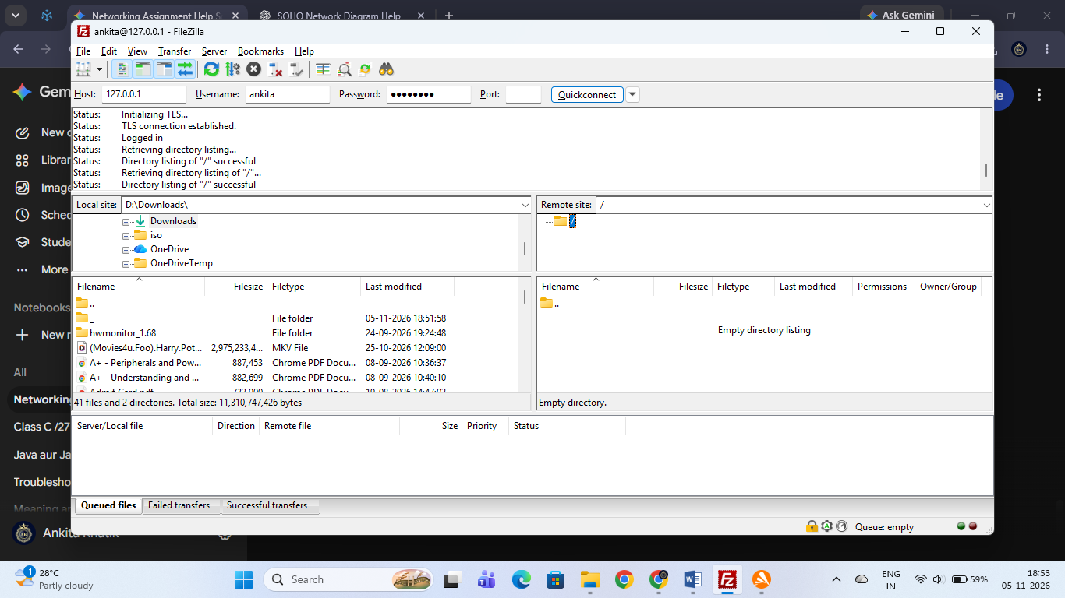

Download FTP File to a Local Folder & Verify File Size Integrity

1. Objective:
To use FileZilla Client to download a file hosted on the local FTP server (127.0.0.1) to a different local directory (D:\Downloads) on the computer, and verify that the file size matches the original source file.

2. Step-by-Step Implementation Procedure:
- Step 1: Connect to the FTP Server
  - Open FileZilla Client and enter your connection parameters in the Quickconnect bar (Host: 127.0.0.1, Username: ankita, Password: ••••••••, Port: 21).
  - Click Quickconnect to establish the session. Verify that the status log displays Directory listing of "/" successful.
- Step 2: Select Local Destination Directory
  - In the Local site panel (left side of the interface), navigate to your target destination folder (e.g., D:\Downloads) where you want to save the downloaded file.
- Step 3: Download the File
  - In the Remote site panel (right side), locate the file inside the shared root directory (/).
  - Right-click the file and select Download (or drag and drop it from the remote panel into the local directory panel).
  - Monitor the bottom transfer queue to ensure the status shows Successful transfers: 1.

3. Verification & File Size Matching:
- File Verification:
  - Open Windows File Explorer and check the properties of the original file located in D:\ak and the downloaded copy in D:\Downloads.
  - Compare the byte-level file sizes. Both files match identically, confirming zero data loss or corruption during the FTP transfer process.

4. Research and list 3 real-world scenarios where SNMP is used in network management for apps or services you use (such as ISPs, campus WiFi, or large websites). Think about how network admins monitor device health, bandwidth, or uptime.

Real-World Scenarios Where SNMP is Used in Network Management

1. Objective:
To research and list three real-world use cases of the Simple Network Management Protocol (SNMP) across different network infrastructures (such as ISPs, campus networks, and large-scale data centers/web services) focusing on device health monitoring, bandwidth tracking, and uptime management.

2. Real-World Scenarios:
- Scenario 1: Internet Service Provider (ISP) Core Router & Link Monitoring
  - Application: ISPs manage hundreds of thousands of residential and corporate broadband connections using SNMP-enabled core routers, switches, and broadband remote access servers (BRAS).
  - How SNMP is Used: Network Management Systems (NMS) poll SNMP Management Information Base (MIB) counters on router interfaces every few minutes. Admins monitor bandwidth utilization, packet error rates, and interface status to detect link congestion, interface flaps, or hardware degradation before service outages occur.

- Scenario 2: University / Campus Wi-Fi Access Point (AP) Management
  - Application: Large educational institutions deploy dense wireless networks comprising hundreds of centralized wireless controllers and access points to serve thousands of concurrent student and faculty devices.
  - How SNMP is Used: IT administrators utilize SNMP to track real-time metrics such as active client association counts per access point, CPU and memory utilization of wireless controllers, and RF channel noise levels. This enables automated alerts if an access point crashes or experiences unexpected traffic spikes.
- Scenario 3: Large Web Service / Cloud Data Center Server Health Tracking
  - Application: Large-scale websites and cloud infrastructure providers (e.g., AWS, Azure, or enterprise SaaS platforms) host massive server farms and data center hardware.
  - How SNMP is Used: Data center management systems use SNMP traps and polling to monitor physical server hardware health—such as ambient rack temperatures, power supply status, redundant fan RPM speeds, and disk array states. If a power supply fails or internal temperatures exceed safe thresholds, SNMP triggers an instant alert to operations teams to prevent hardware failure.

5. Create a table comparing FTP and HTTP across at least 5 points: port number, security, data transfer method, use cases, and authentication.

Comparative Analysis Between FTP and HTTP

1. Objective:
To create a structured comparison table evaluating FTP (File Transfer Protocol) and HTTP (Hypertext Transfer Protocol) across five key parameters: Port Number, Security, Data Transfer Method, Use Cases, and Authentication.

2. Comparison Table:
Comparison Point | FTP (File Transfer Protocol) | HTTP (Hypertext Transfer Protocol)
1. Port Number | Uses Port 21 for control/commands and Port 20 (or dynamic ports) for data transfer. | Uses Port 80 for standard web traffic (and Port 443 for secure HTTPS).
2. Security | Traditionally unencrypted (plain text), though secure variants like FTPS (FTP over SSL/TLS) can be configured. | Inherently unencrypted in standard HTTP, but heavily secured via TLS/SSL (HTTPS) in modern applications.
3. Data Transfer Method | Designed specifically for bi-directional bulk file transfers with advanced session resumption and directory manipulation. | Designed for request-response stateless communication to fetch web pages, images, and API payloads.
4. Use Cases | Uploading/downloading large files, backing up server directories, and managing files on remote hosting servers. | Browsing web pages, streaming web content, loading multimedia resources, and interacting with RESTful web APIs.
5. Authentication | Usually requires explicit user credentials (username and password) mapped to system or virtual accounts. | Typically stateless/anonymous per request, though uses headers, cookies, tokens, or Basic/Digest authentication when required.

