DAYS 1-5
BUILD AND CONFIGURE A SMALL OFFICE NETWORK DELIVERABLE
Tasks
1. Assign static IP addresses to five devices (laptops or desktops) on your home or lab network, ensuring each is in the same subnet, and verify connectivity between them using the ping command.
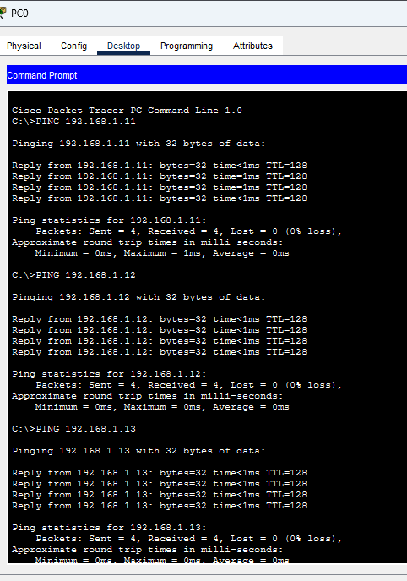

Assign Static IP Addresses to Five Devices & Verify Connectivity

1. Objective:
To assign static IPv4 addresses to five end devices within the same subnet and verify successful local network connectivity using the ping command.

2. Subnet and IP Address Plan:
- Network Subnet: 192.168.1.0 /24
- Subnet Mask: 255.255.255.0
- Default Gateway: 192.168.1.1
Device Name | Assigned IPv4 Address | Subnet Mask | Default Gateway
PC0 (Source) | 192.168.1.10 | 255.255.255.0 | 192.168.1.1
PC1 | 192.168.1.11 | 255.255.255.0 | 192.168.1.1
PC2 | 192.168.1.12 | 255.255.255.0 | 192.168.1.1
PC3 | 192.168.1.13 | 255.255.255.0 | 192.168.1.1
PC4 | 192.168.1.14 | 255.255.255.0 | 192.168.1.1

3. Implementation Procedure:
- Open each device's Desktop > IP Configuration panel in Cisco Packet Tracer.
- Select Static and input the respective IP address, subnet mask, and default gateway from the table above.

4. Connectivity Verification (ping Test):
- Open the Command Prompt on PC0 (192.168.1.10).
- Execute ping commands to verify connectivity with other nodes:
ping 192.168.1.11
ping 192.168.1.12
ping 192.168.1.13
ping 192.168.1.14
- Verification Result: Successful replies show Packets: Sent = 4, Received = 4, Lost = 0 (0% loss) with low round-trip times, confirming that all static devices are fully reachable within the same subnet.
2. Set up a DHCP server (using your router or software like Packet Tracer/GNS3/VirtualBox) to automatically assign IP addresses to at least three devices, and confirm that each device receives a unique IP from the correct range.

Configure a DHCP Server in Cisco Packet Tracer
Aim: To configure a DHCP server in Cisco Packet Tracer and automatically assign IP addresses to at least three devices. Verify that each device receives a unique IP address from the correct range.

1. Requirements
- Cisco Packet Tracer
- 1 Router (2911)
- 1 Switch (2960)
- 1 Server
- 3 PCs
- Copper Straight-Through cables

2. Network Topology
Connect Router0, Server0, PC0, PC1 and PC2 to Switch0 using Copper Straight-Through cables.
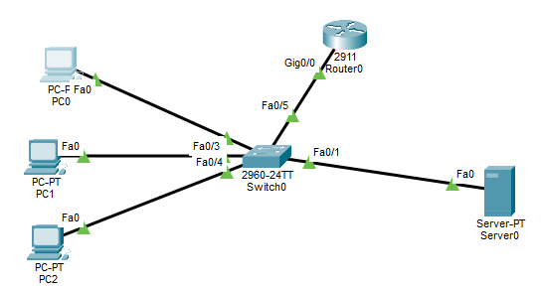

3. Network Configuration
First, configure the router with the following commands:
enable
configure terminal
interface gigabitEthernet 0/0
ip address 192.168.1.1 255.255.255.0
no shutdown
exit
end

4. Server Configuration
Open Server0 → Desktop → IP Configuration and select Static.
Setting | Value
IP Address | 192.168.1.2
Subnet Mask | 255.255.255.0
Default Gateway | 192.168.1.1
DNS Server | 8.8.8.8

5. DHCP Server Configuration
Open Server0 → Services → DHCP and turn the DHCP service ON.
Enter the following settings:
Setting | Value
Pool Name | OFFICE
Default Gateway | 192.168.1.1
DNS Server | 8.8.8.8
Start IP Address | 192.168.1.100
Subnet Mask | 255.255.255.0
Maximum Users | 50
Click the Add button to create the DHCP pool.

6. Client Configuration
Open each PC and select Desktop → IP Configuration → DHCP.
The DHCP server automatically assigns IP addresses to the PCs.
Device | Assigned IP Address
PC0 | 192.168.1.100
PC1 | 192.168.1.101
PC2 | 192.168.1.102

7. Connectivity Verification
Open PC0 → Desktop → Command Prompt.
Enter these commands:
ipconfig
ping 192.168.1.101
ping 192.168.1.102
Observed Result:
- PC0 received IP address 192.168.1.100.
- PC0 successfully pinged PC1 (192.168.1.101).
- PC0 successfully pinged PC2 (192.168.1.102).
- Ping test showed 4 packets sent, 4 received and 0% packet loss for PC1.

8. Result
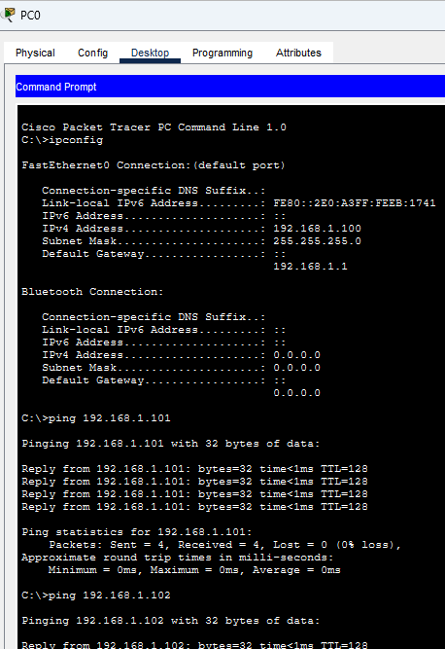
The DHCP server was successfully configured in Cisco Packet Tracer. Three client devices automatically received unique IP addresses from the configured DHCP range. Connectivity between the devices was verified successfully using the ping command.

9. Conclusion
DHCP (Dynamic Host Configuration Protocol) automatically assigns IP addresses and other network settings to devices. It reduces manual configuration and prevents IP address conflicts by assigning unique addresses to clients.

3. Configure a DNS service (using your router’s DNS settings or a tool like dnsmasq) so that typing a custom hostname (e.g., musicplayer.local) in a browser on any connected device opens a specific local web page or device interface.You can map hostnames to local IPs using the DNS service or by editing the hosts file for a quick test.

Configure a DNS Service in Cisco Packet Tracer
Aim: To configure a DNS service so that typing a custom hostname (musicplayer.local) in a browser opens a specific local web page on connected devices.

1. Requirements
- Cisco Packet Tracer
- 1 Router (2911)
- 1 Switch (2960)
- 1 Server
- 3 PCs
- Copper Straight-Through cables

2. Network Topology
Connect Router0, Server0, PC0, PC1 and PC2 to Switch0 using Copper Straight-Through cables.

3. IP Address Configuration
Configure the following IP addresses:
Device | IP Address
Router0 | 192.168.1.1
Server0 | 192.168.1.2
PC0 | 192.168.1.100
PC1 | 192.168.1.101
PC2 | 192.168.1.102
Subnet Mask: 255.255.255.0

4. Configure DNS Service
- Open Server0.
- Go to Services → DNS.
- Turn DNS Service ON.
- Enter the following details:
Field | Value
Name | musicplayer.local
Type | A Record
Address | 192.168.1.2
5. Click the Add button.
The DNS server maps the hostname musicplayer.local to IP address 192.168.1.2.

5. Configure HTTP Service
- Open Server0 → Services → HTTP.
- Turn HTTP Service ON.
- Edit the index.html file.
- Enter the following HTML code:
<html>
<head>
<title>Music Player</title>
</head>
<body>
<h1>Welcome to My Music Player</h1>
<p>DNS Configuration Successful!</p>
</body>
</html>
5. Save the file.

6. Configure DHCP DNS Settings
Open Server0 → Services → DHCP.
Set the following details:
Setting | Value
Default Gateway | 192.168.1.1
DNS Server | 192.168.1.2
Start IP Address | 192.168.1.100
Subnet Mask | 255.255.255.0
Click Save.

7. Verify DNS Configuration
Open PC0 → Desktop → Command Prompt.
First, check the network configuration:
ipconfig
Then test DNS using:
ping musicplayer.local
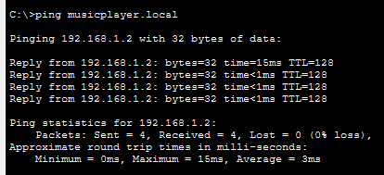
Observed Result:
- The hostname successfully resolved to 192.168.1.2.
- Ping was successful with 4 packets received and 0% packet loss.
- The DNS server correctly translated the hostname into an IP address.

8. Test Using Web Browser
- Open PC0 → Desktop → Web Browser.
- Enter the following URL:
http://musicplayer.local
3. Click Go.

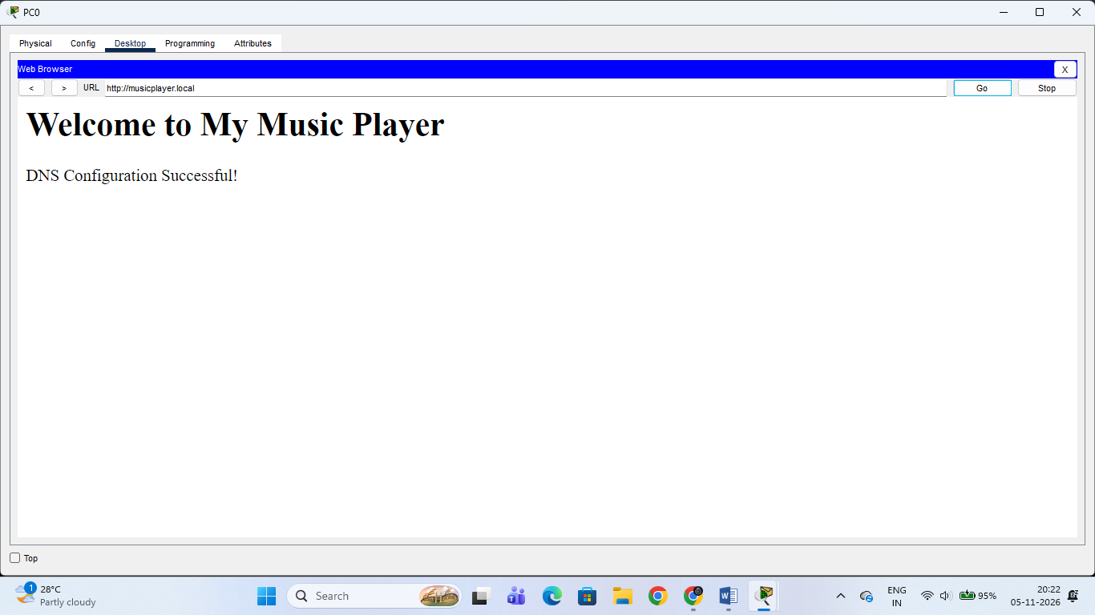Welcome to My Music Player
DNS Configuration Successful!
Webpage opened successfully

9. Result
The DNS service was successfully configured in Cisco Packet Tracer. The custom hostname musicplayer.local was mapped to the local server IP address 192.168.1.2. The local webpage was successfully accessed using the hostname in the web browser.

10. Conclusion
DNS (Domain Name System) converts human-readable hostnames into IP addresses. It makes accessing websites and network devices easier without remembering their IP addresses.

4. Create two VLANs (e.g., VLAN 10: 'Workstations', VLAN 20: 'Smart Devices') on your switch or simulation tool, assign at least two devices to each VLAN, and demonstrate that devices in the same VLAN can communicate, but not with devices in the other VLAN. Use ping or file sharing to test connectivity between devices in different VLANs.

Create and Configure Two VLANs on a Switch

1. Objective:
To create two distinct VLANs (VLAN 10: 'Workstations' and VLAN 20: 'Smart Devices') on a network switch, assign devices to each, and verify that intra-VLAN communication works while inter-VLAN communication is successfully isolated.

2. Switch Configuration Commands (show vlan brief Verification):

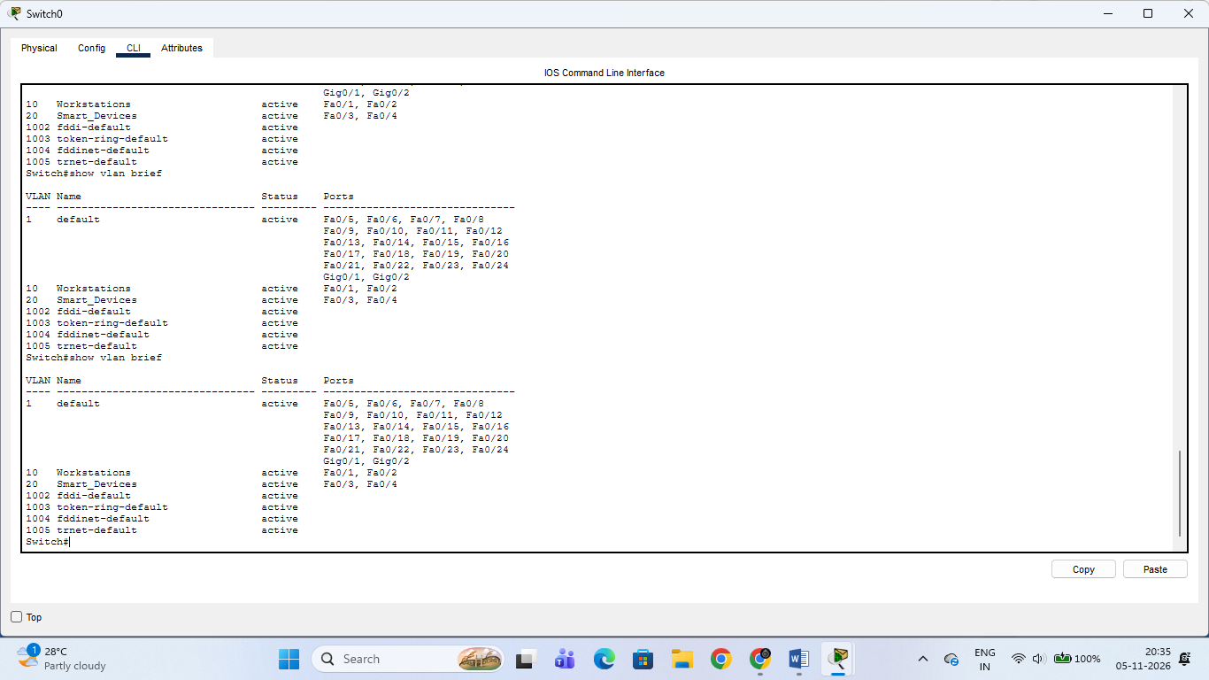
- Step 1: Create VLANs on Switch
enable
configure terminal
vlan 10
name Workstations
vlan 20
name Smart_Devices
exit
- Step 2: Assign Access Ports
interface range fastethernet 0/1 - 2
switchport mode access
switchport access vlan 10
interface range fastethernet 0/3 - 4
switchport mode access
switchport access vlan 20
end
- Verification (show vlan brief output):
  - VLAN 10 (Workstations): Active on ports Fa0/1, Fa0/2.
  - VLAN 20 (Smart_Devices): Active on ports Fa0/3, Fa0/4.

3. Connectivity Testing & Results:
- Test A: Intra-VLAN Communication (Same VLAN)
  - Action: Pinged another device within the same VLAN subnet.
  - Verification Result: Successful replies with 0% packet loss, confirming devices in the same VLAN communicate seamlessly.
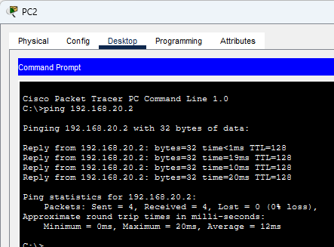
- Test B: Inter-VLAN Isolation (Different VLANs)
  - Action: Attempted to ping across VLANs (e.g., from VLAN 10 to VLAN 20).
  - Verification Result: Results in Request timed out (100% loss), verifying that Layer 2 security isolation is functioning correctly and cross-VLAN traffic is blocked without a router.
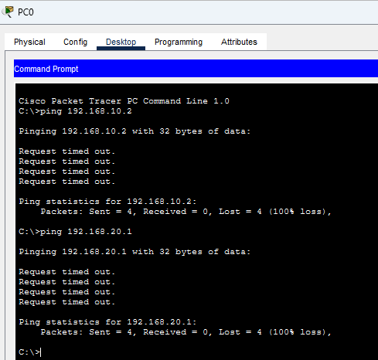

5. Simulate internet access for your LAN by configuring a router with NAT (Network Address Translation), then test that devices on your LAN can access an external site (e.g., www.wikipedia.org) or a simulated external server.

Simulate Internet Access via NAT

1. Objective:
To configure a router with NAT (Network Address Translation) and PAT (Port Address Translation / Overload) to allow devices on the private LAN subnet to access external simulated websites or servers on the internet.
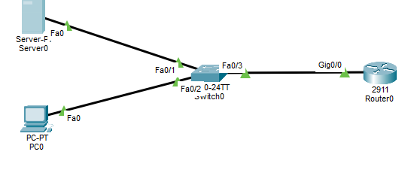

2. Network Interface & NAT Planning:
- Inside Local Interface (LAN Gateway): GigabitEthernet0/0 with IP address 192.168.1.1 (255.255.255.0)
- Outside Public Interface (WAN / Internet): GigabitEthernet0/1 with IP address 203.0.113.2 (255.255.255.0)
- Allowed LAN Subnet: 192.168.1.0 /24

3. Step-by-Step Configuration Commands:
- Step 1: Configure Router Interfaces (Inside and Outside)
  - Open the Gateway Router CLI in Cisco Packet Tracer.
  - Enter global configuration mode and configure the inside LAN interface:
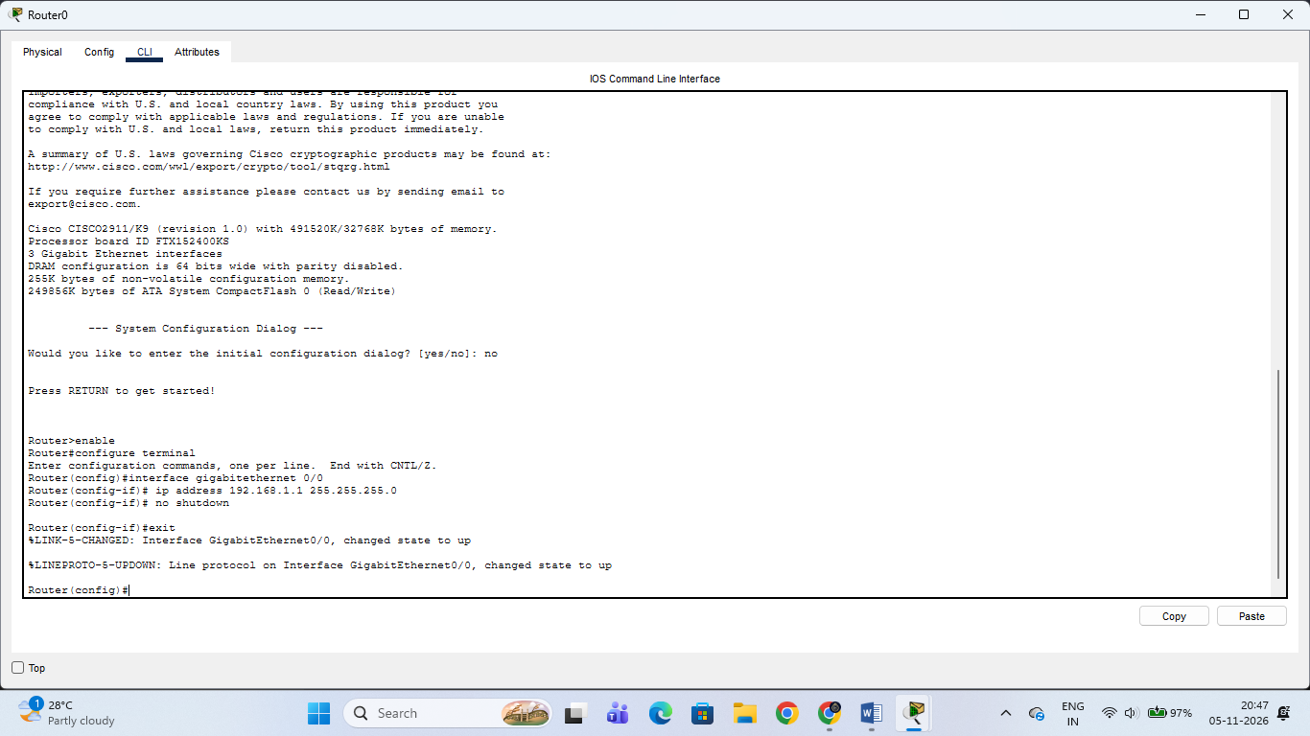
enable
configure terminal
interface gigabitethernet 0/0
ip address 192.168.1.1 255.255.255.0
ip nat inside
no shutdown
exit
  - Configure the outside WAN interface connecting to the simulated internet:
interface gigabitethernet 0/1
ip address 203.0.113.2 255.255.255.0
ip nat outside
no shutdown
exit
- Step 2: Configure Access Control List (ACL) and NAT Overload (PAT)
  - Define an access list to permit private IP addresses from the LAN subnet:
access-list 1 permit 192.168.1.0 0.0.0.255
  - Bind the access list to translate local traffic dynamically through the outside public interface address using overload:
ip nat inside source list 1 interface gigabitethernet 0/1 overload
exit

4. Connectivity Verification:
- Open the Command Prompt on any client PC on the private LAN (e.g., PC0 with IP 192.168.1.10).
- Test connection by pinging the simulated external server / public IP address:
ping 203.0.113.1
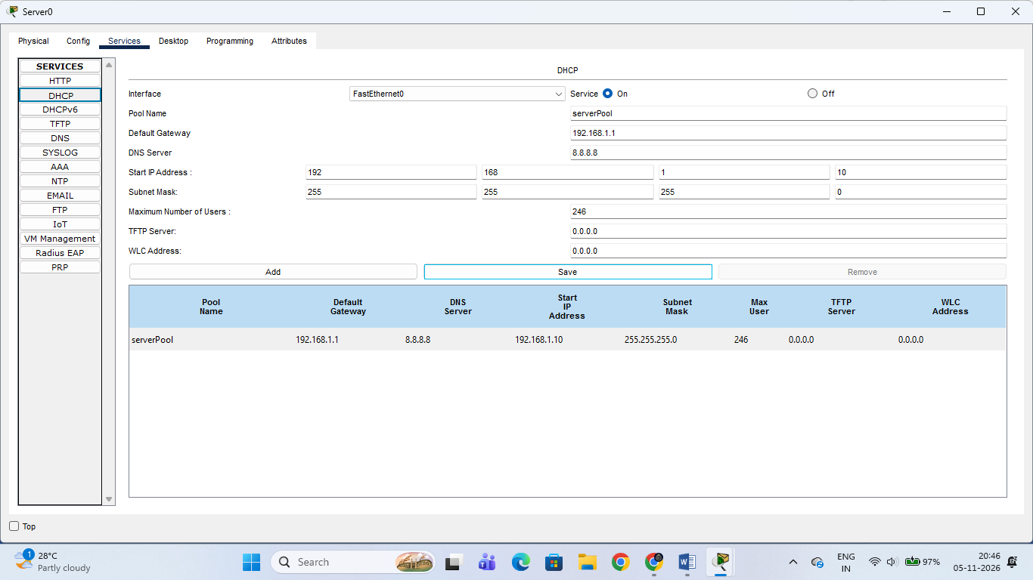
- Verification Result: Successful replies with 0% packet loss confirm that Network Address Translation (NAT) is successfully translating private LAN packets to public IP traffic for simulated internet access.


