DAY 1
INTRODUCTION TO NETWORKPROTOCOLS
Tasks
1. Use Wireshark to capture network traffic while you load www.spotify.com in your browser, then identify and note down at least two DNS packets and two HTTP or HTTPS packets in the capture.
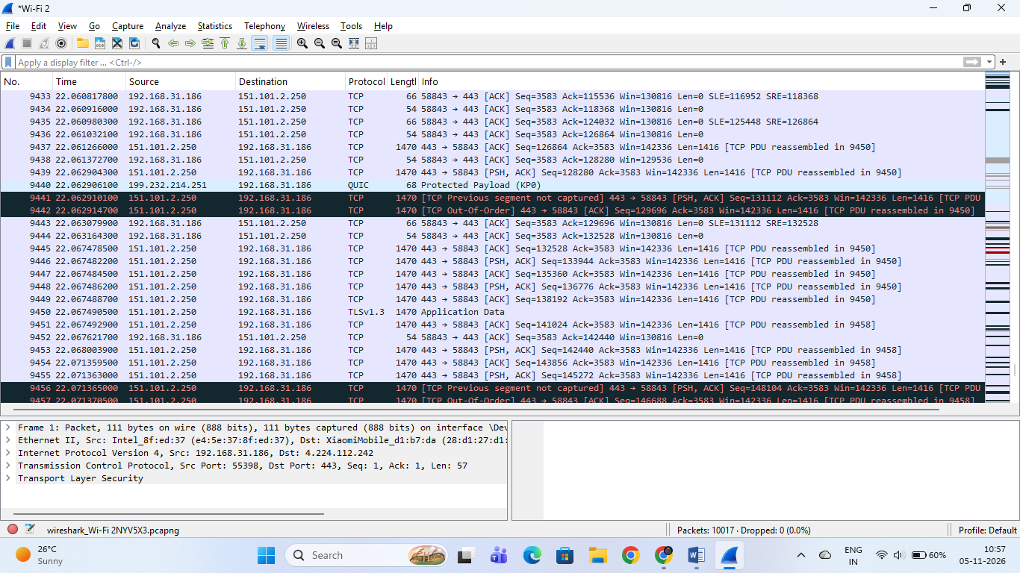

Wireshark Packet Capture Analysis (Spotify Session)
- Active Interface: Wi-Fi 2 (192.168.31.186)
- Observed Protocols & Packets:
  - TCP & TLSv1.3: Frequent communication with Spotify's content delivery servers (e.g., 151.101.2.250) over port 443, handling secure HTTPS data transfer, acknowledgements ([ACK]), segment reassembly, and encrypted application payloads.
  - QUIC: UDP-based connection packets communicating with external endpoints (e.g., 199.232.214.251).
  - Packet Details (from bottom pane example): Shows a TLS packet originating from local IP 192.168.31.186 destined for IP 4.224.112.242 via Transmission Control Protocol (TCP) on port 443.
- File Name: wireshark_Wi-Fi 2NYV5X3.pcapng
2. Simulate a DNS lookup for www.flipkart.com using the nslookup command in your terminal and write down the IP address returned along with a brief explanation of what this result means.
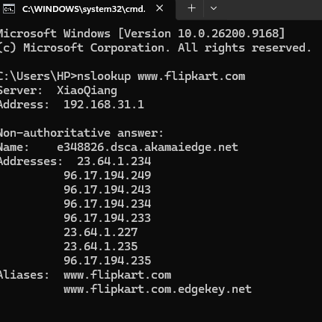

nslookup Simulation Results for [www.flipkart.com](https://www.flipkart.com)
- DNS Server Used: XiaoQiang (192.168.31.1)
- Resolved Canonical Name (CDN Edge): e348826.dsca.akamaiedge.net (mapped via alias [www.flipkart.com](https://www.flipkart.com).edgekey.net)
- Returned IP Addresses: Multiple IPv4 addresses corresponding to Akamai CDN edge servers, including 23.64.1.234, 96.17.194.249, 96.17.194.243, 96.17.194.234, 96.17.194.233, 23.64.1.227, 23.64.1.235, and 96.17.194.235.

Explanation of What This Result Means:
- Domain Translation: The Domain Name System (DNS) acts as the phonebook of the internet, translating the human-readable domain name ([www.flipkart.com](https://www.flipkart.com)) into numerical IP addresses so your computer knows where to send requests.
- Content Delivery Network (CDN): Seeing multiple IP addresses pointing to Akamai (akamaiedge.net) shows that Flipkart utilizes a CDN. This allows traffic to be distributed across edge servers closest to your geographic location, ensuring faster load times, redundancy, and balanced server loads.
3. Explain the difference between HTTP and HTTPS by listing 3 key differences, and give a real-world example of an app or website you use that relies on HTTPS for secure communication.

Difference Between HTTP and HTTPS & Real-World Example

3 Key Differences Between HTTP and HTTPS
Feature | HTTP (HyperText Transfer Protocol) | HTTPS (HTTP Secure)
Security & Encryption | Data is transmitted in plain text; anyone on the network can easily intercept, read, or tamper with it. | Encrypted using SSL/TLS protocols, ensuring that data remains private and secure from eavesdroppers.
Default Port | Operates over TCP Port 80. | Operates over TCP Port 443.
URL & Browser Trust | URLs start with http://; modern web browsers flag these sites as "Not Secure". | URLs start with https:// and feature a secure padlock icon in the browser address bar.

Real-World Example
- Example: Instagram or WhatsApp Web (or online banking portals and e-commerce checkout pages like Flipkart).
- Why it relies on HTTPS: These platforms handle sensitive user data—such as login credentials, personal messages, and private media. HTTPS ensures that all communication between your device and their servers is fully encrypted, preventing attackers from intercepting your password or private data.

4. Open Wireshark and filter for DNS protocol traffic. Try searching for a new website (one you haven't visited recently) in your browser and describe the sequence of DNS queries and responses you observe.Look for packets with 'Standard query' and 'Standard query response' in the Info column.
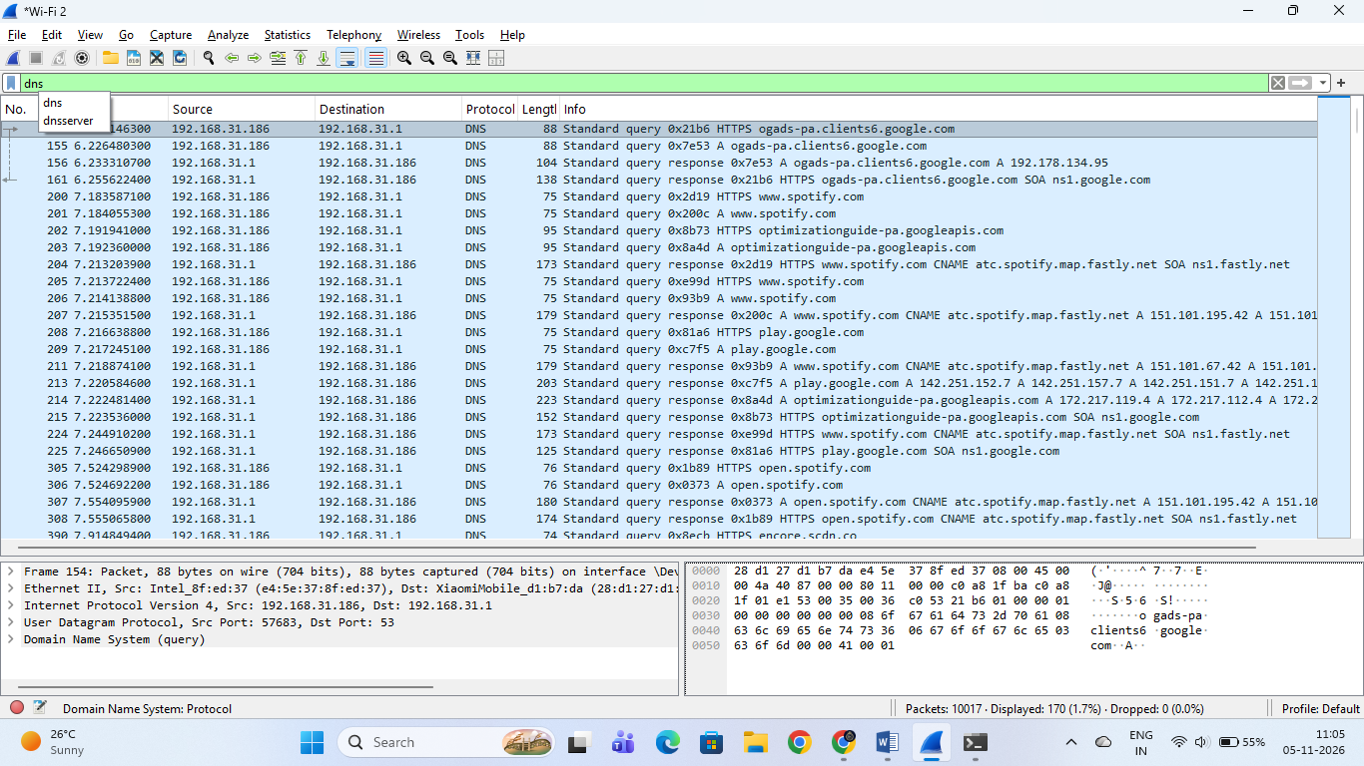

Wireshark DNS Traffic Analysis

1. Wireshark Filter Applied
- Filter Bar Input: dns

2. Sequence of DNS Queries and Responses Observed
As seen in your capture, when your system resolves domain names (such as ogads-pa.clients6.google.com, [www.spotify.com](https://www.spotify.com), and play.google.com), the following sequence occurs:
- Standard Query (Request):
  - Info Column Example: Standard query 0x7e53 A ogads-pa.clients6.google.com
  - Explanation: Your local machine (192.168.31.186) sends a UDP packet over port 53 to the local DNS server (192.168.31.1), requesting the IPv4 address (A record) for the target domain.
- Standard Query Response (Reply):
  - Info Column Example: Standard query response 0x7e53 A 192.178.134.95
  - Explanation: The DNS server replies with a packet containing the resolved IP address, enabling your operating system to establish a direct connection to the target server.

5. Pick any one protocol from DNS, DHCP, FTP, or SNMP (other than HTTP/HTTPS) and write a short scenario describing how it would be used in a real-world app or service you use (for example, how DHCP helps your phone connect to WiFi when you open Instagram at a cafe).

Real-World Scenario for FTP (File Transfer Protocol)
- Selected Protocol: FTP (File Transfer Protocol)
- Real-World App / Service: Web Development & Hosting Deployment (e.g., uploading files via FileZilla to a remote web server).

Scenario Description:
When a web developer finishes designing a new portfolio website on their local computer and wants to publish it live for the world to see, they use an FTP client (such as FileZilla).
- Connection Establishment: The developer enters the remote web server's IP address, username, and password into the FTP client. FTP opens command port 21 to authenticate and establish a control connection.
- Data Transfer: Once authenticated, the developer selects all HTML, CSS, JavaScript, and image files from their local directory and initiates an upload. FTP opens a separate data connection to seamlessly transfer these large bundles of files from the local machine directly into the server's public public-facing directory.
- Result: The files are successfully stored on the remote server, allowing users worldwide to instantly load and view the website through their browsers.

