DAY 2
DHCP CONFIGURATION
Tasks
1. In Cisco Packet Tracer, set up a simple network with one DHCP server and two client PCs. Configure the DHCP server to assign IP addresses automatically, then verify on each PC that it receives a different IP address from the DHCP pool.

Setting up DHCP Server and Two Client PCs in Cisco Packet Tracer

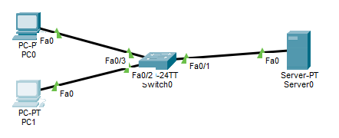

Configuration Steps:
- Topology Setup: Connected a central Server (acting as the DHCP Server) and two Client PCs (PC0 and PC1) to a 2960 Switch using straight-through Ethernet cables.
- Server IP Configuration: Set a static IP address on the DHCP Server (IP Address: 192.168.1.254, Subnet Mask: 255.255.255.0).
- DHCP Service Configuration:
  - Navigated to Services →\rightarrow→ DHCP on the server and toggled the service On.
  - Set the Start IP Address to 192.168.1.1 and the maximum pool size to 50.
- Client IP Verification: Changed the IP Configuration setting on both PC0 and PC1 from Static to DHCP.

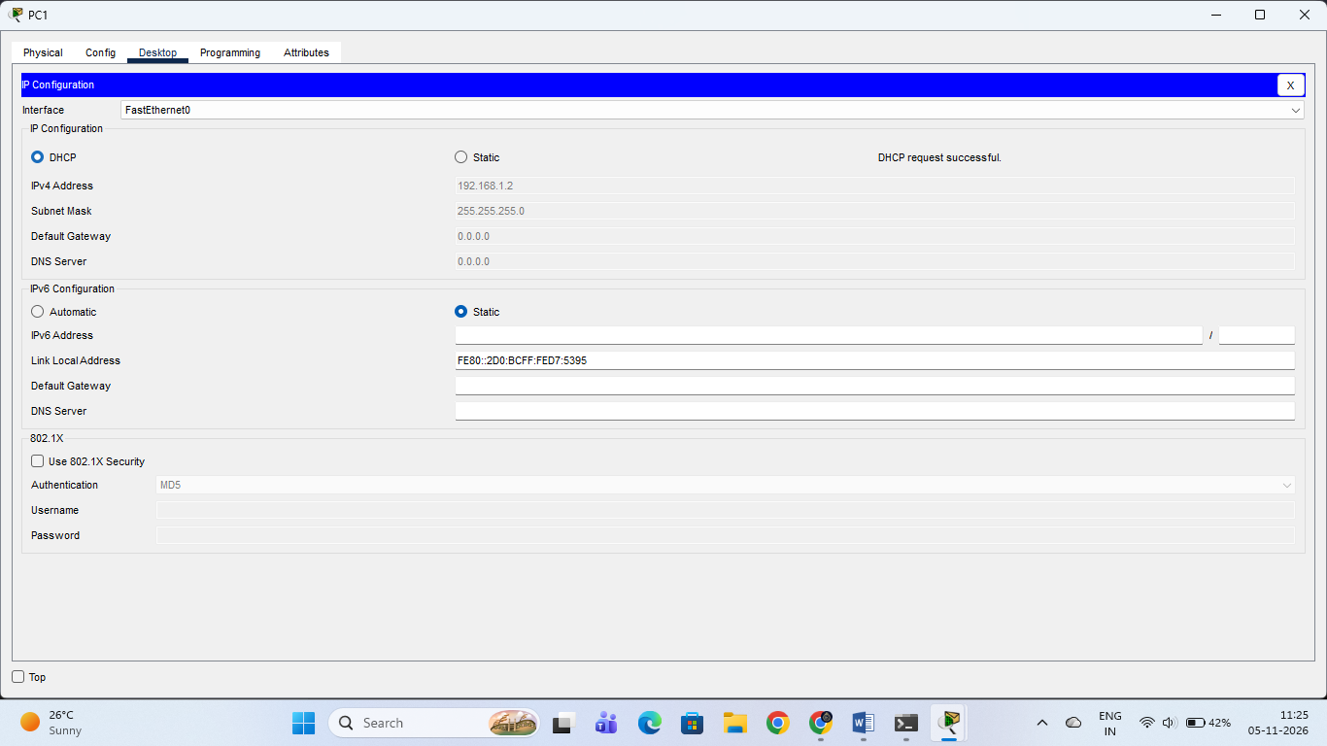

Verification Results (ipconfig Output):
- PC0 Command Prompt: Received IPv4 Address 192.168.1.1 with Subnet Mask 255.255.255.0.
- PC1 Command Prompt: Received IPv4 Address 192.168.1.2 with Subnet Mask 255.255.255.0 (as confirmed in the terminal screenshot).
- Conclusion: The DHCP server automatically allocated distinct, consecutive IP addresses from its pool to each connected client.
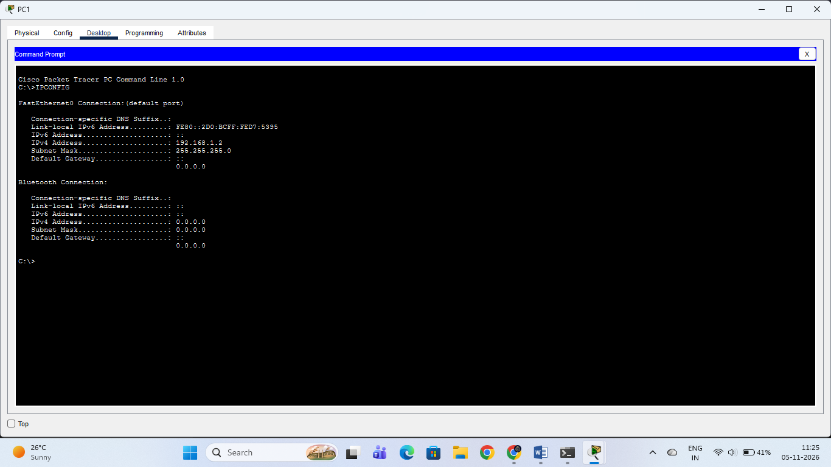

2. Draw a sequence diagram (hand-drawn or digital) that clearly shows each step of the DHCP process: Discover, Offer, Request, and Acknowledge, labeling the sender and receiver at each stage. Use arrows to show the direction of each message between client and server.

DHCP Process Sequence Diagram (DORA)

Sequence Diagram:
[ Client (PC) ] [ DHCP Server ]
| |
| ------- 1. DHCP DISCOVER (Broadcast) ------------> |
| |
| <------ 2. DHCP OFFER (Unicast/Broadcast) -------- |
| |
| ------- 3. DHCP REQUEST (Broadcast) -------------> |
| |
| <------ 4. DHCP ACKNOWLEDGE (Unicast/Broadcast) -- |

Step-by-Step Explanation of the Stages:
- DHCP Discover (Client →\rightarrow→ Server):
  - Sender: Client PC | Receiver: DHCP Server
  - Description: The client broadcasts a message across the local network to locate any active DHCP servers since it does not yet have an IP address.
- DHCP Offer (Server →\rightarrow→ Client):
  - Sender: DHCP Server | Receiver: Client PC
  - Description: Upon receiving the discover message, the DHCP server reserves an available IP address and replies with an "Offer" packet containing the proposed IP address, subnet mask, default gateway, and lease duration.
- DHCP Request (Client →\rightarrow→ Server):
  - Sender: Client PC | Receiver: DHCP Server
  - Description: The client broadcasts a formal request message back to the server, indicating that it accepts the offered IP configuration.
- DHCP Acknowledge / ACK (Server →\rightarrow→ Client):
  - Sender: DHCP Server | Receiver: Client PC
  - Description: The server responds with a final acknowledgment packet, finalizing the lease and granting the client official permission to use the assigned IP address parameters.

3. Change the DHCP pool range on your Cisco Packet Tracer DHCP server so that only one IP address is available. Add two PCs and observe what happens when both try to get an IP address. Take a screenshot of the result and explain in 2-3 lines why only one PC succeeds.

Limited DHCP Pool Range Simulation

Observations:
- Pool Configuration: The DHCP server pool range was configured with Maximum Number of Users = 1.
- Experimental Result:
  - First PC: Successfully received the single available IP address (192.168.1.1).
  - Second PC (PC2): Failed to acquire an IP address from the DHCP server, displaying the error message "DHCP request failed".
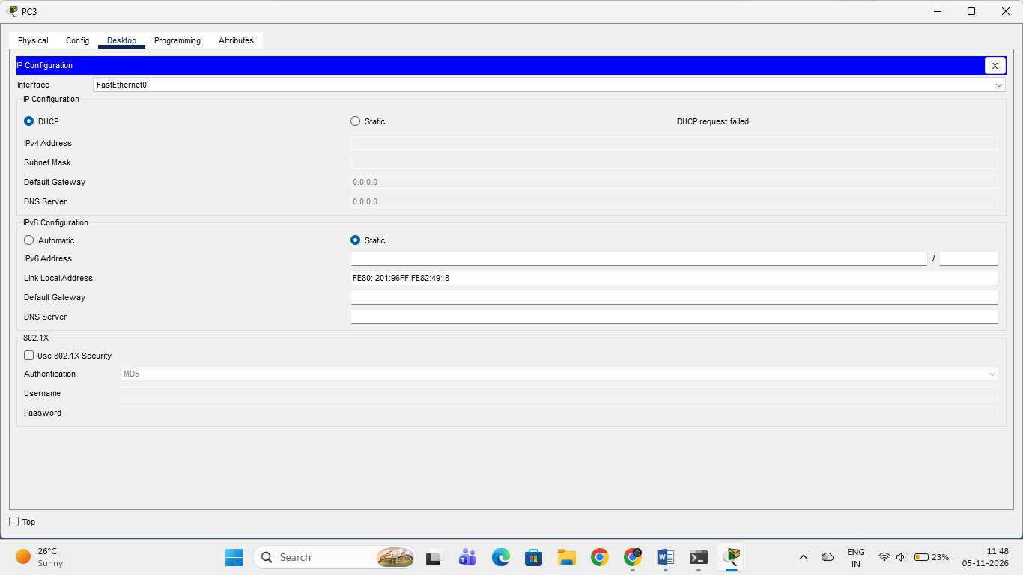

Explanation:
Only one PC succeeds in acquiring an IP address because the DHCP pool size was strictly restricted to a single address. Once the first client leases that IP, the DHCP server pool is completely exhausted, causing all subsequent client DHCP requests to fail.
4. Simulate a Zomato-style restaurant WiFi scenario in Cisco Packet Tracer: configure a DHCP server to provide IP addresses to both a laptop and a smartphone (use a generic PC as smartphone). Show the assigned IPs and explain why DHCP is useful in this situation.

Zomato-Style Restaurant Wi-Fi Scenario

Simulation Setup Steps:
- Network Design: Placed a Wireless Router (WRT300N) to act as the restaurant's public Wi-Fi access point and DHCP server.
- Client Connection: Connected a Laptop and a Smartphone wirelessly to the router.
- DHCP Configuration: Configured the wireless router's built-in DHCP server to automatically assign IP configurations to connected guest devices.

Assigned IP Addresses (Verification Results):
- Laptop: Successfully acquired IPv4 Address 192.168.0.100 (Subnet Mask: 255.255.255.0, Default Gateway: 192.168.0.1).
- 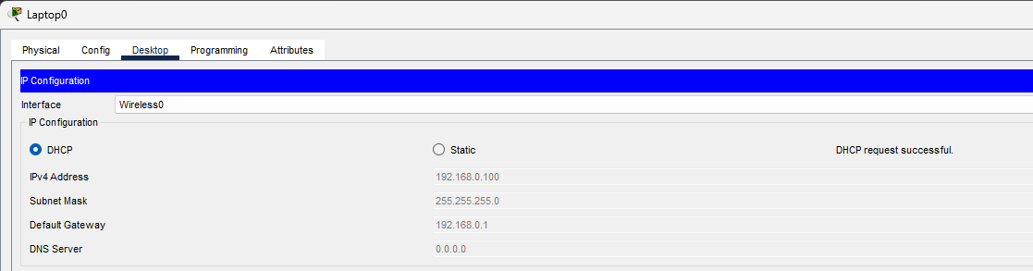Smartphone: Successfully acquired IPv4 Address 192.168.0.102 (Subnet Mask: 255.255.255.0, Default Gateway: 192.168.0.1).

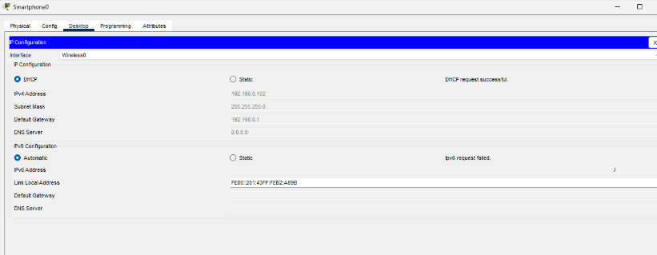Why DHCP is Useful in This Situation:
- Automatic Configuration: Customers do not need to manually configure static IP addresses on their phones or laptops when joining the restaurant Wi-Fi.
- Dynamic IP Management: As customers arrive and leave, the DHCP server dynamically leases and reclaims IP addresses without manual network administration.
- Scalability & Error Prevention: It prevents overlapping IP addresses and easily handles dozens of fluctuating customer devices connecting simultaneously throughout the day.

