DAY-3
DNS SERVER CONFIGURATION
Tasks
1. Install and set up a DNS server on your local machine or a VM using BIND (Linux) or Simple DNS Plus (Windows), then create a new DNS zone for the domain musicmania.in.
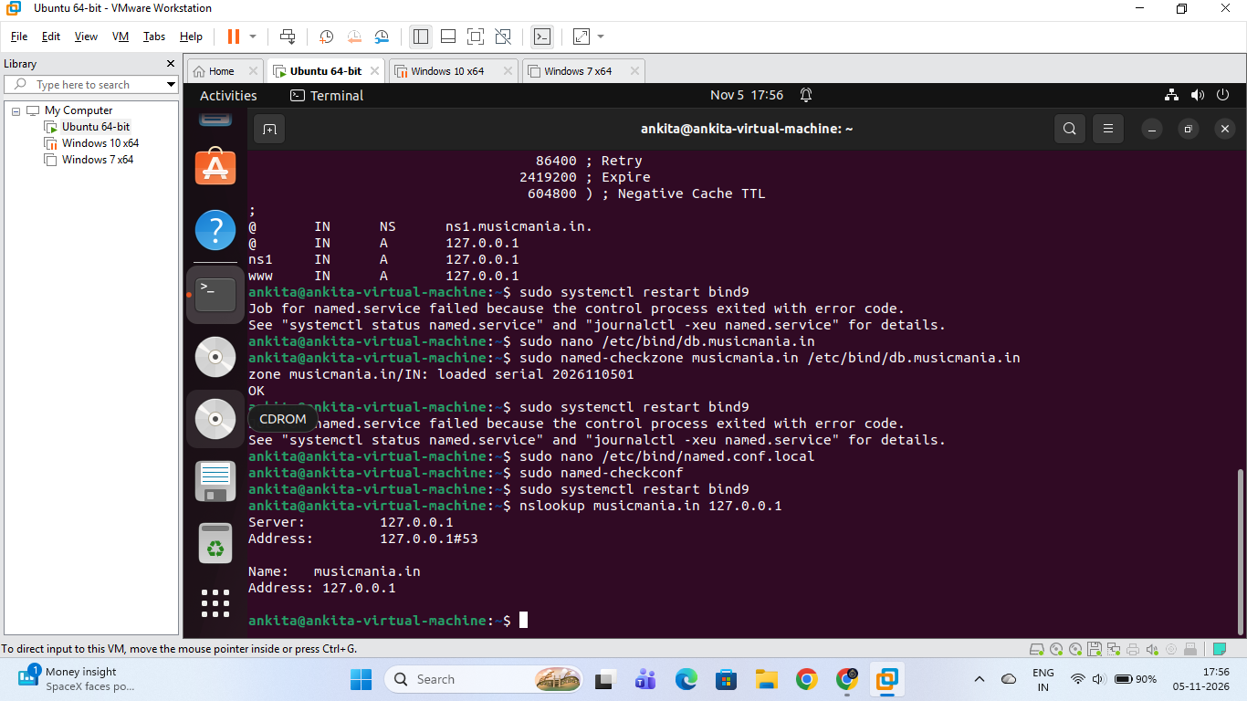

Install and Set Up a DNS Server for musicmania.in

1. Objective:
To install a DNS server on a local Linux virtual machine using BIND9, create a custom forward lookup zone for the domain musicmania.in, and verify successful local name resolution.

2. Step-by-Step Implementation Procedure:
- Step 1: Install BIND9 Package Open the terminal and update package repositories, then install BIND9:
sudo apt update
sudo apt install bind9 bind9utils -y
- Step 2: Configure the Local Zone File (named.conf.local) Open the local configuration file:
sudo nano /etc/bind/named.conf.local
Add the following zone block to declare the musicmania.in master zone:
zone "musicmania.in" {
type master;
file "/etc/bind/db.musicmania.in";
};
(Save using Ctrl + O, press Enter, and exit using Ctrl + X).
- Step 3: Create and Edit the Zone File (db.musicmania.in) Copy the default loopback template to create your custom domain database file:
sudo cp /etc/bind/db.local /etc/bind/db.musicmania.in
sudo nano /etc/bind/db.musicmania.in
Populate the file with the Start of Authority (SOA), Name Server (NS), and Address (A) records:
$TTL 604800
@ IN SOA ns1.musicmania.in. admin.musicmania.in. (
2026110501 ; Serial
604800 ; Refresh
86400 ; Retry
2419200 ; Expire
604800 ) ; Negative Cache TTL
;
@ IN NS ns1.musicmania.in.
@ IN A 127.0.0.1
ns1 IN A 127.0.0.1
www IN A 127.0.0.1
(Save and exit).

3. Verification & Testing:
- Syntax Validation: Check the zone file and general configuration for syntax errors:
sudo named-checkzone musicmania.in /etc/bind/db.musicmania.in
sudo named-checkconf
(Expected output for zone check: OK)
- Restart BIND9 Service: Apply the new configurations by restarting the DNS daemon:
sudo systemctl restart bind9
- Lookup Verification Test: Query the local DNS server to verify domain resolution:
nslookup musicmania.in 127.0.0.1
  - Result/Output: The server successfully resolves musicmania.in to loopback address 127.0.0.1, confirming that the local authoritative DNS server is fully operational.

2. Add an A record in your DNS server configuration to map www.musicmania.in to the IP address 192.168.1.50, then use the nslookup or dig command to verify the mapping works.
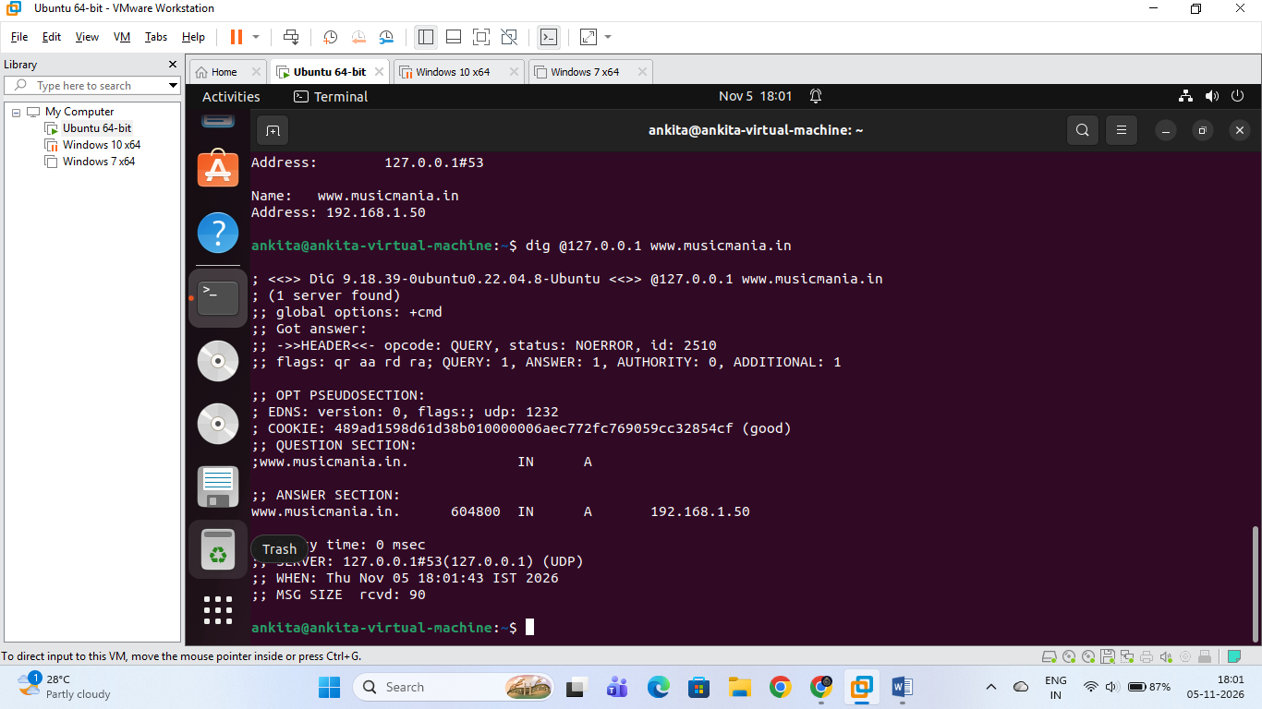

Add an A Record to Map www.musicmania.in to 192.168.1.50 & Verify

1. Objective:
To configure an A record in the BIND9 DNS zone file that maps the domain www.musicmania.in to the IP address 192.168.1.50, and verify the resolution using lookup utilities.

2. Step-by-Step Implementation:
- Step 1: Open the Zone File Run the following command in the terminal to edit the zone configuration file:
sudo nano /etc/bind/db.musicmania.in
- Step 2: Update the Record and Increment Serial Modify the www A record to point to 192.168.1.50 and increment the Serial number (e.g., from 2026110501 to 2026110502) so the DNS server registers the update:
$TTL 604800
@ IN SOA ns1.musicmania.in. admin.musicmania.in. (
2026110502 ; Serial (Incremented)
604800 ; Refresh
86400 ; Retry
2419200 ; Expire
604800 ) ; Negative Cache TTL
;
@ IN NS ns1.musicmania.in.
@ IN A 127.0.0.1
ns1 IN A 127.0.0.1
www IN A 192.168.1.50
(Save the file using Ctrl + O, press Enter, and exit using Ctrl + X).
- Step 3: Check Syntax and Restart BIND9 Validate the zone configuration and restart the DNS service to apply changes:
sudo named-checkzone musicmania.in /etc/bind/db.musicmania.in
sudo systemctl restart bind9

3. Verification & Testing:
- Using nslookup:
nslookup www.musicmania.in 127.0.0.1
  - Result: Successfully resolves to 192.168.1.50.
- Using dig:
dig @127.0.0.1 www.musicmania.in
  - Result: The ANSWER SECTION correctly outputs:
www.musicmania.in. 604800 IN A 192.168.1.50

3. Simulate a typo by adding a CNAME record for play.musicmania.in that points to www.musicmania.in, then test if accessing play.musicmania.in resolves to the correct IP address.
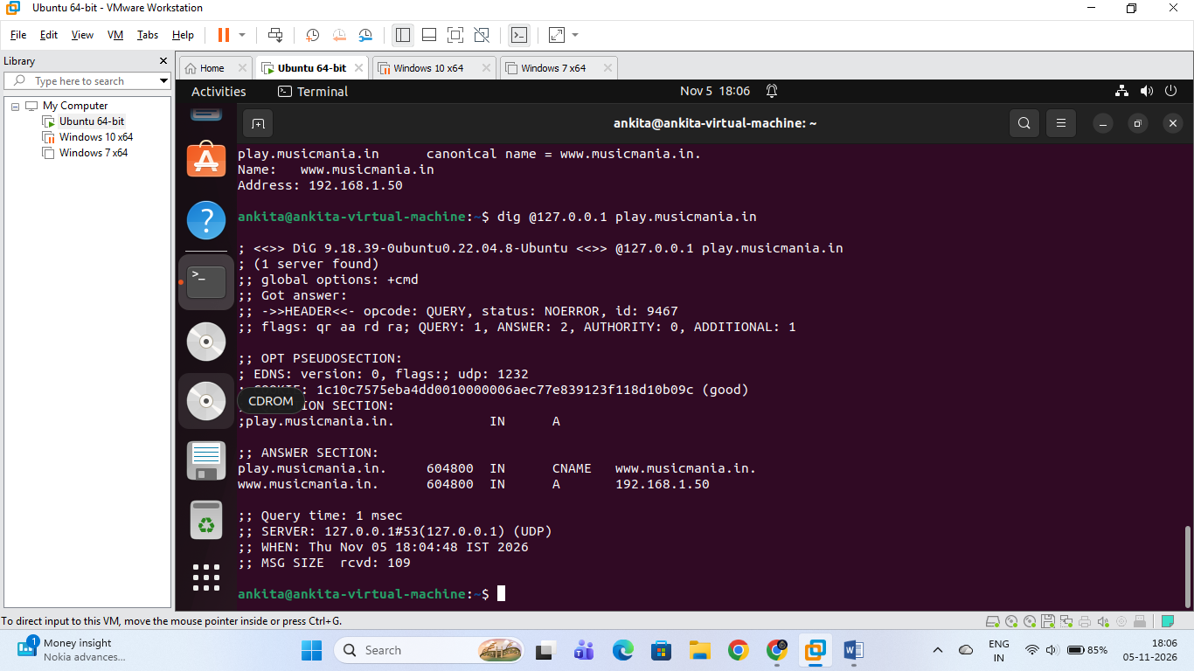

Configure a CNAME Record for play.musicmania.in & Verify Resolution

1. Objective:
To create a CNAME record inside the BIND9 zone file that aliases play.musicmania.in to www.musicmania.in, and verify that querying play.musicmania.in successfully resolves via the target IP (192.168.1.50).

2. Step-by-Step Implementation:
- Step 1: Open the Zone File
sudo nano /etc/bind/db.musicmania.in
- Step 2: Add CNAME Entry & Increment Serial Update the zone file by adding the CNAME record and incrementing the SOA serial number (e.g., to 2026110503):
$TTL 604800
@ IN SOA ns1.musicmania.in. admin.musicmania.in. (
2026110503 ; Serial (Incremented)
604800 ; Refresh
86400 ; Retry
2419200 ; Expire
604800 ) ; Negative Cache TTL
;
@ IN NS ns1.musicmania.in.
@ IN A 127.0.0.1
ns1 IN A 127.0.0.1
www IN A 192.168.1.50
play IN CNAME www.musicmania.in.
(Save with Ctrl + O, Enter, and exit with Ctrl + X).
- Step 3: Syntax Check and Service Restart
sudo named-checkzone musicmania.in /etc/bind/db.musicmania.in
sudo systemctl restart bind9

3. Verification & Results:
- Query via nslookup / dig:
dig @127.0.0.1 play.musicmania.in
- Terminal Output Verification: As shown in your terminal execution, the DNS server correctly processes the request:
  - ANSWER SECTION:
    - play.musicmania.in. points to CNAME www.musicmania.in.
    - www.musicmania.in. points to A record 192.168.1.50

4. Your DNS server is not resolving the domain musicmania.in as expected. Document the step-by-step troubleshooting process you would follow, including checking configuration files, restarting the DNS service, and testing with nslookup or dig. Include at least three different troubleshooting commands or checks in your documentation.
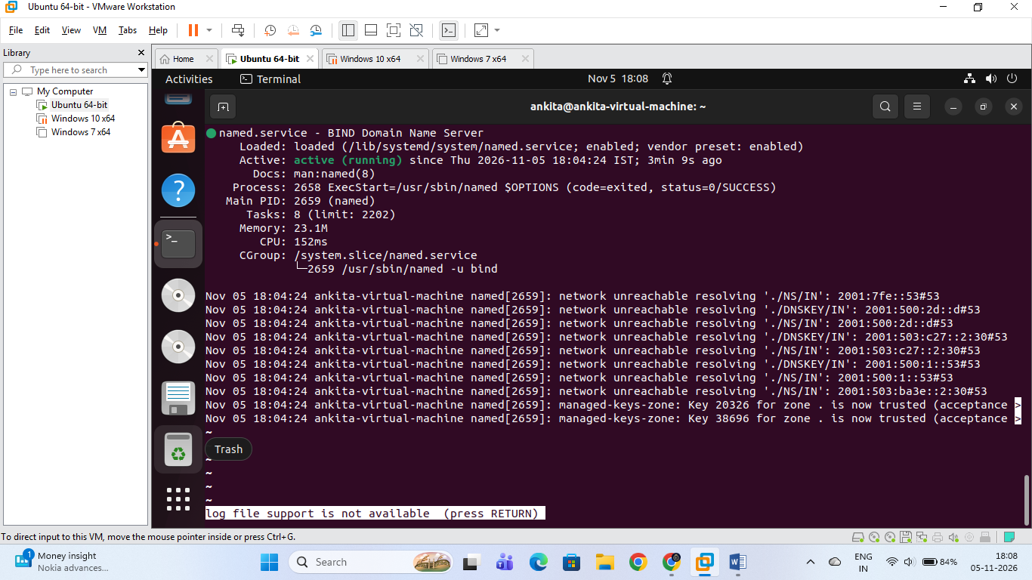

Step-by-Step DNS Server Troubleshooting Documentation

1. Objective:
To document a systematic troubleshooting workflow for diagnosing and resolving domain resolution failures for musicmania.in, including syntax checks, service status validation, and lookup testing.

2. Step-by-Step Troubleshooting Procedure:
- Step 1: Verify General Configuration Syntax Check the main BIND9 configuration file for syntax errors like missing semicolons or incorrect brackets.
  - Command:
sudo named-checkconf
  - Verification: If the command returns no output and silently returns to the prompt, the configuration syntax is completely valid.
- Step 2: Validate Zone File Integrity Check the domain-specific zone file (db.musicmania.in) for correct resource records and proper serial formatting.
  - Command:
sudo named-checkzone musicmania.in /etc/bind/db.musicmania.in
  - Verification: Expected successful output ends with OK and displays the loaded serial number.
- Step 3: Check BIND9 Service Status & Logs Inspect whether the BIND DNS service (named) is actively running or if it failed due to port conflicts/file permissions.
  - Command:
sudo systemctl status bind9
  - Verification: The output should show Active: active (running) in green text. If failed, inspect logs using sudo journalctl -xeu named.service.
- Step 4: Restart the DNS Service Apply configuration updates by restarting the BIND daemon.
  - Command:
sudo systemctl restart bind9
  - Verification: The service restarts without throwing exit error codes.
- Step 5: Test Name Resolution Query the local DNS nameserver to ensure records resolve to the correct destination IP.
  - Command:
nslookup musicmania.in 127.0.0.1
(Or using dig):
dig @127.0.0.1 musicmania.in
  - Verification: The response successfully returns the corresponding IP address (e.g., 127.0.0.1 or 192.168.1.50).

