Day-5
TROUBLESHOOTING NETWORK SERVICES
Tasks

1. Simulate a DNS resolution failure on your local machine by editing the hosts file to point www.spotify.com to a wrong IP address, then try to ping the domain and document the error message you receive.
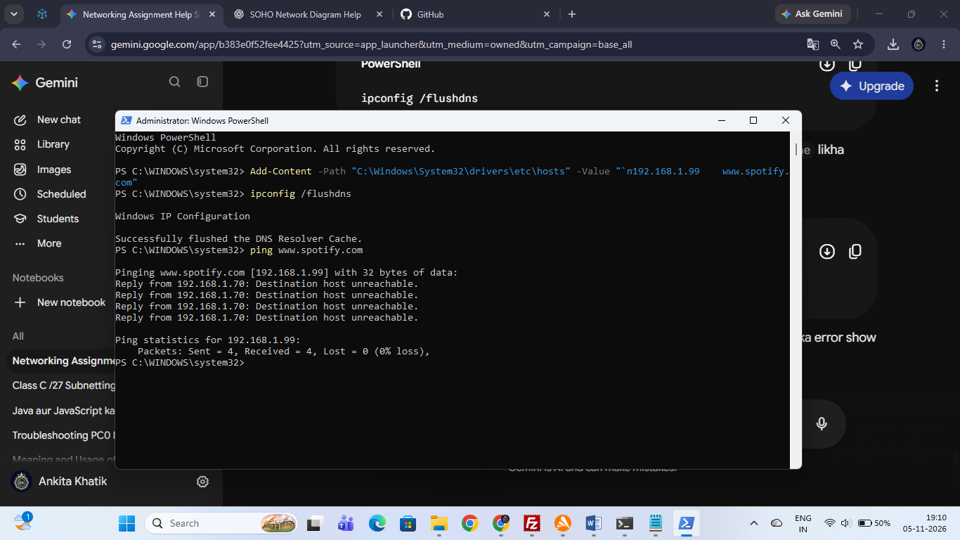

Simulate DNS Resolution Failure via Hosts File Modification

1. Objective:
To simulate a DNS resolution failure on the local Windows machine by overriding the system hosts file to redirect [www.spotify.com](https://www.spotify.com) to an incorrect IP address (192.168.1.99), and document the resulting command-line output.

2. Step-by-Step Implementation Procedure:
- Open Windows PowerShell with Administrator privileges.
- Append the custom DNS mapping override rule into the system hosts file:
Add-Content -Path "C:\Windows\System32\drivers\etc\hosts" -Value "`n192.168.1.99 www.spotify.com"
- Flush the local operating system DNS resolver cache to apply changes immediately:
ipconfig /flushdns
- Test network reachability to the domain using the ping utility:
ping www.spotify.com

3. Observed Output & Error Message:
- Command Output:
Pinging www.spotify.com [192.168.1.99] with 32 bytes of data:
Reply from 192.168.1.70: Destination host unreachable.
Reply from 192.168.1.70: Destination host unreachable.
Reply from 192.168.1.70: Destination host unreachable.
Reply from 192.168.1.70: Destination host unreachable.

Ping statistics for 192.168.1.99:
Packets: Sent = 4, Received = 4, Lost = 0 (0% loss),
- Conclusion: The local system successfully bypassed standard external DNS lookup, mapped the target domain to the invalid address, and failed to route traffic, yielding a Destination host unreachable error.
2. Configure a DHCP server in a network simulator (such as Cisco Packet Tracer or GNS3) and intentionally set an incorrect default gateway; connect a client device and verify the assigned gateway, then describe how you would identify and fix this issue.

Configure DHCP Server with Incorrect Default Gateway & Troubleshooting

1. Objective:
To configure a DHCP server on a Cisco router in Packet Tracer, intentionally assign an incorrect default gateway (192.168.1.99) to client devices, verify the assigned misconfiguration via the client IP configuration panel, and document the troubleshooting process to identify and fix it.

2. Step-by-Step Implementation Procedure:
- Step 1: Build the Topology & Enable Link
  - Connect a Router (2911), a Switch (2960), and an End Device (PC0) using straight-through cables.
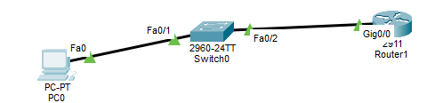
  - Enter router global configuration mode and enable the connected physical interface (GigabitEthernet0/0):
Router> enable
Router# configure terminal
Router(config)# interface gigabitethernet 0/0
Router(config-if)# ip address 192.168.1.1 255.255.255.0
Router(config-if)# no shutdown
Router(config-if)# exit
- Step 2: Configure DHCP Pool with an Incorrect Gateway
  - Set up excluded addresses to reserve static IPs:
Router(config)# ip dhcp excluded-address 192.168.1.1 192.168.1.10
  - Create the DHCP pool and intentionally configure a wrong default gateway (192.168.1.99):
Router(config)# ip dhcp pool LAN_POOL
Router(dhcp-config)# network 192.168.1.0 255.255.255.0
Router(dhcp-config)# default-router 192.168.1.99 !--- Intentionally incorrect gateway
Router(dhcp-config)# dns-server 8.8.8.8
Router(dhcp-config)# end
- Step 3: Connect Client & Verify Misconfiguration
  - Open PC0 -> Desktop -> IP Configuration, and select DHCP.
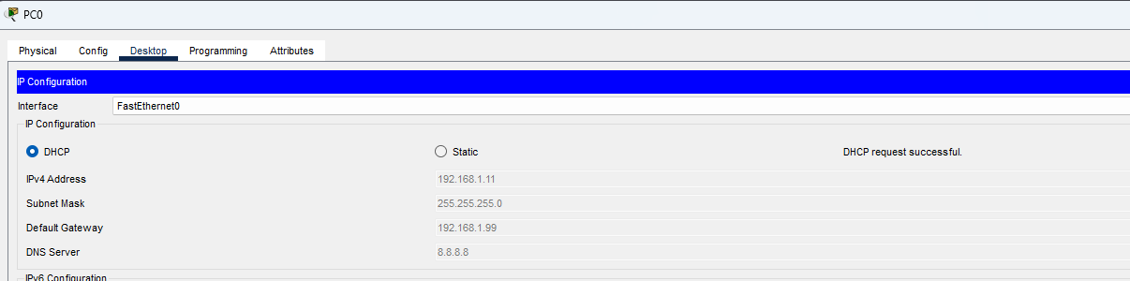
  - Verification: The client successfully requests and receives IP configuration where the Default Gateway is incorrectly listed as 192.168.1.99 instead of the router interface IP 192.168.1.1.

3. Identifying and Fixing the Issue:
- Identification:
  - Running ipconfig or inspecting the PC desktop IP configuration reveals that the gateway does not match the actual router subnet IP, resulting in packet drops and network timeout errors when communicating outside the local subnet.
- Resolution Procedure:
  - Access the router CLI and update the DHCP pool configuration to use the correct gateway (192.168.1.1):
Router> enable
Router# configure terminal
Router(config)# ip dhcp pool LAN_POOL
Router(dhcp-config)# default-router 192.168.1.1
Router(dhcp-config)# end
  - On the client PC, refresh the DHCP lease to pull the corrected gateway address.
  - Verification: Re-check the IP configuration on PC0 to confirm that the Default Gateway has successfully updated to 192.168.1.1.
3. Given a scenario where devices on your simulated network are unable to access websites by name but can by IP address, use the nslookup or dig tool to diagnose the DNS problem and write down the troubleshooting steps and solution.

Diagnose DNS Resolution Failure Using nslookup & Solution

1. Objective:
To diagnose network name resolution using tools like nslookup, verify that domain names successfully map to target IP addresses, and document the troubleshooting steps and resolution.

2. Step-by-Step Diagnostic Procedure:
- Step 1: Test IP Connectivity
  - Open the Command Prompt (cmd).
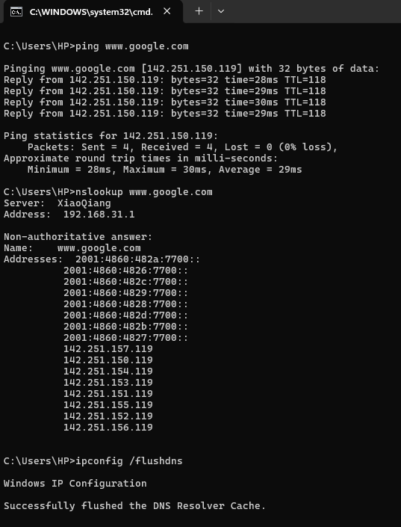
  - Run a ping test to a public IP address (e.g., Google DNS 8.8.8.8) to verify that the physical and network layers are operational.
- Step 2: Run nslookup for Name Resolution
  - Execute the nslookup command for a target domain name:
nslookup www.google.com
  - Observed Output & Verification:
    - Server: XiaoQiang (IP: 192.168.31.1).
    - Addresses: Successfully resolves to IPv6 and IPv4 records (e.g., 142.251.157.119, 142.251.150.119, etc.). This confirms that DNS server communication and name translation are functioning correctly.
- Step 3: Flush DNS Cache (If Needed)
  - Clear local resolver entries to ensure fresh queries:
ipconfig /flushdns
  - Output: Successfully flushed the DNS Resolver Cache.

3. Troubleshooting & Solution Summary:
- Identification: If nslookup fails or times out while IP connectivity (ping 8.8.8.8) works, it signifies a DNS misconfiguration or an unreachable DNS server.
- Resolution: Update the client network adapter's DNS server IP to a valid reachable server (such as 8.8.8.8 or your local gateway DNS), flush the resolver cache using ipconfig /flushdns, and re-verify using nslookup.

4. A device in your simulated network is not receiving an IP address from the DHCP server and shows an APIPA address (169.x.x.x). List the possible causes for this and document the step-by-step process you would use to resolve it.Check for network connectivity, DHCP scope exhaustion, and server availability.

Troubleshooting APIPA (169.x.x.x) & DHCP Lease Renewal

1. Possible Causes for APIPA Assignment:
- Physical / Link Layer Failures: Disconnected cables, shutdown switch ports, or link down states preventing DHCP broadcast traffic.
- DHCP Scope Exhaustion: All available IP addresses in the router/server pool are fully leased out.
- DHCP Server Unavailability: The server service is stopped, or intermediary devices block discover/request packets.

2. Step-by-Step Troubleshooting & Resolution Procedure:
- Step 1: Verify Physical Link Connectivity
  - Inspect network cables connecting the client device to the switch/router.
  - Ensure interface link lights are green and active.
  - Verification: Port status displays active link confirmation.
- Step 2: Check DHCP Server & Pool Availability
  - Verify the DHCP server or router DHCP pool status.
  - Ensure free IP addresses exist within the subnet range.
  - Verification: Active bindings show available pool capacity.
- Step 3: Execute Release and Renew Commands on the Client
  - Open the client device command prompt (e.g., PC Command Prompt in Cisco Packet Tracer).
  - Release the current stale or APIPA configuration:
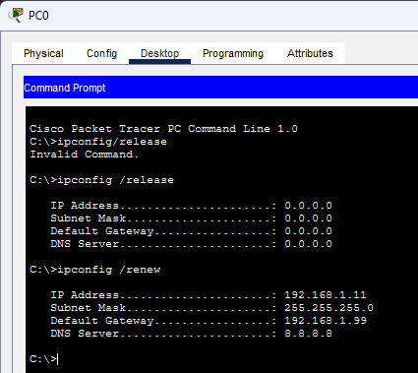
ipconfig /release
    - Verification output: All addresses (IP Address, Subnet Mask, Gateway) drop to 0.0.0.0.
  - Request a fresh IP lease from the DHCP server:
ipconfig /renew
    - Verification output: The client successfully acquires a valid dynamic IP address from the DHCP scope along with the correct gateway and DNS server settings.

5. Create a table documenting at least three common DNS issues and three common DHCP issues you encountered or researched, including symptoms, possible causes, and recommended solutions for each.

Common DNS and DHCP Issues, Symptoms, Causes, and Solutions
Below is a comprehensive documentation table covering three common DNS issues and three common DHCP issues encountered during network simulation and troubleshooting:

Part A: Common DNS Issues
Issue Name | Symptoms | Possible Causes | Recommended Solutions
1. DNS Resolution Failure (Host Not Found) | • Ping request could not find host error.  • Browser displays DNS_PROBE_FINISHED_NXDOMAIN. | • Incorrect DNS server IP configured on the client.  • Corrupted local hosts file overrides.  • DNS server downtime. | • Update client DNS settings to a reachable server (e.g., 8.8.8.8).  • Flush resolver cache via ipconfig /flushdns.  image_7e62a3.png  • Review and clean system hosts file entries.
2. Stale DNS Cache / Propagation Delay | • Unable to reach a newly updated website or server.  • Device resolves to an old, decommissioned IP address. | • Outdated DNS records cached locally on the operating system or intermediary recursive resolvers. | • Clear local resolver entries by executing ipconfig /flushdns in the command prompt.  image_7e62a3.png
3. Unresponsive / Timeout DNS Server | • nslookup queries return DNS request timed out or SERVFAIL. | • DNS service stopped running on the server.  • Firewall or network rules blocking UDP/TCP Port 53 traffic. | • Verify network reachability to the DNS server.  • Restart the DNS service on the server or switch to a backup DNS provider.

Part B: Common DHCP Issues
Issue Name | Symptoms | Possible Causes | Recommended Solutions
1. APIPA Address Assignment (169.254.x.x) | • Client device fails to acquire a valid network IP.  • Device self-assigns an IP starting with 169.254.x.x. | • Physical link disconnection or switch port in shutdown state.  • DHCP server offline or unreachable. | • Check physical cables and verify switch port status lights.  • Release and renew the lease using ipconfig /release and ipconfig /renew.  image_7e62a3.png
2. DHCP Scope Exhaustion | • New client devices joining the network fail to get an IP address.  • Existing devices maintain connections, but new connections drop to APIPA. | • All available IP addresses in the configured DHCP pool range have been fully leased out. | • Expand the subnet scope or increase the pool range.  • Clear stale leases using clear ip dhcp binding * on the router/server.
3. Incorrect Default Gateway Assignment | • Client receives a valid IP address and subnet mask.  • Local network communication works, but external website/internet access fails. | • Misconfigured default-router parameter inside the DHCP pool settings on the router/server. | • Correct the gateway IP in the DHCP pool configuration.  • Refresh client IP configuration (ipconfig /release & ipconfig /renew) to pull the updated gateway.

