Day 2 (Power Supply Systems)
Tasks
Q.1 List 3 real-world devices in your home or college that use SMPS (Switched Mode Power Supply) and 2 devices that use UPS (Uninterruptible Power Supply), explaining in one line why each device needs that type of power supply.
Ans=
1. Devices using SMPS (Switched Mode Power Supply)
- Desktop PC (Computer Tower)
  - Reason: Requires highly efficient conversion of AC mains voltage into multiple stable DC voltages (+3.3V, +5V, +12V) for internal components like CPU and GPU.
- Laptop Charger / Power Adapter
  - Reason: Needs a compact, lightweight power supply that can step down high AC voltage to low DC voltage with minimal heat generation during travel.
- Wi-Fi Router Adapter
  - Reason: Requires a continuous, regulated low-voltage DC power supply that stays cool and consumes minimal energy during 24/7 operation.
2. Devices using UPS (Uninterruptible Power Supply)
- Desktop PC System
  - Reason: Requires immediate battery backup during power outages to prevent sudden shutdown, avoiding unsaved work loss and operating system corruption.
- Network Server / Storage System (NAS)
  - Reason: Needs constant, clean power to maintain continuous network uptime and prevent database corruption or hardware damage from power surges.

Q.2 Draw and label a diagram showing the main internal components of a typical SMPS unit found in a desktop PC, including AC input, rectifier, transformer, and DC output sections.<br><br><em><strong>Hint:</strong> You can hand-draw and upload a photo, or use any free diagram tool like draw.io.</em>
Ans=
Internal Block Diagram of a Typical PC SMPS Unit
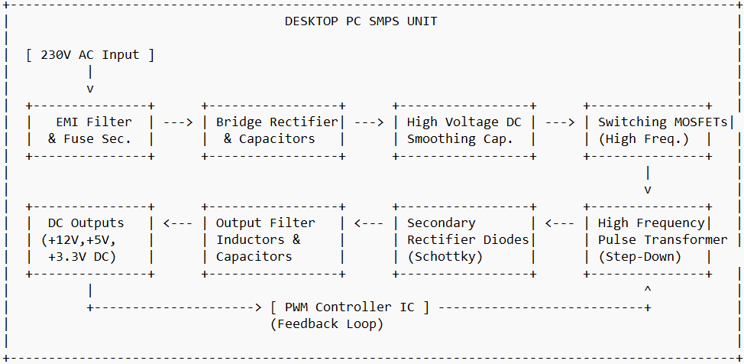
Main Internal Components & Section Labels
- AC Input Section (Protection & Filtering):
  - Power Socket & Fuse: Receives 230V AC power from the wall outlet; fuse provides over-current protection.
  - EMI / RFI Filter: Removes high-frequency electromagnetic noise and interference from the AC line.
- Primary High-Voltage Rectifier & Switching Section:
  - Bridge Rectifier: Converts AC voltage into raw, pulsating DC voltage.
  - Filter Capacitors: Smooth out the raw DC voltage into stable high-voltage DC (~300V).
  - Switching MOSFETs (Transistors): Controlled by a PWM (Pulse Width Modulation) IC, turning the high-voltage DC on and off rapidly (tens to hundreds of kilohertz).
- Transformer Section:
  - High-Frequency Step-Down Transformer: Takes the high-frequency AC pulse from the MOSFETs and steps down high voltage to low AC voltages required by PC components.
- Secondary Rectifier & Output Filter Section (DC Output):
  - Schottky Diodes (Secondary Rectifiers): Convert low-voltage high-frequency AC back into DC voltage.
  - LC Output Filter (Inductors & Low-ESR Capacitors): Smooths out ripple voltage to produce clean, stable DC power lines (+12V, +5V, +3.3V).
- Feedback & Control Circuit:
  - Optocoupler & PWM Controller: Continuously monitors the output voltages and dynamically adjusts the MOSFET switching pulse length to maintain steady output under varying loads.

Q.3 Take photos or find clear images online of the following power connectors: ATX 24-pin motherboard connector, SATA power connector, Molex connector, and PCIe 6/8-pin connector. For each, write its name, the devices it powers, and one safety tip for connecting/disconnecting it.
Ans=
Power Connectors Overview
1. ATX 24-Pin Motherboard Connector
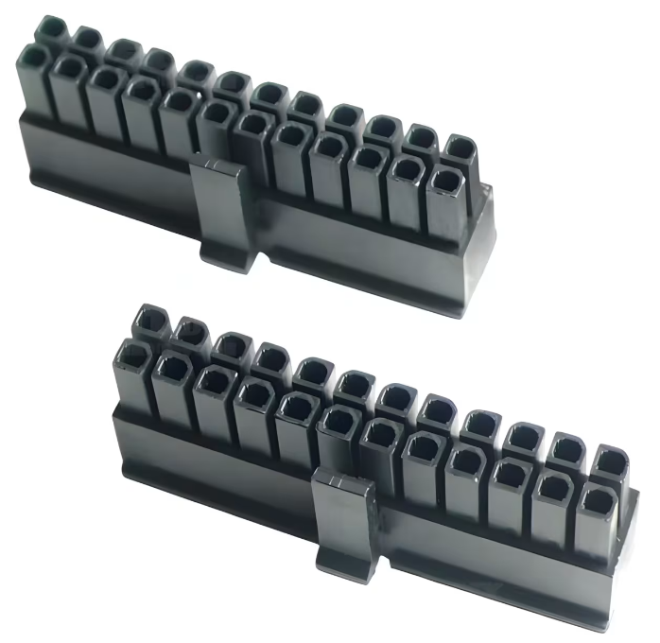

Name: ATX 24-Pin Motherboard Connector
Devices it Powers: The main computer motherboard (providing power to the chipset, RAM, PCIe slots, and connected low-power components).
Safety Tip: Always ensure the locking latch is fully engaged and clicked into place before turning on the system, and press down firmly on the plastic housing (not the individual wires) when unplugging to avoid damaging the solder joints on the motherboard.

2. SATA Power Connector
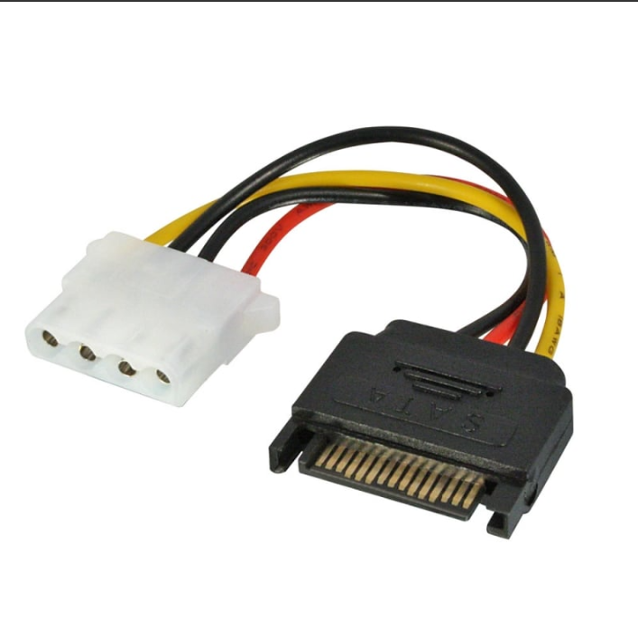
- Name: SATA Power Connector
- Devices it Powers: SATA SSDs (Solid State Drives), traditional HDDs (Hard Disk Drives), and optical disk drives.
- Safety Tip: Pull straight out by the molded plastic plug rather than twisting or tugging on the attached wires to prevent the pins from loosening or pulling out of the housing.
3. Molex Connector
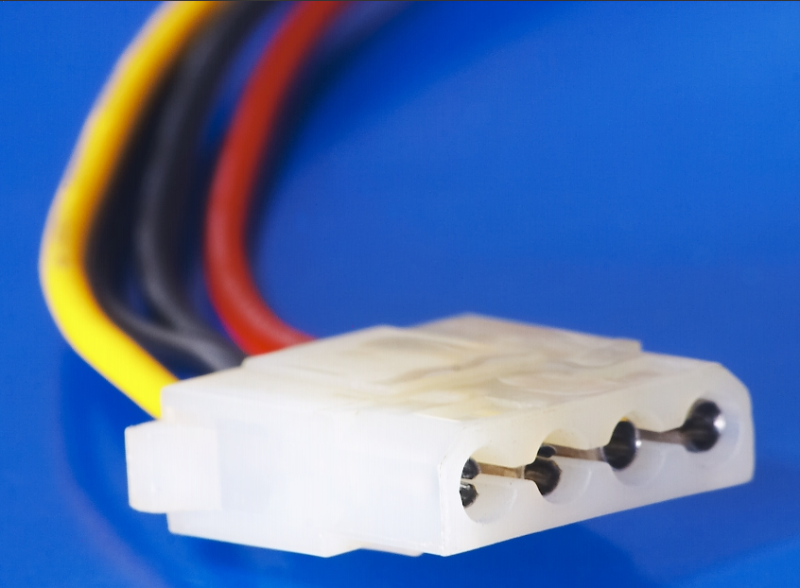
- Name: Molex Connector (4-Pin Peripheral Power Connector)
- Devices it Powers: Legacy drives, older case fans, fan controllers, and some lighting/pump accessories.
- Safety Tip: Because Molex pins can sometimes push backward out of the plastic housing when connecting, hold both the male and female ends securely to align them carefully without using excessive force.
4. PCIe 6/8-Pin Connector
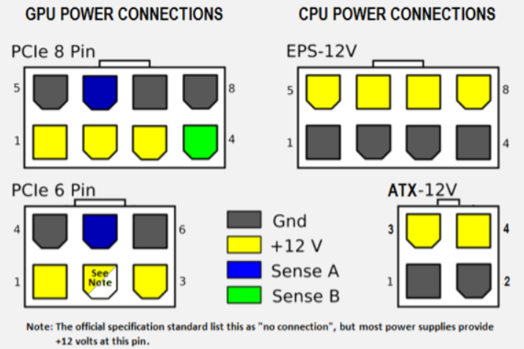
- Name: PCIe 6/8-Pin Power Connector
- Devices it Powers: Dedicated graphics cards (GPUs).
- Safety Tip: Always press down on the release clip/latch on top of the connector before trying to pull it out of the graphics card to avoid snapping the plastic retention mechanism.

Q.4 Imagine you are setting up a new gaming PC. List the steps you would follow to connect the SMPS to the motherboard, graphics card, and storage devices, mentioning which specific cables and connectors are used for each.
Ans=
1. Connecting to the Motherboard
- Cables & Connectors Used:
  - 24-Pin ATX Main Power Cable: Large 24-pin rectangular connector.
  - 8-Pin (4+4) EPS / CPU Power Cable: Marked as "CPU" on the connector header.
- Steps:
  - Main Power: Take the large 24-pin ATX cable from the SMPS and align its plastic locking latch with the latch mechanism on the 24-pin socket located on the right edge of the motherboard. Press firmly until it clicks into place.
  - CPU Power: Locate the 8-pin (4+4) CPU power cable. Connect it to the 8-pin EPS socket usually located near the top-left corner of the motherboard (near the CPU socket/VRM heatsinks). Ensure the latch snaps securely.
2. Connecting to the Graphics Card (GPU)
- Cable & Connector Used:
  - 6+2 Pin PCIe Power Cable: Marked as "PCIe" or "VGA".
- Steps:
  - Check your graphics card's power requirements (e.g., 6-pin, 8-pin, 16-pin, or dual 8-pin inputs).
  - For an 8-pin requirement, combine the 6-pin and 2-pin pieces of the 6+2 PCIe cable together.
  - Align the latch on the cable connector with the GPU power socket and insert it firmly until you hear a distinct click.
  - Note: If your GPU requires multiple 8-pin connectors, it is best practice to use separate individual PCIe cables from the SMPS rather than daisy-chaining a single cable.
3. Connecting to Storage Devices (SATA SSDs / HDDs)
- Cable & Connector Used:
  - 15-Pin SATA Power Cable: Flat, wide connector with an "L"-shaped inner key.
- Steps:
  - Take the SATA power cable coming from the SMPS.
  - Align the internal "L"-shaped slot of the connector with the matching "L"-shaped pin header on the back of your 2.5-inch SATA SSD or 3.5-inch Hard Drive.
  - Push the connector gently straight in until it sits flush against the drive. (Note: M.2 NVMe SSDs draw power directly from the motherboard's PCIe slot and do not require external SMPS cables).
4. Cable Management & Final Check
- Steps:
  - Route all excess cables through the back panel cutouts of the PC case and secure them with zip ties or velcro straps to maintain clean airflow.
  - Double-check that all power latch clips are locked and no cables are touching fan blades.
  - Plug the main AC power cord into the back of the SMPS and flip the SMPS rocker switch to the "I" (ON) position.

