Peripheral and power supply

DAY 1- overview of peripherals
Tasks:-

Q.1 Create a table listing 3 types of printers, 2 types of scanners, and 2 types of webcams, and for each, write one real-life use case (for example: 'Inkjet printer – printing college assignments').
Ans=
Types of Peripherals & Their Detailed Real-Life Use Cases
Category | Type of Device | Description & Real-Life Use Case
Printer 1 | Inkjet Printer | Uses liquid ink sprayed onto paper. Ideal for home and personal use, such as printing colorful college project reports, family photos, and graphics-heavy assignments.
Printer 2 | Laser Printer | Uses toner powder and heat to produce fast, high-quality text output. Widely used in corporate offices, banks, and internet cafes for high-volume text document printing.
Printer 3 | Thermal Printer | Uses heat to print on special heat-sensitive paper without ink. Commonly used in retail stores, POS counters, and ATMs to print customer transaction receipts quickly.
Scanner 1 | Flatbed Scanner | Features a glass plate where paper is placed. Used in offices and digital centers to create high-resolution digital copies of physical documents, certificates, and photos.
Scanner 2 | Barcode / Handheld Scanner | A portable hand-held scanner using optical sensors. Used by retail shop cashiers and warehouse managers to instantly scan product barcodes for inventory tracking and billing.
Webcam 1 | Integrated / Built-in Webcam | The default camera built into laptop bezels. Used by students and professionals for attending routine online lectures, family video calls, and basic team meetings.
Webcam 2 | External USB / HD Webcam | A standalone high-definition camera mounted on a monitor. Used by content creators, live streamers, and remote workers who require high video resolution and autoframing.

Q.2 Draw a labeled diagram showing how a typical home printer connects to a laptop or PC, including the connection interface used (USB, Wi-Fi, or Bluetooth).
Ans=
Connection Diagram

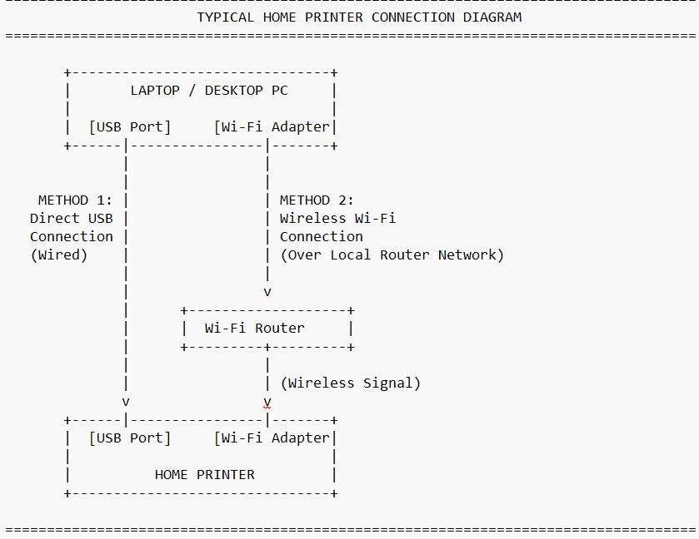

Component & Connection Details:
- Primary Connection Interfaces Used:
  - Wired Connection (USB): Uses a standard USB Type-A to USB Type-B cable directly connecting the computer's USB port to the printer's rear USB port. This offers a fast, plug-and-play setup.
  - Wireless Connection (Wi-Fi): The printer and computer connect to the same local Wi-Fi router network wirelessly. This allows printing from anywhere in the home without cable constraints.
  - Alternative Wireless (Bluetooth): Used for direct short-range pairing between mobile devices/laptops and portable printers without needing a Wi-Fi router.
- Flow Description:
  - In a USB Setup, data signals travel directly through the copper wiring of the USB cable.
  - In a Wi-Fi Setup, print commands sent from the laptop are transmitted as radio waves to the Wi-Fi router, which routes the data wirelessly to the printer's onboard Wi-Fi receiver.

Q.3 List three different connection interfaces (such as USB, Wi-Fi, Bluetooth) used by peripherals like printers, scanners, and webcams, and for each, name one advantage and one disadvantage.<br><br><em><strong>Hint:</strong> Think about speed, convenience, and compatibility.</em>
Ans=
Peripheral Connection Interfaces

Connection Interface | Key Advantage | Key Disadvantage
1. USB (Wired) | High Speed & Stability: Offers fast data transfer speeds with zero signal interference, making it very reliable for large print jobs or high-definition webcam streaming. | Physical Cable Limits: Restricts mobility due to limited cable lengths and requires a physical port on the host computer.
2. Wi-Fi (Wireless) | Convenience & Network Sharing: Allows multiple computers, laptops, and smartphones on the same network to share a single device without plugging in any physical cables. | Network Dependency: Connection quality depends heavily on Wi-Fi signal strength and router performance, which can lead to connection drops or slow speeds.
3. Bluetooth (Wireless) | Easy Direct Pairing: Simple, low-power setup that connects directly to host devices without needing an external network router or local Wi-Fi. | Limited Range & Speed: Has much slower data transfer speeds and a limited operating range (~10 meters), making it unsuitable for transmitting heavy files or HD video feeds.

Q.4 Pick any one device you use at home or college (printer, scanner, or webcam). Write step-by-step instructions for how you would connect it to your computer, including what cable or wireless method you would use and any setup steps required.
Ans=
Step-by-Step Setup Guide for Connecting an External USB Webcam
Selected Device: External USB High-Definition Webcam
Connection Method: Wired Connection via USB Cable
Step 1: Physical Placement and Mounting
- Unbox the external USB webcam and unwind its attached USB cable.
- Unfold the webcam’s adjustable mounting clip/stand.
- Securely mount the webcam on top of your laptop screen or desktop monitor so the camera lens is positioned at eye level. Alternatively, place it on a flat desk surface or attach it to a tripod if supported.
Step 2: Physical Cable Connection
- Locate an available USB 2.0 or USB 3.0 port on your computer (laptop or desktop tower).
- Insert the webcam’s standard USB-A (or USB-C) connector firmly into the port.
Step 3: Driver Installation and System Recognition
- Turn on your computer (if it is not already running).
- The operating system (such as Windows 10/11 or macOS) will automatically detect the new hardware device via Plug-and-Play (PnP) technology.
- Wait a few seconds while the operating system automatically downloads and installs the required basic generic drivers in the background. A notification will appear saying "Device is ready for use."
Step 4: Testing and Configuring the Setup
- Open your computer's default Camera app (or any video communication tool like Zoom, Google Meet, or Microsoft Teams).
- Navigate to the app's Settings > Video menu.
- Under the camera selection dropdown, choose your newly connected external webcam instead of the built-in laptop camera.
- Check the live video preview to adjust the camera angle, focus, and lighting as needed. Verify that the built-in microphone of the webcam is also selected in the audio settings.

