Day 2: Routers and Switches
Tasks
1.Draw a labelled diagram of a typical home WiFi router and a network switch, clearly marking at least 3 different ports (such as WAN, LAN, Console) and the location of status LEDs.
Ans
Diagrams of a Home Wi-Fi Router and Network Switch
1. Typical Home Wi-Fi Router Diagram (Rear & Front Panel)

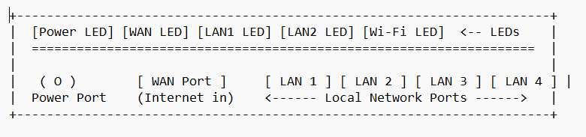
Annotated Port & LED Details:
- Status LEDs (Front Panel): Visual indicators displaying real-time power state, active internet connection (WAN), local port activity (LAN), and wireless signal broadcast (Wi-Fi).
- WAN Port (Wide Area Network): Usually colored blue/yellow; connects directly to the ISP modem line to receive global internet access.
- LAN Ports (Local Area Network): Standard RJ-45 Ethernet ports used to connect local devices like PCs, Smart TVs, and switches via wired cables.
- Power Port (DC Jack): Input socket connecting the external power adapter to provide electrical power to the router.

2. Network Switch Diagram (Front & Rear Panel)
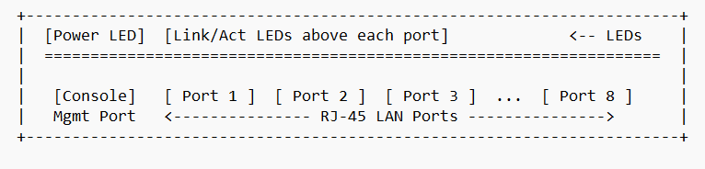
- Annotated Port & LED Details:
  - Status LEDs: Top panel LEDs showing overall system power status, along with individual Link/Activity LEDs above each port indicating speed and data transmission.
  - LAN Ports (Ports 1–8): High-speed RJ-45 ports used to connect local endpoints (e.g., PCs, printers, access points) within the same network.
  - Console Port: Dedicated management port used by administrators to connect a serial terminal cable for initial device configuration and troubleshooting.

2.List 3 key differences between routers and switches in terms of their main functions and how they handle network traffic.<br><br><em><strong>Hint:</strong> Think about how each device deals with IP addresses, MAC addresses, and the types of networks they connect.</em>
Ans
Key Differences Between Routers and Switches
- 1. Types of Networks Connected:
  - Router: Connects completely different networks together, such as connecting a local private network (LAN) to an external public network like the Internet (WAN).
  - Switch: Connects multiple devices within the same local network (LAN) to allow them to communicate directly with one another.
- 2. Addressing & Data Handling (IP vs. MAC Addresses):
  - Router: Operates using IP addresses (Layer 3 - Network Layer). It examines the destination IP address of incoming data packets to route them across different subnets and networks.
  - Switch: Operates using MAC addresses (Layer 2 - Data Link Layer). It maintains a MAC address table to direct data frames specifically to the physical network card of the destination device on the local network.
- 3. Traffic Management & Domain Separation:
  - Router: Separates broadcast domains and collision domains. It prevents local network broadcast noise from spilling over into external networks, choosing the most efficient paths for global traffic.
  - Switch: Creates separate collision domains for each connected port, but shares a single broadcast domain across all ports by default (unless segmented using VLANs).

3.Take a real or virtual image of a router and a switch (from your home, lab, or Google Images), and identify the following on each: Power port, at least 2 Ethernet ports, and any LED indicators. Annotate the image or describe their position and purpose.
Ans
Hardware Identification and Description (Router & Switch)
- Home Wi-Fi Router Identification

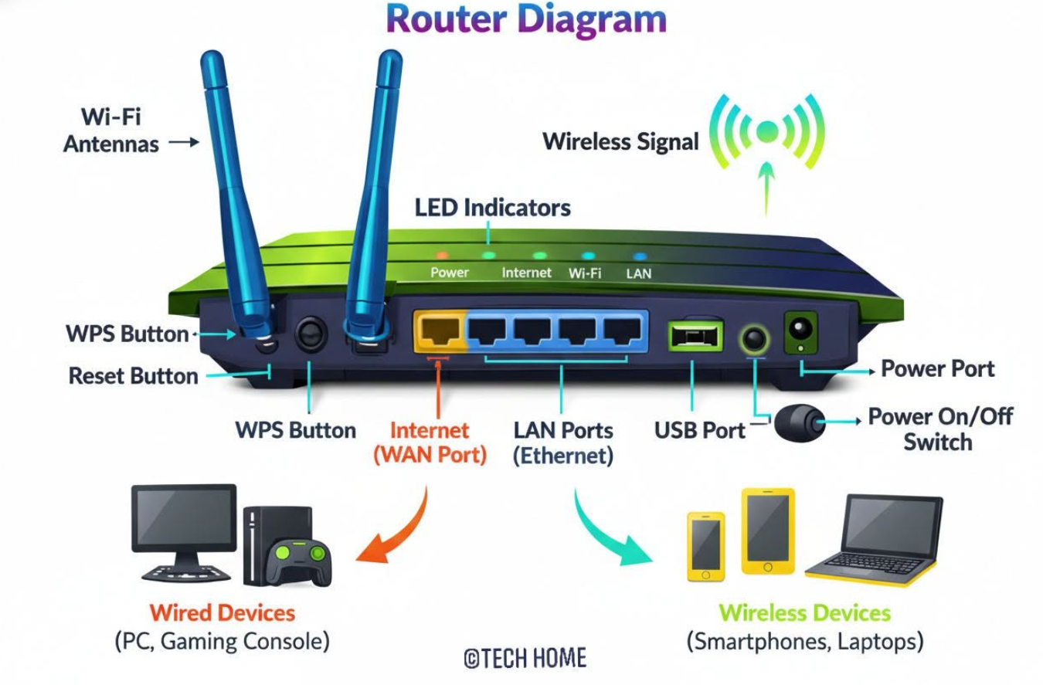
- Power Port:
  - Position: Located on the far-left or far-right side of the rear panel (labeled as "DC-IN" or "Power").
  - Purpose: Receives electrical power from the wall adapter to boot up and power the router hardware.
- Ethernet Ports (LAN 1, LAN 2, and WAN):
  - Position: Located along the center of the rear panel. The WAN port (typically colored blue or yellow) is separated from the yellow LAN ports (LAN 1, LAN 2, etc.).
  - Purpose: The WAN port connects to the ISP modem for internet input, while the LAN Ethernet ports connect local devices like desktop PCs, laptops, or switches via RJ-45 cables.
- LED Indicators:
  - Position: Located across the front panel or directly above each Ethernet port.
  - Purpose: Indicates operational status (Power LED = device status; WAN LED = active internet connection; LAN 1/2 LEDs = active physical cable links and data transmission).
2. Network Switch Identification
- Power Port:
  - Position: Located on the rear panel of desktop switches (DC jack) or standard C14 AC power socket on rack-mounted switches.
  - Purpose: Supplies electrical power to operate the internal switching fabric and processing unit.
- Ethernet Ports (Ports 1 through 8/24):
  - Position: Arrayed neatly along the front panel as numbered RJ-45 sockets.
  - Purpose: Provides wired connectivity to end-user devices (PCs, printers, IP phones, access points) within the local area network.
- LED Indicators:
  - Position: Positioned at the corner of the front panel (System Power LED) and built directly into or above each Ethernet port socket (Link/Activity LEDs).
  - Purpose: A solid green light indicates an active link (device connected), while a blinking light indicates active data packet transmission across that port.
4.Imagine you are setting up a small gaming café network for IPL streaming and multiplayer matches. Write a short scenario explaining which device (router or switch) you would connect first to the ISP line, and how you would connect 8 gaming PCs to the network. Justify your choices.
Ans
Gaming Café Network Setup Scenario
Scenario & Connection Layout:
To set up a reliable, low-latency network for a gaming café hosting live IPL streaming and multiplayer gaming matches, the installation follows this specific sequence:
- First Device Connected to ISP Line: The Router.
  - The incoming ISP cable (fiber modem output) plugs directly into the WAN port of the main Router.
- Connecting 8 Gaming PCs:
  - A high-speed 16-port Gigabit Switch is connected to one of the LAN ports on the Router via a Cat6 Ethernet cable.
  - All 8 gaming PCs are plugged directly into individual ports on the Switch using high-quality Cat6 Ethernet cables.
Justification of Choices:
- Why Connect the Router First?
  - Network Gateway & Routing: The router is required to act as the interface between the public Internet (WAN) and the private gaming café network (LAN).
  - IP Address Allocation (DHCP): The router runs a DHCP server to automatically assign unique private IP addresses to all gaming PCs so they can communicate online.
  - Security (NAT & Firewall): Network Address Translation (NAT) and built-in firewall protections on the router secure the gaming devices from external cyber threats.
- Why Use an Unmanaged Gigabit Switch for the 8 Gaming PCs?
  - Low Latency & High Bandwidth: Switches offer dedicated 1 Gbps full-duplex bandwidth per port. This prevents packet collisions and network congestion, ensuring seamless 4K IPL streaming and zero-lag multiplayer gaming.
  - Port Expansion: Standard home/small office routers usually only have 4 LAN ports. An external switch easily expands physical port capacity to connect all 8 PCs without overloading the router's switching capability.
  - Wired vs. Wireless Stability: Using direct Ethernet connections via the switch guarantees maximum stability and minimal ping jitter compared to Wi-Fi.

