DAY 2 : Network Topologies
Tasks
1.Draw a diagram of a bus topology and label all key components, then write one real-world example where this topology might be used.
Ans=
+-----------------------+
| TERMINATOR |
+-----------+-----------+
|
| <--- Main Backbone Cable
+---------------------+---------------------+
| | |
+----+----+ +----+----+ +----+----+
| T-Connector | T-Connector | T-Connector
+----+----+ +----+----+ +----+----+
| <-- Drop Line | |
+----+----+ +----+----+ +----+----+
| PC 1 | | PC 2 | | Printer |
+---------+ +---------+ +---------+
|
|
+-----------+-----------+
| TERMINATOR |
+-----------------------+

Key Components:
- Backbone Cable: The central coaxial or Ethernet cable through which data flows across the network.
- Nodes / Devices: Computers, servers, or peripheral devices (like printers) connected to the network.
- Terminators: Devices placed at both ends of the main backbone cable to absorb signals and prevent signal bounce-back (reflection).
- Drop Lines: Small cables that connect individual devices to the main backbone cable.
- T-Connectors: Hardware connectors used to join the drop line cable to the main backbone cable.

A classic real-world example of Bus Topology is an early local area network (LAN) setup in a small office or computer lab using 10Base2 or 10Base5 coaxial cabling. It was widely used in small networks where cost efficiency and simple wiring were prioritized over high-speed redundant connections.

2.In Cisco Packet Tracer, create a simple star topology with one switch and four PCs connected to it; name each PC after a popular app (e.g., WhatsApp, Zomato, Spotify, Flipkart) and take a screenshot of your topology.
Ans=
- Placed one central Switch (2960) in the Cisco Packet Tracer workspace.
- Added four PCs around the switch and renamed them as WhatsApp, Zomato, Spotify, and Flipkart.
- Connected each PC to the central switch using Copper Straight-Through cables, forming a physical Star Topology where every node is independently linked to the central hub/switch.
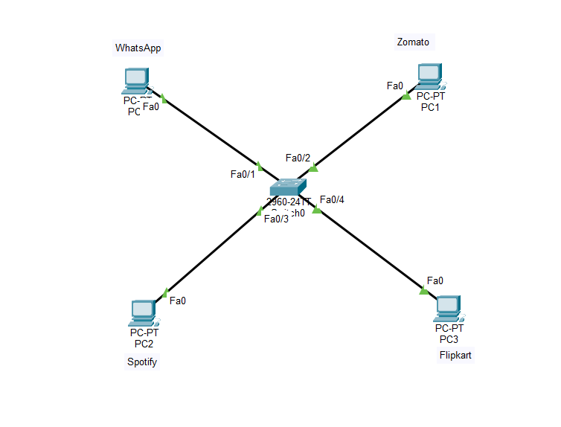

3.Draw a ring topology diagram and explain in 2-3 sentences how data travels between devices in this setup.<br><br><em><strong>Hint:</strong> Use arrows to show the direction of data flow.</em>
Ans=
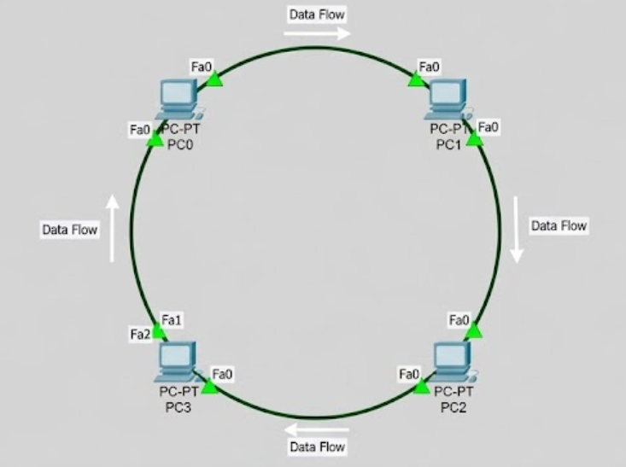

In a ring topology, data travels from one device to another in a continuous, unidirectional (one-way) loop until it reaches its intended destination. Each device acts like a repeater, receiving a packet of data and passing it along to the next device in the ring.
4.Compare mesh and star topologies by listing 2 advantages and 2 disadvantages of each in a table format.
Ans=
Topology | Advantages | Disadvantages
Mesh Topology | 1. High Redundancy & Reliability: Agar ek path fail ho jaye, toh data dusre path se travel kar leta hai.  2. High Security: Har device ka direct connection hone ki wajah se data zyada secure hota hai. | 1. High Cost: Isme bohot zyada cabling aur hardware ports ki zarurat padti hai, jisse yeh costly ho jata hai.  2. Complex Setup: Iska installation aur network management kafi mushkil hota hai.
Star Topology | 1. Easy Troubleshooting & Expansion: Kisi ek device ya cable ke kharab hone par baaki network par asar nahi padta, aur naye devices aasani se jud sakte hain.  2. Simple Management: Central switch ki wajah se network ko monitor karna aasan hota hai. | 1. Single Point of Failure: Agar central switch ya hub kharab ho jaye, toh poora network down ho jata hai.  2. Hardware Dependency: Iske liye extra hardware (Switch/Hub) aur har device ke liye alag cable ki zarurat hoti hai.

