DAY 3 : Switch and Router Configuration
Tasks
1.Log in to Cisco Packet Tracer or any network simulation tool, add a switch, and create two VLANs named 'Sales' and 'Support' with VLAN IDs 10 and 20.
Ans=
- Steps Performed in Cisco Packet Tracer:
- Logged into the switch CLI and entered privileged execution mode.
- Entered global configuration mode using configure terminal.
- Created VLAN 10 and named it Sales.
- Created VLAN 20 and named it Support.
- Commands Used:

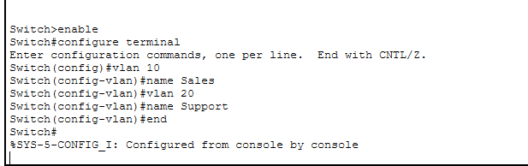

2.Assign three different switch ports to VLAN 10 (Sales) and two ports to VLAN 20 (Support), then verify the VLAN membership using the show vlan command.<br><br><em><strong>Hint:</strong> Use the interface range command to select multiple ports efficiently.</em>
Ans=
• Steps Performed:
- Used the interface range command to select ports Fa0/1 to Fa0/3 and assigned them to VLAN 10 (Sales) in access mode.
- Selected ports Fa0/4 and Fa0/5 using interface range and assigned them to VLAN 20 (Support) in access mode.
- Verified the port mapping using the show vlan brief command.
• Commands Used:

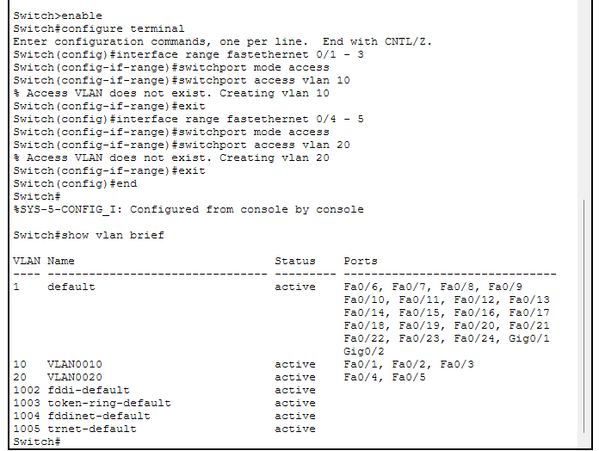
3.Connect two routers using a serial or Ethernet link in your simulation tool, assign IP addresses to their interfaces, and configure a static route on Router 1 to reach the LAN behind Router 2.
Ans=
Steps Performed in Simulation Tool:
- Topology Setup: Connected two routers (Router0 and Router1) using a serial link. Attached a switch and a PC (PC4) to form a local area network (LAN) behind Router1.
- IP Addressing: Assigned IP addresses to the router serial interfaces (205.168.1.1 and 205.168.1.2) and the LAN interface (192.168.2.1), and configured the PC with an IP address (192.168.2.10) and default gateway.
- Static Routing: Configured a static route on Router0 to reach the remote LAN network (192.168.2.0/24) through the next-hop IP address of Router1.
- Verification: Tested connectivity by pinging from the PC to the remote router's interface, resulting in a successful reply with 0% packet loss.
2. Main Commands Used:
- Interface Configuration:
configure terminal
interface serial 0/1/0
ip address 205.168.1.1 255.255.255.0
no shutdown
Static Route Configuration:
ip route 192.168.2.0 255.255.255.0 205.168.1.2
screenshot:
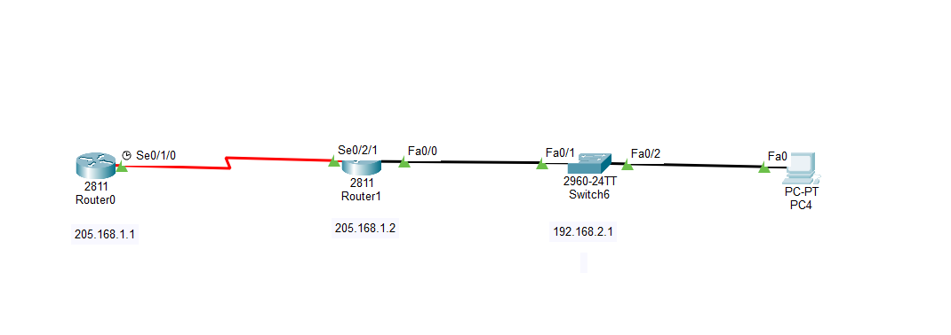
4.Simulate a scenario where a device in the 'Sales' VLAN tries to ping a device in the 'Support' VLAN and explain why the ping fails, then suggest what configuration would allow inter-VLAN communication.<br><br><em><strong>Hint:</strong> Think about router-on-a-stick or Layer 3 switch concepts.</em>
Ans=
1. Scenario & Why the Ping Fails:
- Scenario: When a computer in the Sales VLAN (VLAN 10) tries to send data (ping) to a computer in the Support VLAN (VLAN 20), the ping request fails and results in a "Destination Host Unreachable" error.
- Reason for Failure:
  - VLANs (Virtual Local Area Networks) are separate logical broadcast domains.
  - A standard Layer 2 switch only forwards traffic within the same VLAN and cannot route packets between different VLANs by itself.
  - Because there is no Layer 3 routing device acting as a gateway between them, the traffic cannot cross from VLAN 10 to VLAN 20, causing the ping to fail.
2. Configuration to Allow Inter-VLAN Communication:
To enable communication between different VLANs, a Layer 3 routing device is required. This can be achieved using one of the following two methods:
- Method 1: Router-on-a-Stick (Using a Router):
  - Connect a physical link from the switch to a Router and configure that port as an 802.1Q Trunk Port.
  - On the router, configure sub-interfaces (e.g., GigabitEthernet 0/0.10 for VLAN 10 and GigabitEthernet 0/0.20 for VLAN 20) with appropriate IP gateway addresses and encapsulation dot1Q tags.
- Method 2: Layer 3 Switch (Using SVIs):
  - If using a Layer 3 switch, enable routing globally using the command ip routing.
  - Create Switched Virtual Interfaces (SVIs) for each VLAN (e.g., interface vlan 10 and interface vlan 20) and assign gateway IP addresses to them, allowing direct internal routing between the VLANs.

