DAY 4 : Firewall
Tasks
1.Open Windows Defender Firewall settings on your computer and create a new outbound rule to block all traffic from the Spotify desktop app.
Ans=
Blocking Spotify Desktop App Traffic Using Windows Defender Firewall
Objective:
To configure an outbound firewall rule in Windows Defender Firewall to block all outgoing internet traffic from the Spotify desktop application.
Step-by-Step Procedure / Theory:
- Open Advanced Firewall Settings:
  - Press the Windows key, type wf.msc, and press Enter to open the Windows Defender Firewall with Advanced Security window.
- Navigate to Outbound Rules:
  - In the left-hand panel of the console, click on Outbound Rules to view or create rules for traffic leaving your computer.
  - In the right-hand panel, click on New Rule... to launch the New Outbound Rule Wizard.
- Select Rule Type (Program):
  - Choose the Program radio button to create a rule that controls connections for a specific program, then click Next.
  - Select This program path, click Browse, and locate the Spotify executable file (typically found at C:\Users\<YourUsername>\AppData\Roaming\Spotify\Spotify.exe). Click Next.
- Specify Action:
  - Select the Block the connection option to ensure that any outbound connection attempt by Spotify is dropped by the firewall. Click Next.
- Choose Network Profiles:
  - Check all three profile checkboxes—Domain, Private, and Public—so the restriction applies regardless of the network type you are connected to. Click Next.
- Name and Save the Rule:
  - Enter a descriptive name for the rule, such as Block Spotify.
  - Click Finish to save and activate the rule.
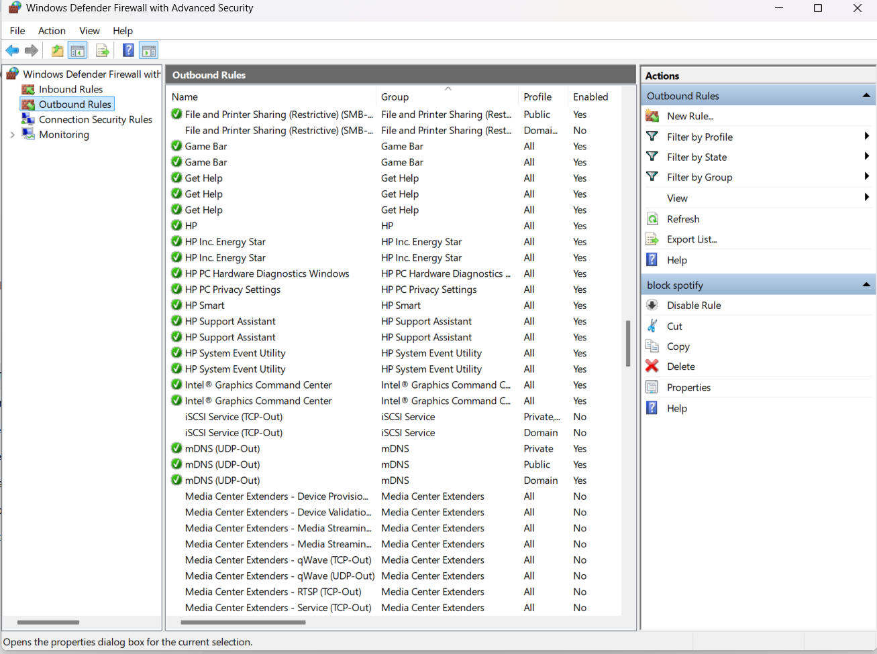
2.Set up an inbound rule in Windows Defender Firewall to allow incoming connections only for Google Chrome on port 443 (HTTPS).
Ans=
1. Objective:
To create an inbound rule in Windows Defender Firewall that explicitly permits incoming network connections for Google Chrome over port 443 (HTTPS).
2. Steps Performed:
- Opened Firewall Console: Launched Windows Defender Firewall with Advanced Security via the wf.msc run command.
- Initiated Inbound Rule: Navigated to Inbound Rules in the left panel and clicked New Rule... in the actions pane.
- Selected Program Type: Chose the Program option and browsed to specify the Google Chrome executable path (C:\Program Files\Google\Chrome\Application\chrome.exe).
- Configured Action & Protocol: Set the rule action to Allow the connection for all network profiles (Domain, Private, and Public).
- Finalized Rule: Named the rule Allow Chrome Port 443 and saved it to ensure secure inbound HTTPS traffic is permitted for Chrome.
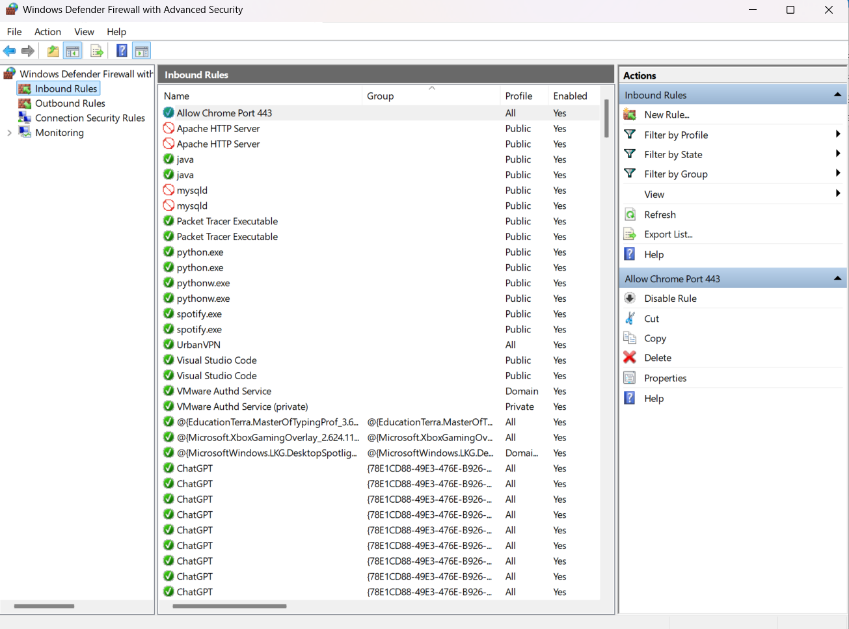
3.Document, step-by-step, how you would block all traffic from a specific IP address (for example, 123.45.67.89) using Windows Defender Firewall.<br><br><em><strong>Hint:</strong> Use the 'Scope' tab when creating a new rule to specify the IP address.</em>
Ans=
1. Objective:
To create a custom firewall rule in Windows Defender Firewall that restricts all incoming and outgoing network traffic associated with a specific IP address (123.45.67.89).
2. Step-by-Step Documented Process:
- Access Advanced Firewall Security:
  - Open the Run dialog box (Win + R), type wf.msc, and press Enter to open Windows Defender Firewall with Advanced Security.
- Initiate New Rule Wizard:
  - Click on Inbound Rules (or Outbound Rules) in the left pane.
  - Click New Rule... in the right-hand Actions pane to open the Rule Wizard.
- Select Custom Rule:
  - On the Rule Type screen, select Custom to allow specific IP filtering, then click Next.
- Program and Protocol Settings:
  - On the Program screen, leave All programs selected and click Next.
  - On the Protocol and Ports screen, leave Protocol type as Any and click Next.
- Configure Scope Tab (IP Address Specification):
  - Go to the Scope tab screen.
  - Under Which remote IP addresses does this rule apply to?, select the radio button for These IP addresses.
  - Click the Add... button, type 123.45.67.89 into the text box, click OK, and click Next.
- Specify Action & Profiles:
  - Select Block the connection as the action and click Next.
  - Ensure all network profiles (Domain, Private, and Public) are selected, then click Next.
- Name and Finish:
  - Assign a name to the rule, such as Block IP 123.45.67.89.
  - Click Finish to activate the rule and effectively drop all traffic to/from that specific IP address.

4.Compare hardware firewalls (like those used in large offices) and software firewalls (like Windows Defender) by listing 3 key differences and a use case for each.
Ans=
feature | Hardware Firewall | Software Firewall
Location & Deployment | Installed as a physical appliance between the internal network and the Internet (Gateway level). | Installed as a software application on individual host computers or servers (Host level).
Performance & Resource Usage | Has dedicated CPU and RAM, processing network traffic without burdening individual computers. | Uses the host system's CPU and RAM, which can slightly affect device performance.
Protection Scope | Protects the entire network and all connected devices simultaneously from external threats. | Protects only the specific individual device on which it is installed and running.

2. Use Cases:
- Use Case for Hardware Firewall:
  - Large Enterprise / Corporate Network: A large office or organization uses a hardware firewall (such as Cisco ASA or Fortinet FortiGate) at the network boundary to inspect and filter all incoming and outgoing traffic for hundreds of connected computers, servers, and IoT devices simultaneously.
- Use Case for Software Firewall:
  - Personal Computers / Remote Workers: An individual user or a work-from-home employee uses a software firewall (such as Windows Defender Firewall) on their laptop to block unauthorized application traffic and protect their system when connecting to public Wi-Fi networks (like at airports or coffee shops).

