DAY-5: Review and Practice Practical
Tasks
1.Open Cisco Packet Tracer and create a new project file named 'HomeWiFiNetwork.pkt' with three PCs and one wireless router connected appropriately.
Ans=
1. Steps Performed in Cisco Packet Tracer:
- Added Network Devices: Placed one Wireless Router (WRT300N) and three end-user PCs (PC0, PC1, PC2) into the workspace.
- Configured Wireless Modules: Powered off each PC, replaced their default Ethernet NICs with wireless modules (WMP300N), and powered them back on to establish a wireless link to the router.
- Verified Connectivity: Confirmed that all three PCs automatically associated with the Wireless Router via 2.4GHz Wi-Fi signals.
- Saved Project File: Saved the workspace configuration as HomeWiFiNetwork.pkt.

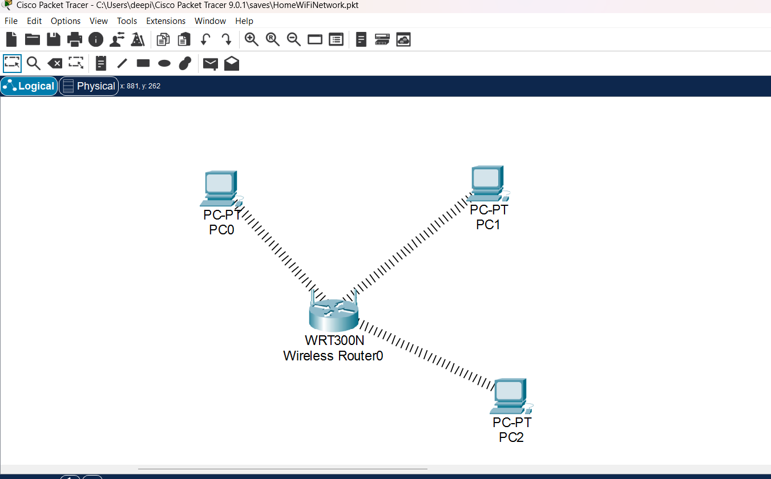

2.Assign static IP addresses to each PC in your Packet Tracer network so they are on the same subnet (e.g., 192.168.10.x), and configure the default gateway to the router's IP.
Ans=
Objective:
To assign static IP addresses and default gateway settings to the wireless PCs in the Packet Tracer network so they reside on the same logical subnet (192.168.10.x).
2. Steps Performed:
- Opened the configuration window for each PC (PC0, PC1, PC2), navigated to the Desktop tab, and selected IP Configuration.
- Configured static IP addresses and gateway for each device:
  - PC0: IP Address: 192.168.10.10, Subnet Mask: 255.255.255.0, Default Gateway: 192.168.10.1.
  - PC1: IP Address: 192.168.10.11, Subnet Mask: 255.255.255.0, Default Gateway: 192.168.10.1.
  - PC2: IP Address: 192.168.10.12, Subnet Mask: 255.255.255.0, Default Gateway: 192.168.10.1.
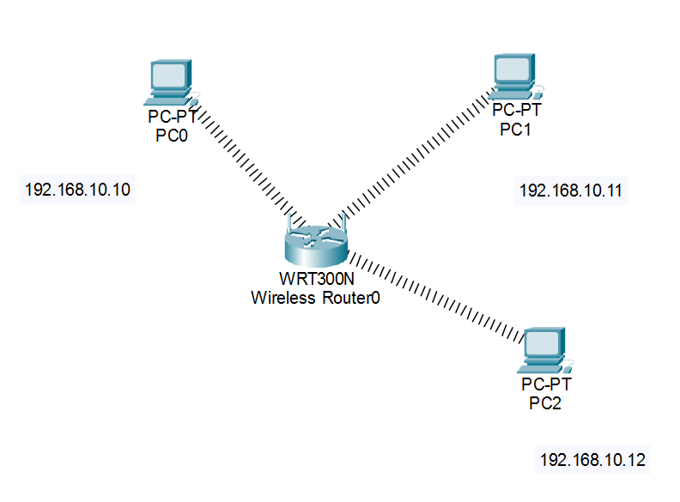
3.Test connectivity by using the Packet Tracer 'ping' tool to verify that all PCs can communicate with each other and the router.<br><br><em><strong>Hint:</strong> Use the Command Prompt tool on each PC and type 'ping [other PC’s IP]'.</em>
Ans=
- Opened the Command Prompt on PC0 and pinged the wireless router gateway (192.168.10.1)
- Result: Received successful replies with 0% packet loss, confirming active communication between the wireless client and the network router.
- Similarly, tested connectivity to peer PCs (192.168.10.11 and 192.168.10.12), confirming successful intra-network communication.

Screenshots:

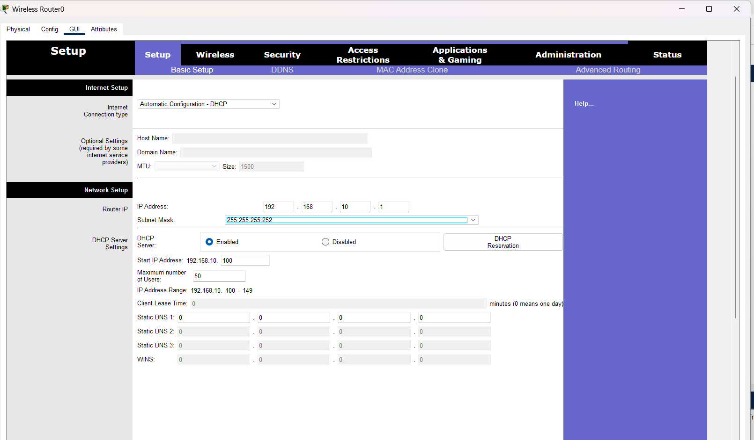

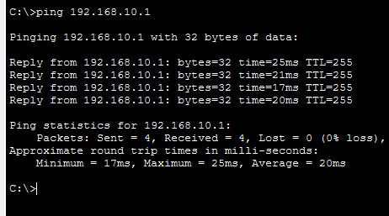
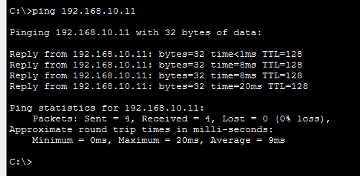
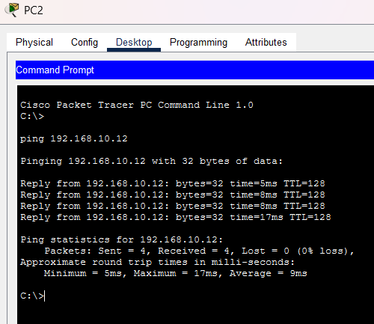
4.Document each step you took to build and configure your Packet Tracer network, including screenshots of your topology and the IP configuration windows for each PC, in a Word or PDF file.
Ans=
1. Objective
The objective of this assignment is to design, implement, and verify a wireless local area network (WLAN) topology in Cisco Packet Tracer. This includes replacing standard wired network interface cards with wireless modules on end-user workstations, provisioning a wireless router, configuring static IP addresses within a common subnet, and testing end-to-end connectivity using ICMP echo requests (ping).
2. Network Topology & Equipment Setup
A star topology was established consisting of a wireless broadband router and three personal computers equipped with wireless client adapters.
- Wireless Router: Model WRT300N, functioning as the central wireless access point and default gateway for the local subnet.
- Workstations: Three PCs (PC0, PC1, and PC2) deployed in the workspace.
- Module Replacement: The default wired Ethernet ports (`PT-HOST-NM-1CFE`) on each workstation were removed after powering down the devices and replaced with wireless network interface cards (`WMP300N`).
- Association: Upon powering the workstations back on, wireless signals established connectivity between each PC and the central WRT300N router.
Project File Reference: Saved locally as HomeWiFiNetwork.pkt.
3. Static IP Configuration Table
To ensure deterministic routing and node-to-node communication within the local broadcast domain, static IPv4 addresses, subnet masks, and default gateway parameters were assigned to each host.
Device Name | IP Address | Subnet Mask | Default Gateway
Wireless Router0 | 192.168.10.1 | 255.255.255.0 | N/A (Gateway)
PC0 | 192.168.10.10 | 255.255.255.0 | 192.168.10.1
PC1 | 192.168.10.11 | 255.255.255.0 | 192.168.10.1
PC2 | 192.168.10.12 | 255.255.255.0 | 192.168.10.1

4. Connectivity & Ping Verification
Network reachability was verified using the built-in Command Prompt tool on the workstations via ICMP echo requests.
- Router Gateway Ping: Executing ping 192.168.10.1 from PC0 successfully returned replies with 0% packet loss (average round-trip time ~20ms).
- Peer-to-Peer Ping: Verification tests between client workstations (`192.168.10.10` to `192.168.10.11` and `192.168.10.12`) confirmed fully operational intra-subnet communication across the wireless medium.
Screenshots:
