DAY 1 : Introduction to network and OSI model

Tasks
1.Install Wireshark on your laptop, start a capture on your main network interface, and visit any website (like instagram.com). Stop the capture and note down the protocol names you see in the packet list.
Ans=
rocedure:
- Installed Wireshark on my laptop.
- Started packet capture on the active network interface.
- Opened a website in the browser.
- Stopped the capture and checked the Protocol column.

Result: Network packets were captured successfully, and the protocol names were identified from the packet list.

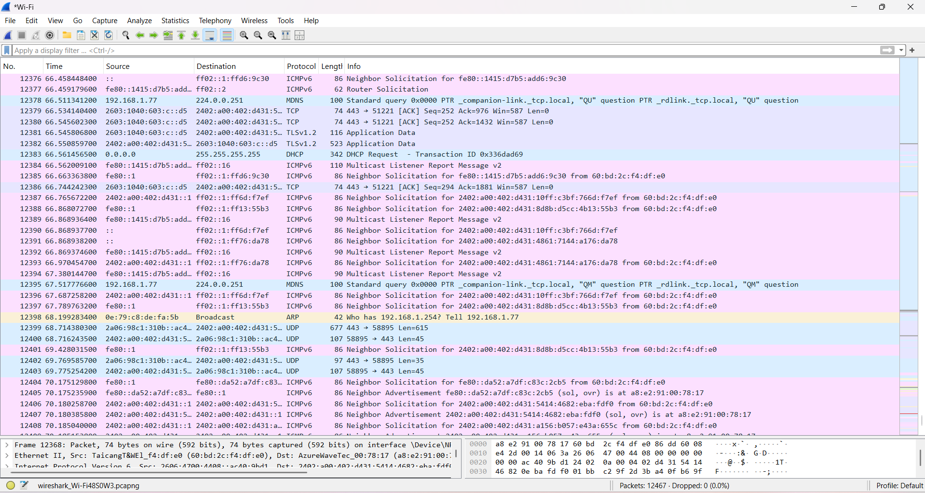

Protocols Observed:
- TCP
- UDP
- ICMPv6
- ARP
- TLSv1.2
- DNS
2.Pick any 3 packets from your Wireshark capture and identify which OSI layer each packet mainly represents (for example, HTTP for Application layer, TCP for Transport layer, etc.).<br><br><em><strong>Hint:</strong> Use the Protocol column and Info details in Wireshark to help you map protocols to OSI layers.</em>
Ans=
1. Packet No. 12398
- Protocol: ARP (Address Resolution Protocol)
- Info: Who has 192.168.1.254? Tell 192.168.1.77
- OSI Layer: Data Link Layer (Layer 2)
- Reasoning: ARP resolves logical IP addresses to physical MAC addresses on the local network, operating closely with the data link layer.
2. Packet No. 12376
- Protocol: ICMPv6 (Internet Control Message Protocol version 6)
- Info: Neighbor Solicitation for fe80::1415:d7b5:add6:9c30
- OSI Layer: Network Layer (Layer 3)
- Reasoning: ICMPv6 handles error reporting, diagnostics, and neighbor discovery for IPv6, which functions at the network layer.
3. Packet No. 12379
- Protocol: TCP (Transmission Control Protocol)
- Info: 443 -> 51221 [ACK] Seq=252 Ack=976 Win=587 Len=0
- OSI Layer: Transport Layer (Layer 4)

3.Create a colorful diagram of the OSI Model using any drawing tool (MS Paint, Canva, or even paper and upload a photo). For each layer, add a real-world example from apps you use daily (e.g., WhatsApp uses the Application layer, Instagram images use the Presentation layer, etc.).
Ans=

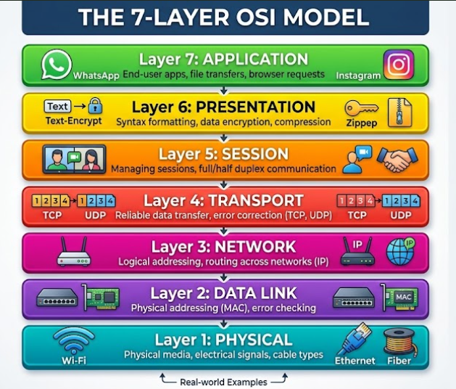

Layer-wise Real-World App Examples:
- Layer 7 (Application): WhatsApp / Gmail (Used for user interaction and messaging).
- Layer 6 (Presentation): Instagram / Netflix (Handles data compression, encryption, and media formats like JPEG/MP4).
- Layer 5 (Session): Zoom / Spotify (Manages and maintains continuous connection sessions).
- Layer 4 (Transport): Online Gaming / Web Browsing (Ensures reliable end-to-end data delivery via TCP/UDP).
- Layer 3 (Network): Google Maps / Routers (Handles IP addressing and data routing across networks).
- Layer 2 (Data Link): Wi-Fi Router / Ethernet Switch (Manages node-to-node local communication using MAC addresses).
- Layer 1 (Physical): Ethernet Cables / Wi-Fi Waves (Transmits raw binary bits over physical cables or radio frequencies).

4.Explain how sending a message on WhatsApp travels through at least 4 layers of the OSI Model, describing what happens at each layer in your own words.<br><br><em><strong>Hint:</strong> Think about how your message is typed, packaged, sent over the internet, and received.</em>
Ans=
When you send a message on WhatsApp, it moves down through the OSI layers on your phone, travels across the internet, and moves up through the layers on the receiver's phone. Here is how it travels through at least 4 key layers in your own words:
1. Application Layer (Layer 7)
- What happens: This is where you interact directly with the app. When you open WhatsApp, type a message (e.g., "Hello!"), and press send, the Application layer generates the data using application protocols (like HTTP/MQTT) to prepare your message for transmission.
2. Transport Layer (Layer 4)
- What happens: Once the message is created, the Transport layer (using TCP) takes your message and breaks it down into smaller segments or packets. It ensures reliable delivery, checking for any errors and managing flow control so that your message arrives complete and in the correct order.
3. Network Layer (Layer 3)
- What happens: The Network layer adds logical addressing (source and destination IP addresses) to the data packets. This acts like a shipping address, allowing routers across the internet to determine the best path (routing) to forward the message toward the recipient's device.
4. Physical & Data Link Layers (Layers 1 & 2)
- What happens: Finally, at the lowest layers, the packets are converted into physical signals—such as Wi-Fi radio waves, electrical pulses, or light signals—and transmitted through your phone's antenna or mobile data network into the physical medium to reach the internet.

