DAY 2 : TCP/IP
Tasks
1.Open Wireshark, capture network traffic while you refresh the Flipkart homepage, and identify one packet each belonging to the Application, Transport, Internet, and Network Access layers by examining their headers.
Ans =
By capturing network traffic while browsing web pages (like Flipkart), we can examine a single packet (for example, Packet No. 8072 containing TLS traffic) and break down its headers from the bottom layers to the top layers:
- Network Access Layer (Layer 2)
  - Protocol: Ethernet II
  - Header Details: Found at the very bottom pane of Wireshark showing the Source MAC Address and Destination MAC Address of the local network interface and router.
- Internet Layer / Network Layer (Layer 3)
  - Protocol: IPv6 / IPv4
  - Header Details: Specifies the logical routing information, including the Source IP Address and Destination IP Address.
- Transport Layer (Layer 4)
  - Protocol: TCP (Transmission Control Protocol)
  - Header Details: Displays port information such as Source Port and Destination Port (e.g., port 443 for HTTPS/TLS web traffic), along with sequence and acknowledgement numbers.
- Application Layer (Layer 7)
  - Protocol: TLSv1.2 / HTTP
  - Header Details: Contains the high-level application data, security encryption records, and web communication data used directly by the browser.

Screenshot:
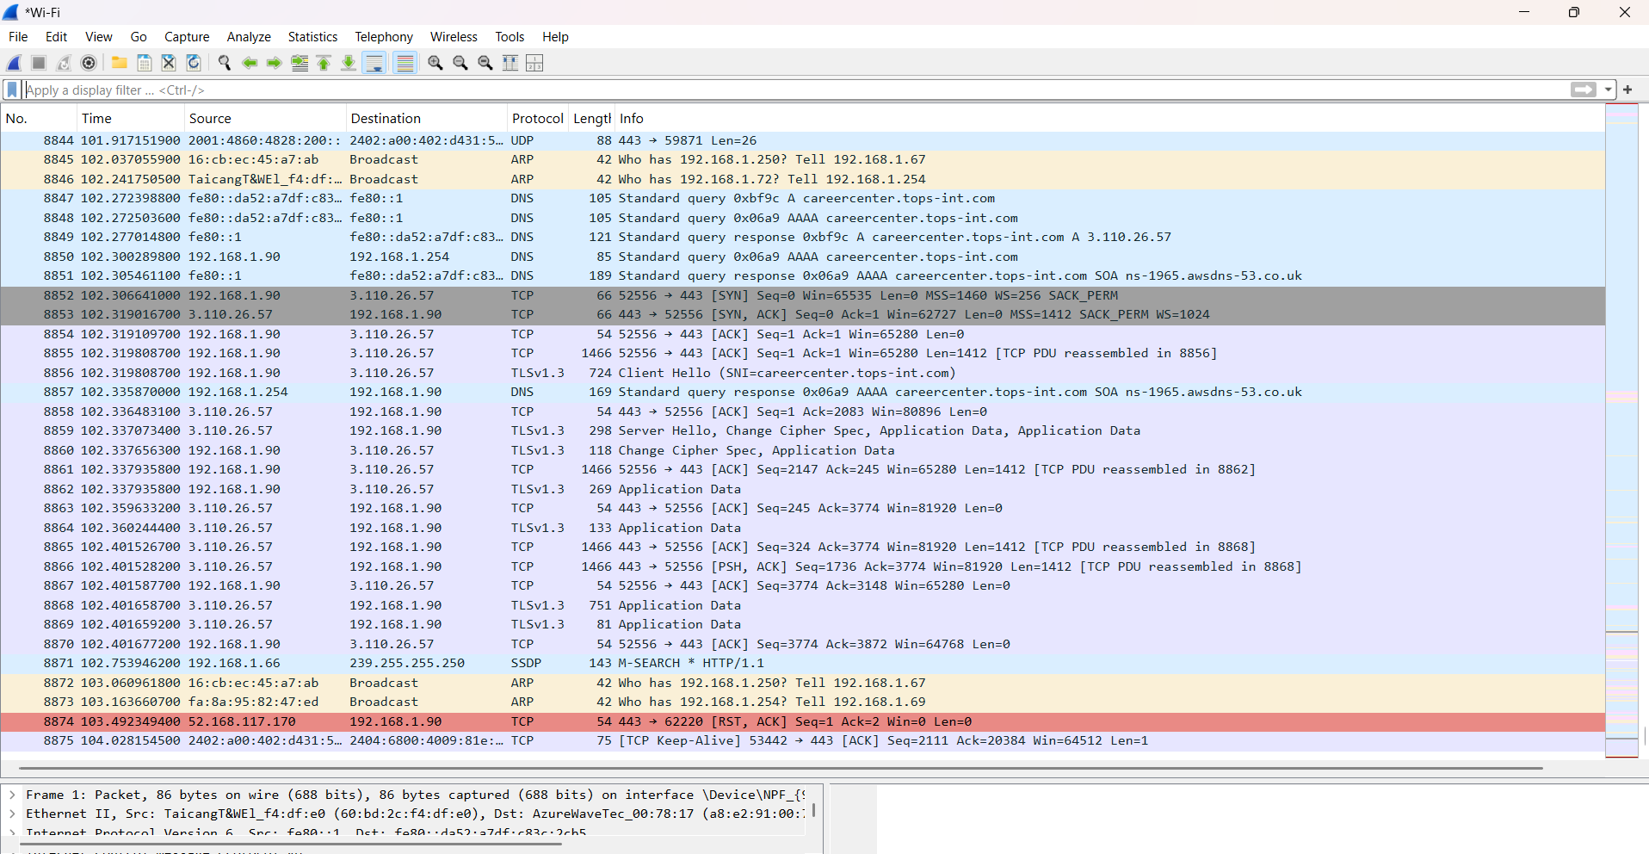

2.Create a table comparing the OSI and TCP/IP models, listing all layers side-by-side, and for each layer, give a real-world example from any app you use (e.g., WhatsApp message, Zomato order).
Ans =
Layer Level | OSI Model (7 Layers) | TCP/IP Model (4 Layers) | Real-World App Example (WhatsApp / Zomato / Browser)
Application | 7. Application Layer | \multirow{3}{*}{4. Application Layer} | WhatsApp / Zomato App: Typing and sending a chat message or placing a food order on the user interface.
 | 6. Presentation Layer |  | Instagram / Netflix: Handling data encryption, compression, and media formats (JPEG, PNG, MP4).
 | 5. Session Layer |  | Zoom / Spotify: Opening, managing, and closing active streaming or login sessions.
Transport | 4. Transport Layer | 3. Transport Layer | Web Browsing / Online Gaming: Using TCP/UDP protocols for reliable end-to-end data delivery and error checking.
Network | 3. Network Layer | 2. Internet Layer | Google Maps / Routers: Using logical IP addresses to route data packets across different networks.
Physical / Link | 2. Data Link Layer | \multirow{2}{*}{1. Network Access / Link Layer} | Wi-Fi Router / Ethernet Switch: Managing local node-to-node communication using physical MAC addresses.
 | 1. Physical Layer |  | Ethernet Cables / Wi-Fi Signals: Transmitting raw binary bits (0s and 1s) physically through wires or radio waves.

3.Given a screenshot of a TCP segment header (provided by your trainer), label the fields that belong to the Transport layer and explain what each field does in 1-2 lines.<br><br><em><strong>Hint:</strong> Look for fields like Source Port, Destination Port, Sequence Number, etc.</em>
Ans=
Based on a TCP segment header diagram, here are the key fields belonging to the Transport layer and their functions:
- Source Port
  - Function: Identifies the sending application or process on the source device so that the receiver knows where to send the response back.
- Destination Port
  - Function: Identifies the receiving application or service on the target device (e.g., port 443 for HTTPS web traffic) to ensure proper data delivery.
- Sequence Number
  - Function: Tracks the specific order of data bytes being transmitted, ensuring the receiver can reassemble them correctly even if they arrive out of order.
- Acknowledgement Number
  - Function: Confirms the successful receipt of data bytes by indicating the exact sequence number of the next expected byte.
- Window Size (Receiver Window)
  - Function: Manages network flow control by telling the sender how much incoming data the receiver can currently accept without buffer overflow.
- Checksum
  - Function: Provides error checking to verify that the TCP header and data packets were not corrupted or altered during transmission.
Screenshot:
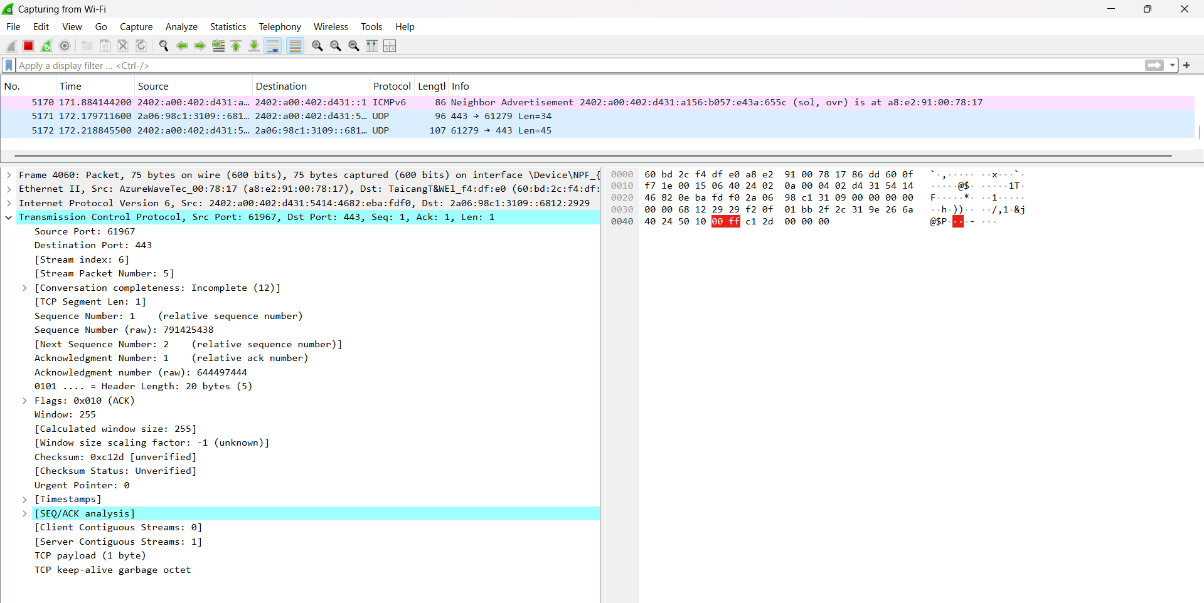

4.Draw a diagram showing how a message sent from your device to Instagram's server passes through each TCP/IP layer, and annotate what happens at each step using simple app-related terms (e.g., 'message split into packets', 'IP address added', etc.).
Ans=
[ User types message/story on Instagram App ]
│
▼
┌──────────────────────────────────────┐
4. Application Layer
- Message/Media created & formatted
└──────────────────────────────────────┘
│ (Data)
▼
┌──────────────────────────────────────┐
3. Transport Layer
- Message split into packets (TCP)
- Port numbers added
└──────────────────────────────────────┘
│ (Segments)
▼
┌──────────────────────────────────────┐
2. Internet Layer
- Source & Destination IP added
- Routed across the internet
└──────────────────────────────────────┘
│ (Packets / Datagrams)
▼
┌──────────────────────────────────────┐
1. Network Access / Link Layer
- MAC addresses added
- Converted to Wi-Fi/cable signals
└──────────────────────────────────────┘
│
▼
[ Instagram's Server ]
Step-by-Step Annotations:
- Application Layer (Layer 4):
  - What happens: You open Instagram, type your message or upload a photo, and hit send. The app formats this data using application protocols (like HTTP/HTTPS).
- Transport Layer (Layer 3):
  - What happens: The message is split into smaller segments/packets using TCP, and port numbers (such as port 443 for secure web traffic) are attached to ensure reliable and ordered delivery.
- Internet Layer (Layer 2):
  - What happens: The IP address is added (your device's IP as the source and Instagram server's IP as the destination) so routers can properly guide the packets across the internet.
- Network Access / Link Layer (Layer 1):
  - What happens: Physical MAC addresses are attached for local network delivery, and the digital data is converted into physical signals (Wi-Fi radio waves or electrical pulses) to leave your device.

5.Pick any one packet you captured in Wireshark and write which TCP/IP layer it belongs to, how you identified it, and what real-world action in an app (like sending a WhatsApp message or booking a ticket on BookMyShow) it represents.
Ans=
- Selected Packet: TCP Packet (Source Port: 61967, Destination Port: 443 / HTTPS)
- TCP/IP Layer:
  - Transport Layer
- How I Identified It:
  - I identified it in Wireshark by looking at the Protocol column, which explicitly displays TCP (Transmission Control Protocol).
  - Furthermore, expanding the packet details reveals key Transport Layer header fields such as Source Port (61967), Destination Port (443), Sequence Number, and Acknowledgement Number.
- Real-World Action Represented:
  - This packet represents a secure connection request or data transfer between my web browser and a secure web server while browsing a website (such as loading a product page on Flipkart or making a search on Google). Port 443 indicates encrypted HTTPS traffic used to keep user data private.

