DAY 3 : Introduction to IP Address
Task
1.List the key differences between IPv4 and IPv6 addressing by creating a two-column table with at least 4 points for each.
Ans=
Key Differences Between IPv4 and IPv6 Addressing:
Feature / Point | IPv4 Addressing | IPv6 Addressing
Address Length | 32-bit numeric address. | 128-bit alphanumeric address.
Address Format | Dotted-decimal notation (e.g., 192.168.1.1). | Colon-hexadecimal notation (e.g., 2001:db8::1).
Address Space | Provides about $4.3×{10}^{9}$ unique addresses (approx. 4.3 billion). | Provides an astronomically large number of unique addresses ($3.4×{10}^{38}$).
Configuration | Requires manual configuration, DHCP, or DHCPv4 for IP assignment. | Supports Stateless Address Autoconfiguration (SLAAC) and DHCPv6.
Security | IPsec is optional and needs to be implemented separately. | IPsec is built-in as a mandatory core protocol for secure communication.

2.Given the following scenario: You have 4 devices (laptop, phone, smart TV, and printer) connected to your home WiFi. Assign a unique static IPv4 address to each device using the 192.168.10.0/24 network, and write down the IP, subnet mask, and default gateway for each device.
Ans =
Given the network range 192.168.10.0/24, the available host IP addresses range from 192.168.10.1 to 192.168.10.254. The subnet mask for all devices is 255.255.255.0, and the default gateway (assigned to the home Wi-Fi router) is 192.168.10.1.
Here are the unique static IPv4 configurations assigned to each home device:
- Laptop
  - IP Address: 192.168.10.10
  - Subnet Mask: 255.255.255.0
  - Default Gateway: 192.168.10.1
- Phone
  - IP Address: 192.168.10.20
  - Subnet Mask: 255.255.255.0
  - Default Gateway: 192.168.10.1
- Smart TV
  - IP Address: 192.168.10.30
  - Subnet Mask: 255.255.255.0
  - Default Gateway: 192.168.10.1
- Printer
  - IP Address: 192.168.10.40
  - Subnet Mask: 255.255.255.0
  - Default Gateway: 192.168.10.1
3.Calculate the number of valid subnets and hosts per subnet if you use a /27 CIDR subnet mask on a 192.168.1.0 network. List the first three valid subnet address ranges (network address to broadcast address) and the usable host IPs in each.
Ans=
Answer:
- Subnets and Hosts Calculation:
  - Given Network: 192.168.1.0 (Default /24 network)
  - New Subnet Mask: /27 (which means 255.255.255.224, having 3 subnet bits borrowed).
  - Number of Valid Subnets: $2^{3}=8$ subnets.
  - Number of Usable Hosts per Subnet: $2^{\left(32-27\right)}-2=2^{5}-2=32-2=30$ usable hosts.
- First Three Valid Subnet Address Ranges & Usable IPs:
  - Subnet 1:
    - Network Address: 192.168.1.0
    - Usable Host IP Range: 192.168.1.1 to 192.168.1.30
    - Broadcast Address: 192.168.1.31
  - Subnet 2:
    - Network Address: 192.168.1.32
    - Usable Host IP Range: 192.168.1.33 to 192.168.1.62
    - Broadcast Address: 192.168.1.63
  - Subnet 3:
    - Network Address: 192.168.1.64
    - Usable Host IP Range: 192.168.1.65 to 192.168.1.94
    - Broadcast Address: 192.168.1.95

4.You are given the IP address 10.0.5.17 with subnet mask 255.255.255.0. Determine the network address, broadcast address, and the range of valid host addresses for this subnet.<br><br><em><strong>Hint:</strong> Convert the subnet mask to CIDR notation and use bitwise AND for network address calculation.</em>
Ans=
Given the IP address 10.0.5.17 and the subnet mask 255.255.255.0 (which corresponds to CIDR notation /24):
- Network Address:
  - Calculated by keeping the network portion the same and setting all host bits to 0.
  - Network Address: 10.0.5.0
- Broadcast Address:
  - Calculated by setting all host bits to 1.
  - Broadcast Address: 10.0.5.255
- Range of Valid Host Addresses:
  - The usable host IPs range from the first IP after the network address up to the last IP before the broadcast address.
  - Valid Host Range: 10.0.5.1 to 10.0.5.254
5.Use an online subnet calculator tool (such as https://www.subnet-calculator.com/) to verify your answer for the previous task. Take a screenshot of your calculation and write one line explaining if your manual answer matched the tool's output.
Ans=
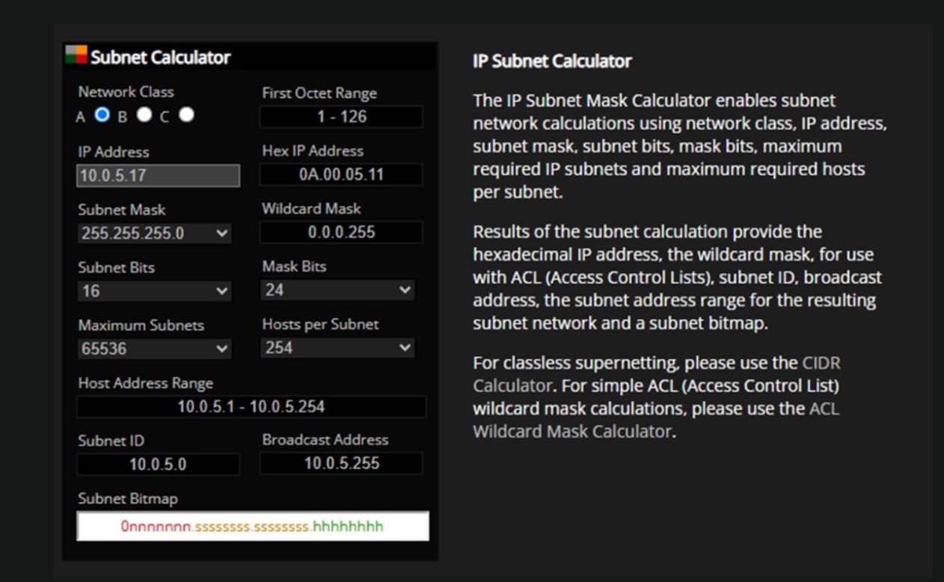
my manual calculation completely matched the tool's output, confirming the network address as 10.0.5.0, the broadcast address as 10.0.5.255, and the valid host range as 10.0.5.1 to 10.0.5.254

