DAY 5 : NETWORK TESTING
Tasks
1.Use the ping command to test connectivity from your computer to www.youtube.com and note the average response time.
Ans=
command Executed: ping [www.youtube.com](https://www.youtube.com)
Target IP Addressed (IPv6): 2001:4860:4829:400::
Ping Statistics:
- Packets: Sent = 4, Received = 4, Lost = 0 (0% packet loss)
- Minimum Response Time: 12ms
- Maximum Response Time: 13ms
- Average Response Time: 12ms
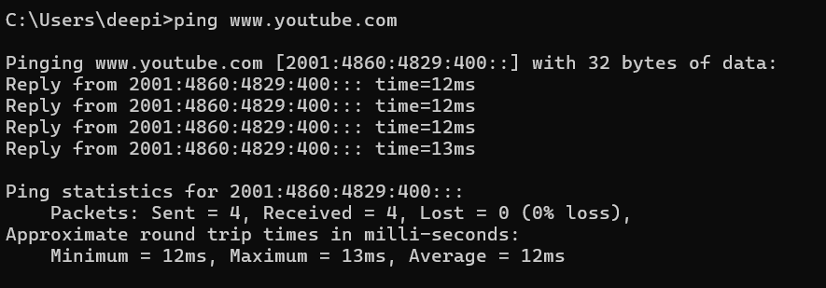

2.Run the traceroute (tracert on Windows) command to www.flipkart.com and list all the intermediate hops shown in the output.<br><br><em><strong>Hint:</strong> Each hop represents a network device your data passes through to reach the destination.</em>
Ans=
• Command Executed: tracert [www.flipkart.com](https://www.flipkart.com)
• Target Destination: e348826.dsca.akamaiedge.net (23.55.244.170)
• Intermediate Hops Listed in the Output:
- Hop 1: 1 ms, 1 ms, 1 ms — dsldevice.lan (192.168.1.254) (Local Gateway / Home Router)
- Hop 2: *, 3 ms, 4 ms — 10.130.192.1 (ISP Local Access Router)
- Hop 3: 4 ms, 3 ms, 4 ms — 10.111.13.5 (ISP Backbone Router)
- Hop 4: *, *, * — Request timed out. (Intermediate router filtering ICMP responses)
- Hop 5: 15 ms, 13 ms, 13 ms — 103.241.47.110 (ISP Transit Router / Edge Network)
- Hop 6: 13 ms, 13 ms, 12 ms — 49.44.129.94 (Akamai CDN / Content Delivery Network Router)
- Hop 7: 14 ms, 13 ms, 14 ms — a23-55-244-170.deploy.static.akamaitechnologies.com (23.55.244.170) (Destination Server)

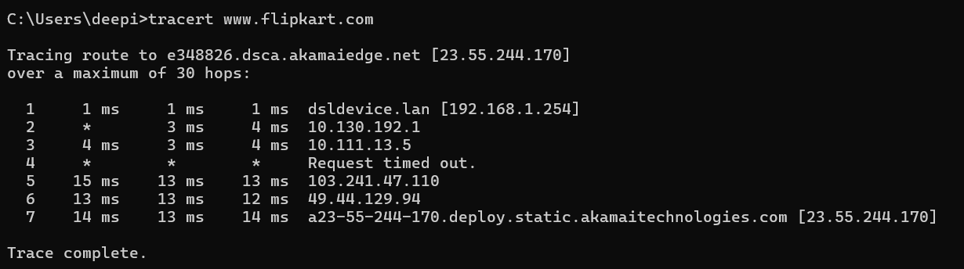
3.Use the nslookup tool to find the IP address of www.zomato.com and record the result.
Ans=
Command Executed: nslookup [www.zomato.com](https://www.zomato.com)
DNS Server Used: fe80::1
Canonical Name (Alias/CDN): e70929.dsca.akamaiedge.net (Aliased from [www.zomato.com](https://www.zomato.com) via zomato.edgekey.net)
Resolved IP Addresses:
- IPv6 Addresses:
  - 2600:140f:4::17da:f99a
  - 2600:140f:4::17da:f9a1
- IPv4 Addresses:
  - 23.55.244.186
  - 23.55.244.185

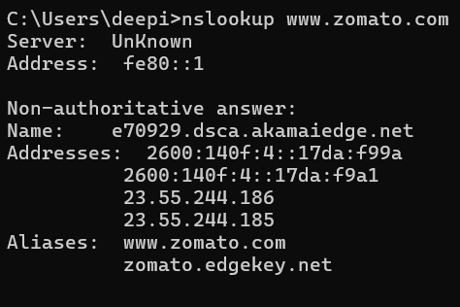

4.Test connectivity to another device on your local network (such as your friend's laptop or your phone) using the ping command and describe what happens if the device is offline.
Ans=
• Testing Connectivity on the Local Network: To test connectivity to another device on the same local area network (LAN/Wi-Fi), the ping command is executed along with the target device's local IP address (e.g., ping 192.168.1.15).
• Behavior and Output When the Device is Offline: If the target device is offline, powered off, or disconnected from the network, the ping test will fail. The command prompt will not receive any ICMP echo reply packets and will display error messages such as:
- Request timed out.
- Destination host unreachable.
• Technical Explanation: When a device is offline, the local operating system or router tries to reach its MAC address via ARP (Address Resolution Protocol) or sends out ICMP packets. Because the device is inactive and cannot respond, the packets are dropped, resulting in a 100% packet loss after the maximum retry attempts are exhausted.

5.Create a short report (5-7 lines) summarizing which tool (ping, traceroute, nslookup) is most useful for diagnosing each of these problems: (a) Website not loading, (b) Slow connection, (c) Suspecting DNS issues.<br><br><em><strong>Constraint:</strong> Give a specific example for each tool based on your own test results above.</em>
Ans=
To diagnose network issues, different diagnostic tools serve specific purposes: ping is most useful for checking basic server reachability, as demonstrated when testing connectivity to [www.youtube.com](https://www.youtube.com)
(average response time of 12ms). traceroute is ideal for troubleshooting slow connections or routing bottlenecks by identifying intermediate path failures, as seen when tracing hops to [www.flipkart.com](https://www.flipkart.com)
through local and ISP routers. Finally, nslookup is essential for resolving domain name resolution failures and suspected DNS misconfigurations, proven by successfully querying the IP records of [www.zomato.com](https://www.zomato.com). Together, these three utilities provide a comprehensive toolkit for troubleshooting web accessibility, latency, and name resolution faults.

