DAY 6 : Introduction to Network Device
Tasks
1.Create a table listing the main functions and typical ports used by switches, routers, hubs, firewalls, and access points in a home WiFi setup.
Ans=
Device | Main Function | Typical Ports
Switch | Connects multiple wired devices in a local network (LAN). | Ethernet ports (RJ-45)
Router | Connects different networks and shares internet between devices. | WAN port, LAN ports (RJ-45)
Hub | Connects multiple devices and sends incoming data to all connected ports. | Ethernet ports (RJ-45)
Firewall | Protects the network by monitoring and filtering incoming and outgoing traffic. | Ethernet ports; TCP/UDP ports such as 80, 443
Access Point (AP) | Provides Wi-Fi connectivity to wireless devices. | Ethernet port (RJ-45); Wi-Fi uses 2.4 GHz and 5 GHz bands

2.Given images or diagrams of network devices, label each device and mark the ports (Ethernet, console, power, antenna) for at least three devices.
Ans=
Network Devices and Their Ports
- Router: WAN port, LAN (Ethernet) ports, console port, power port, and antennas (if available).
- Switch: Ethernet ports, console port, and power port.
- Wireless Access Point (AP): Ethernet port, power port, and antennas (if available).
Diagram labels: Label each device and mark its ports as shown below.
- Ethernet port: Connects network cables.
- Console port: Used to configure and manage network devices.
- Power port: Supplies electrical power to the device.
- Antenna: Sends and receives wireless signals.

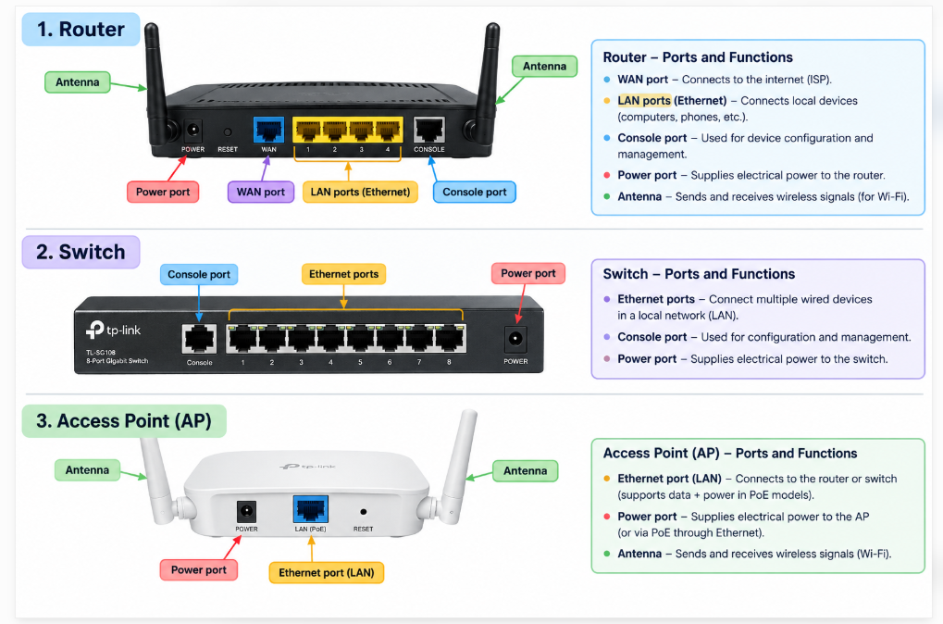
3.Pick a popular app you use daily (like Instagram, Zomato, or Paytm) and describe in 3-4 lines how at least two different network devices (from switches, routers, firewalls, access points) play a role when you use that app.
Ans=
Instagram
- When I use Instagram, the access point connects my mobile phone to the Wi-Fi network wirelessly.
- The router connects my home network to the internet and forwards data between my device and Instagram's servers.
- Switches connect multiple devices within a network and forward data to the correct destination.
- Firewalls help protect Instagram's servers by filtering network traffic and blocking unauthorized access.

4.Suppose your college WiFi is slow and sometimes disconnects. Based on the features of access points, switches, and routers, suggest one possible reason for the issue and how upgrading one device could help.<br><br><em><strong>Hint:</strong> Think about device capacity, coverage, and traffic handling.</em>
Ans=
One possible reason for slow college Wi-Fi is that the access point cannot handle too many connected students at the same time. This can cause slow internet and frequent disconnections. Upgrading to a modern, high-capacity access point with better coverage can support more users and provide a faster, more stable Wi-Fi connection.

