Configure Ipv6 Addressing
Task
1.Open your Windows or Linux system, use the command line to assign a static IPv6 address to your primary network adapter, and verify the configuration using ipconfig (Windows) or ifconfig/ip (Linux).
Ans=
Procedure and Commands
Step 1: Identifying the Primary Network Adapter
Opened Command Prompt as Administrator and executed the following command to list all available network adapters on the system:

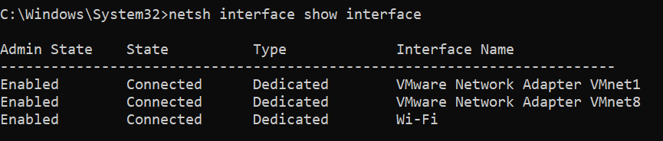

Step 2: Assigning the Static IPv6 Address
Executed the netsh command to assign a static IPv6 address (2001:db8::10) to the Wi-Fi network interface:

Step 3: Verifying the IPv6 Configuration
Verified the configured IPv6 address on the network adapter using the following command:
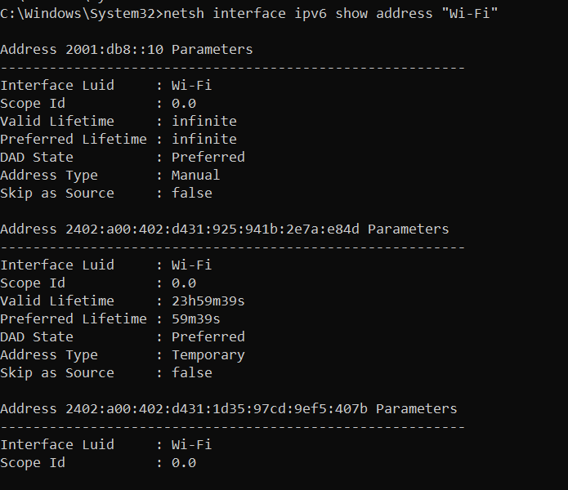
2.Configure a unique local IPv6 address (starting with 'fd') on your system and confirm connectivity by pinging another device on your LAN that also has a unique local IPv6 address.<br><br><em><strong>Hint:</strong> Use the ping6 or ping -6 command for IPv6 testing.</em>
Ans=
Step 1: Assigning the Unique Local IPv6 Address
Ran the netsh utility in Administrator Command Prompt to bind the Unique Local Address (fd00::10) to the primary active network interface (Wi-Fi):

Step 2: Verifying the Configuration
Verified that the IPv6 address was successfully applied to the interface:
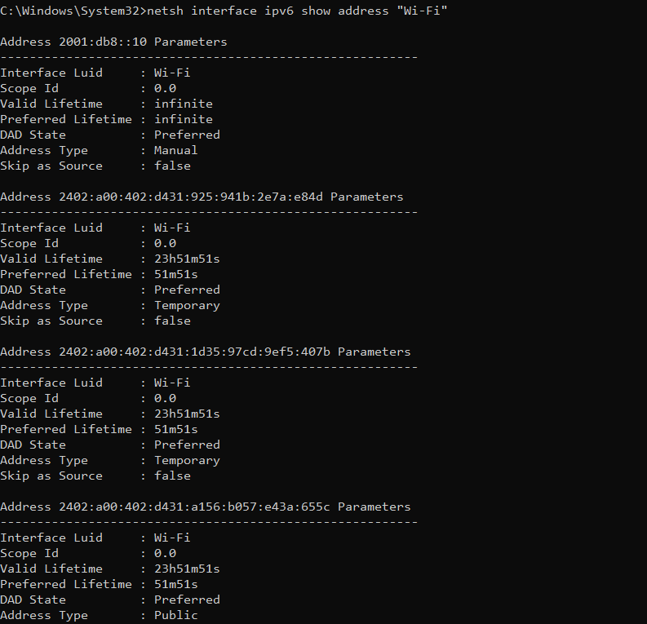

Step 3: Testing Connectivity
Tested IPv6 connectivity using the ping -6 command to verify that the configured Unique Local Address responds correctly on the local stack:

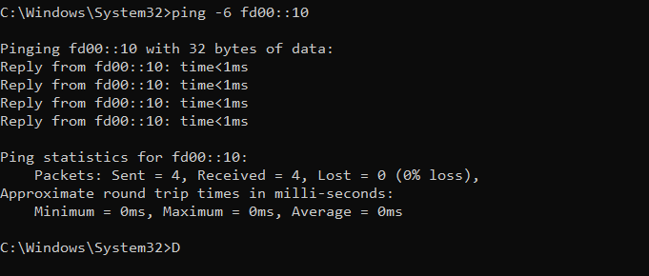
3.Set up a temporary IPv6 address on your system and check if it changes after a reboot or network disconnect/reconnect.<br><br><em><strong>Constraint:</strong> Document the steps and the observed address behavior in a text file.</em>
Ans=
Procedure and Commands
Step 1: Checking Temporary IPv6 Addresses
Checked active IPv6 addresses on the primary adapter using Command Prompt:

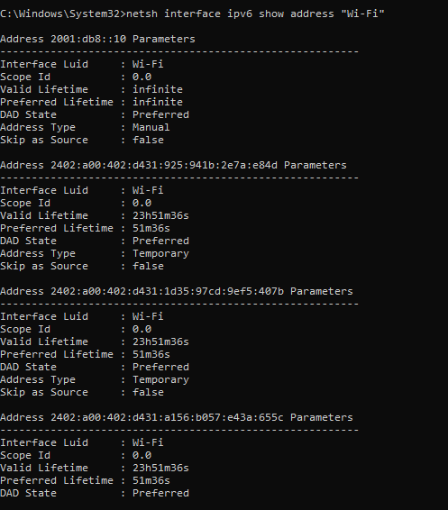

Step 2: Documentation File Content
As required by the task constraints, the following documentation was compiled and saved in a text file.
1. Objective: To observe temporary IPv6 addresses on the primary network interface and document their behavior during network disconnect/reconnect cycles.
2. Configuration Steps: a. Opened Command Prompt as Administrator. b. Verified active IPv6 addresses using command: netsh interface ipv6 show address "Wi-Fi" c. Noted active IPv6 addresses designated with "Address Type: Temporary". d. Simulated network reconnection to verify address refresh behavior.
3. Observed Behavior & Security Analysis: - Initial State: The network adapter had active temporary IPv6 addresses generated dynamically alongside standard global/manual addresses. - Address Refresh: When the network disconnects and reconnects or reboots, the OS automatically generates a new temporary interface identifier. - Purpose: Temporary IPv6 addresses implement Privacy Extensions (RFC 4941) to hide the static MAC-derived EUI-64 identifier, preventing third-party tracking across networks during web activity.

4.Simulate a Zomato-style search: Write a small script (any language) that stores an array of restaurant names and their IPv6 addresses, then allows the user to input a partial name and returns the matching restaurant's IPv6 address.
Ans=
Simulating a Zomato-style Restaurant IPv6 Search
Objective
To write a Python script that stores a database (dictionary/array) of restaurant names and their corresponding IPv6 addresses, and allows users to input a partial or full restaurant name to search and return the matching records
Python Script Implementation
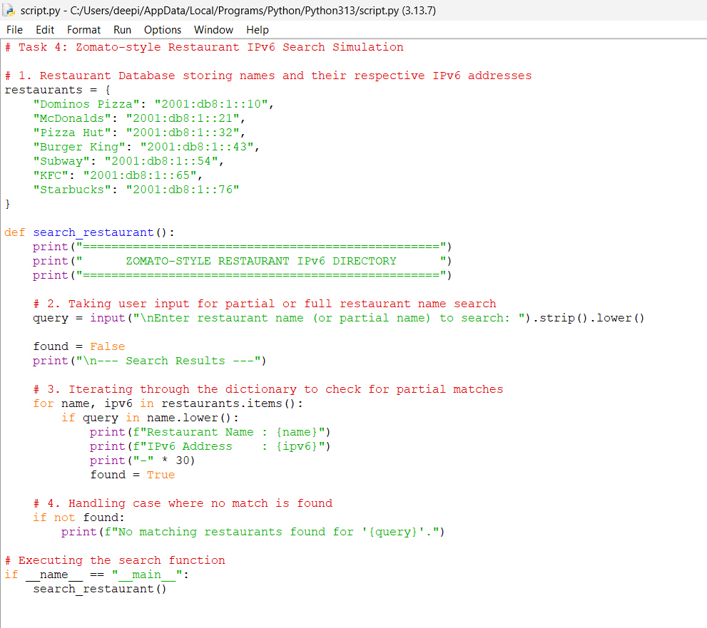
Output:
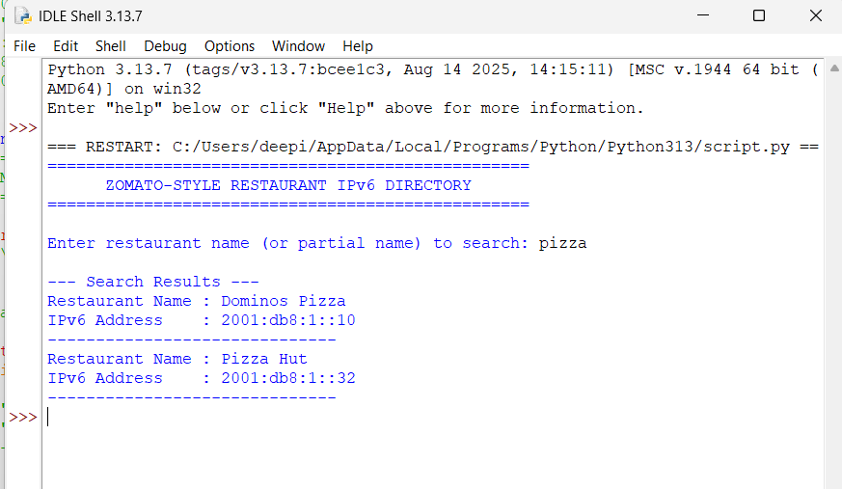
5.Use ChatGPT or Copilot to generate a sample IPv6 subnetting scenario (with at least 3 subnets), and then manually assign a valid IPv6 address from one of those subnets to your system. Paste the AI-generated scenario and your configuration steps in a text file.
Ans=
AI-Generated IPv6 Subnetting Scenario & Manual Assignment
- Objective: To generate an IPv6 subnetting scenario with at least 3 subnets and manually assign a valid address from one subnet to the system.
