Network Cable and Connectors

Tasks
1.Draw a labeled diagram of a Cat6 Ethernet cable, showing the color order of wires in the T568B standard and labeling the RJ-45 connector pins.
Ans:
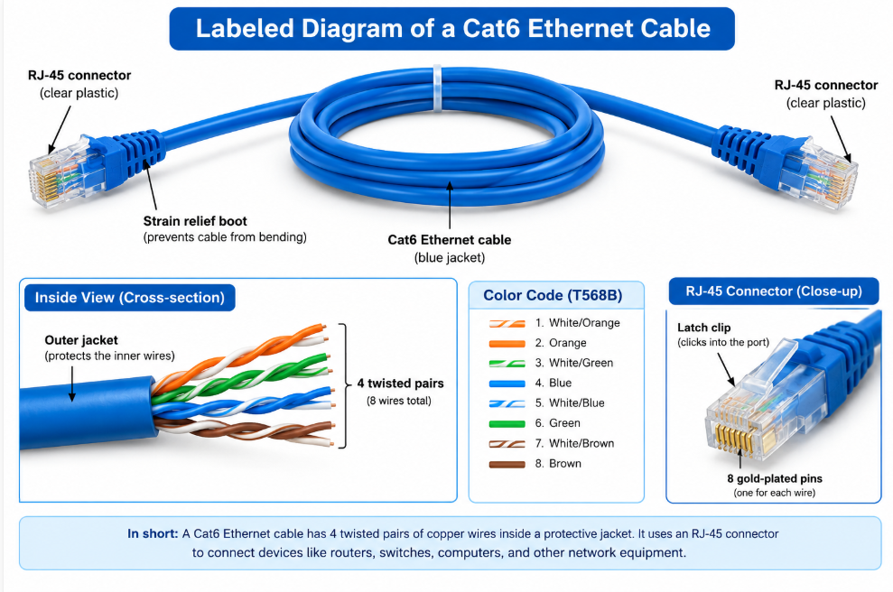

2.List three types of network cables (such as Cat5e, Cat6, and fiber optic) and for each, mention one real-world app or device (like a WiFi router, Zomato POS terminal, or IPL streaming server) where it would be used, explaining why.
Ans :
Network Cable | Real-World Application / Device | Why it is used
Cat5e | Wi-Fi Router | It is suitable for normal internet connections and supports speeds up to 1 Gbps.
Cat6 | Zomato POS Terminal | It provides faster and more reliable communication between the POS system and the network.
Fiber Optic | IPL Streaming Server | It supports very high-speed data transmission over long distances, which is useful for streaming large amounts of video data.

3.Watch a YouTube video showing how to crimp an RJ-45 connector onto a network cable, then write down the step-by-step process in your own words and mention two common mistakes to avoid.
Ans :
Step-by-step process for crimping an RJ-45 connector:
- Cut the cable to the required length using a cable cutter.
- Remove the outer jacket from about 1–2 cm of the cable using a cable stripper.
- Separate the 8 wires and straighten them properly.
- Arrange the wires in T568B order:
  - White/Orange
  - Orange
  - White/Green
  - Blue
  - White/Blue
  - Green
  - White/Brown
  - Brown
- Make the wire ends equal by cutting them straight.
- Insert the 8 wires into the RJ-45 connector, making sure each wire reaches the correct pin.
- Put the connector into the crimping tool and press it firmly.
- Check the connector to make sure the wires are in the correct order and properly fixed.
- Test the cable using a LAN cable tester.
Two common mistakes to avoid:
- Wrong wire color order — The wires must be arranged correctly according to T568B.
- Wires not inserted fully into the RJ-45 connector — This can cause a poor connection or make the cable fail the test.

4.Given the following scenario: You are setting up a gaming zone for an IPL screening event and need to connect multiple screens and consoles. Choose the appropriate cable and connector types for high-speed, reliable connections, and explain your choices.
Ans : For an IPL screening gaming zone, I would use Cat6 Ethernet cable with RJ-45 connectors for network connections. Cat6 provides a fast and stable connection, which is useful for gaming and streaming.
I would use an HDMI cable with an HDMI connector to connect gaming consoles to screens. HDMI provides high-quality video and audio through a single cable.
Therefore, Cat6 + RJ-45 is used for network connections, while HDMI is used to connect consoles with screens.

5.Find and share a photo (from your home, college, or online) of any network cable or connector in use (such as behind a WiFi router or at a café's POS counter), and describe what type it is and what devices it connects.<br><br><em><strong>Hint:</strong> Look for blue or yellow cables with clear plastic ends (RJ-45) or thin round cables for fiber optics.</em>
Ans:
I found a photo of a Cat6 Ethernet cable with an RJ-45 connector. It is used to connect a Wi-Fi router to a laptop or PC. The RJ-45 connector is attached to both ends of the cable. It provides a fast and stable network connection.
Photo:
