Network Devices
Tasks
1.Draw and label a simple home network diagram showing a router, switch, and three devices (like a laptop, smartphone, and smart TV), indicating how each device connects to the network.
Ans :
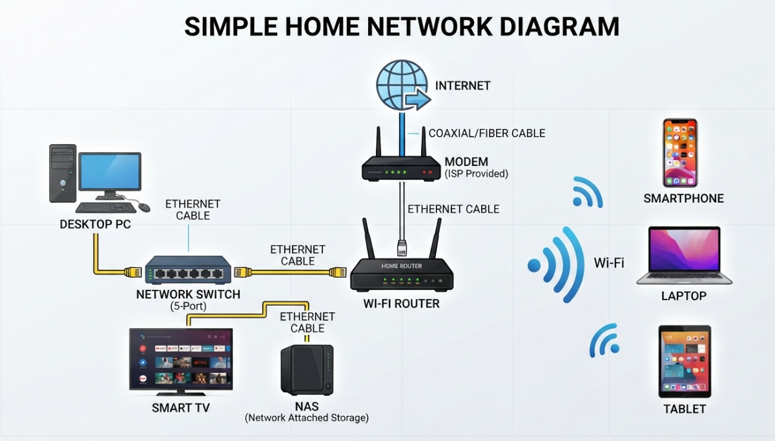
2.Create a comparison table listing at least four network devices (router, switch, hub, access point) and describe one real-world use case for each, referencing apps or services you use daily (e.g., WiFi for streaming on YouTube, LAN gaming, etc.).
Ans :
Network Device | Core Function | Real-World Use Case
Router | Connects your home network to the outside internet and directs traffic between them. | Streaming on YouTube or Netflix: The router takes data from the global internet and routes it to your specific home devices so you can watch videos without interruption.
Switch | Connects multiple devices together within a local wired network (LAN) using cables. | LAN Gaming or File Transfer: Connecting your PC and a friend's console directly to a switch to play Valorant or Counter-Strike with the lowest possible latency and no lag.
Hub | An older device that connects local devices but blindly broadcasts data to every port, making it slower than a switch. | Legacy Networking or Monitoring: Used in older setups to connect a shared office printer, or by network engineers to monitor all data traffic passing through a small network segment.
Access Point (AP) | Extends the wireless signal of a router to cover areas with poor signal. | Scrolling Instagram/TikTok in bed: If your main router is in the living room, an Access Point upstairs ensures you have strong Wi-Fi bars to load high-definition reels and shorts smoothly.

3.Write a short scenario where you explain how data travels from your phone to the internet when you order food on Zomato, mentioning the role of each network device involved (router, switch, access point).
Ans :
When I open the Zomato app on my smartphone and tap "Place Order" to get my food delivered, my data instantly travels through three key network devices to reach the internet:
- Step 1: The Access Point (AP)
My phone transmits the order request wirelessly via Wi-Fi signals. Since I am sitting in my bedroom, these wireless signals are first captured by the Access Point mounted on the hallway wall. This device ensures that my phone maintains a strong, seamless wireless connection to the local network.
- Step 2: The Switch
The Access Point is linked by a physical ethernet cable to a network Switch inside the living room cabinet. The switch acts as a local traffic controller. It immediately receives the data from the Access Point and directs it cleanly over a wired path to my main router, ensuring no local data gets mixed up or delayed.
- Step 3: The Router
The switch hands the data over to my Wi-Fi Router. The router acts as the gateway connecting my house to the outside world. It reads the destination address for the Zomato servers, packages my digital order, and routes it out over the global internet so the restaurant can receive it and start preparing my food.

4.Given this situation: you have a WiFi router, but your gaming PC only has an Ethernet port and is far from the router. Suggest two different network devices you could use to connect your PC to the internet and explain how each would work in this setup.<br><br><em><strong>Hint:</strong> Think about devices like switches, powerline adapters, or WiFi extenders.</em>
Ans :
1. Powerline Adapter
- How it works: You plug one adapter into the wall near your router and connect them with a cable. You plug the second adapter near your PC and run a cable from it into your PC.
- Why it helps: It uses your home's existing electrical wiring to send internet data through the walls like a hidden cable.
2. Wi-Fi Extender (with an Ethernet port)
- How it works: You plug it into a wall outlet halfway between your router and your PC. It catches the router's wireless signal, and then you connect it to your PC using a cable.
- Why it helps: It acts as a bridge, turning the wireless signal into a wired connection for your PC without running long wires across the house.

