IP Routing And Routing Protocol
Tasks
1.Draw a simple network diagram showing three devices (like your phone, a friend's laptop, and a smart TV) connected through a router, and label the IP addresses for each device and the router's interfaces.
Ans :
[ Internet / WAN ]
|
(Router W AN Port)
+----------------+
| Wi-Fi Router |
| Gateway: |
| 192.168.1.1 |
+----------------+
/ | \
(Wi-Fi) / | \ (Wi-Fi)
/ | \
+--------------+ | +--------------+
| My Smartphone| | | Smart TV |
| IP: | | | IP: |
| 192.168.1.5 | | | 192.168.1.20 |
+--------------+ | +--------------+
|
(Wi-Fi)
|
+---------------+
| Friend's |
| Laptop |
| IP: |
| 192.168.1.10 |
+---------------+
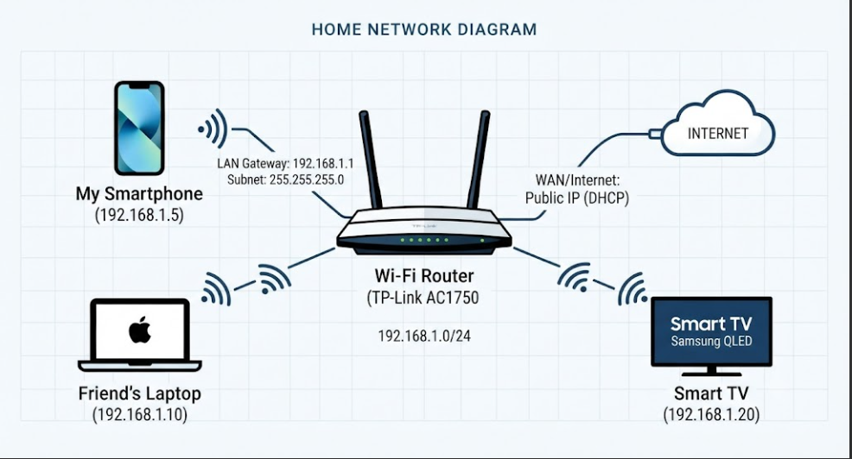

• Router (Default Gateway): 192.168.1.1 (LAN Interface IP)
• Device 1 (My Smartphone): 192.168.1.5
• Device 2 (Friend's Laptop): 192.168.1.10
• Device 3 (Smart TV): 192.168.1.20

2.Simulate manual IP routing by writing a step-by-step explanation of how a packet would travel from your laptop to a friend's computer in a different subnet, including which router(s) it passes through and how the routing decision is made.<br><br><em><strong>Hint:</strong> Use made-up IP addresses and show the routing table entries that would be checked at each hop.</em>
Ans :
Step 1: My laptop has IP address 192.168.1.10 and my friend's computer has IP address 192.168.2.20. Both computers are in different subnets.
Step 2: My laptop checks the destination IP address. As the destination is in a different subnet, the packet is sent to the default gateway 192.168.1.1.
Step 3: Router R1 checks its routing table. It finds the route to 192.168.2.0/24 through Router R2 (10.0.0.2) and forwards the packet.
Step 4: Router R2 checks its routing table. It finds that 192.168.2.0/24 is directly connected and forwards the packet to my friend's computer.
Step 5: My friend's computer receives the packet.
Routing Table of Router R1:
Destination | Next Hop
192.168.1.0/24 | Direct
192.168.2.0/24 | 10.0.0.2
Routing Table of Router R2:
Destination | Next Hop
192.168.2.0/24 | Direct
192.168.1.0/24 | 10.0.0.1

3.Create a routing table for a fictional Zomato-style delivery network with three branches in different cities, each on a different subnet. Specify the network address, subnet mask, next hop, and interface for each route.
Ans :
Routing Table for a Zomato-Style Delivery Network
Network Address | Subnet Mask | Next Hop | Interface
192.168.1.0 | 255.255.255.0 | Directly Connected | G0/0
192.168.2.0 | 255.255.255.0 | 10.0.0.2 | G0/1
192.168.3.0 | 255.255.255.0 | 10.0.0.6 | G0/2
Branches:
- Ahmedabad: 192.168.1.0/24
- Mumbai: 192.168.2.0/24
- Delhi: 192.168.3.0/24
Explanation: Each branch has a different subnet. The router uses the network address, subnet mask, next hop, and interface to forward data to the correct branch.

4.Compare static routing and dynamic routing protocols (like RIP or OSPF) by listing 3 pros and 3 cons of each, using examples from real-world apps or services you use (e.g., how a food delivery app might benefit from dynamic routing).
Ans :
Static Routing vs Dynamic Routing
1. Static Routing
Pros:
- It is simple to configure for small networks.
- It does not use extra bandwidth to exchange routing updates.
- It is more secure because routes are manually configured.
Cons:
- It requires manual configuration.
- It does not automatically change routes when a link fails.
- It is difficult to manage in large networks.
Example: A small restaurant can use static routing to connect its computers and billing system.
2. Dynamic Routing (RIP/OSPF)
Pros:
- It automatically learns routes.
- It can find another route when a network link fails.
- It is suitable for large networks.
Cons:
- It uses bandwidth to exchange routing updates.
- It requires more processing and memory.
- It is more complex to configure than static routing.

5.Use ChatGPT or another AI tool to generate a sample configuration for setting up OSPF routing between two routers, then explain in your own words what each configuration line does.<br><br><em><strong>Hint:</strong> Paste the AI-generated config and annotate each part with a short description.</em>
Ans :
Router 1 Configuration:
Router1(config)# router ospf 1
Router1(config-router)# network 192.168.1.0 0.0.0.255 area 0
Router1(config-router)# network 10.0.0.0 0.0.0.3 area 0
Explanation:
- router ospf 1 – Enables OSPF routing process 1.
- network 192.168.1.0 0.0.0.255 area 0 – Advertises the 192.168.1.0 network in OSPF area 0.
- network 10.0.0.0 0.0.0.3 area 0 – Enables OSPF on the matching router interface and advertises the network in area 0.
Router 2 Configuration:
Router2(config)# router ospf 1
Router2(config-router)# network 192.168.2.0 0.0.0.255 area 0
Router2(config-router)# network 10.0.0.0 0.0.0.3 area 0
Explanation:
- router ospf 1 – Enables OSPF routing process 1.
- network 192.168.2.0 0.0.0.255 area 0 – Advertises the 192.168.2.0 network in OSPF area 0.
- network 10.0.0.0 0.0.0.3 area 0 – Enables OSPF on the matching router interface and advertises the network in area 0.

