Switching and VLAN

Tasks
1.Draw a simple network diagram showing three devices (like your laptop, a friend's phone, and a smart TV) connected to a switch, and label which device is in which VLAN (e.g., VLAN 10 for streaming, VLAN 20 for personal devices).
Ans :
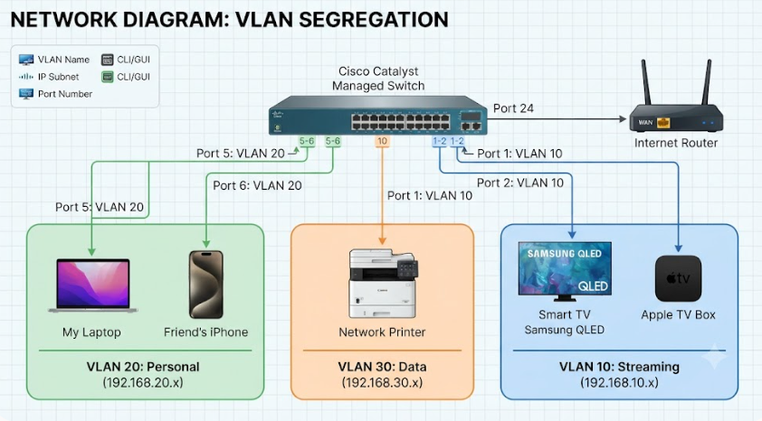
VLAN and Port :
- Port 1 & 2: Configured for VLAN 10 (Streaming devices).
- Port 5 & 6: Configured for VLAN 20 (Personal devices).
- Port 10: Configured for VLAN 30 (Network printer).

2.Configure a simulated switch using Cisco Packet Tracer or NetSim: create two VLANs (VLAN 10 and VLAN 20), assign three PCs to VLAN 10 and two PCs to VLAN 20, and verify that PCs in different VLANs cannot ping each other.<br><br><em><strong>Hint:</strong> Use the 'vlan' and 'switchport access vlan' commands in the simulator CLI.</em>
Ans :
- Devices Used: One 2960 Switch and 5 PCs.
- VLAN 10 (Ports Fa0/1 to Fa0/3): Assigned to PC0, PC1, and PC2 with IP addresses in the 192.168.10.x subnet (10, 11, 12).
- VLAN 20 (Ports Fa0/4 to Fa0/5): Assigned to PC3 and PC4 with IP addresses in the 192.168.20.x subnet (13, 14).

Screenshots:

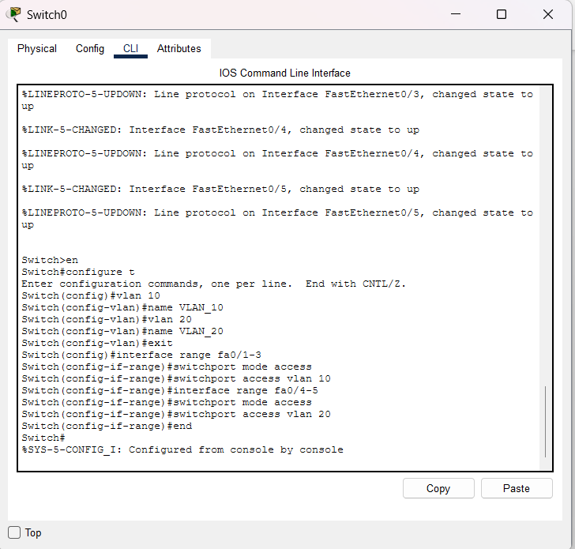

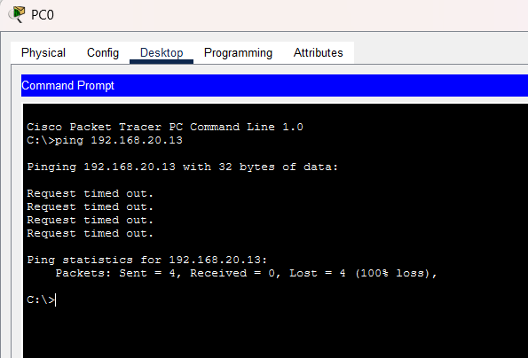

3.In any network simulator, set up a scenario where you move a PC from VLAN 10 to VLAN 20. Show the before and after configuration commands and test connectivity to confirm the change.
Ans :
Moving a PC from VLAN 10 to VLAN 20 in a Network
Configuration Commands
A. Before Configuration (PC in VLAN 10)
Initially, the switch port connected to the PC (FastEthernet 0/1) was configured as an access port under VLAN 10:
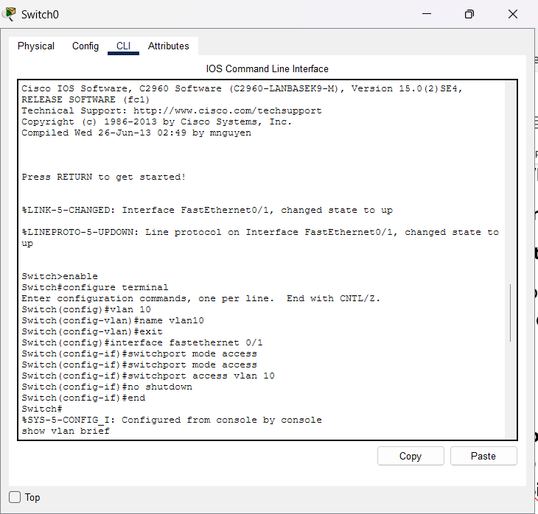
B. After Configuration (Moving PC to VLAN 20)
To move the PC to VLAN 20, create VLAN 20 on the switch and reassign port FastEthernet 0/1 to it:
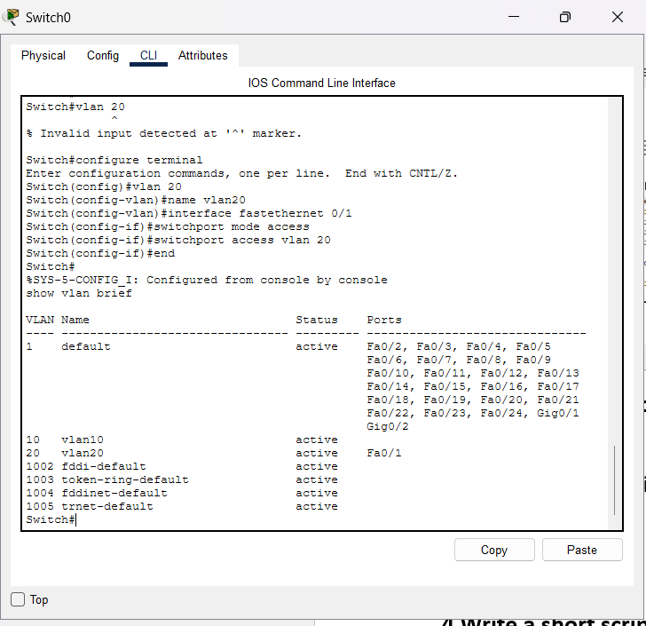

4.Write a short script or command list that would automate assigning 10 ports on a switch to VLAN 30, using the syntax of your chosen simulator (Packet Tracer, NetSim, or GNS3).<br><br><em><strong>Constraint:</strong> Use a loop or range command if supported by the tool to avoid repeating the same command 10 times.</em>
Ans :
Switch> enable
Switch# configure terminal
Switch(config)# vlan 30
Switch(config-vlan)# name VLAN30
Switch(config-vlan)# interface range fastethernet 0/1 - 10
Switch(config-if-range)# switchport mode access
Switch(config-if-range)# switchport access vlan 30
Switch(config-if-range)# end

Explanation of Key Commands
- vlan 30: Creates VLAN 30 in the switch's VLAN database.
- interface range fastethernet 0/1 - 10: Selects a continuous range of 10 ports at once, satisfying the constraint to avoid repeating commands individually.
- switchport mode access: Configures the selected ports as access ports.
- switchport access vlan 30: Assigns all 10 ports in the specified range to VLAN 30 in a single step.

