Network Topology

Tasks
1.Draw and label diagrams of star, bus, and mesh network topologies on paper or using any drawing tool. For each, write one real-world app or service (like WhatsApp, Flipkart, or IPL streaming) that could use that topology and explain why in 1-2 lines.
Answer:
- Star Topology:
Example: WhatsApp
A central server manages communication between users. Devices communicate through a central point.

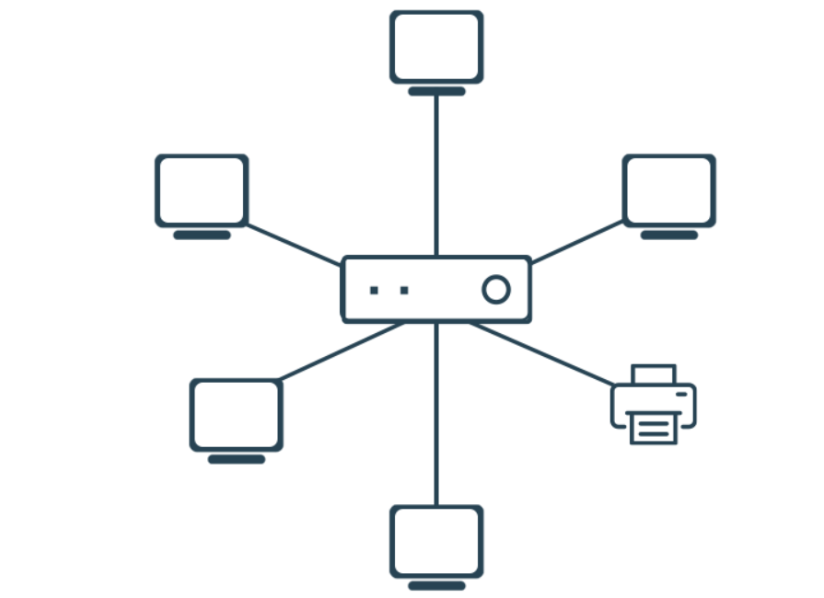
Star topology

- Bus Topology:
Example: Office/College LAN
In a simple shared network, multiple computers can communicate using a common communication line.
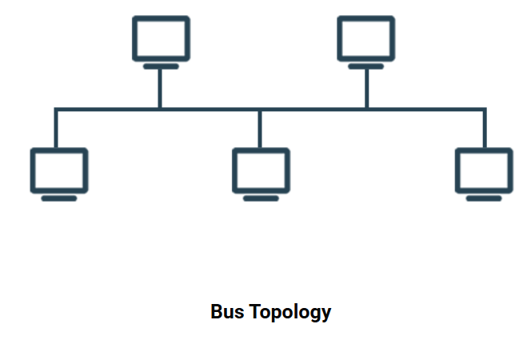

- Mesh Topology:
Example: Internet
Mesh networks provide multiple paths between devices, so data can use another path if one connection fails.
2.Create a comparison table listing at least four pros and four cons for each of these topologies: star, bus, ring, mesh. Include a column for 'Best Use Case' and give an example from apps you use (e.g., Instagram, Zomato, Paytm).
Answer:
Topology | Pros (Advantages) | Cons (Disadvantages) | Best Use Case | Example
Star | 1. Easy to install  2. Easy to manage  3. Failure of one device does not affect others  4. Easy to find problems | 1. Needs a central device  2. More cable is required  3. Central switch failure affects the network  4. Can be more expensive | Home, college, and office networks | Instagram – users connect to servers through network infrastructure
Bus | 1. Simple design  2. Uses less cable  3. Easy to set up for small networks  4. Low cost | 1. Main cable failure affects the network  2. Performance decreases with more devices  3. Difficult to troubleshoot  4. Limited network length | Small and temporary networks | College/office LAN – devices can share a common communication line
Ring | 1. Data travels in an organized way  2. Less chance of data collision  3. Equal access for devices  4. Can work efficiently under controlled traffic | 1. One break can affect communication  2. Difficult to add/remove devices  3. Troubleshooting can be difficult  4. More complex than bus topology | Specialized network environments | Paytm – its services depend on reliable network communication between systems
Mesh | 1. Very reliable  2. Multiple paths for data  3. Failure of one connection may not stop communication  4. Good fault tolerance | 1. Expensive to install  2. Requires many cables/connections  3. Complex to manage  4. Difficult to maintain | Large and critical networks | Zomato – its online services rely on interconnected systems and multiple network paths

3.Imagine you are designing a new multiplayer mobile game like PUBG or Free Fire. Choose a suitable network topology for the game servers and justify your choice in 3-4 lines, mentioning how it would impact speed, reliability, and cost.
Answer :
Chosen Topology: Mesh Topology
I would choose Mesh Topology for a multiplayer mobile game because it provides multiple paths for data, which improves reliability.
If one connection fails, data can use another available path, helping maintain stable gameplay and reducing interruptions.
It can provide good performance for communication between servers, but it is more expensive and complex to set up and maintain.
Therefore, it is suitable when reliability is more important than cost.
Do you like this personality?

4.Given this scenario: A small Flipkart-style warehouse wants to connect 8 computers for order processing and inventory updates. Recommend a network topology, sketch a quick diagram, and explain your reasoning in 2-3 lines.<br><br><em><strong>Hint:</strong> Consider factors like cost, ease of troubleshooting, and future expansion.</em>
Answer :
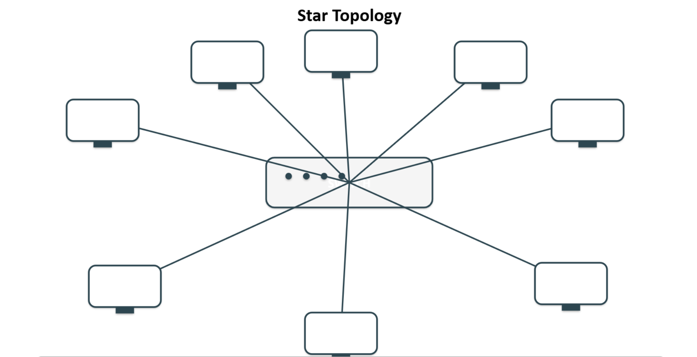

Reasoning:
Star topology is suitable because all 8 computers connect to a central switch, making the network easy to manage and troubleshoot.
It is reasonably cost-effective and allows easy future expansion by connecting more computers to the switch.

