WEEK 9 – HOUSING DATA CLEANING AND TRANSFORMATION
Dataset: KC House Data
NAME: DEEPIKA J
DEP:BSC DS AND AI

Objective
To clean and transform the housing dataset using Power Query in Power BI and prepare it for further analysis.

Dataset Description
The KC House Data dataset contains information about house sales in King County. It includes details such as house price, bedrooms, bathrooms, living area, lot area, location, year built and renovation details.

Data Cleaning
- Loaded the KC House Data CSV dataset into Power BI for preparation.
- Reviewed the available fields and verified their assigned data types.
- Converted the sale date field into the Date data type with the suitable regional setting.
- Used the column quality option to review valid entries, blank values and errors.
- Set appropriate number and text formats for the required columns.

Data Transformation
Added the following new columns in Power Query to make the dataset more useful:
- Sale Year – Retrieved the year value from the property sale date.
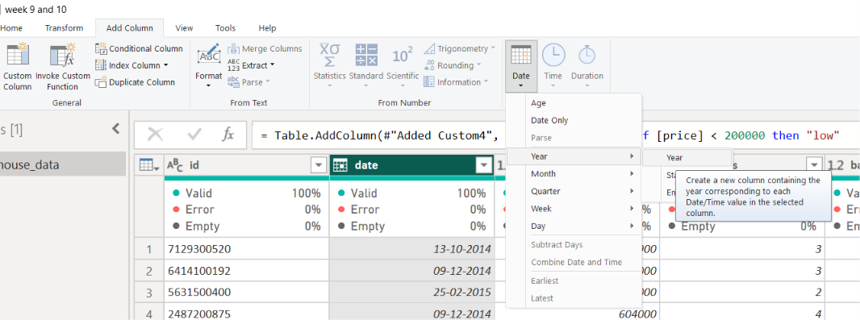

- Sale Month – Obtained the month name from the sale date field.
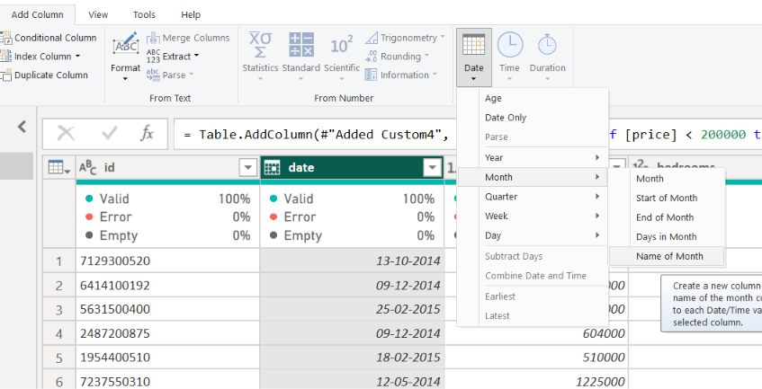

- Property Age – Found the property's age by comparing the sale year with the year it was built.

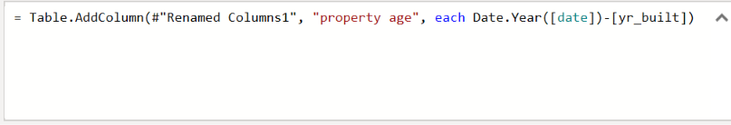

- Price per SqFt – Worked out the selling price for each square foot of area.
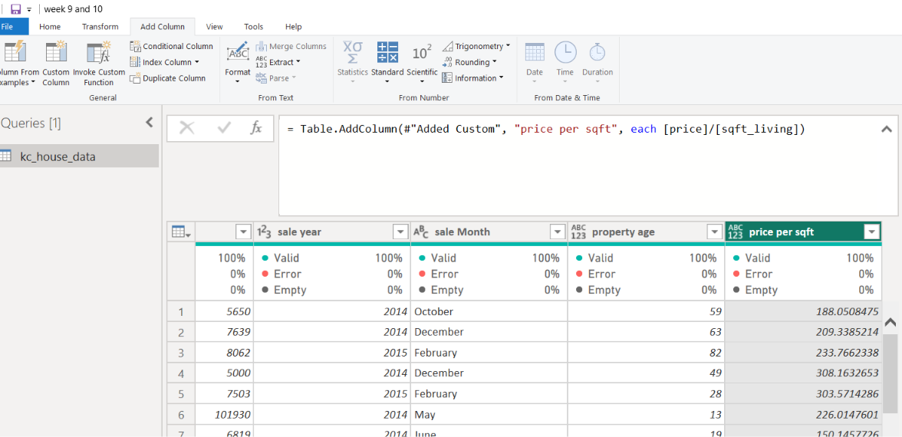
- Total Area – Combined the living area and lot area to create a total-area field.
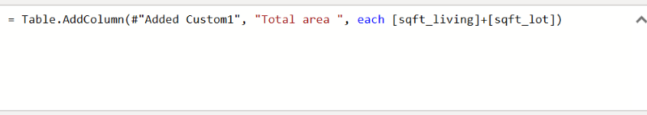

- Is Renovated – Marked each property as Yes or No depending on its renovation details.
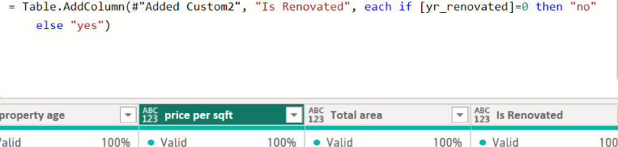

- Property Size Category – Grouped houses into Small, Medium and Large categories.
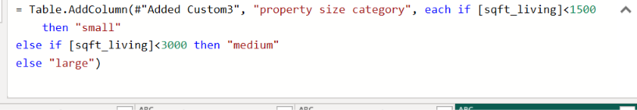

- Price Tier – Divided properties into Low, Medium, High and Luxury price groups.

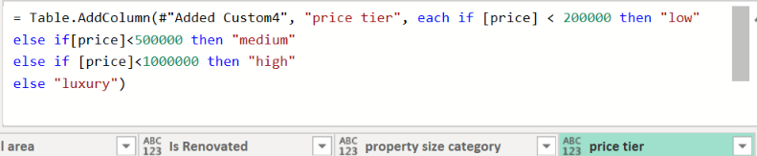

Tools Used
- Microsoft Power BI Desktop
- Power Query Editor for data preparation
- KC House Data CSV file

Result
The housing dataset was successfully cleaned and transformed by creating additional columns and organizing the data into suitable formats. The prepared dataset is ready for creating visualizations and performing real estate analysis.

Conclusion
This project helped in understanding data cleaning, data type conversion and data transformation using Power Query in Power BI.

