WEEK 10 – REAL-ESTATE ANALYTICS DASHBOARD
Dataset: King County House Sales Dataset
NAME: DEEPIKA J | ROLL NUMBER: E25DA008
DEPARTMENT: B.Sc. Data Science and AI | WEEK: 10
1. Objective
To create an interactive Power BI dashboard for analysing house sales in King County. The dashboard helps explore property prices, locations, house features and sales patterns.
2. Dataset Description
The King County House Sales Dataset contains property sale information such as price, bedrooms, bathrooms, living area, grade, condition, waterfront status, sale year, latitude and longitude. The dataset was preprocessed during Week 9 and used for this dashboard.
3. Problem Statement
Real-estate managers need a clear way to understand property prices, locations, house characteristics and sales trends. An interactive dashboard makes these details easier to compare and analyse.
4. Dashboard Measures
- Total Properties Sold – displays the count of property records.
- Average House Price – shows the average selling price.
- Median House Price – shows the middle house-price value.
- Average Living Area – displays the average living area.
- Average Price per SqFt – a measure listed in the task objectives; it is not visibly shown as a KPI in the supplied dashboard screenshot.
5. Visualizations Created
- Geographic map – plots properties using latitude and longitude.
- Average price by grade – compares average house prices across property grades.
- Average price by bathrooms – compares house prices by bathroom count.
- Average price by condition – shows price differences for property condition levels.
- Count of properties by sale year – displays the number of sales in each year.
- Count of properties by waterfront – compares waterfront and non-waterfront properties.
- Average price by bedrooms – compares average prices based on bedroom count.
- KPI cards – display total properties, average house price, median house price and average living area.
6. Dashboard Screenshot
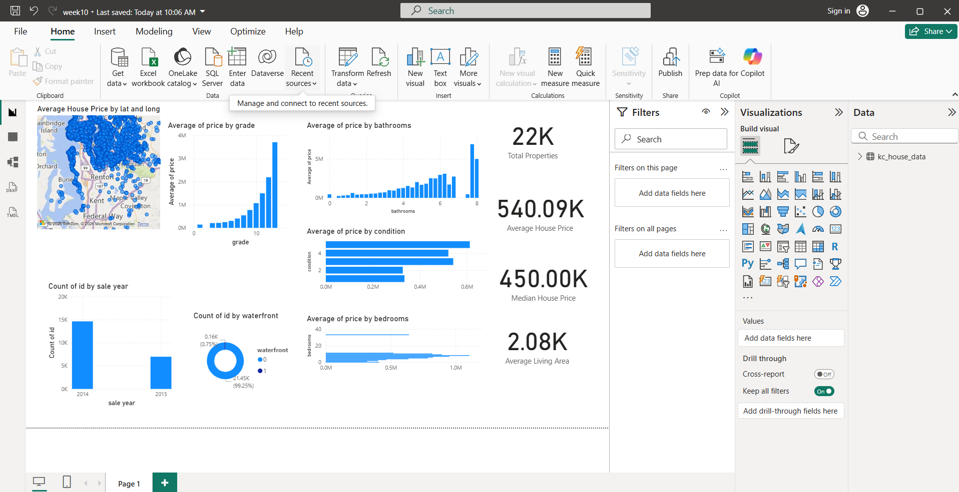
Figure 1: Real-Estate Analytics Dashboard created in Power BI
7. Tasks and Deliverables
- Created a geographic map visual using the available location coordinates.
- Prepared charts to study price distribution by grade, bathrooms, condition and bedrooms.
- Added a sale-year chart and a waterfront-status chart.
- Displayed key property statistics using KPI cards.
- The supplied task also mentions numeric range parameters for dynamic filtering and publishing/delivering the dashboard; these are not confirmed by the screenshot.
8. Tools Used
- Microsoft Power BI Desktop
- Power Query Editor (for the Week 9 preprocessed dataset)
- King County House Sales Dataset
9. Result
A Real-Estate Analytics Dashboard was created in Power BI using the King County house sales data. It presents property locations, price comparisons, sale-year counts, waterfront details and key summary values in one report page.
10. Conclusion
This activity provided practical experience in building an interactive dashboard and using different Power BI visuals to understand real-estate data. The report makes important housing details easier to view and compare.

