FAKESNIFF

SOFTWARE ENGINEERING PROJECT REPORT
[Submitted in Partial Fulfillment]
As a part of the curriculum of

B.Sc. (H) COMPUTER SCIENCE

SHYAMA PRASAD MUKHERJI COLLEGE FOR WOMEN
UNIVERSITY OF DELHI


Submitted by:
DEEPIKA (23075570015)
DIVYA (23075570018) RAJUL BENGANI (23075570047)

ACKNOWLEDGEMENT
It gives me immense pleasure to present you to this FAKE-SNIFF WEBAPPLICATION. We were lucky to get enormous support from extremely talented people, who deserve our great gratitude.
Firstly, we would like to thank our teacher and guide, Mr. Lavkush Gupta, who gave his valuable suggestions and ideas whenever we needed them. Also, he encouraged us to work on this project tirelessly by giving us numerous consultations. We are also grateful to our parents for their constant support and guidance, and for providing us with the necessary resources for the project.
Lastly, we would like to thank our classmates for their valuable suggestions for the betterment of this project and everybody who has helped us directly or indirectly in the completion of this project.
We are immensely grateful to everyone involved in this project as without their inspiration and valuable suggestion it would not have been possible to develop the project within the limited time frame.

CERTIFICATE
This is to certify that the project entitled, “FAKE-SNIFF”, has been submitted by Deepika, Divya and Rajul Bengani in partial fulfillment of the requirements of Bachelor of Computer Science (Hons.) embodies the work done by them during, semester V of their course under the supervision of Mr. Lavkush Gupta, Assistant Professor, Department of Computer Science, Shyama Prasad Mukherji College for Women, University of Delhi.

Mr. Lavkush Gupta
(Project Guide)

TABLE OF CONTENTS
- PROBLEM STATEMENT.............................................................................................06
- PROCESS MODEL........................................................................................................07
- REQUIREMENTS ANALYSIS.....................................................................................11

3.1 DFD...............................................................................................................11
3.1.1 Context Diagram............................................................................11
3.1.2 Level 1 DFD...................................................................................12
3.1.3 Level 2 DFD...................................................................................12

3.2 DATA DICTIONARY..................................................................................15 3.3 USE CASES..................................................................................................16
3.3.1 Use Case Diagram..........................................................................16
3.3.2 Use Case Description.....................................................................17
- SOFTWARE REQUIREMENTS SPECIFICATION (SRS)
  - INTRODUCTION
    - Category........................................................................................21
    - Purpose.........................................................................................21
    - Scope..............................................................................................21
    - Definitions, acronyms, and abbreviations......................................23
    - Overview........................................................................................23
  - PROJECT DESCRIPTIONS
    - Product Perspective........................................................................24
    - Product Functions...........................................................................24
    - Actor Characteristics......................................................................25
    - Constraints.....................................................................................25
    - Assumptions and Dependencies....................................................27
    - Assumption....................................................................................27
  - SPECIFIC REQUIREMENTS
    - External Interfaces.........................................................................28
    - Functional Requirements...............................................................29
    - Performance Requirements............................................................30
    - Design Constraints.........................................................................31
    - Software System Attributes............................................................31
    - Logical Database Requirement......................................................32
    - Change Management Process........................................................32

- PROJECT PLANNING
  - PROJECT SCHEDULING...........................................................................34

5.2 TIMELINE CHART.....................................................................................35 5.3 EFFORT ESTIMATION & FP-BASED COMPUTING..............................36 5.4 RISK ANALYSIS.........................................................................................57 5.5 RISK TABLE AND RMMM PLAN............................................................60
- CONSTRUCTION............................................................................................................62
- TESTING........................................................................................................................63
- REFERENCES...............................................................................................................XX 8. ANNEXURES................................................................................................................XX

LIST OF FIGURES
Figure no. | Description | Page No.
2.1 | Prototyping Model | 10
3.1 | Context Level Diagram | 11
3.2 | Level 1 DFD | 12
3.3 | Level 2 DFD (for media upload) | 12
3.4 | Level 2 DFD (for detect) | 13
3.5 | Level 2 DFD (for vault management) | 13
3.6 | Level 2 DFD (for report generation) | 14
3.7 | Use Case Diagram | 16
5.1 | Project Scheduling | 34
5.2 | Project Timeline Chart | 35
9.1 | Landing Page | 69
9.2 | Sign Up Page | 69
9.3 | Log In Page | 70
9.4 | User Dashboard | 70
9.5 | My Vault | 71
9.6 | Image Upload | 71
9.7 | Result-1 | 72
9.8 | Result-2 | 72
9.9 | Save the image | 73
9.10 | Report Generation | 73
9.11 | Report Sent Successfully | 74
9.12 | Feedback | 74
9.13 | Chatbot | 75
9.14 | Upload and Send | 75
9.15 | Admin Dashboard | 76
70

LIST OF TABLES
Table No. | Description | Page No.
3.1 | Data Dictionary | 15
5.1 | Risk Table | 40
5.2 | Function Point Calculation Table | 44

1. PROBLEM STATEMENT

PURPOSE: -
The project FAKE SNIFF aims to develop an online platform that helps users verify the authenticity of digital content, particularly images. In today’s digital era, misinformation spreads rapidly through manipulated visuals, creating serious risks to public trust, social stability, and individual reputation. Since fake media can be easily produced and shared on social platforms, users often struggle to judge whether the information they view or forward is genuine.
Currently, there are very few user-friendly tools that allow quick verification of visual content. Even when misinformation is identified, users lack a proper system to store evidence, prepare structured reports, or notify relevant authorities. Individuals affected by fake content also do not have convenient ways to archive, filter, or retrieve suspicious material for personal or legal use.
To address these issues, FAKE SNIFF provides a comprehensive web-based solution. Users can upload images for verification, and detection algorithms classify them as real or fake. A built-in chatbot guides users through the entire process—from uploading and checking content to generating reports and communicating with authorities. Any fake content found is securely stored with a timestamp in an online vault. Users can also download stored files in a zip format or search them easily using filters such as date or media type.
By offering a centralized system for verification, secure storage, and reporting—supported by an interactive chatbot—FAKE SNIFF empowers users to combat misinformation, promote digital awareness, and assist in maintaining accountability in the digital space.

ACTORS: -
- Users: o People o Cyber Cell
- Admin

2. PROCESS MODEL
The best suited model for this project is Prototyping Model.
We have used this model as it is used when the customers do not know the exact project requirements beforehand. In this model, a prototype of the end product is first developed, tested, and refined as per customer feedback repeatedly till a final acceptable prototype is achieved which forms the basis for developing the final product. In this process model, the system is partially implemented before or during the analysis phase thereby giving the customers an opportunity to see the product early in the life cycle. The process starts by interviewing the customers and developing the incomplete high-level paper model. This document is used to build the initial prototype supporting only the basic functionality as desired by the customer. Once the customer figures out the problems, the prototype is further refined to eliminate them. The process continues until the user approves the prototype and finds the working model to be satisfactory.

Advantages
- The customers get to see the partial product early in the life cycle. This ensures a greater level of customer satisfaction and comfort.
- New requirements can be easily accommodated as there is scope for refinement.
- Missing functionalities can be easily figured out.
- Errors can be detected much earlier thereby saving a lot of effort and cost, besides enhancing the quality of the software.
- The developed prototype can be reused by the developer for more complicated projects in the future.
- Flexibility in design.
- Early feedback from customers and stakeholders can help guide the development process and ensure that the final product meets their needs and expectations.
- Prototyping can be used to test and validate design decisions, allowing for adjustments to be made before significant resources are invested in development.
- Prototyping can help reduce the risk of project failure by identifying potential issues and addressing them early in the process.
- Prototyping can facilitate communication and collaboration among team members and stakeholders, improving overall project efficiency and effectiveness.
- Prototyping can help bridge the gap between technical and non-technical stakeholders by providing a tangible representation of the product.

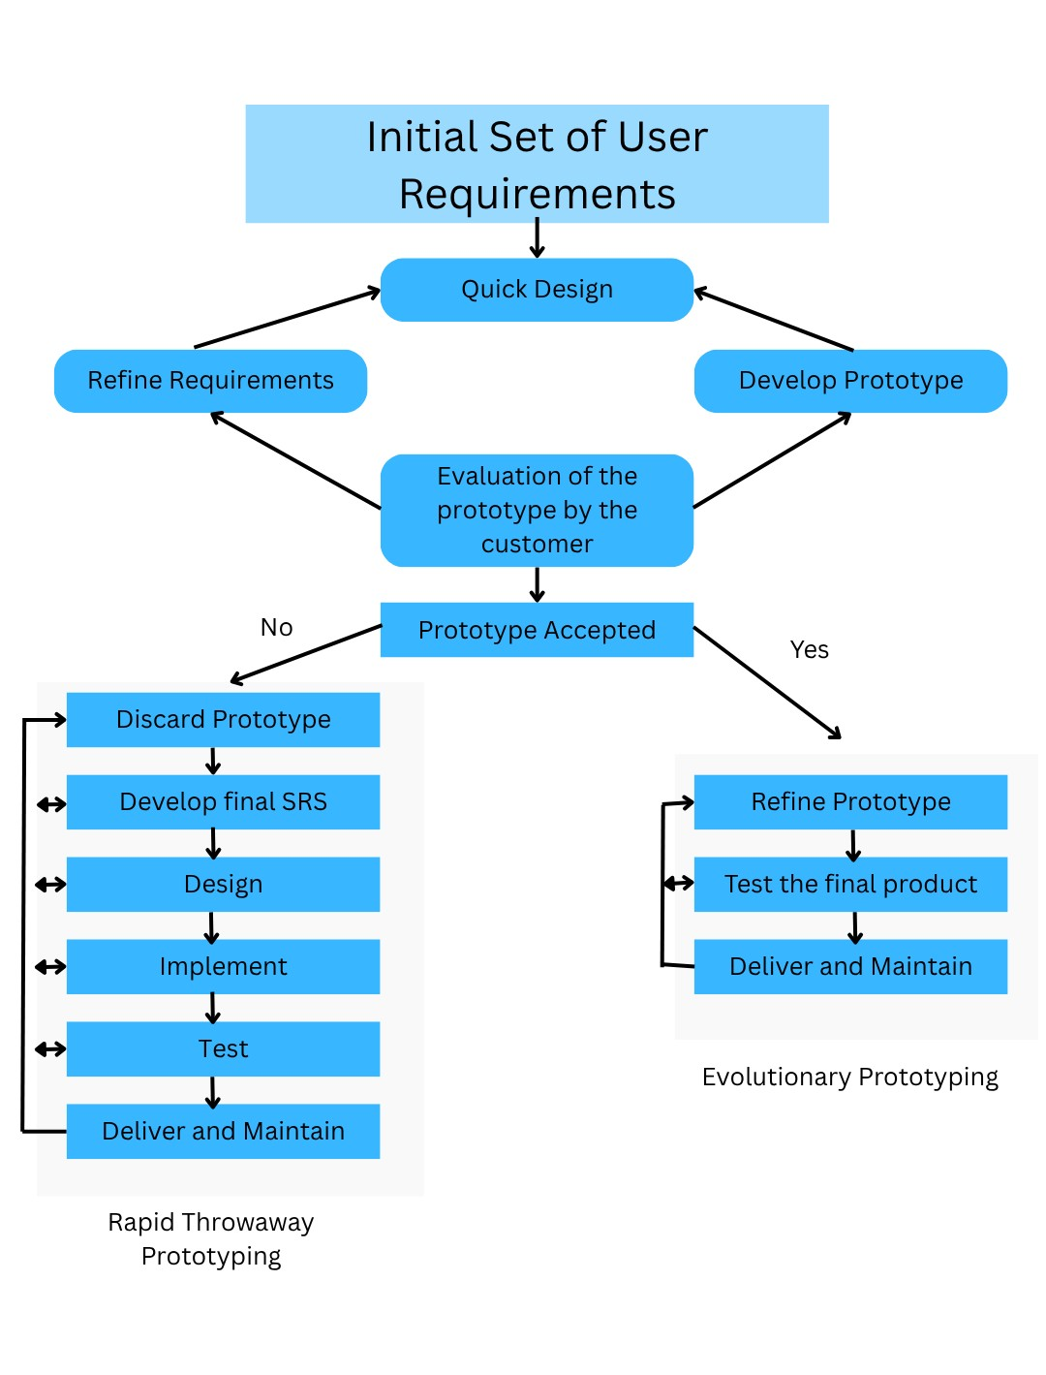
Fig 2.1 Prototyping Model

3. REQUIREMENT ANALYSIS

3.1 DATA FLOW DIAGRAMS

3.1.1 CONTEXT LEVEL DIAGRAM
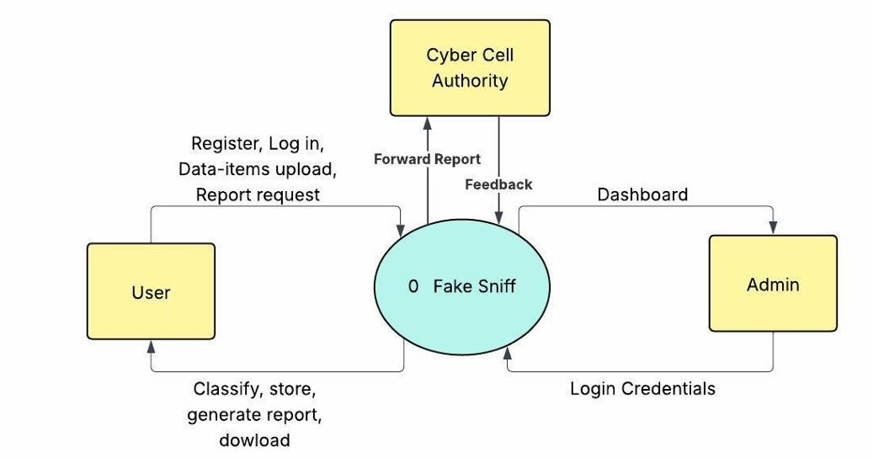
Fig 3.1 Context Level Diagram

3.1.2 LEVEL 1 DFD
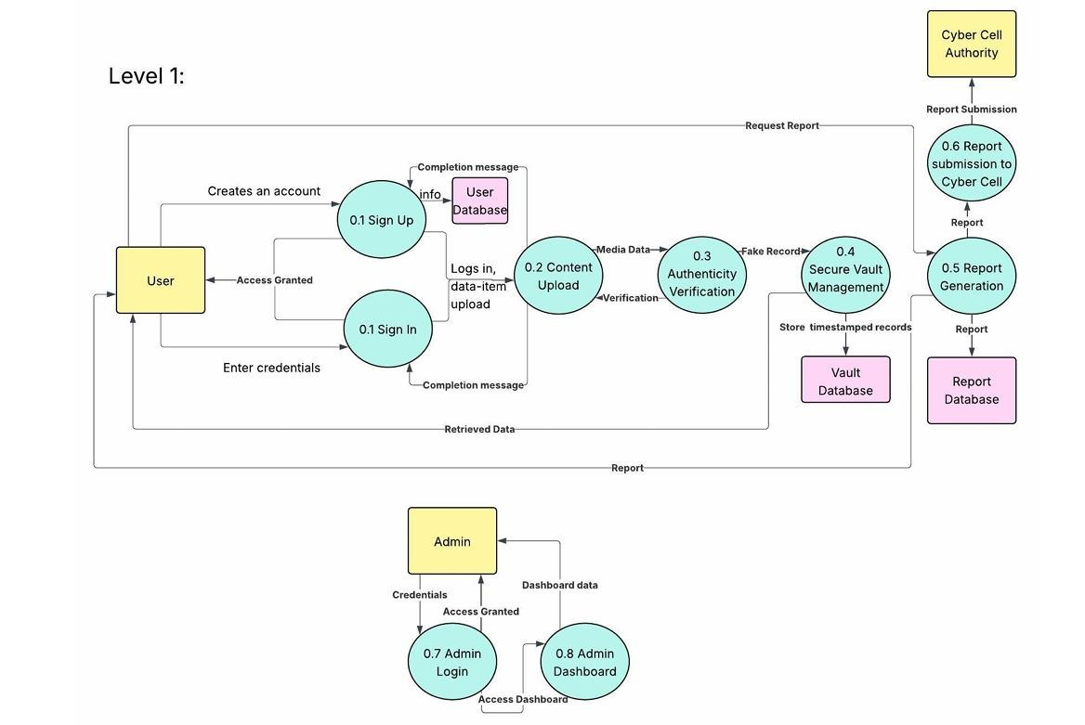
Fig 3.2 Level 1 DFD

3.1.3 LEVEL 2 DFD (for media upload)
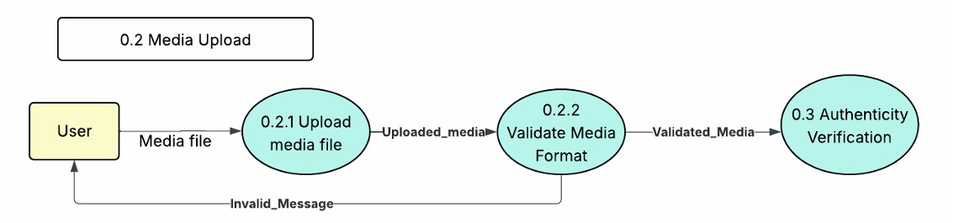
Fig 3.3 Level 2 DFD (for media upload)

3.1.4 LEVEL 2 DFD (for detect)

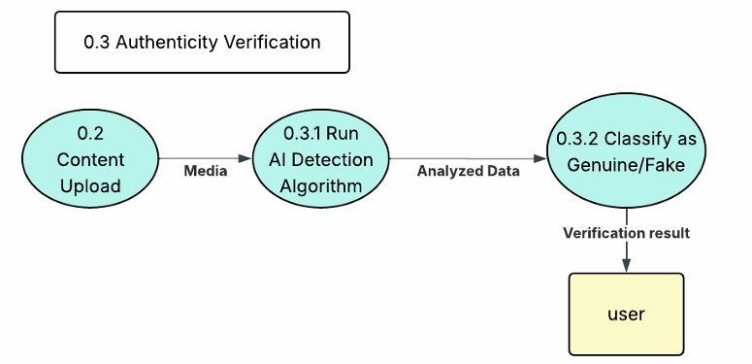
Fig 3.4 Level 2 DFD (for detect)

3.1.5 LEVEL 2 DFD (for vault storage)
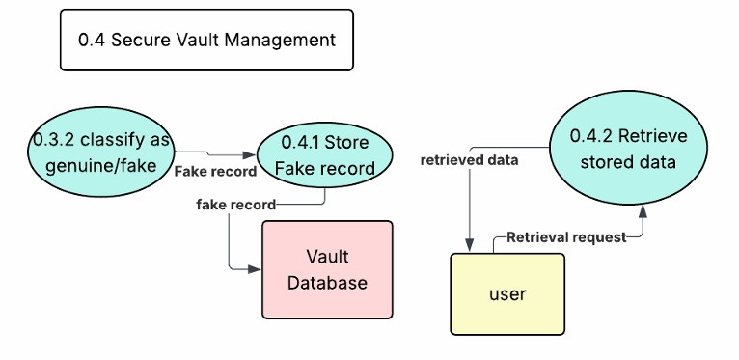
Fig 3.5 Level 2 DFD (for vault management)

3.1.6 LEVEL 2 DFD (for report generation)

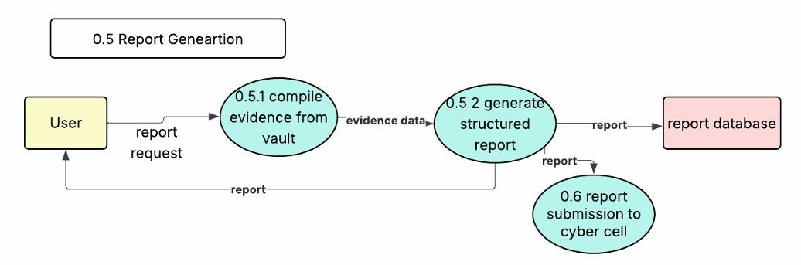
Fig 3.6 Level 2 DFD (for report generation)

3.2 DATA DICTIONARY
Legal Characters: [a-z | A-Z]
Digit: [0-9]
Special Characters: [@ | $ | + | - | . ]
1. | First Name | {Legal character}*
2. | Last Name | {Legal character}*
3. | Email Id | {Legal character + Digit + Special character}*
4. | Username | {Legal character + Digit + Special character}*
5. | Password | {Legal character + Digit + Special character}*
6. | Feedback | {Legal character + Digit + Special character}*
Table 3.1 Data Dictionary

3.3 USE CASE

3.3.1 USE CASE DIAGRAM

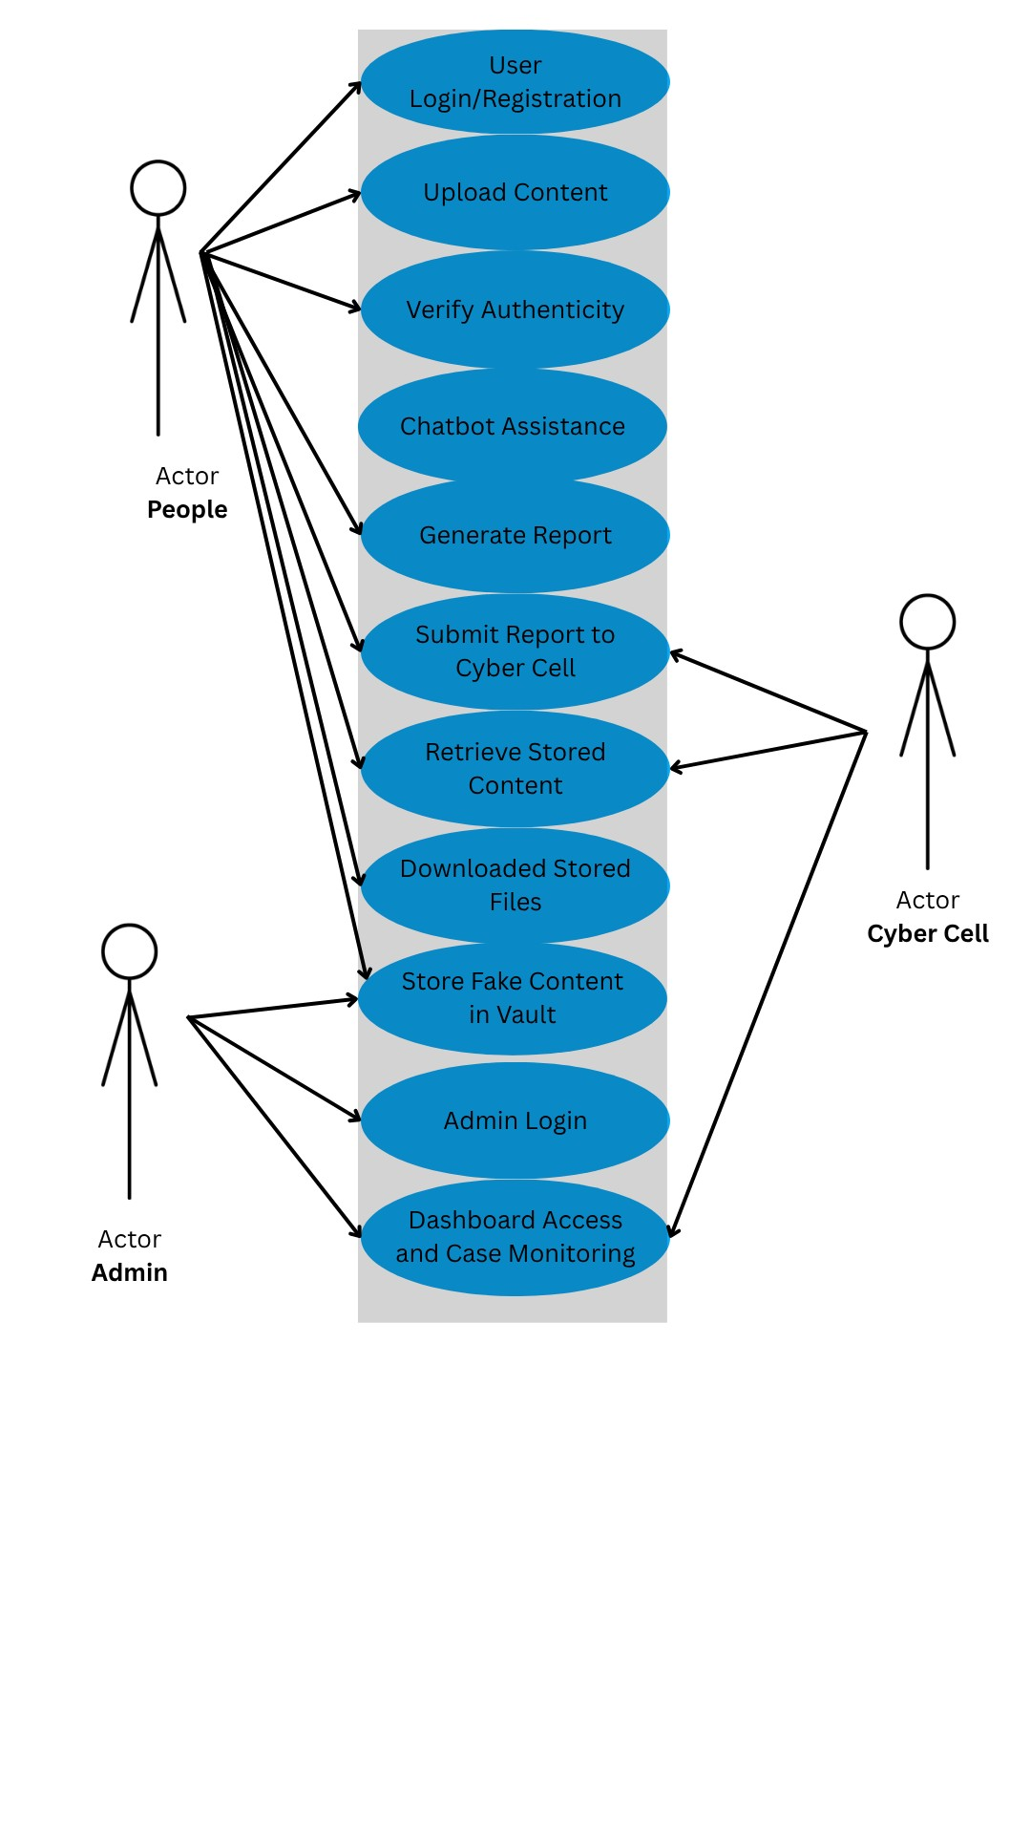
Fig 3.7 Use Case Diagram

3.3.2 USE CASE DESCRIPTION
Use Case 1: User Login / Registration
- Primary Actor: User
- Precondition: User must have registered (or sign up during first use)
- Main Success Scenario:
      - User enters credentials.
      - System validates details
      - User Dashboard Opens
- Exception: Invalid Credentials -> error message
- Postcondition: User gains access to the system

Use Case 2: Upload Content
- Primary Actor: User • Precondition: User is logged in
- Main Success Scenario:
    - User browses and selects file.
    - System checks file type and size
    - File is accepted
- Exception: Unsupported format -> error message
- Postcondition: Content ready for authenticity check

Use Case 3: Verify Authenticity
- Primary Actor: User • Precondition: Content Uploaded
- Main Success Scenario:
  - System runs detection algorithm.
  - Returns status: Fake / Not Fake
- Exception: Algorithm fails-> fallback / manual review
- Postcondition: Content classified.

Use Case 4: Store Fake Content in Vault
- Primary Actor: System
- Precondition: Verification must detect fake
- Main Success Scenario:
  - System stores file in the backend database.
  - Timestamp and referaence are assigned.
- Exception: Database error -> retry
- Postcondition: Content stroed in vault.

Use Case 5: Generate Report
- Primary Actor: User
- Precondition: Content already stored in vualt
- Main Success Scenario:
    - System retrives content details.
    - Generate report (PDF/Excel)
    - Provides download option
- Exception: No data available-> error
- Postcondition: Report Ready for submission.

Use Case 6: Submit Report to Cyber Cell
- Primary Actor: User • Precondition: Report generated.
- Main Success Scenario:

1. Report securely transferred to cyber cell portal
2. Confirmation Received through an acknowledgement. • Exception: Cyber Cell API unavailable-> queue request
- Postcondition: Complaint Registered with authorities.

Use Case 7: Retrieve Stored Content
- Primary Actor: User
- Precondition: Content must exist in the database
- Main Success Scenario:
      - User enter filter criteria.
      - System fetches matching file
- Exception: No matches found.
- Postcondition: User retrieves filtered results.
Use Case 8: Download Stored Files
- Primary Actor: User
- Precondition: Content exists in vault
- Main Success Scenario:
    - System compresses selected files.
    - User downloads ZIP.
    - Provides download option
- Exception: File not found-> error
- Postcondition: Files retrieved offline.
Use Case 9: Admin Login
- Primary Actor: Admin
- Precondition: Admin account exists
- Main Success Scenario:
  - System validates credentials.
  - Admin enters dashboard.
- Exception: Wrong credentials-> deny access
- Postcondition: Admin logged in.

Use Case 10: Admin Dashboard & Case Monitoring
- Primary Actor: Admin
- Precondition: Admin logged in.
- Main Success Scenario:
  - System loads recent uploads, fake detection and user activity metrics..
  - Admin monitors flagged cases
- Exception: Database connection fails.
- Postcondition: Admin sees updated statistics.

Use Case 11: Chatbot Guidance
- Primary Actor: Chatbot Assistant, User
- Precondition: User logged in
- Main Success Scenario:
    - Chatbot prompts for content upload.
    - Guides user to verify.
    - Suggests report generations and authority submission.
- Exception: User exists chat mid process-> error
- Postcondition: User supported in workflow of the system.

4.SOFTWARE REQUIREMENT SPECIFICATION

4.1 INTRODUCTION
This section gives a scope description and overview of everything included in Document.
4.1.1 CATEGORY
Web Application

4.1.2 PURPOSE
This document outlines the specifications for the FAKE SNIFF system, a web-based. platform created to identify and stop the spread of false information via manipulated
Images and to help victims of digital threats preserve evidence and seek help.
The primary aims of the system are to:
•Give users the ability to upload and confirm the legitimacy of digital content
(images)
•Use detection algorithms to automatically categorize content as authentic or fraudulent/manipulated.
•Securely archive media that is identified as fake or that is used in harassment/blackmail/threatening contexts, preserving metadata and timestamps for use in investigations.
•Create organized, legally structured reports for flagged content and forward them to cyber authorities (Cyber Cell) when required.
•Provide a guided, user-friendly workflow (via chatbot) for victims to document incidents, generate reports, and understand next steps.
•Support anonymity and privacy controls for users who wish to submit evidence without revealing identity

4.1.3 SCOPE
FAKE SNIFF is a web-based application that enables users to verify the authenticity of uploaded media and to securely collect and report digital evidence, including evidence of threats or coercive communications. The system is intended for general users, victims of online harassment, administrators, and authorized cyber authorities.
Primary services provided:
- Verification of Content: Users submit images or text-based documents for automated authenticity checks; results returned as Genuine or Fake/Manipulated.

•Threat / Abuse Documentation: Users can submit media and contextual information when content is used to threaten, blackmail, or harass; the system preserves evidence in a forensically sensible manner (timestamp, hash, metadata).
- Safe Storage (Vault): Every item flagged as fake or abusive is archived with tamper-evident metadata and access controls.
- Report Generation: Structured, downloadable reports (PDF) that combine media, metadata, detection results, and user-provided context (threat statements) are produce for legal and investigative use.
- Report Submission: Users may transmit generated reports to designated cyber authorities (Cyber Cell) via secure channels or download them for offline submission.
- Search &amp; Retrieval: Users and admins can filter and retrieve archived items by date, media type, status, or case ID.
- Admin Dashboard: Administrators can monitor uploads, review flagged content, manage reports, and coordinate with authority contacts.
- Chatbot Assistance: An interactive assistant helps users upload media, collect contextual details (e.g., messages, threat descriptions), generate reports, and locate helplines or next steps.
Ease of Access:
- Web-based; accessible from devices with internet access.
- Designed for non-technical users with step-by-step guidance and privacy-preserving defaults.
Limitations And Assumptions:
- Supported media: common image formats (e.g., .jpg, .png) (Video and advanced multimedia are out of scope for the current version.)
- The accuracy of verification depends on the detection algorithms; false positives/negatives are possible.
- The system is not a substitute for legal advice; it facilitates evidence collection and reporting but does not provide legal or medical counsel.
- When users request report submission to authorities, the system assumes the Cyber Cell endpoint/acceptance mechanism exists and that authorized channels are available; in absence of direct integration, reports can be exported for manual submission.
- Preservation of evidentiary value depends on secure storage and audit logs; legal admissibility of stored content will depend on local laws and procedures.

4.1.4 DEFINITION, ACRONYMS AND ABBREVIATIONS
- SRS (Software Requirements Specification): A formal document that captures functional and non-functional requirements of the software system to be developed.
- DFD (Data Flow Diagram): A graphical representation of how data moves through the system, showing processes, data stores, and external entities.
- UML (Unified Modeling Language): A standardized modeling language used to specify, visualize, construct, and document the artifacts of software systems (e.g., use case diagrams, DFD).
- FAKE SNIFF: The name of the proposed web-based system that verifies the authenticity of news articles and images, generates reports, and supports communication with authorities.
- Chatbot Assistant: An interactive software component integrated within FAKE SNIFF that guides the user through upload, verification, reporting, and retrieval processes.
- Cyber Cell (Authority): A specialized branch of law enforcement that deals with online crimes, including misinformation, fraud, and cyber threats.
- Admin: The system administrator responsible for managing user registrations, database records, and ensuring smooth functioning of the application.
- Verification Algorithm: The detection mechanism used by the system to classify uploaded content as genuine or fake.
- Database (Secure Vault): The backend storage where all detected fake content and reports are archived with timestamps for retrieval.

4.1.5 OVERVIEW
FAKE SNIFF is a web-based system that helps users verify the authenticity of images. The system uses detection algorithms to classify content a genuine or fake. Fake content is stored in a secure database with timestamps, and users can generate structured reports to send directly to cyber authorities. A built-in chatbot assists users during upload, verification, reporting, and retrieval. The system also provides filters to search and download stored content. Overall, FAKE SNIFF aims to combat misinformation, promote digital literacy, and support law Enforcement.

4.2 PROJECT DESCRIPTION
The FAKE SNIFF system belongs to the category of web-based applications with AI- driven verification algorithms. It functions as an independent platform, accessible through any modern browser, but can also integrate with external entities such as Cyber Cell Authorities for report forwarding.
The product consists of the following major components:
- User Module – allows users to register/login, upload suspicious content, and request verification or reports.
- Verification Engine – applies algorithms to classify content as authentic, fake, or threatening.
- Secure Vault – backend repository where flagged content (fake or threatening) is securely stored with timestamps and metadata.
- Report Management Module – generates structured reports and allows forwarding to authorities.
- Admin Dashboard – enables administrators to manage system activity, review uploads, and assist with authority communications.
- Chatbot Assistant – provides guided, conversational support for novice users.
The system is self-contained but depends on:
- A stable internet connection.
- Supported web browsers (Chrome, Firefox, Edge).

4.2.2 PROJECT FUNCTIONS
The Fake Sniff system provides the following key functions:
- User Registration and Authentication
Users can create accounts and log in securely using unique credentials.
- Media Upload and Validation
Users can upload digital media (images, videos, documents) for authenticity checking. The system validates the file and analyzes it using detection algorithms.
- Fake Media Detection
The system evaluates uploaded content and classifies it as genuine or fake with an associated confidence score.
- Threatening/Abusive Content Reporting
Users can report harmful media (used for blackmail, harassment, threats), which is stored securely for evidence preservation.
- Report Generation
The system generates structured reports containing detection results, timestamps. Reports may be requested in summary or detailed formats.
- Evidence Management
Detected fake or harmful records are stored in the secure vault for future retrieval and forensic use.
- Admin Oversight
Administrators can manage users, monitor dashboard statistics, validate reports, and escalate verified reports to authorities.
- Forwarding to Cyber Cell Authorities
Verified reports are securely transmitted to external cyber cell authorities for further legal or investigative action.
- Dashboard and Analytics
The system provides admins with real-time insights such as total users, total reports, and number of detected fake media items.
- Chatbot Assistance
A built-in chatbot guides users in uploading files, reporting content, and navigating the system.

4.2.3 ACTOR CHARACTERISTICS
The Fake Sniff system is intended for a wide range of users, including general internet users, administrators, and authorized authorities. Each type of user is expected to possess different levels of expertise and attributes:
1. End Users (General Public / Victims / Digital Citizens)
- Educational Level: Minimum high school education; basic literacy is required.
- Experience: Should be comfortable using smartphones or personal computers. ❖ Technical Expertise: Must know how to upload files from their device.
- Should be familiar with navigating websites or mobile applications.
- Basic knowledge of English is required; however, the system may provide multilanguage support in future versions.
• Required Attributes:
- Ability to operate internet-connected devices.
- Awareness of fake media problems or intent to verify suspicious content.

2.Administrators (System Operators)
Educational Level: Undergraduate level or higher, preferably with knowledge of IT systems.
Experience: Familiarity with monitoring dashboards and managing digital content.
Technical Expertise:
- Should understand system logs, detection results, and statistical dashboards.
- Must know how to verify and validate reports before forwarding to authorities.
- Comfortable handling secure authentication procedures.
3. Cyber Cell Authorities (Law Enforcement / Legal Bodies)
- Educational Level: Professional law enforcement or equivalent role.
- Experience: Prior experience in handling digital crime or cybercrime reports.
- Technical Expertise:
  - Must know how to access reports in PDF.
  - Should be able to interpret metadata (timestamps, detection results, confidence score). Basic familiarity with digital evidence handling for legal use.

4.2.4 CONSTRAINTS
- Technical Constraints
  - A stable internet connection is required for uploading media and generating reports.
  - The application will initially be developed for web browsers (Windows OS); mobile (Android/iOS) support may be added later.
  - The system is designed to operate on a single centralized server at a time to maintain data integrity and security.
  - File size for media uploads will be restricted (e.g., maximum 25 MB per file) to ensure quick verification and storage.
  - The system supports limited media types at present: images, videos, and documents.
- Interface Constraints
  - The primary interface language will be English; future versions may include multilanguage support.
  - The interface will be designed with a simple, user-friendly layout but will not support advanced customization by users.
- Regulatory and Legal Constraints
  - Any report forwarded to cyber authorities must follow legal standards of evidence handling.
  - The system will not provide legal advice; it will only generate structured reports that users may forward.
  - Use of the system may require user consent agreements and adherence to privacy and data protection laws (e.g., IT Act, GDPR in future expansion).
- Operational Constraints
  - The system requires users and administrators to log in with valid credentials before accessing services.
  - Reports can only be forwarded to registered cyber cell authorities integrated within the system.
  - Only authorized administrators can validate reports before escalation.

4.2.5 ASSUMPTIONS AND DEPENDENCIES
- The system assumes that a stable internet connection is available for uploading files, verification, and sending reports to the Cyber Cell.
- The product requires a back-end database server (such as XAMPP / MySQL) for storing user information, login credentials, verification history, and generated reports.
- The system assumes that users will provide a valid email ID during registration for verification and communication purposes.
- The system depends on the availability of a functional file upload service for images, documents, and URLs.
- The system assumes that external verification algorithms or APIs (if used) are available and functional to generate accurate authenticity results.
- The system depends on web browser compatibility, meaning the application should be accessed through updated browsers such as Chrome, Edge, or Firefox.
- The Cyber Cell assumes that users upload genuine cases.

4.2.6 Assumption
- Users must have basic knowledge of computer functionality.
- Users must have basic knowledge of English.

4.3 SPECIFIC REQUIREMENTS

4.3.1 EXTERNAL INTERFACE
This section provides a detailed description of all inputs and outputs from the FAKE SNIFF system. It provides a description of the hardware, software, and communication interfaces along with basic prototypes of the user interface.
4.3.1.1 User Interfaces Input:
- User enters registration/login details.
- User uploads content (articles in text/PDF or images in JPG/PNG).
- User requests verification, report generation, retrieval, and sending reports. Output:
- System displays classification result (Genuine / Fake).
- System shows generated reports with content details and timestamps.
- Chatbot assistant provides step-by-step guidance.
4.3.1.2 Hardware Interfaces Client Devices:
- PC, Laptop, or Mobile device with web browser. Server Hardware:
- Web server with minimum 8 GB RAM, 4-core processor, and 500 GB storage.
- Backup storage for archived reports and fake content. I/O Devices:
- Standard keyboard/mouse for input.
- Display screen for results/reports.
4.3.1.3 Software Interfaces
- Operating System: Cross-platform (Windows, Linux, macOS).
- Web Browser: Chrome, Firefox, Edge (latest versions).
- Database: Django
- Backend: Django
- Frontend: HTML, Bootstrap for UI.

4.3.2 FUNCTIONAL REQUIREMENTS
The FAKE SNIFF system shall provide the following functional features:
4.3.2.1 User Registration and Login
- FR1: The system shall allow a new user to register with valid details.

FR2: The system shall authenticate existing users with email and password.
4.3.2.2 Content Upload and Verification
- FR3: The system shall allow users to images (JPG, PNG).
- FR4: The system shall validate file type before processing.
- FR5: The system shall classify uploaded content as genuine or fake using detection algorithms.
4.3.2.3 Report Generation and Communication
- FR6: The system shall generate structured reports of detected fake content.
- FR7: The system shall allow users to download reports in PDF/ZIP format.
- FR8: The system shall send reports securely to cyber authorities on user request.
4.3.2.4 Content Storage and Retrieval
- FR9: The system shall store all detected fake content in a secure backend
- database with timestamps.
- FR10: The system shall allow retrieval of stored content using filters (date, type).
- FR11: The system shall allow bulk download of retrieved files.
4.3.2.5 Chatbot Assistant : FR12: The system shall provide a chatbot assistant to guide users through upload, verification, and reporting processes.

4.3.3 PERFORMANCE REQUIREMENTS
This section specifies both static and dynamic numerical requirements for the FAKE SNIFF system.
4.3.3.1 Static Numerical Requirements
- The system shall support up to 100 simultaneous users without performance degradation.
- Each user session shall be active on one device at a time (no parallel logins with same credentials).
- The system shall handle up to 10 GB of stored fake content and associated reports initially, scalable to higher storage as required.
- The system shall support multiple file types: .jpg, .png.
4.3.3.2 Response Time
- The login process shall not take more than 2 seconds under normal network conditions.
The file upload and verification process shall not take more than 5 seconds for standard files (up to 5 MB).
- The system shall display verification results immediately after the detection algorithm finishes execution.
- The chatbot shall respond to user queries within 2 seconds.
4.3.3.3 Throughput
- The system shall process at least 50 verification requests per minute.
- Report generation shall be completed within 3 seconds for a single item.
- The system shall support 20 report submissions per minute to cyber authorities.
4.3.3.4 Availability
- The system shall maintain 99% uptime excluding scheduled maintenance.
- Database backup shall be performed automatically every 24 hours.

4.3.4 Design Constraints
- This software can be run on Personal Computers, Smartphones, Tablets.
- For security and authentication purposes username/email-id and password must be provided.

4.3.5 SOFTWARE SYSTEM ATTRIBUTES [NON-FUNCTIONAL]
4.3.5.1 Reliability
- The system shall provide consistent and correct classification of content (genuine/fake).
- Detection algorithm must ensure zero tolerance for misclassification due to internal system errors.
- Backup mechanisms shall be in place to avoid data loss in case of server failure.
4.3.5.2 Availability
- The system shall be available to users 24/7, provided internet connectivity is present.
- Reports and fake content records shall remain accessible for at least 6 months after submission.
- In case of downtime (maintenance), users shall be notified in advance.
4.3.5.3 Security
Only users with valid login credentials (User ID and Password) can access the system.
- Role-based access: Admins can manage registrations, while users can only upload and verify content.
4.3.5.3 Maintainability
- Updates, bug fixes, and enhancements shall be deployed on the server side by the Admin/developers.
- Modular design shall allow detection algorithms to be replaced or upgraded without affecting the full system.
4.3.5.4 Portability
- The system shall be accessible on any modern web browser (Chrome, Firefox, Edge).
- The platform shall be cross-device compatible (PC, laptop, tablet, smartphone).

4.3.6 LOGICAL DATABASE REQUIREMENT
The FAKE SNIFF system requires a structured database to store user details, uploaded content, verification results, and generated reports. The database shall maintain integrity, support efficient retrieval, and enforce relationships between entities.
Database: User
Fields: First Name
Last Name
Email Id
Username
Password
Confirm_Password

4.3.7 CHANGE MANAGEMENT PROCESS
- Logging and Filtering Changes
All new change requests (UI updates, verification improvements, database modifications, etc.) are collected and logged.
Irrelevant or duplicate requests are filtered out before analysis.
Managing Changes
Each valid change request is analyzed based on feasibility, impact, priority, and required effort.
Team members decide whether the change affects UI, backend, detection algorithm, or reporting module.
- Change Approval
The supervisor or team lead evaluates the analyzed request and approves or rejects it. Approved changes move ahead for implementation; rejected ones are documented.
- Review and Close Request
After implementation, the change is reviewed and tested by the team.
If it works correctly without affecting other modules, the request is formally closed.
- Change Reporting
All approved and completed changes are documented, including details of what was changed, who did it, and why.
This maintains traceability and helps future maintenance.

5. PROJECT PLANNING

5.1 Project Scheduling

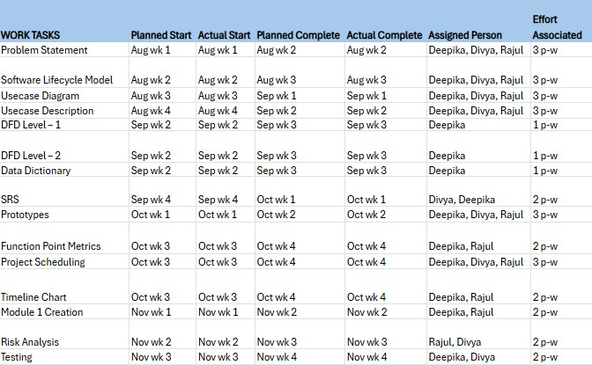
Fig 5.1 Project Scheduling

5.2 Project Timeline Chart
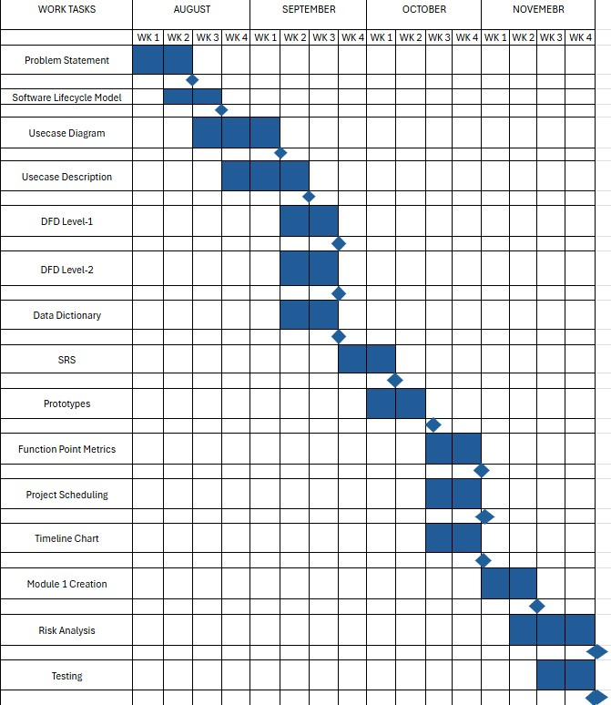
Fig 5.2 Project Timeline Chart

5.3 Effort Estimation and FP Based Computing
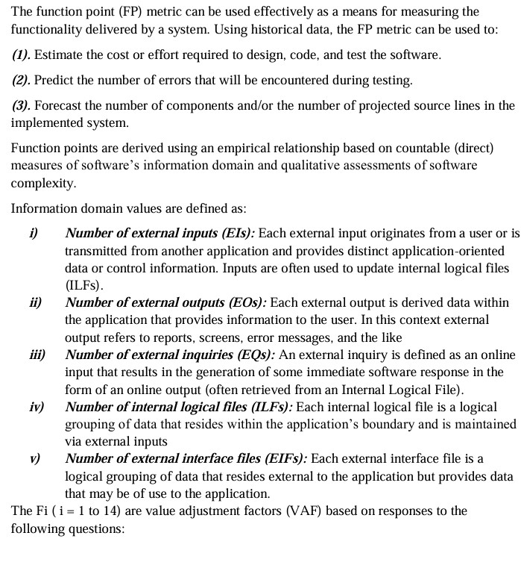
Project Estimation
Page-wise
S.No. | Page Title | Measured Parameters
 |  | External Inputs | External  Outputs | External Inquiries | Internal Logical Files | External Interface Files
1 | Landing Page | 3 | 0 | 0 | 0 | 0
2 | Log In Page | 6 | 1 | 0 | 0 | 0
3 | Sign Up Page | 8 | 1 | 0 | 0 | 0
4 | Dashboard | 7 | 3 | 0 | 3 | 0
5 | Vault | 3 | 4 | 2 | 1 | 0
6 | Upload | 2 | 0 | 0 | 0 | 0
7 | Verified:Not  Fake | 3 | 2 | 0 | 0 | 0
8 | Verified:Fake | 4 | 2 | 0 | 0 | 0
9 | Save the  Details | 6 | 0 | 0 | 1 | 0
10 | Report Generation | 4 | 5 | 0 | 1 | 0
11 | Cyber Cell | 2 | 0 | 0 | 0 | 1
12 | Report Generation | 1 | 1 | 0 | 1 | 0
13 | AI Assistant | 6 | 1 | 1 | 0 | 0
14 | Web Software  Admin  Dashboard | 7 | 4 | 0 | 4 | 0
15 | Feedback | 2 | 1 | 0 | 1 | 0

Total |  | 64 |  | 25 |  | 3 |  | 12 |  | 1

Count Total Calculation
Measured Parameters | Count | Weighing Factor (Average) | Sub-total
External Inputs | 64 | 4 | 256
External Outputs | 25 | 5 | 125
External Inquiries | 3 | 4 | 12
Internal Logical Files | 12 | 10 | 120
External Interface Files | 1 | 7 | 7
 |  | Count Total | 520

Function Point Calculation
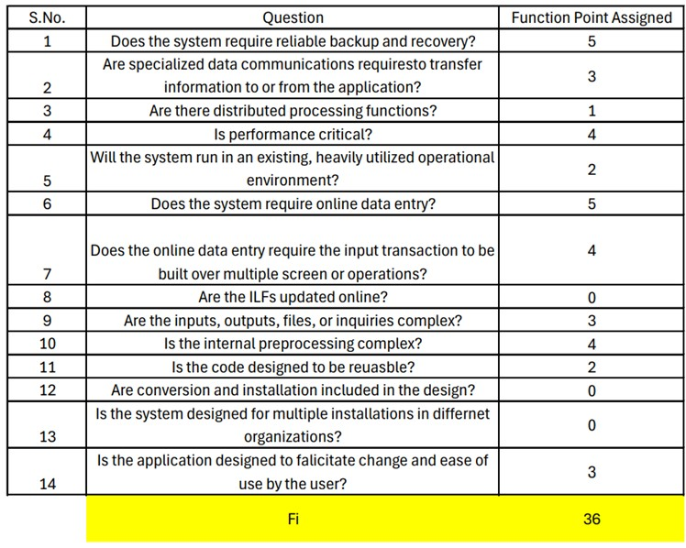
Fig 5.2
Once these data have been collected, a complexity value is associated with each count. Organizations that use function point methods develop criteria for determining whether a particular entry is simple, average, or complex. To compute function points (FP), the following relationship is used:
Function Point = W(FP) = Count Total * [0.65 + (0.01 * ΣFi)]
W(FP) = 520 * [0.65 + (0.01 * 36)]
W(FP) = 520 * [0.65 + 0.36]
= 520 * 1.01 = 525.2 ≈ 525 FP

Let
Average Productivity = X = 4 FP/person-month Labour rate = Y = Rs 8000 per person per month

So,
Cost per FP = Z = Y / X = Rs 8000 / 4 = Rs 2000 (approx.)
Total estimated project cost = W * Z = 525 * 2000 = Rs 10,50,000 (approx.)
Estimated effort = W / X = 525 / 4 = 131 person-months (approx.)
Since there are 3 team members,
Effort per person = 131 / 3 = 43.6 months (approx.)
Hence, the project is estimated to require 131 person-months of effort, with a total cost of Rs 10,50,000, distributed across 3 members, each contributing approximately 44 months of work.

COMPUTING FUNCTION POINT

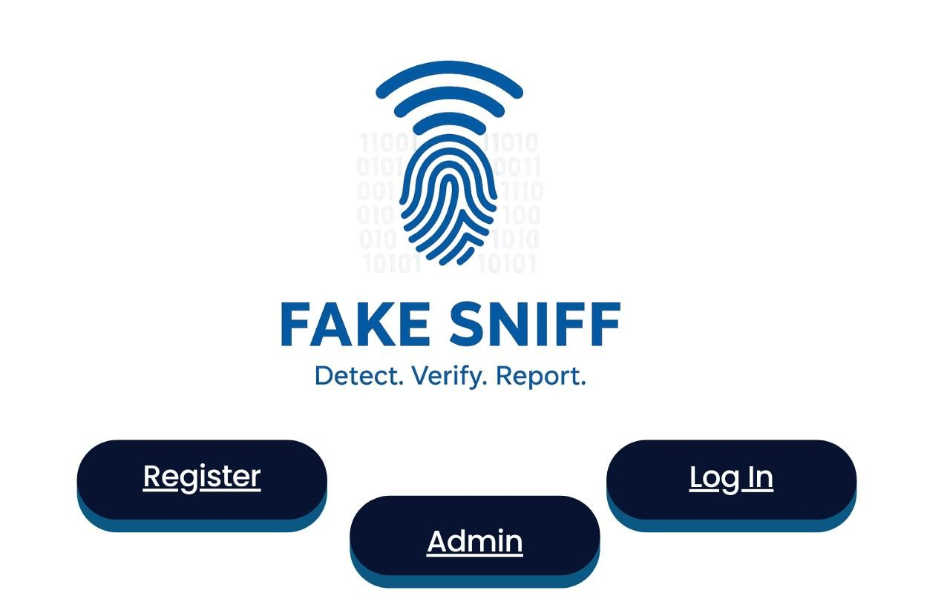
Number | of | External | Inputs: |  | 3
Number | of | External | Outputs |  | :0
Number | of | External | Inquiries: |  | 0
Number | of | Internal Logical | File | : | 0
Number of External Interfaces : 0
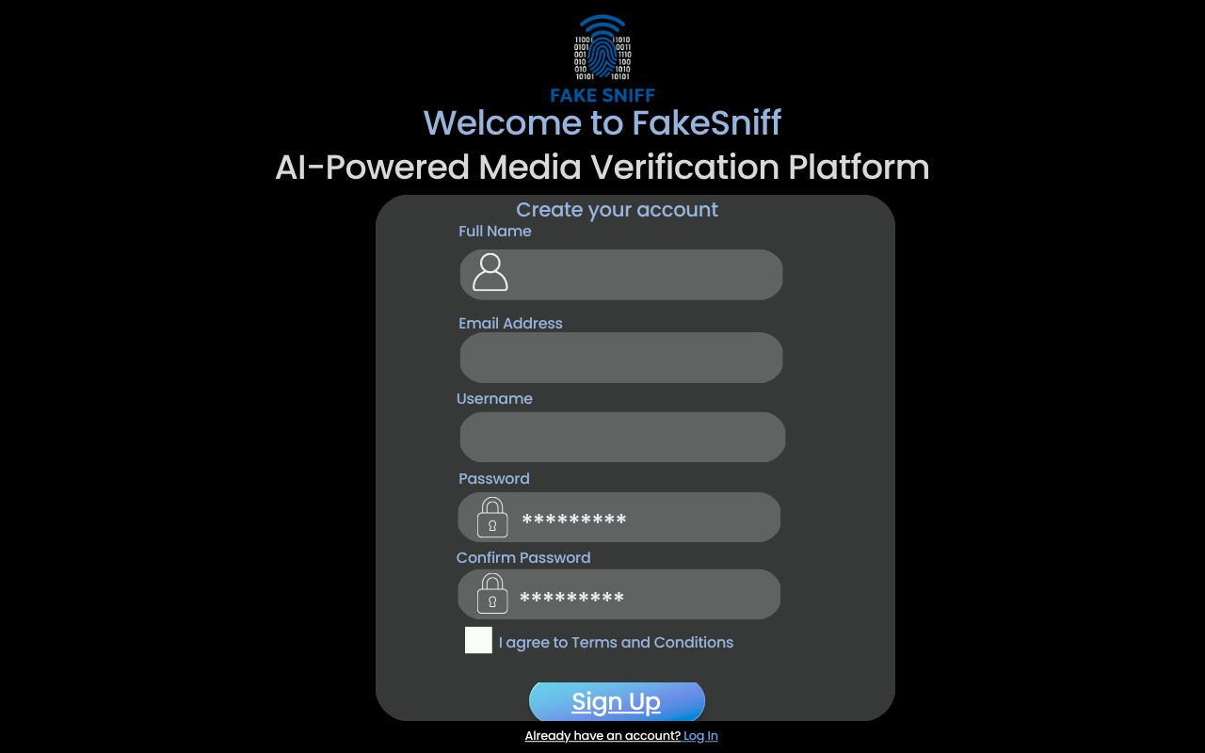
Number of External | Inputs: |  | 8
Number of External | Outputs |  | :1
Number of External | Inquiries: |  | 0
Number of Internal Logical  Number of External Interfaces : 0 | File | : | 0
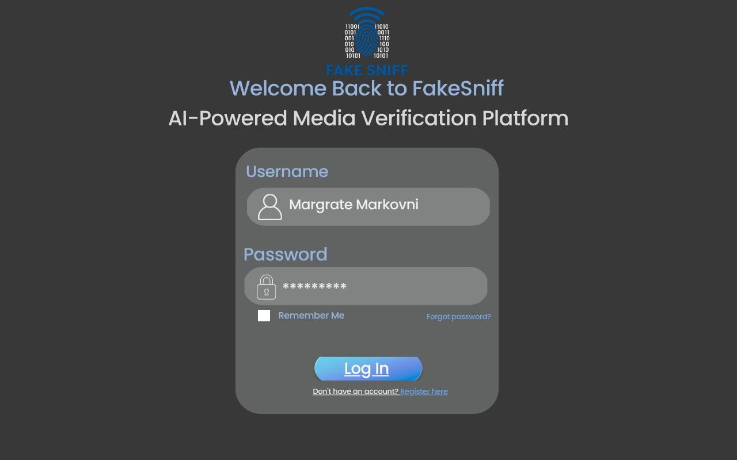
Number of External | Inputs: |  | 6
Number of External | Outputs |  | :1
Number of External | Inquiries: |  | 0
Number of Internal Logical  Number of External Interfaces : 0 | File | : | 0
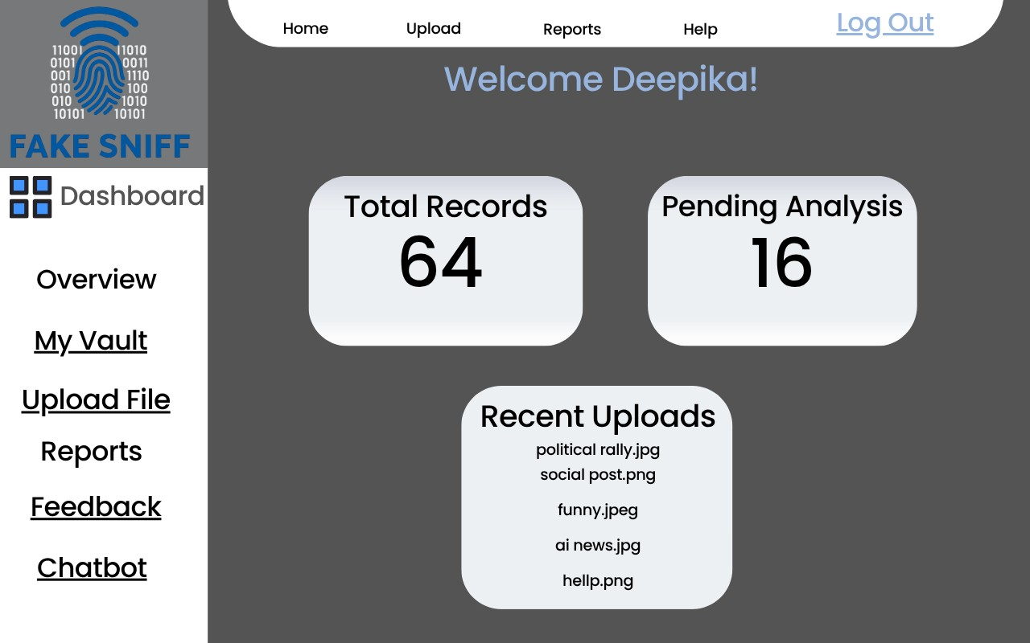
Number of External Inputs: 7
Number of External Outputs :3
Number of External Inquiries: 0 Number of Internal Logical File : 3 Number of External Interfaces : 0
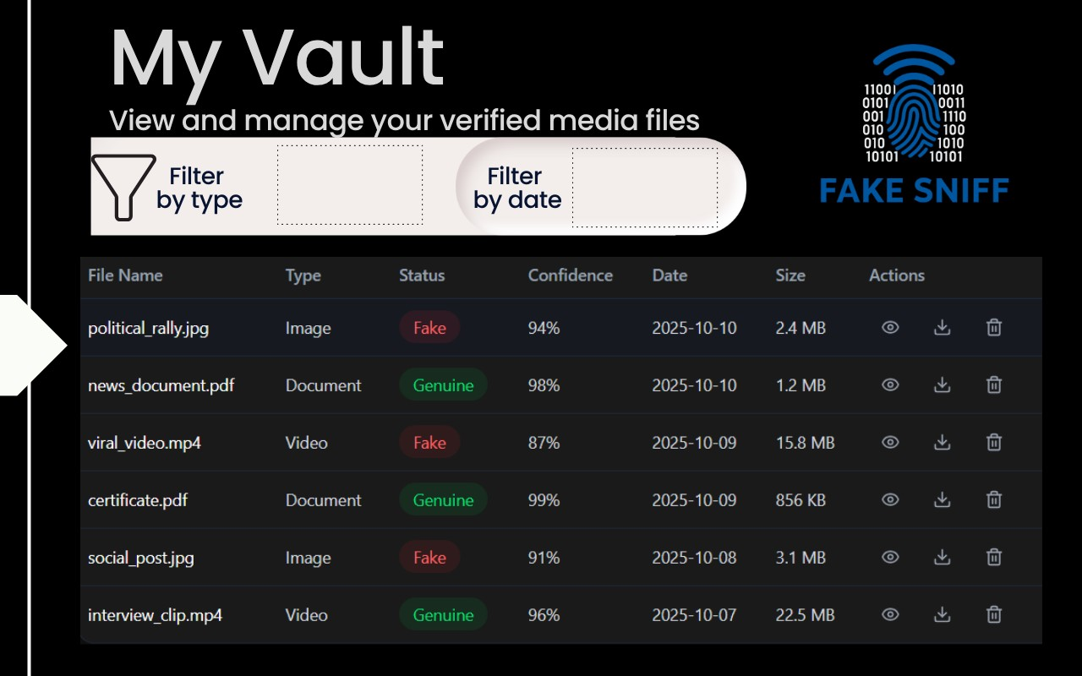
Number of External | Inputs: |  | 6
Number of External | Outputs |  | :1
Number of External | Inquiries: |  | 2
Number of Internal Logical  Number of External Interfaces : 0 | File | : | 1
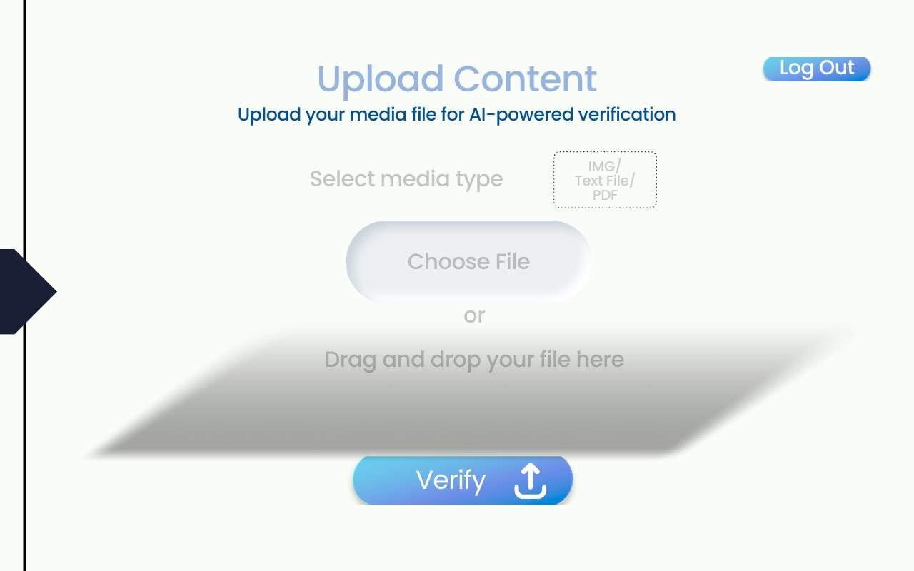
Number of External | Inputs: |  | 2
Number of External | Outputs |  | :0
Number of External | Inquiries: |  | 0
Number of Internal Logical  Number of External Interfaces : 0 | File | : | 0
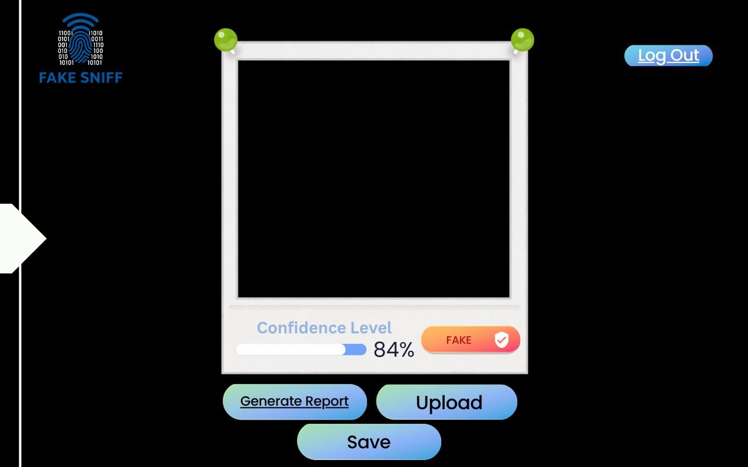
Number of External | Inputs: |  | 4
Number of External | Outputs |  | :2
Number of External | Inquiries: |  | 0
Number of Internal Logical  Number of External Interfaces : 0 | File | : | 0
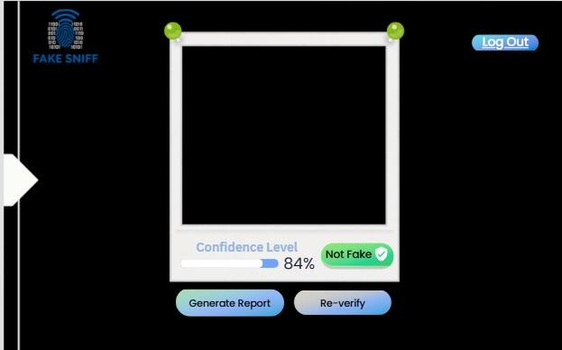
Number of External | Inputs: |  | 3
Number of External | Outputs |  | :2
Number of External | Inquiries: |  | 0
Number of Internal Logical  Number of External Interfaces : 0 | File | : | 0

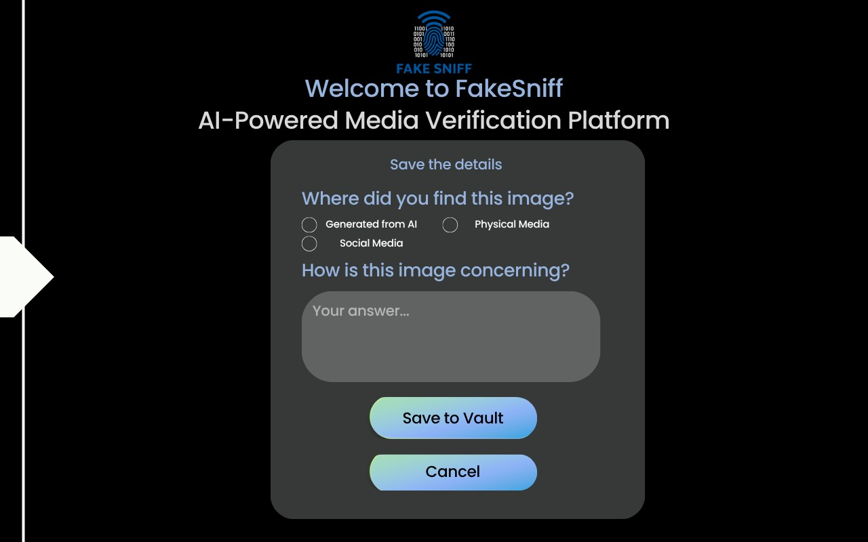
Number of External | Inputs: |  | 6
Number of External | Outputs |  | :0
Number of External | Inquiries: |  | 0
Number of Internal Logical  Number of External Interfaces : 0 | File | : | 1
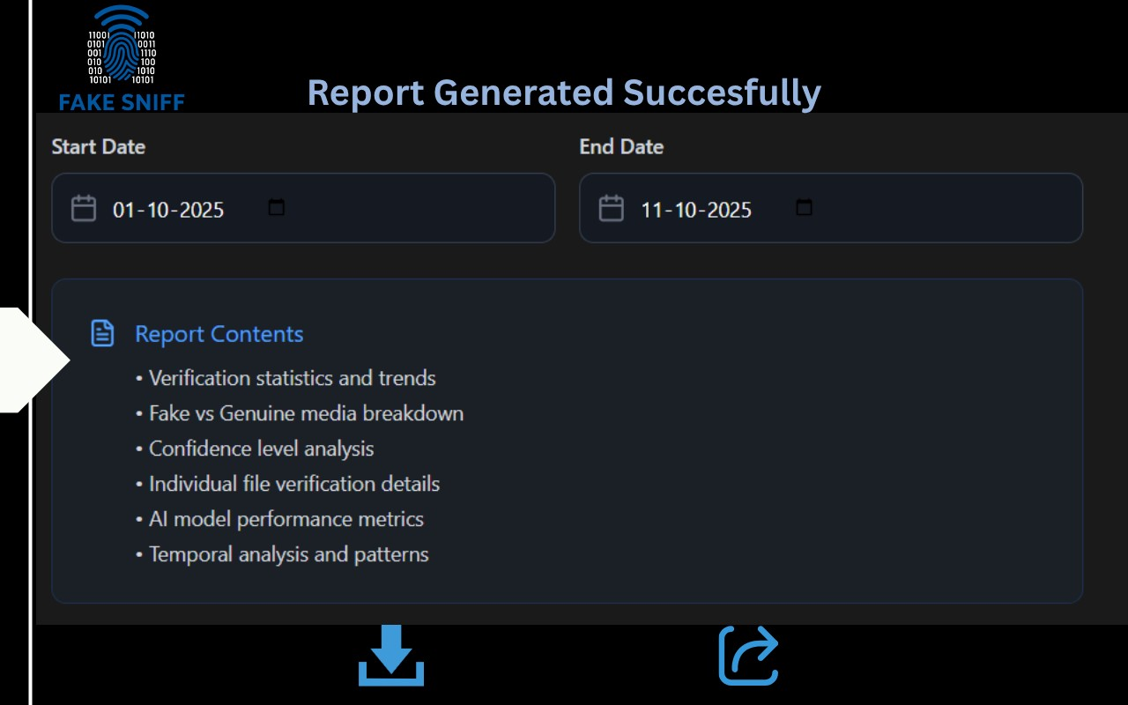
Number of External | Inputs: |  | 4
Number of External | Outputs |  | :5
Number of External | Inquiries: |  | 0
Number of Internal Logical  Number of External Interfaces : 0 | File | : | 1
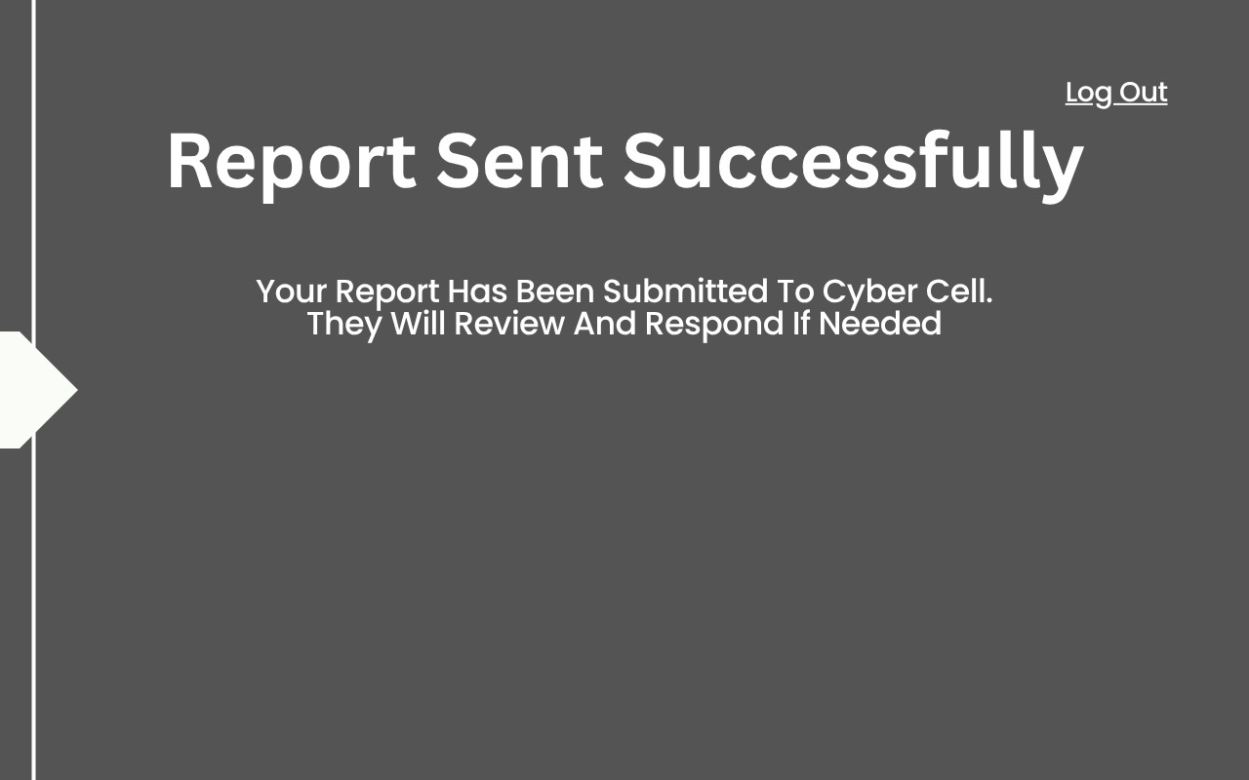
Number of External | Inputs: |  | 1
Number of External | Outputs |  | :1
Number of External | Inquiries: |  | 0
Number of Internal Logical  Number of External Interfaces : 0 | File | : | 1
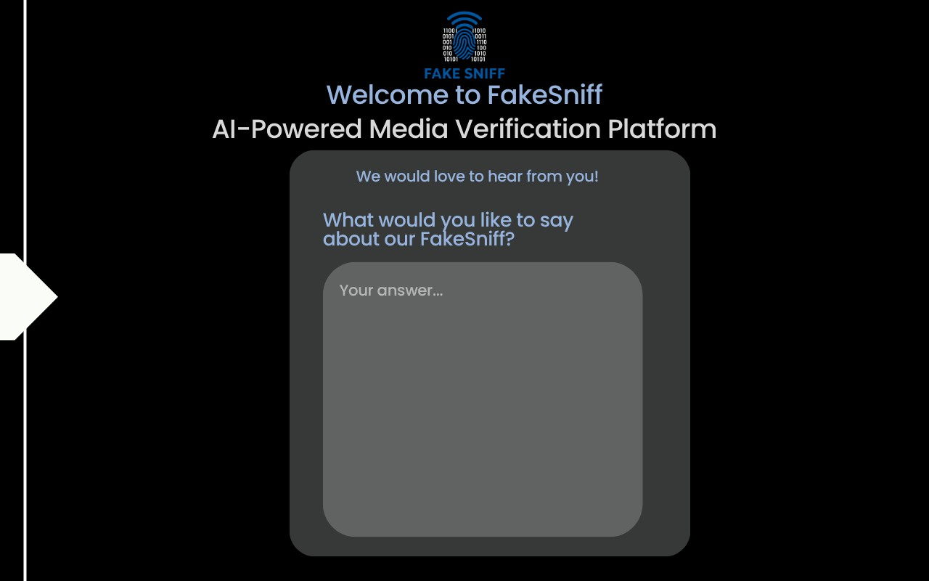
Number of External | Inputs: |  | 2
Number of External | Outputs |  | :1
Number of External | Inquiries: |  | 0
Number of Internal Logical  Number of External Interfaces : 0 | File | : | 1
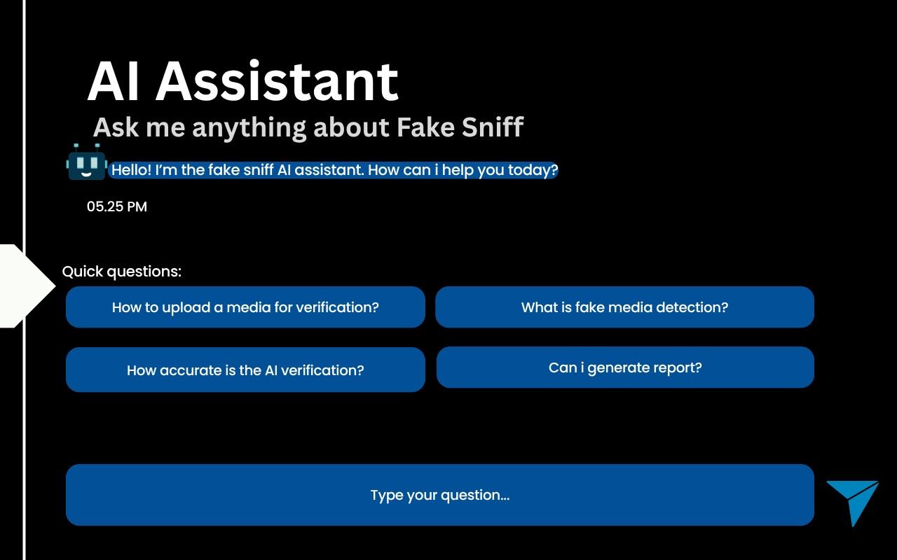
Number of External | Inputs: |  | 6
Number of External | Outputs |  | :1
Number of External | Inquiries: |  | 1
Number of Internal Logical  Number of External Interfaces : 0 | File | : | 0
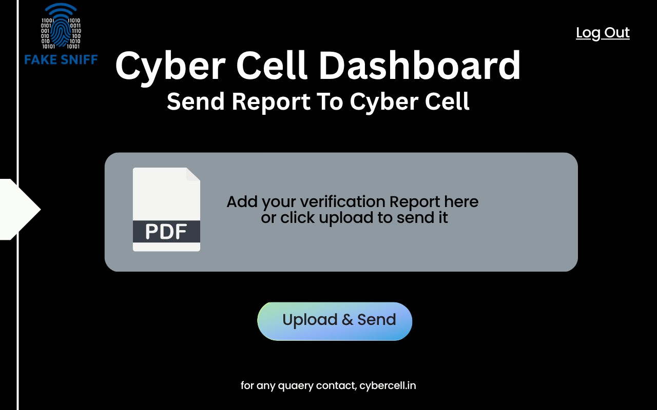
Number of External | Inputs: |  | 2
Number of External | Outputs |  | :0
Number of External | Inquiries: |  | 0
Number of Internal Logical  Number of External Interfaces : 1 | File | : | 0
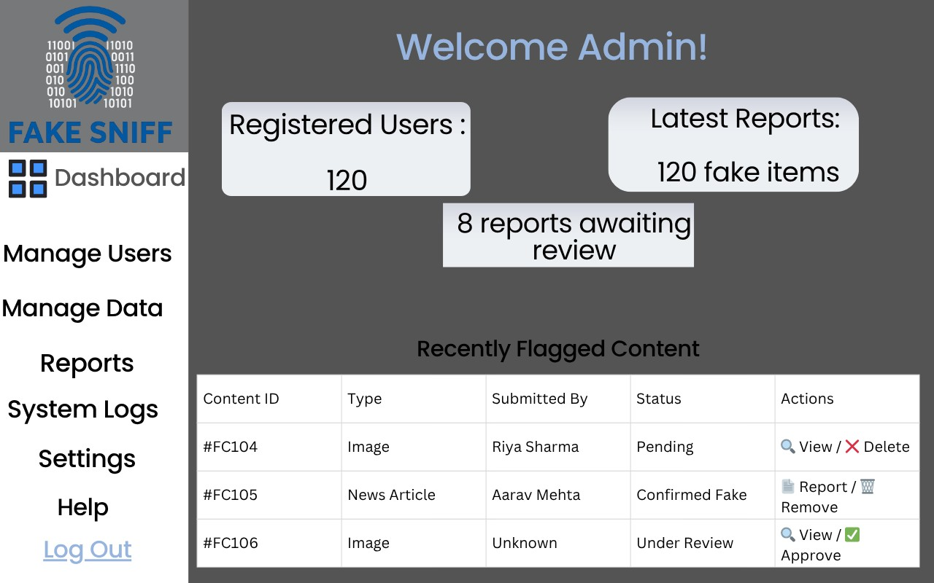

Number of External Inputs: 7
Number of External Outputs :4
Number of External Inquiries: 0 Number of Internal Logical File : 4
Number of External Interfaces : 0

5.4 Risk Analysis
Risk always involves two characteristics:
- Uncertainty — the risk may or may not happen; there are no 100% probable risks.
- Loss — if the risk becomes a reality, unwanted consequences or losses will occur.
Risk analysis is the process of identifying the risks or uncertainties in the applications or software.

Steps Involved in Risk Analysis
- Risk identification i.e., identify anything that may cause harm.
- Decide who may be harmed and how.
- Assess the risks and record the findings.
- Develop a plan to manage these risks.

Risk Identification
Risk identification is a systematic attempt to specify threats to the project plan (estimates, schedule, resource loading, etc.).

There are two distinct types of risks:
- Generic risks — a potential threat to every software project.
- Product-specific risks — risks that are specific to a particular project. A checklist can be used for risk identification in the following generic subcategories:
- Product Size (PS) — Risks associated with the overall size of the software to be built or modified.
- Business Impact (BU) — Risks due to constraints imposed by management or the marketplace.
- Stakeholder Characteristics (CU) — Risks associated with the sophistication of stakeholders and communication issues.
- Process Definition (PD) — Risks related to how well the software process is defined and followed.
- Development Environment (DE) — Risks associated with the availability and quality of development tools.
- Technology to be Built (TE) — Risks arising from system complexity and new technology.
- Staff Size and Experience (ST) — Risks based on the experience and capability of the software engineering team.

Assessing Overall Project Risk
The following questions are derived from survey data collected from experienced software project managers worldwide.

- Have top software and customer managers formally committed to support the project? —
Yes
- Are end users enthusiastically committed to the project and the system/product to be built? —
Yes
- Are requirements fully understood by the software engineering team and its customers? —
Yes
- Have customers been fully involved in defining requirements? —
Yes
- Do end users have realistic expectations? —
Yes
- Is the project scope stable? —
Yes
- Does the software engineering team have the right mix of skills? —
No
- Are project requirements stable? —
Yes
- Does the project team have experience with the technology to be implemented? —
No
- Is the number of people on the project team adequate to do the job?
— No
- Do all customer/user groups agree on the importance of the project and the requirements for the system/product? —
Yes

5.5 RISK TABLE AND RMMM PLAN
Risk | Catego ry | Probability | Impact | RMMM
Size estimate may be significantly low | PS | 60% | 2 | Mitigation: Use modular design and conduct early requirements review. Monitoring: Every week, compare the amount of work completed to the amount planned.  Management: Reorder features and modify the timeline if there is underestimation.
Larger number of users than planned | PS | 30% | 3 | Mitigation: Test on a large sample dataset and design for scalability. Monitoring: Throughout testing, keep an eye on the system's response and load.

 |  |  |  | Management: If overload is found, optimize the code or upgrade the hosting.
Less reuse than planned | PS | 70% | 2 | Mitigation: Create reusable elements (e.g., HTML blocks, CSS). Monitoring: Keep tabs on code duplication between modules. Management: Modularize recurring components and refactor code.
End users resist system | BU | 40% | 3 | Mitigation: Use feedback loops to make sure the design is user-friendly. Monitoring: Gather input while demonstrating the prototype. Management: Based on user feedback, simplify UI/UX.
Delivery deadline will be tightened | BU | 50% | 2 | Mitigation: Set reasonable goals and provide weekly progress reports. Monitoring: Every week, compare planned and actual progress. Management: Temporarily extend work hours or remove non-essential features.
Funding will be lost | CU | 40% | 1 | Mitigation: Use only free tools (such as VS Code, Canva, and Figma) as a mitigation.  Monitoring: Keep tabs on any newly acquired paid dependencies. Management: If funding ceases, switch to open-source alternatives.
Customer will change requirements | PS | 80% | 2 | Mitigation: Maintain a flexible and reviewed requirement document. Monitoring: Use a shared document to keep track of request modifications.  Management: Depending on the project schedule, approve or delay new requests.
Technology will not meet exceptions | TR | 30% | 1 | Mitigation: Before using Canva,  Figma, or VS Code, research the tools. Monitoring: Take note of any restrictions encountered during design or coding.
 |  |  |  | Management: In the event of a significant constraint, switch to backup technology.
Lack of training on tools | DE | 80% | 3 | Mitigation: Hold quick courses on HTML/CSS, Figma, and Canva. Monitoring: Assess each task's performance by the members. Management: Assign an experienced employee to help others.
Staff inexperienced | ST | 30% | 2 | Mitigation: Promote peer code review and assign easier modules first. Monitoring: Keep tabs on the percentage of rework and quality. Management: Offer guidance and additional time to finish tasks.
Staff turnover will be high | ST | 60% | 2 | Mitigation: Use Google Drive to keep track of shared documents.  Monitoring: Verify that each member updates their work logs once a week. Management: Divide up outstanding work among the members who are available.

Table 5.1 Risk Table

6. CONSTRUCTION
Module 1
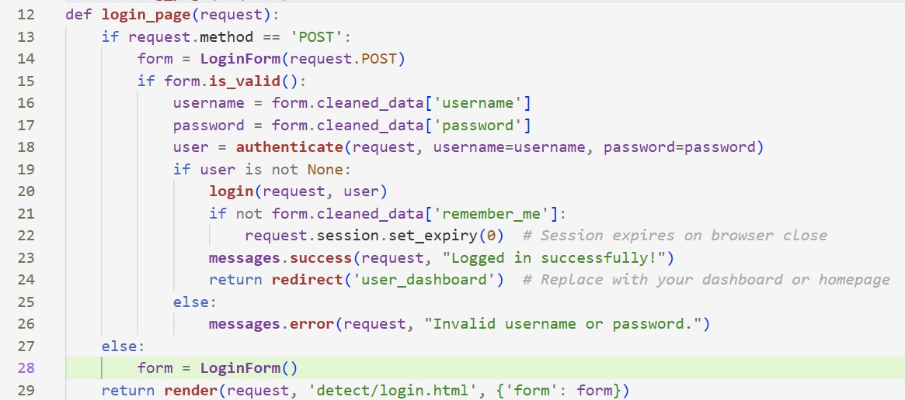

Module 2
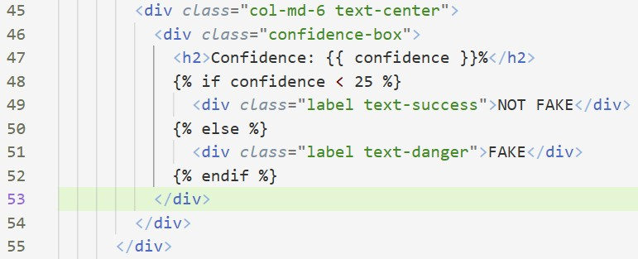

7. TESTING
Module 1: LogIn
Pseudocode:
- Enter Username
- Enter Password
- Click LogIn
- If Username==User.username and Password==User.password
- Show message (“Logged in successfully!”)
- Redirect to User Dashboard
- Else
- Show Error (“Invalid username or password.”) 9. Procedure End
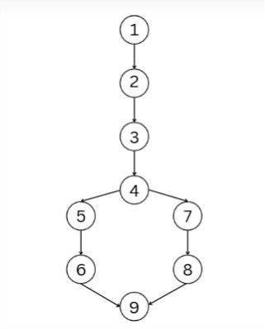
Cyclomatic Complexity of Resultant Graph
- CC=Total No. Of Regions=2
- CC=No. of Edges-No. of nodes+ 2p
= 9-9+2(1)=2
- CC=No. Of predicate nodes+1
= 1+1=2

Independent Basic Paths From The Graph
Path 1: 1->2->3->4->5->6->9 Path 2: 1->2->3->4->7->8->9

Black Box Testing
Username | Password | Expected Output
False | False | False
False | True | False
True | False | False
True | True | True

Module 2: Detection
Pseudocode:
- Run algorithm on uploaded image.
- If Confidence <= 25%
- Print(“Not Fake”)
- Else
- Print(“Fake”)
- Procedure End
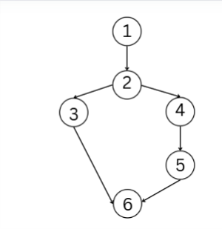
Cyclomatic Complexity of Resultant Graph
- CC=Total No. Of Regions=2
- CC=No. of Edges-No. of nodes+ 2p
= 6-6+2(1)=2
- CC=No. Of predicate nodes+1
= 1+1=2

Independent Basic Paths From The Graph
Path 1: 1->2->3->6-
Path 2: 1->2->4->5->6
Black Box Testing
Confidence | Expected Output
<=25% | Not Fake
>25% | Fake

8. REFERENCES
- Image Forgery Detection: A Survey of Recent Deep-Learning Approaches
- Image Forgery Detection Using Deep Learning: A Review
- Kaggle – Image Forgery Detection Datasets

9. ANNEXURES


Fig 9.1 Landing Page


Fig 9.2 Sign Up Page


Fig 9.3 Log In Page

Fig 9.4 User Dashboard

Fig 9.5 My Vault

Fig 9.6 Image Upload


Fig 9.7 Result-1


Fig 9.8 Result-2

Fig 9.9 Save the details


Fig 9.10 Report generation

Fig 9.11 Report Sent Successfully

Fig 9.12 Feed Back

Fig 9.13 Chatbot

Fig 9.14 Upload and Send

Fig 9.15 Admin Dashboard

